Resource: Video Bible Dictionary
Video Bible Dictionary © 2023 SRV Partners. Released under CC BY-SA 4.0 license. Video Bible Dictionary has been adapted in the following languages: Tok Pisin, عربي, Français, हिंदी, Bahasa Indonesia, Português, Русский, Español, Kiswahili, 简体中文 from Video Bible Dictionary © 2023 SRV Partners. Released under CC BY-SA 4.0 license by Mission Mutual

Video Bible Dictionary

P

Palo

Video Content
(70 seconds)
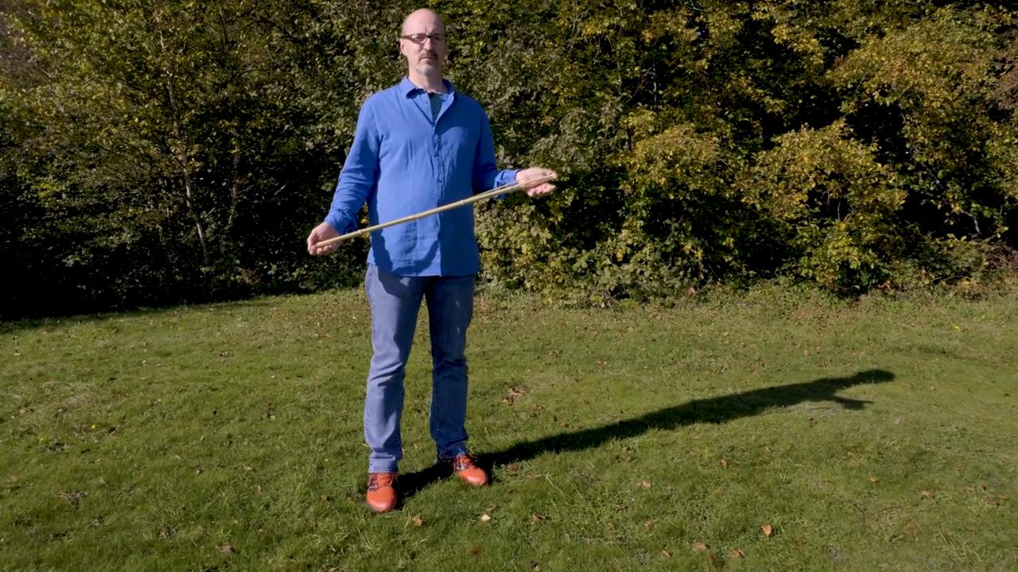
link

Paloma

Video Content
(91 seconds)
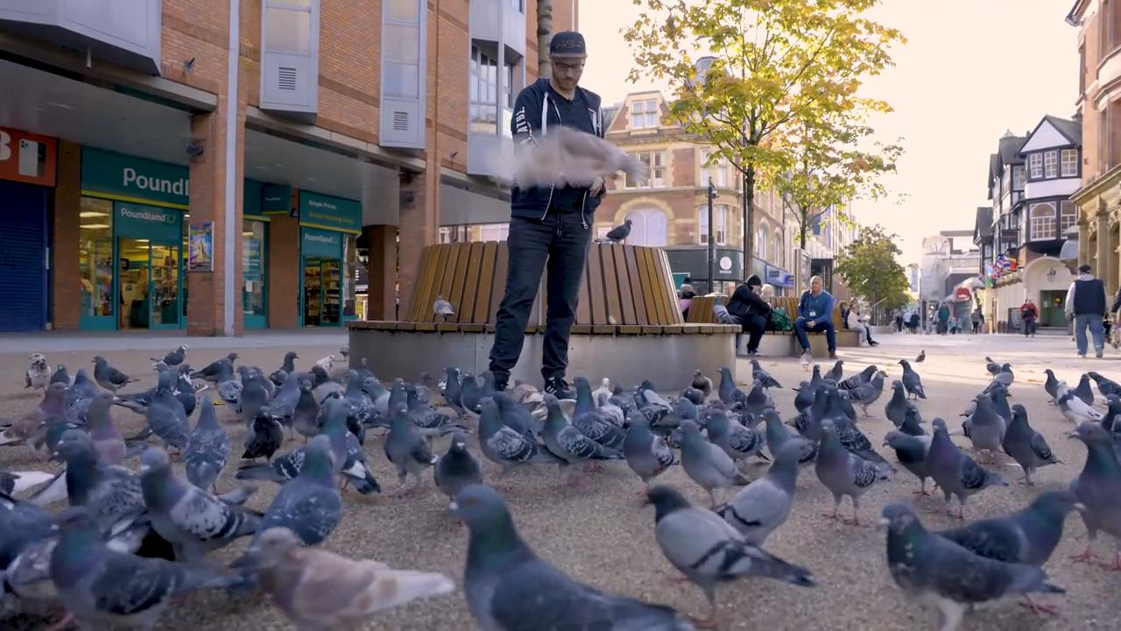
link

Pan sin levadura

Video Content
(71 seconds)
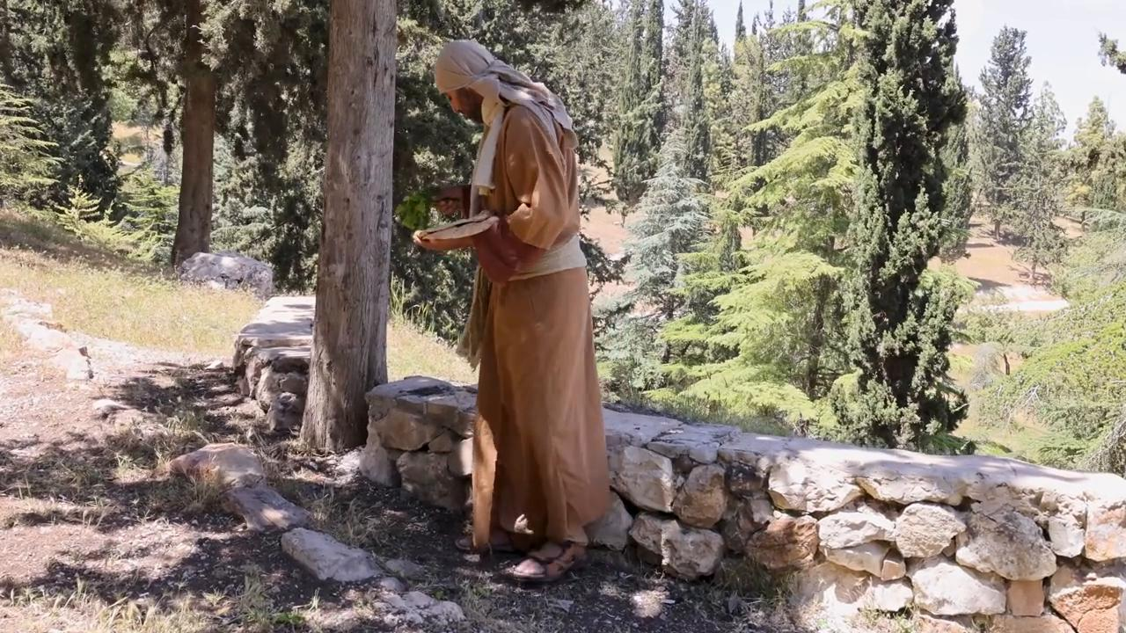
link

Pescado cocido

Video Content
(81 seconds)
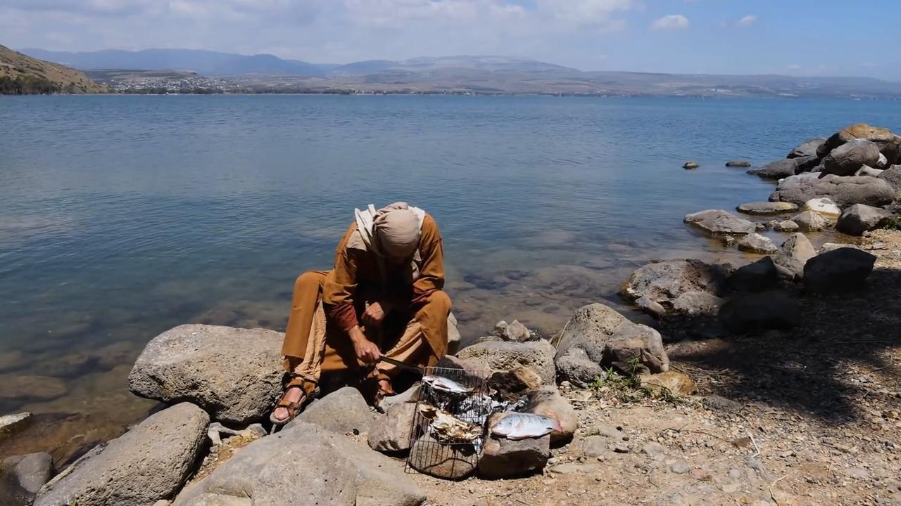
link

Pez

Video Content
(85 seconds)
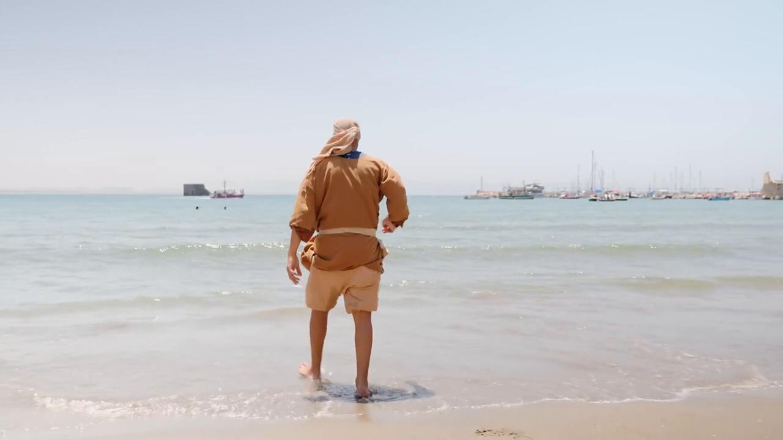
link

Piedra angular

Video Content
(77 seconds)
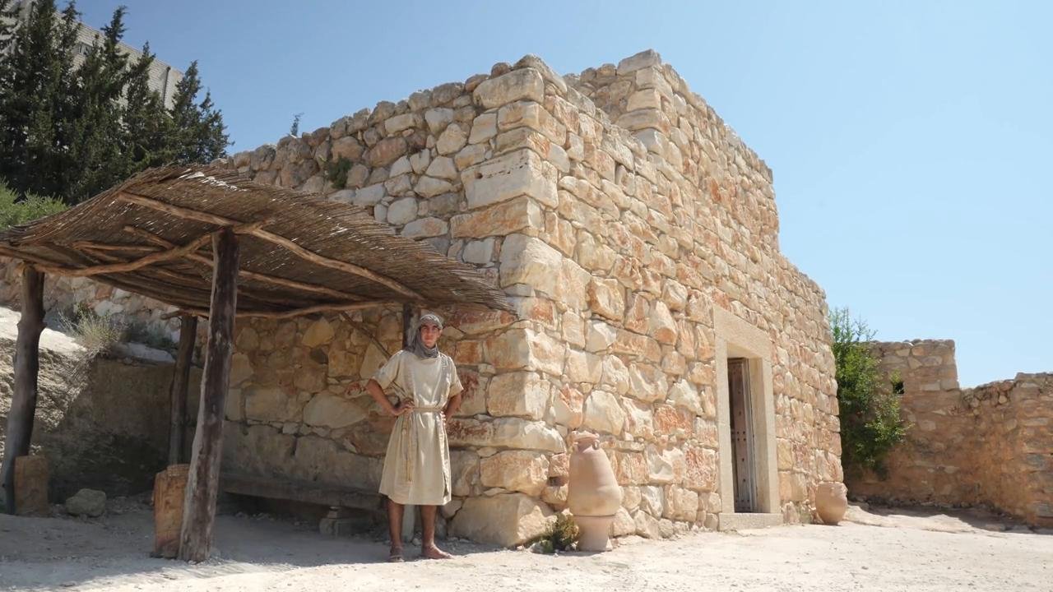
link

Piedra de molino

Video Content
(88 seconds)
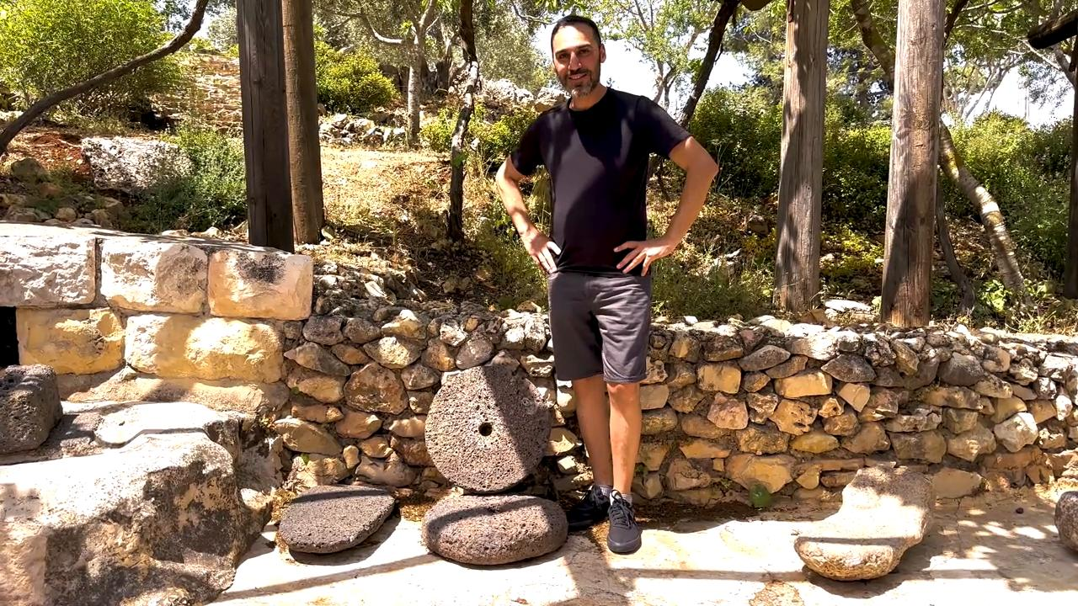
link

