Resource: Video Bible Dictionary
Video Bible Dictionary © 2023 SRV Partners. Released under CC BY-SA 4.0 license. Video Bible Dictionary has been adapted in the following languages: Tok Pisin, عربي, Français, हिंदी, Bahasa Indonesia, Português, Русский, Español, Kiswahili, 简体中文 from Video Bible Dictionary © 2023 SRV Partners. Released under CC BY-SA 4.0 license by Mission Mutual

Video Bible Dictionary

T

Torre de vigilancia para un viñedo

Video Content
(97 seconds)
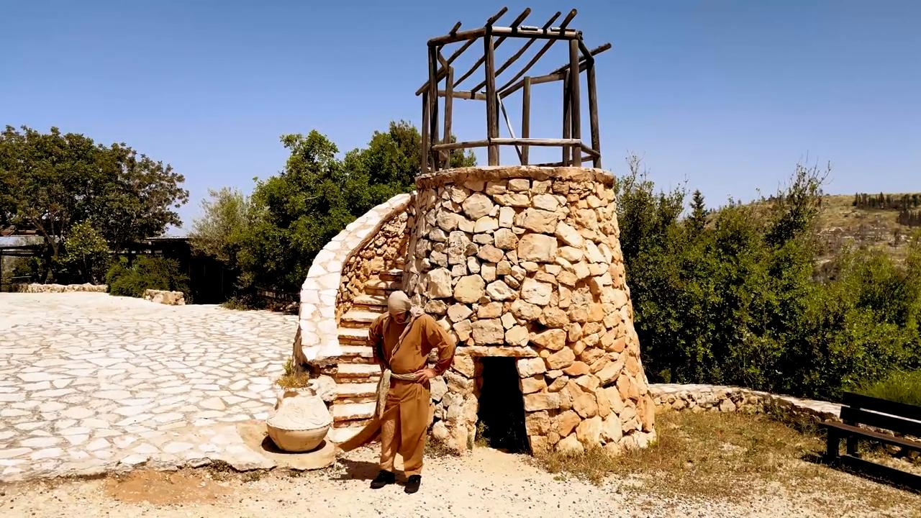
link

Trigo con espigas

Video Content
(131 seconds)
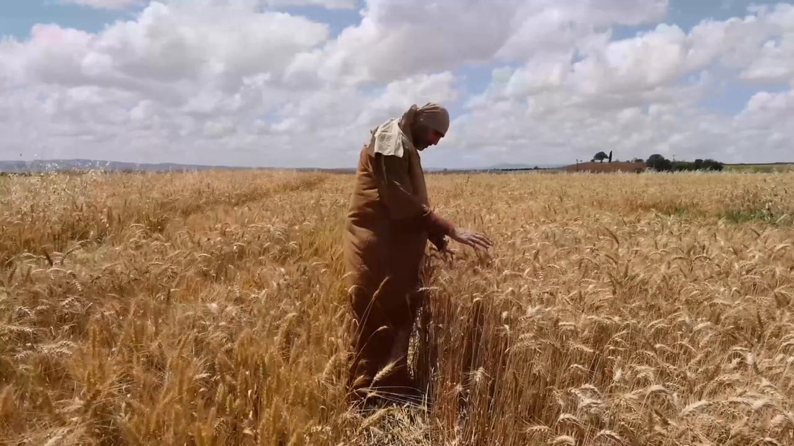
link

Trigo listo para la cosecha

Video Content
(79 seconds)
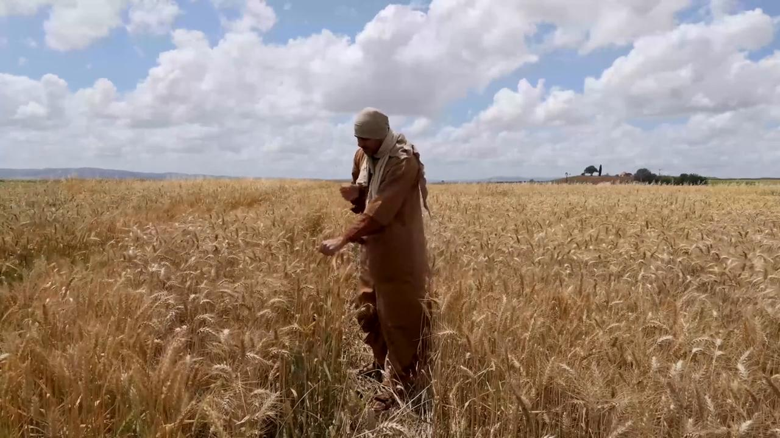
link

Tumba del jardín

Video Content
(84 seconds)
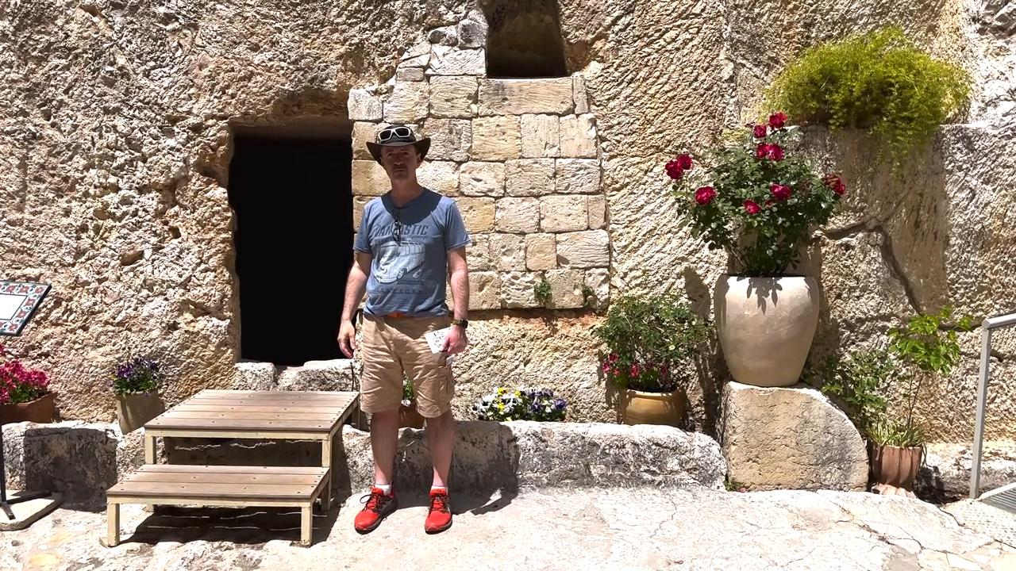
link

Tumbas

Video Content
(93 seconds)
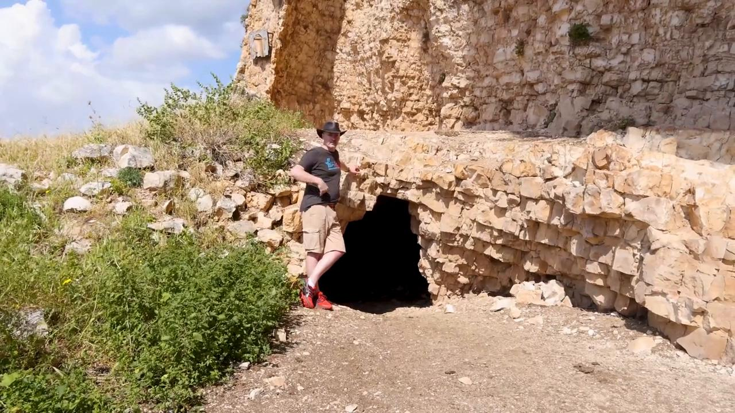
link

Túnica

Video Content
(82 seconds)
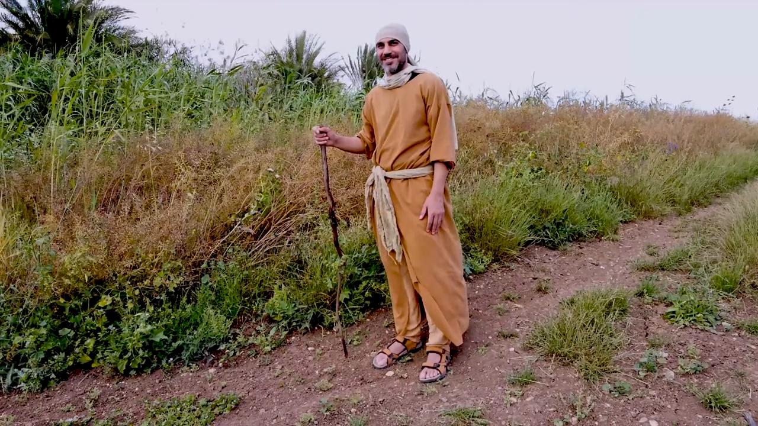
link

Túnica blanca

Video Content
(76 seconds)
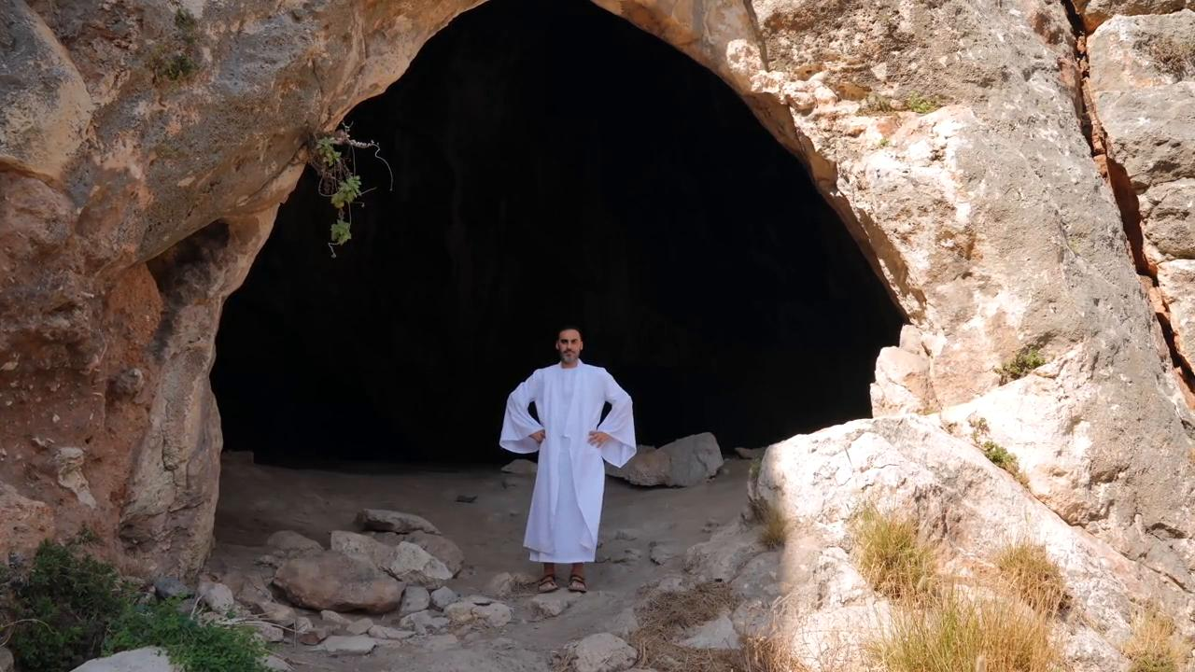
link

Túnica púrpura

Video Content
(89 seconds)
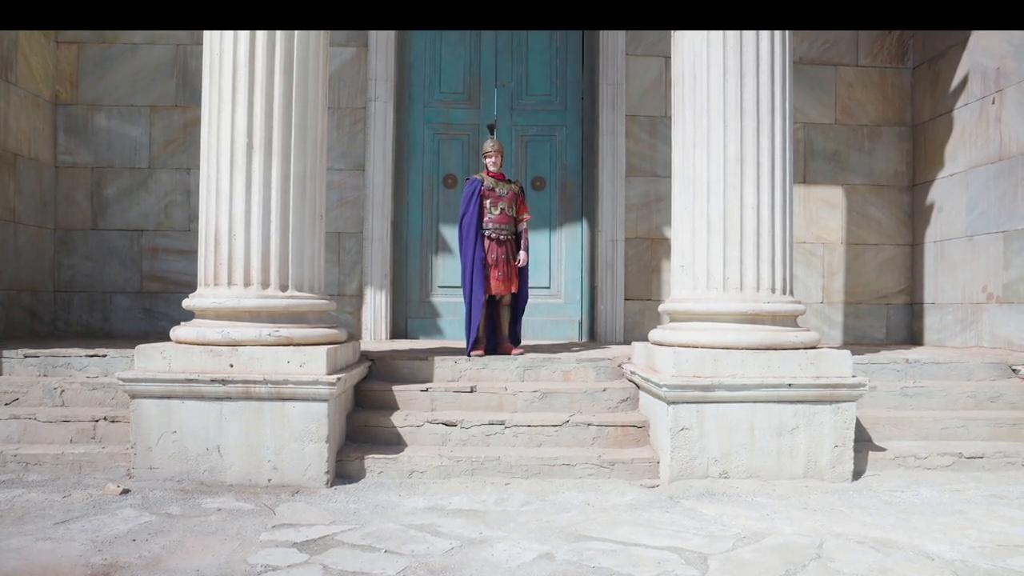
link

