Resource: Videos (Video Bible Dictionary)
Video Bible Dictionary © 2023 SRV Partners. Released under CC BY-SA 4.0 license. Video Bible Dictionary has been adapted in the following languages: Tok Pisin, عربي, Français, हिंदी, Bahasa Indonesia, Português, Русский, Español, Kiswahili, 简体中文 from Video Bible Dictionary © 2023 SRV Partners. Released under CC BY-SA 4.0 license by Mission Mutual

Videos (Video Bible Dictionary)

A

Adult and Kid Goat

Video Content
(67 seconds)
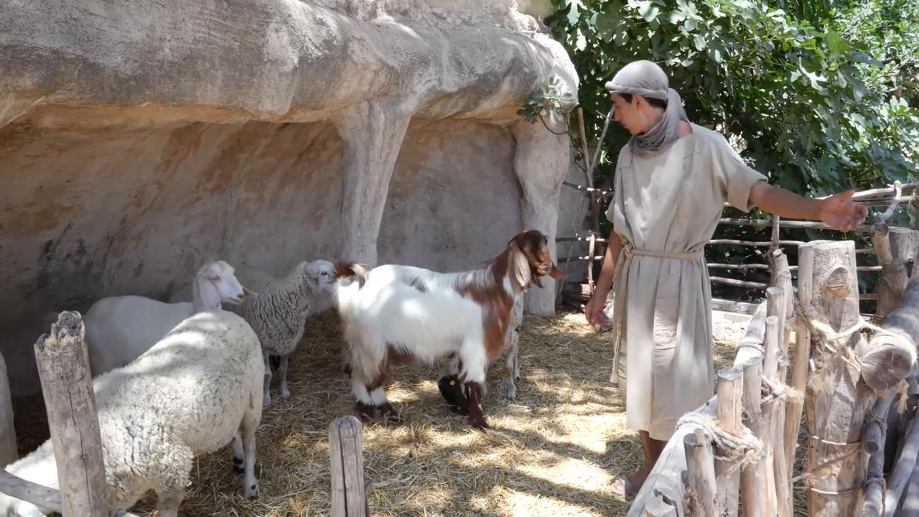
link

Adult Donkey

Video Content
(89 seconds)
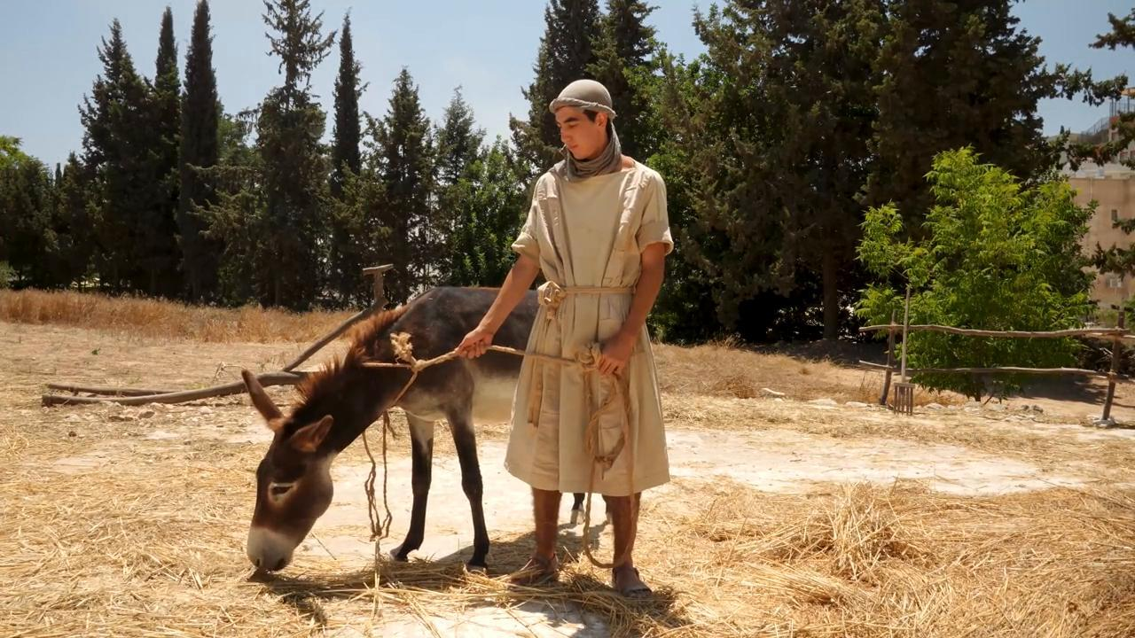
link

Alabaster Jar

Video Content
(73 seconds)

link

Ashes

Video Content
(74 seconds)
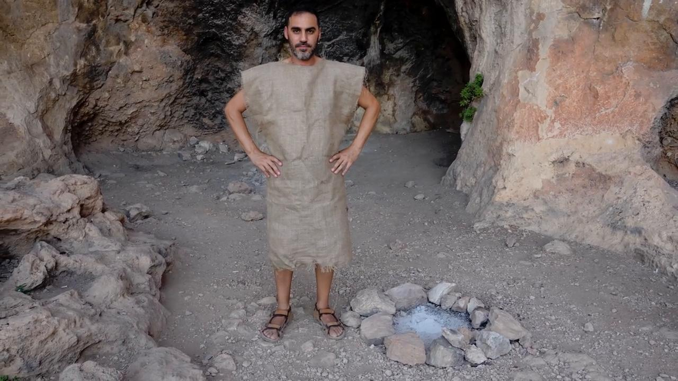
link

Axe

Video Content
(69 seconds)
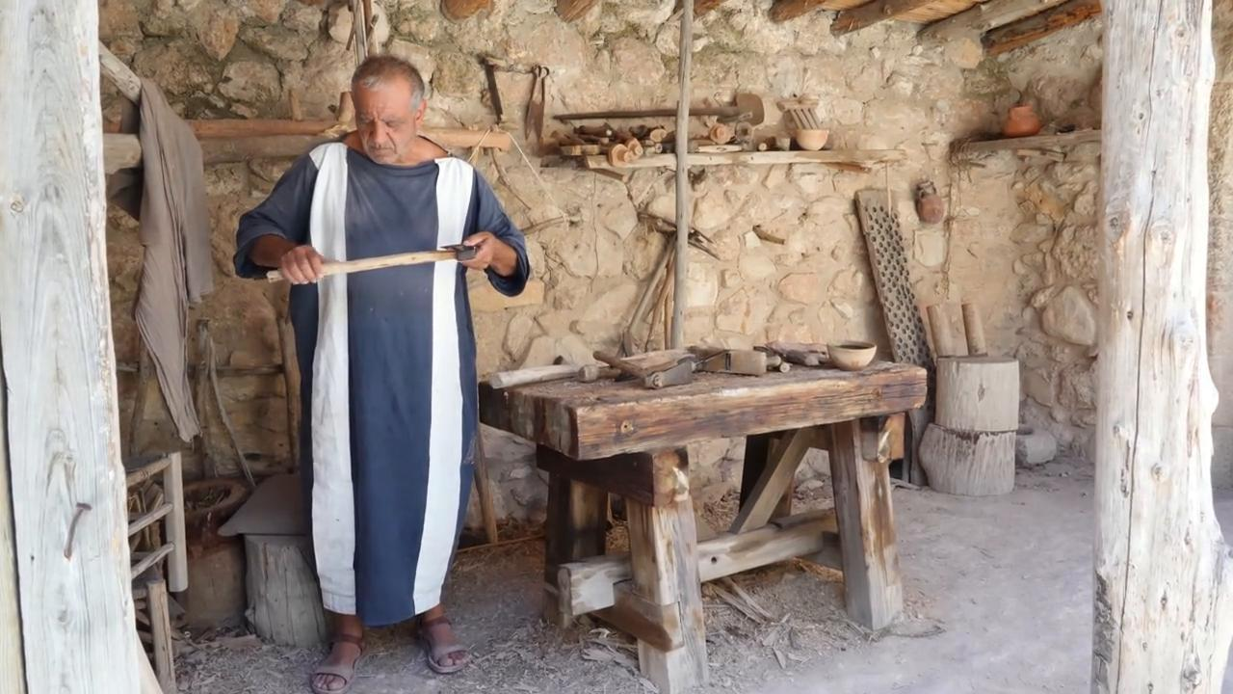
link

