Resource: Videos (Video Bible Dictionary)
Video Bible Dictionary © 2023 SRV Partners. Released under CC BY-SA 4.0 license. Video Bible Dictionary has been adapted in the following languages: Tok Pisin, عربي, Français, हिंदी, Bahasa Indonesia, Português, Русский, Español, Kiswahili, 简体中文 from Video Bible Dictionary © 2023 SRV Partners. Released under CC BY-SA 4.0 license by Mission Mutual

Videos (Video Bible Dictionary)

B

Basket as a Bushel

Video Content
(77 seconds)
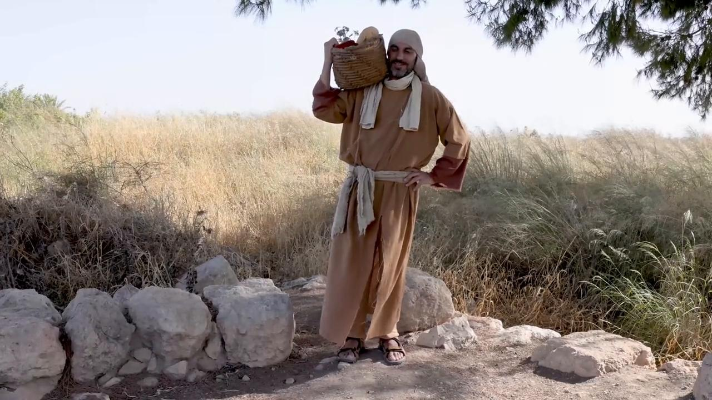
link

Basket for Provisions

Video Content
(88 seconds)

link

Belt

Video Content
(71 seconds)
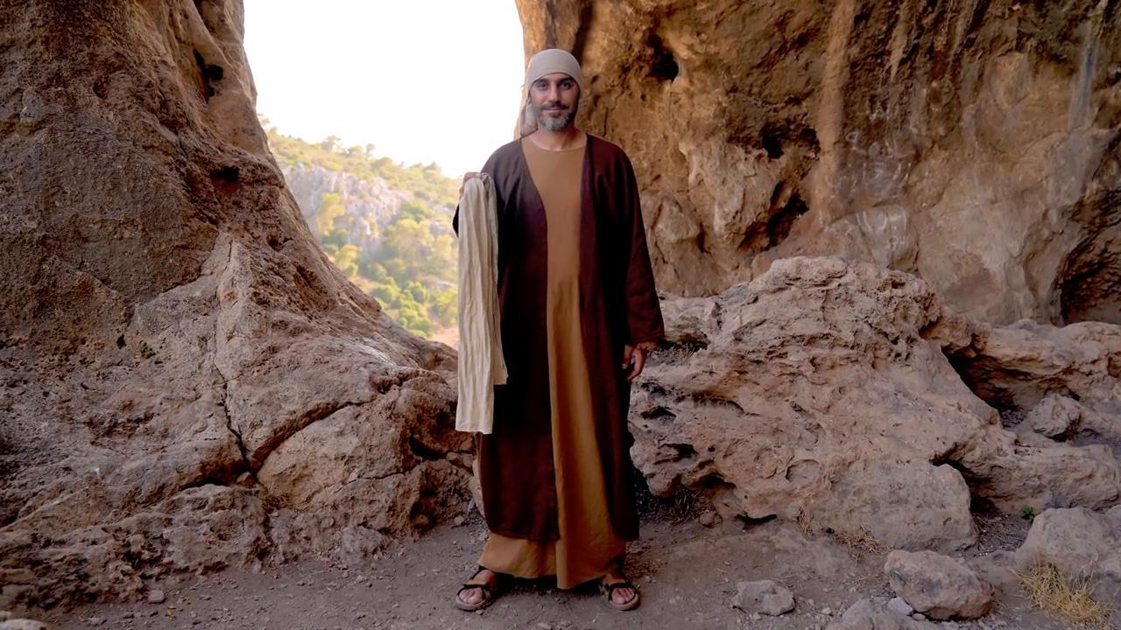
link

Bitter Herbs

Video Content
(71 seconds)
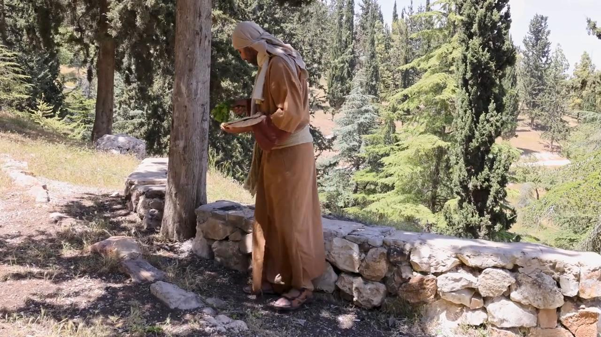
link

Bow and Arrows

Video Content
(107 seconds)
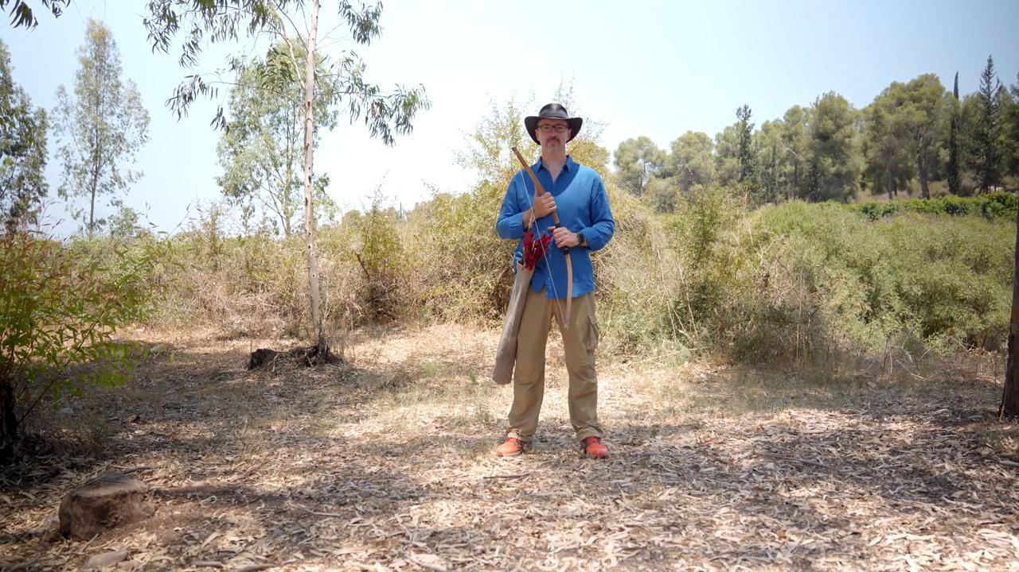
link

