Resource: Videos (Video Bible Dictionary)
Video Bible Dictionary © 2023 SRV Partners. Released under CC BY-SA 4.0 license. Video Bible Dictionary has been adapted in the following languages: Tok Pisin, عربي, Français, हिंदी, Bahasa Indonesia, Português, Русский, Español, Kiswahili, 简体中文 from Video Bible Dictionary © 2023 SRV Partners. Released under CC BY-SA 4.0 license by Mission Mutual

Videos (Video Bible Dictionary)

C

Camel

Video Content
(58 seconds)
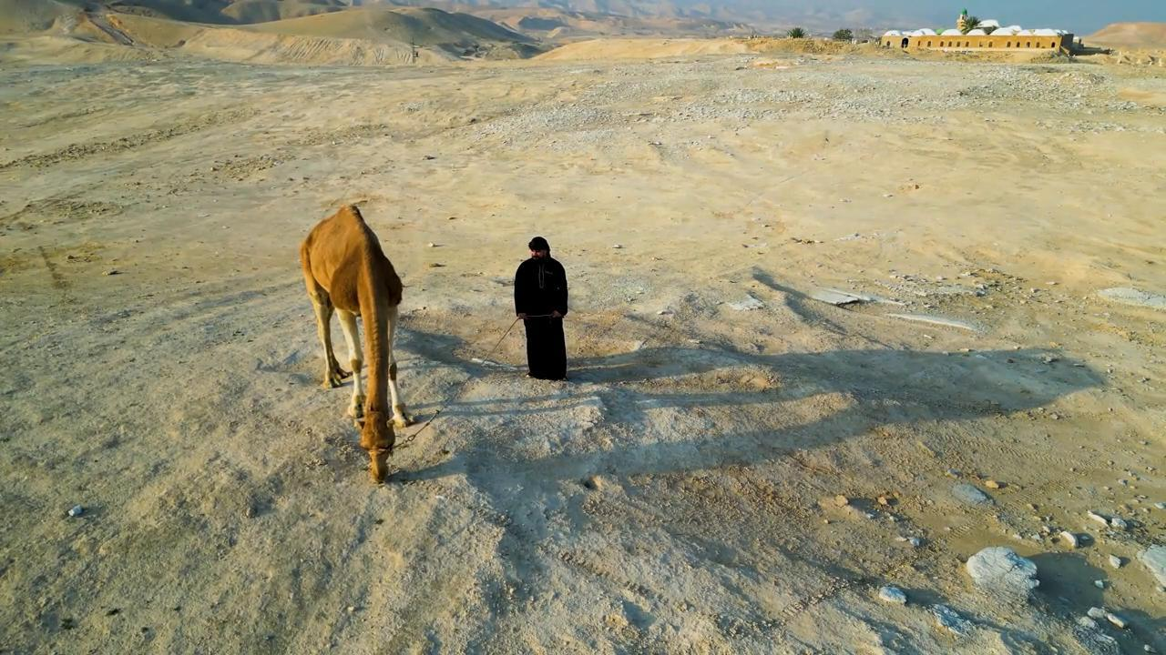
link

Cave

Video Content
(94 seconds)
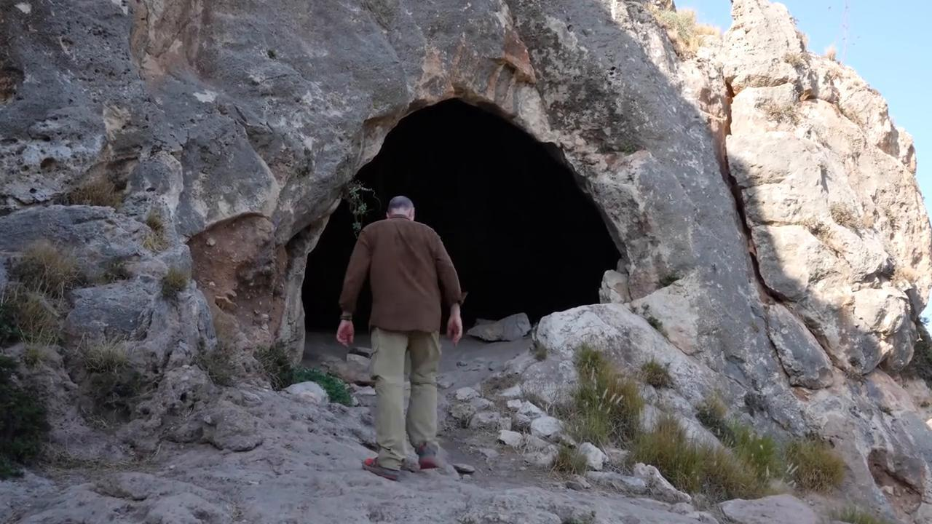
link

Chains

Video Content
(73 seconds)
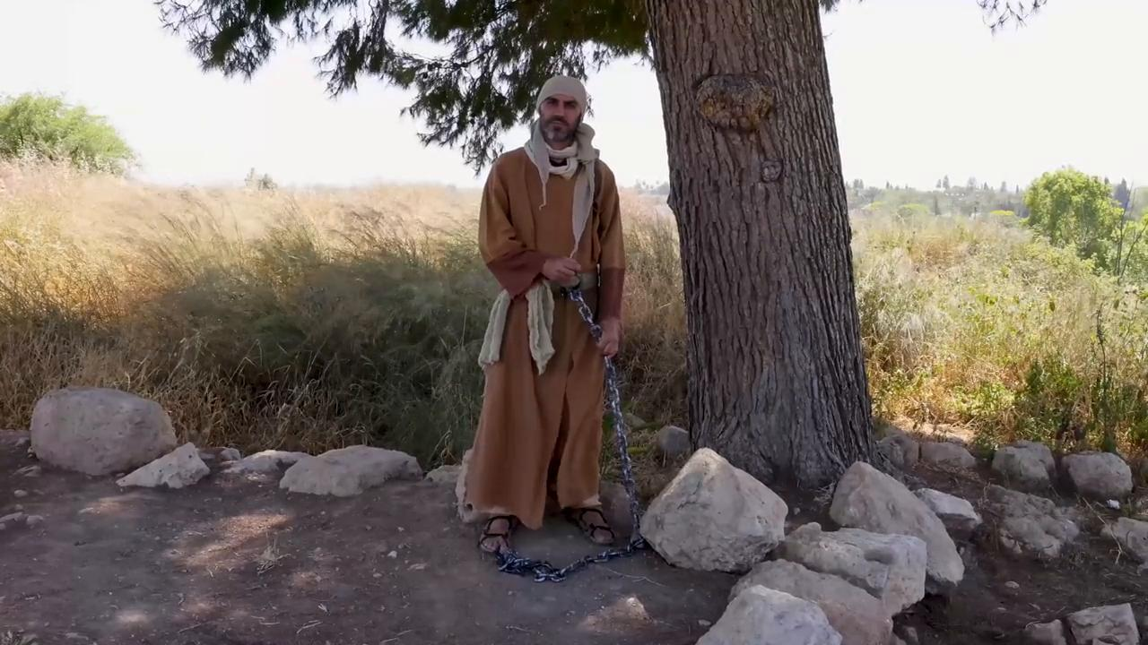
link

Cliffs

Video Content
(49 seconds)
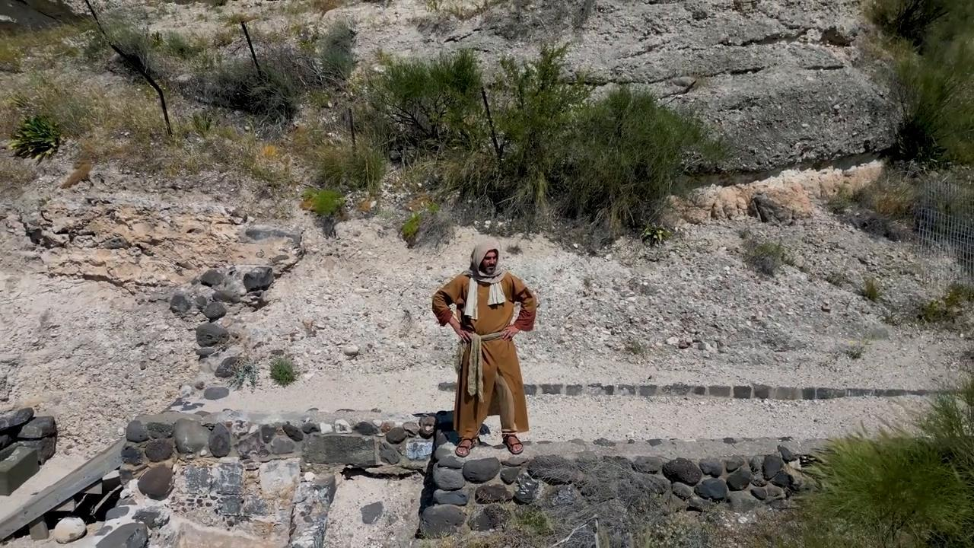
link

Cloak of Camel Hair

Video Content
(86 seconds)
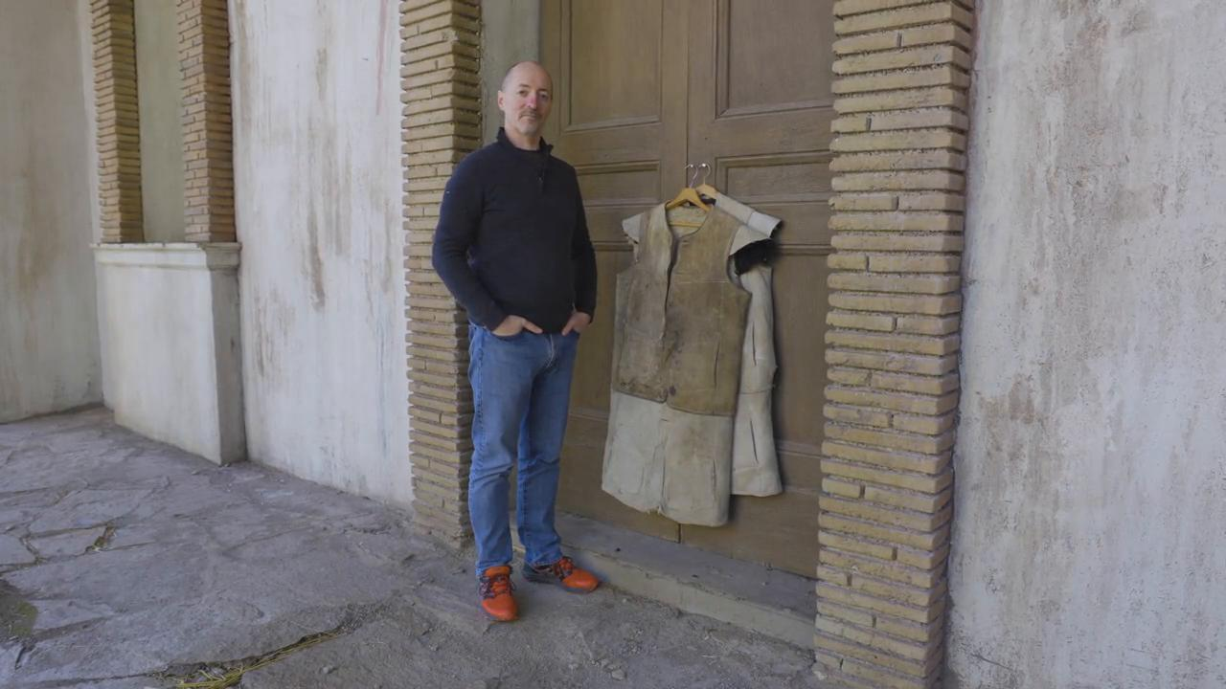
link

Club

Video Content
(74 seconds)
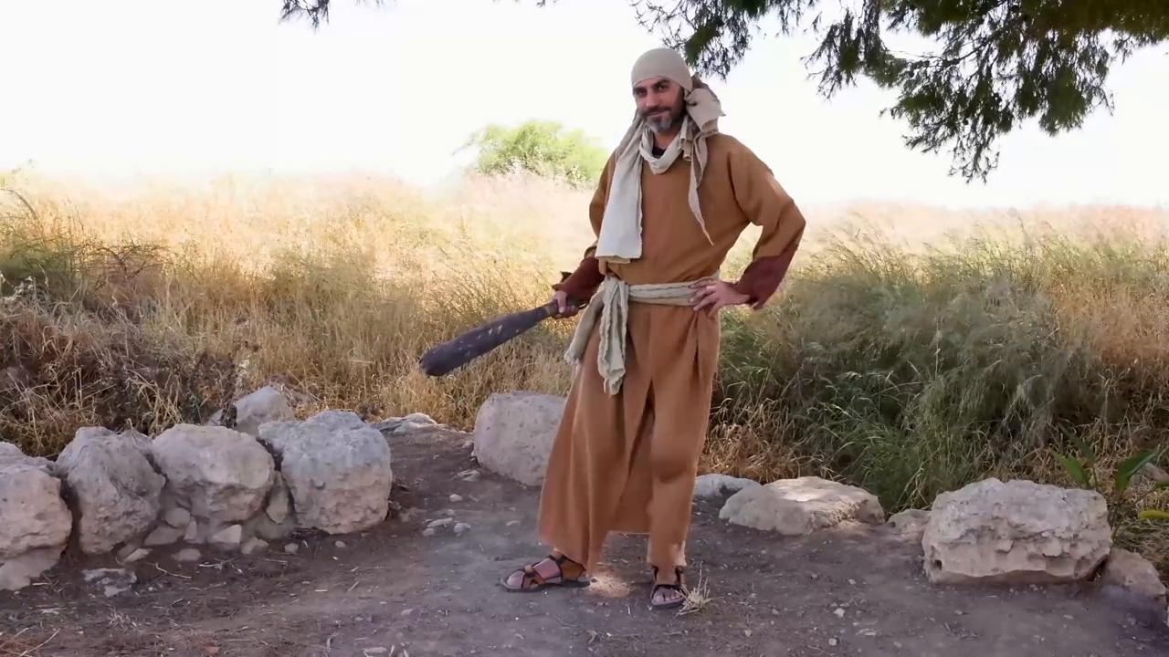
link

Coins

Video Content
(65 seconds)
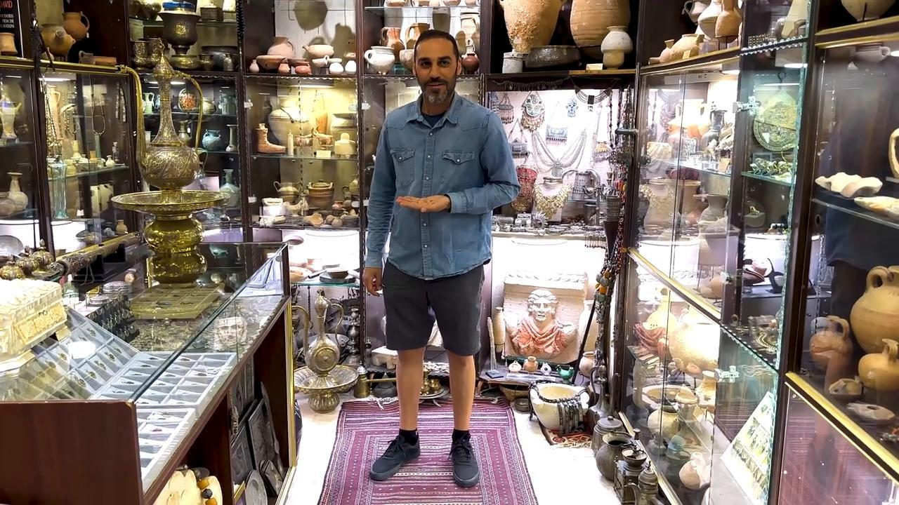
link

Cooked Fish

Video Content
(81 seconds)
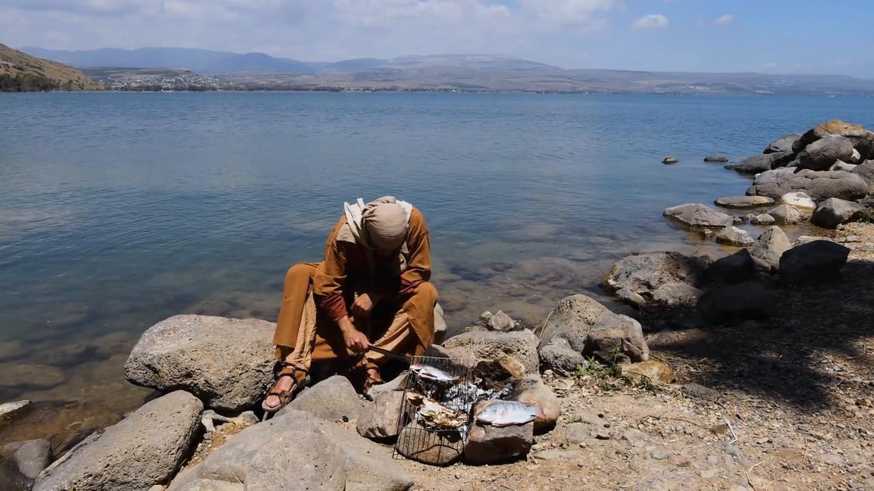
link

Copper Coins

Video Content
(69 seconds)

link

Cornerstone with a Wall

Video Content
(77 seconds)
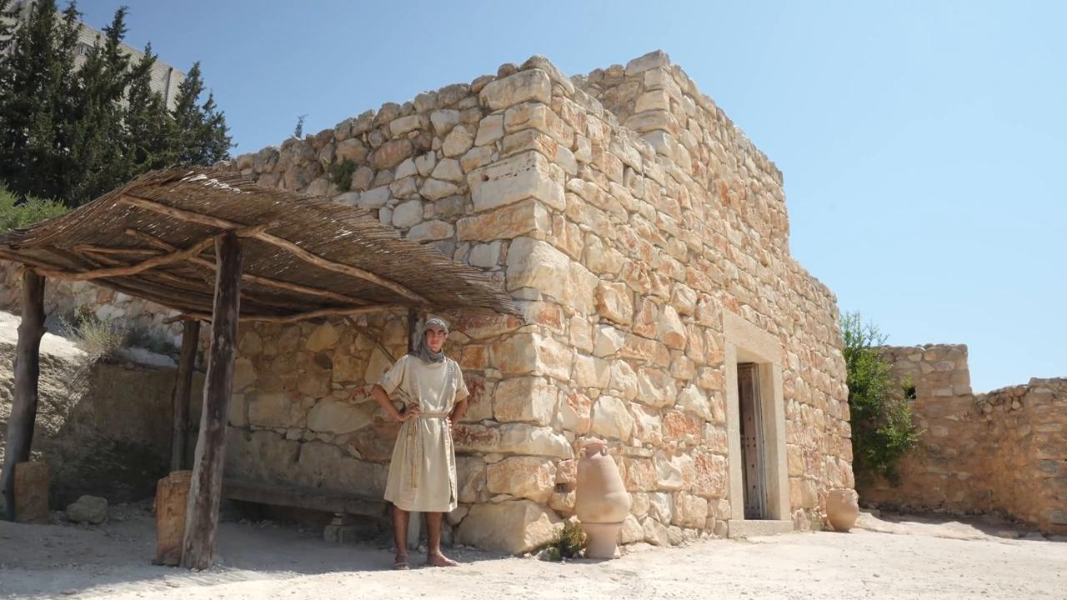
link

