Resource: Videos (Video Bible Dictionary)
Video Bible Dictionary © 2023 SRV Partners. Released under CC BY-SA 4.0 license. Video Bible Dictionary has been adapted in the following languages: Tok Pisin, عربي, Français, हिंदी, Bahasa Indonesia, Português, Русский, Español, Kiswahili, 简体中文 from Video Bible Dictionary © 2023 SRV Partners. Released under CC BY-SA 4.0 license by Mission Mutual

Videos (Video Bible Dictionary)

F

Fine Linen Cloth

Video Content
(68 seconds)
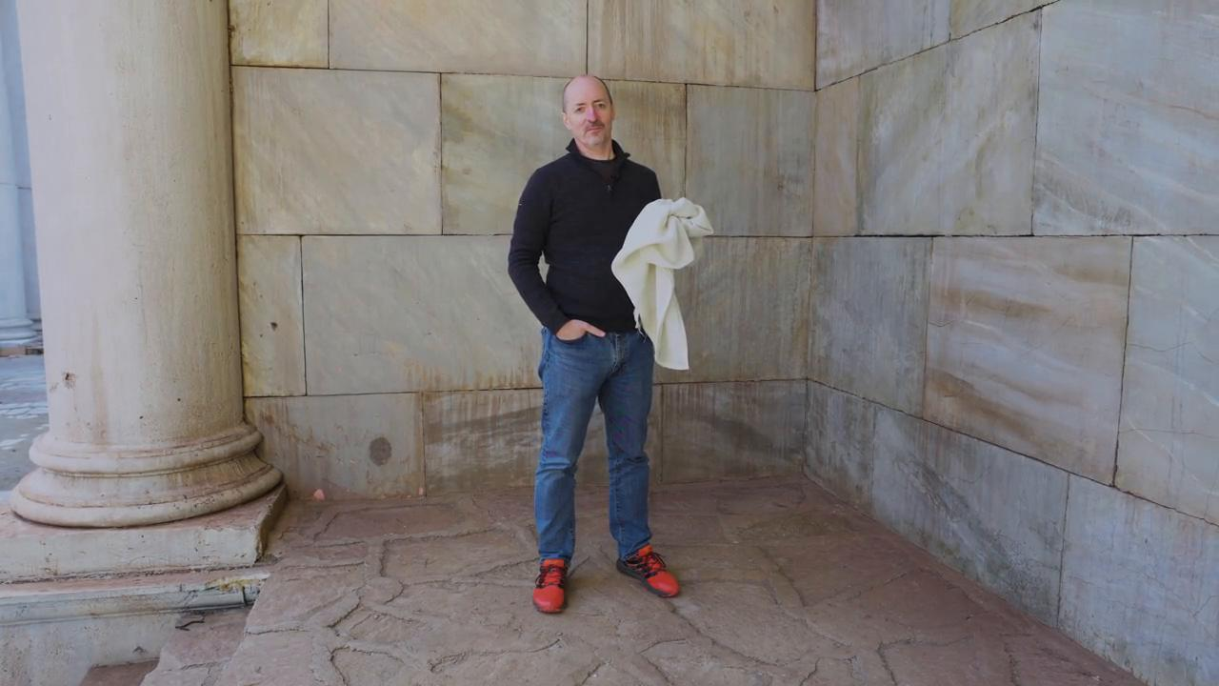
link

Fish

Video Content
(85 seconds)
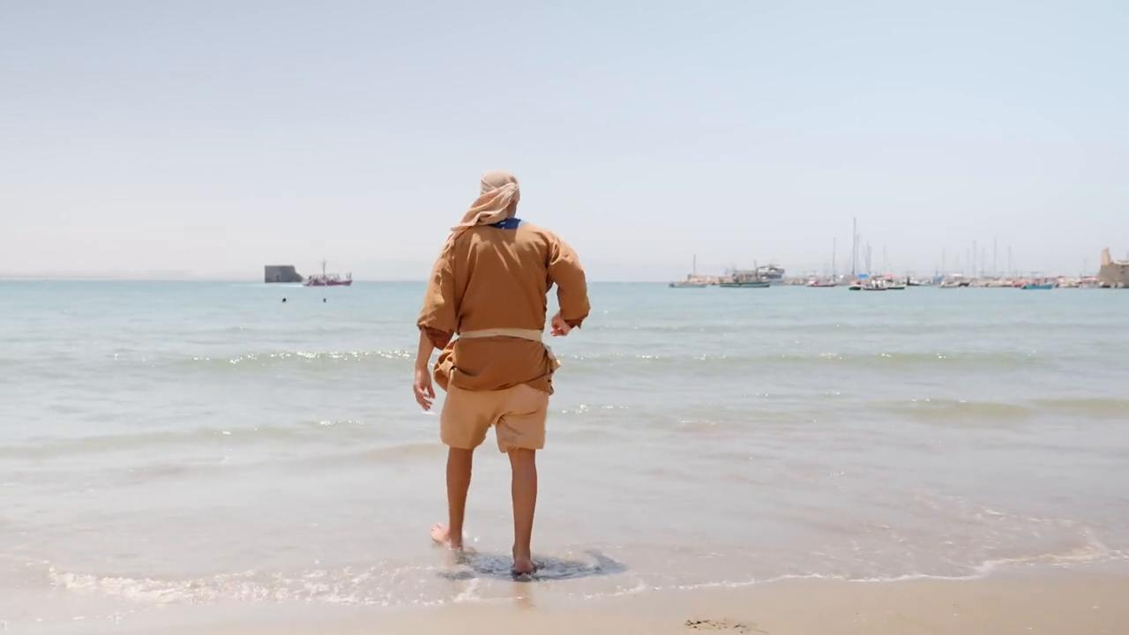
link

Fish Scales

Video Content
(72 seconds)
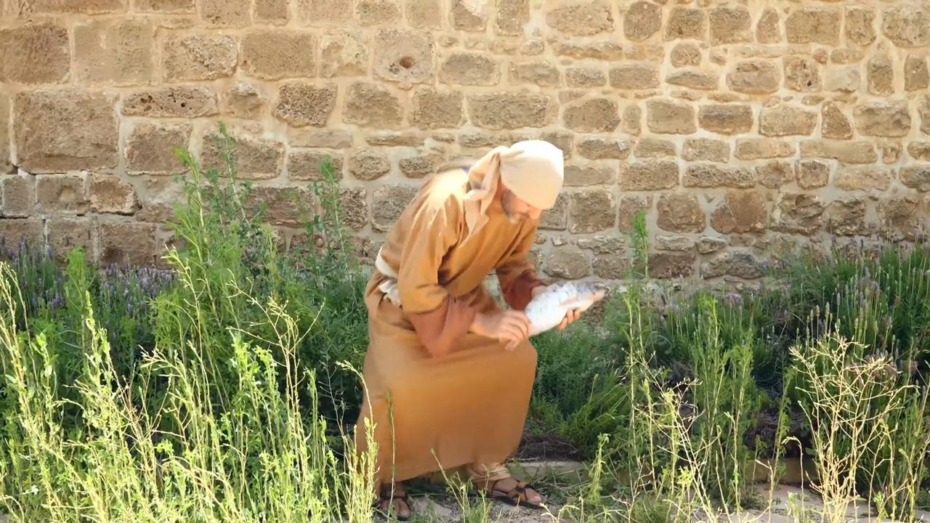
link

Fishing Net

Video Content
(82 seconds)
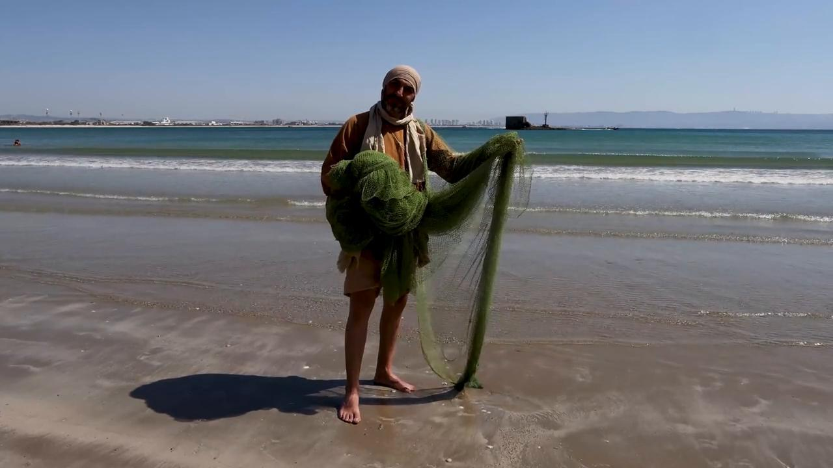
link

Four Soils

Video Content
(89 seconds)
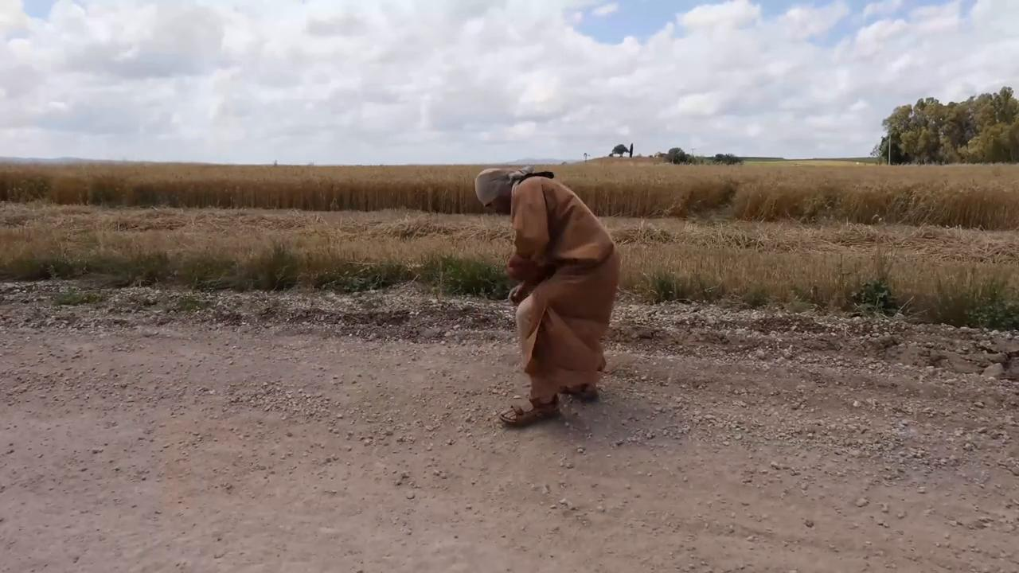
link

