Resource: Videos (Video Bible Dictionary)
Video Bible Dictionary © 2023 SRV Partners. Released under CC BY-SA 4.0 license. Video Bible Dictionary has been adapted in the following languages: Tok Pisin, عربي, Français, हिंदी, Bahasa Indonesia, Português, Русский, Español, Kiswahili, 简体中文 from Video Bible Dictionary © 2023 SRV Partners. Released under CC BY-SA 4.0 license by Mission Mutual

Videos (Video Bible Dictionary)

H

Hail Falling

Video Content
(12 seconds)

link

House in the Time of Jesus

Video Content
(87 seconds)
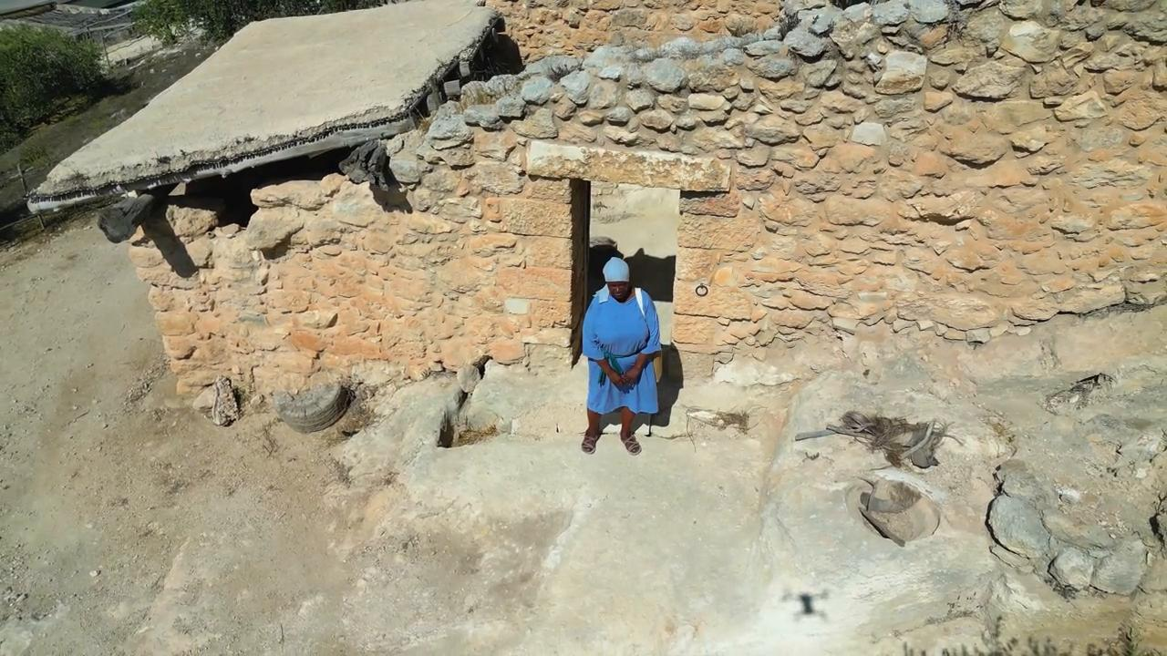
link

