Resource: Videos (Video Bible Dictionary)
Video Bible Dictionary © 2023 SRV Partners. Released under CC BY-SA 4.0 license. Video Bible Dictionary has been adapted in the following languages: Tok Pisin, عربي, Français, हिंदी, Bahasa Indonesia, Português, Русский, Español, Kiswahili, 简体中文 from Video Bible Dictionary © 2023 SRV Partners. Released under CC BY-SA 4.0 license by Mission Mutual

Videos (Video Bible Dictionary)

M

Man Who Is Girded Up

Video Content
(67 seconds)
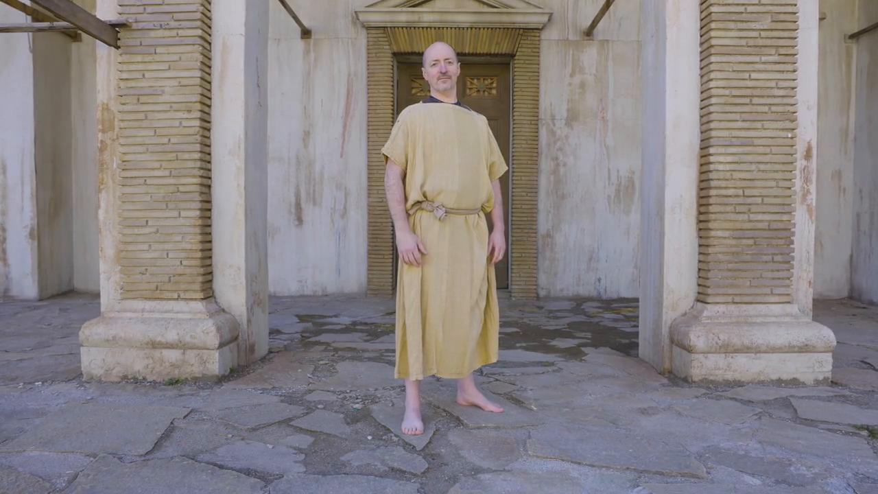
link

Manger

Video Content
(70 seconds)
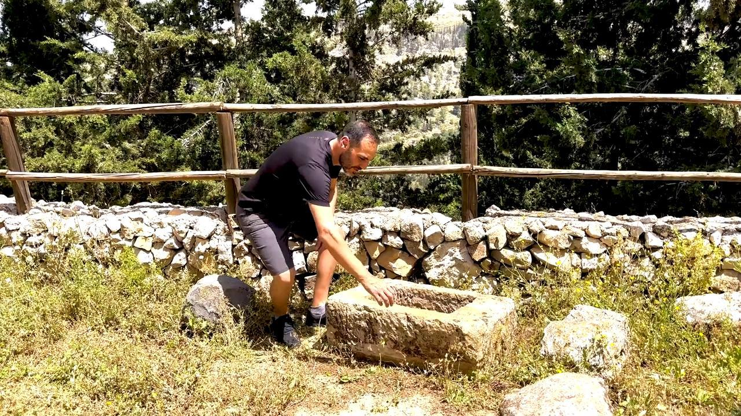
link

Millstone

Video Content
(88 seconds)
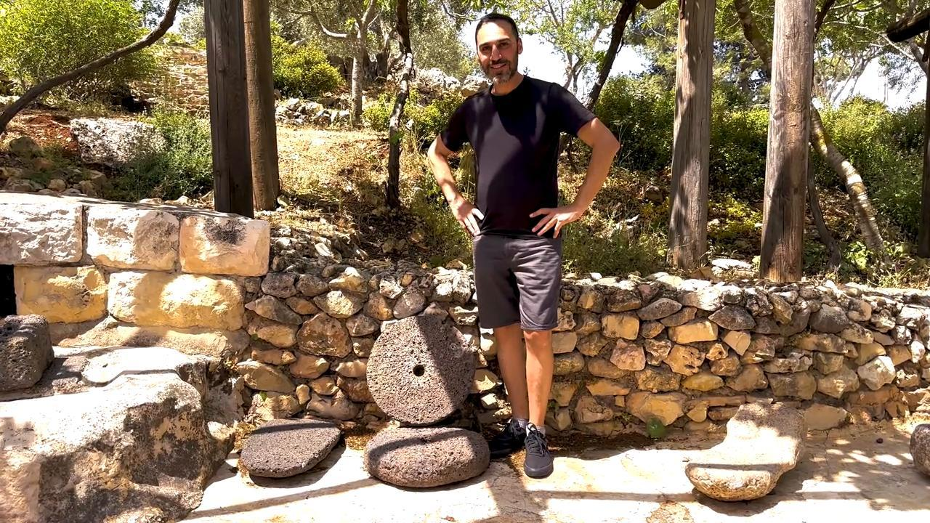
link

Mount of Olives

Video Content
(90 seconds)
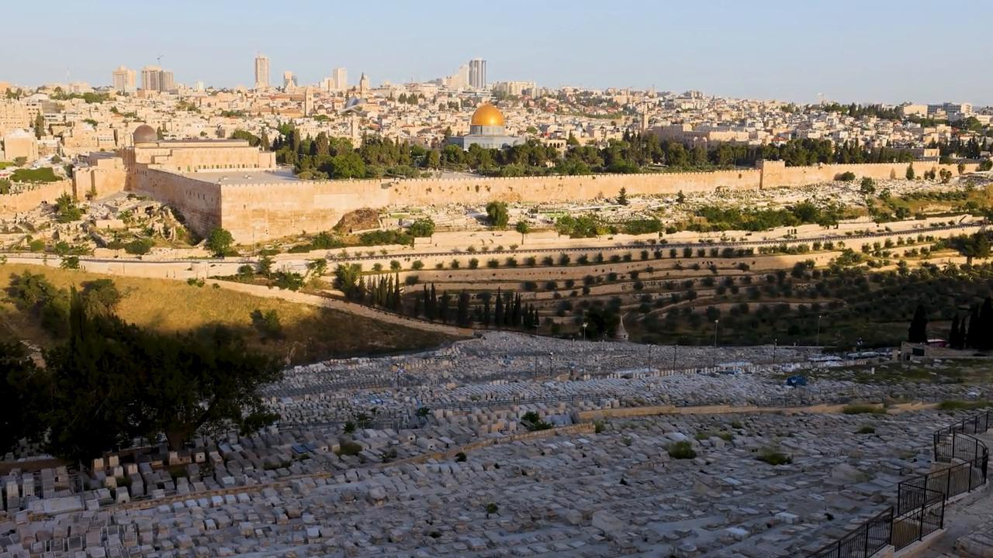
link

Mount Precipice

Video Content
(101 seconds)
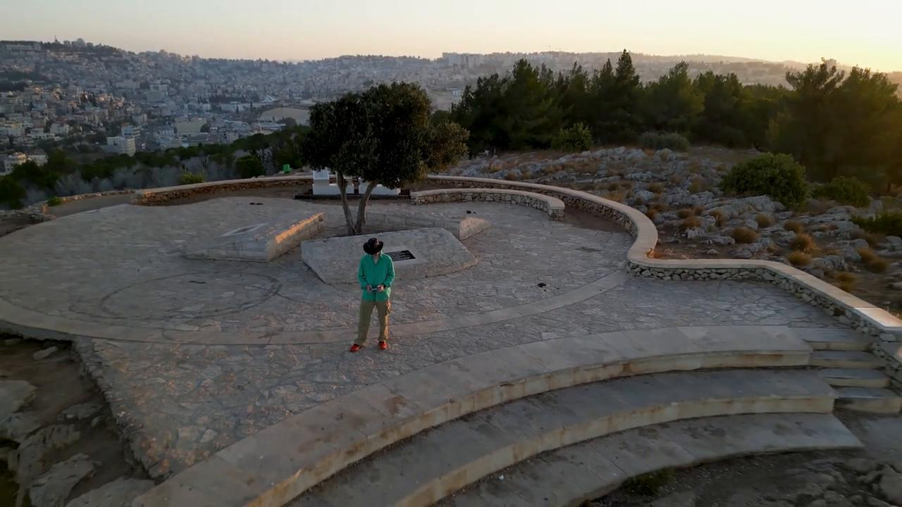
link

