Resource: Videos (Video Bible Dictionary)
Video Bible Dictionary © 2023 SRV Partners. Released under CC BY-SA 4.0 license. Video Bible Dictionary has been adapted in the following languages: Tok Pisin, عربي, Français, हिंदी, Bahasa Indonesia, Português, Русский, Español, Kiswahili, 简体中文 from Video Bible Dictionary © 2023 SRV Partners. Released under CC BY-SA 4.0 license by Mission Mutual

Videos (Video Bible Dictionary)

P

Pearls

Video Content
(75 seconds)
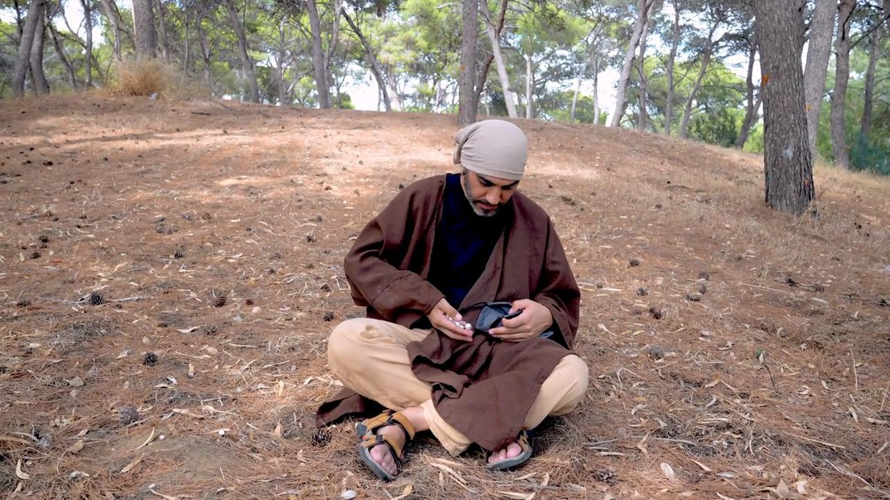
link

Pine Trees

Video Content
(91 seconds)
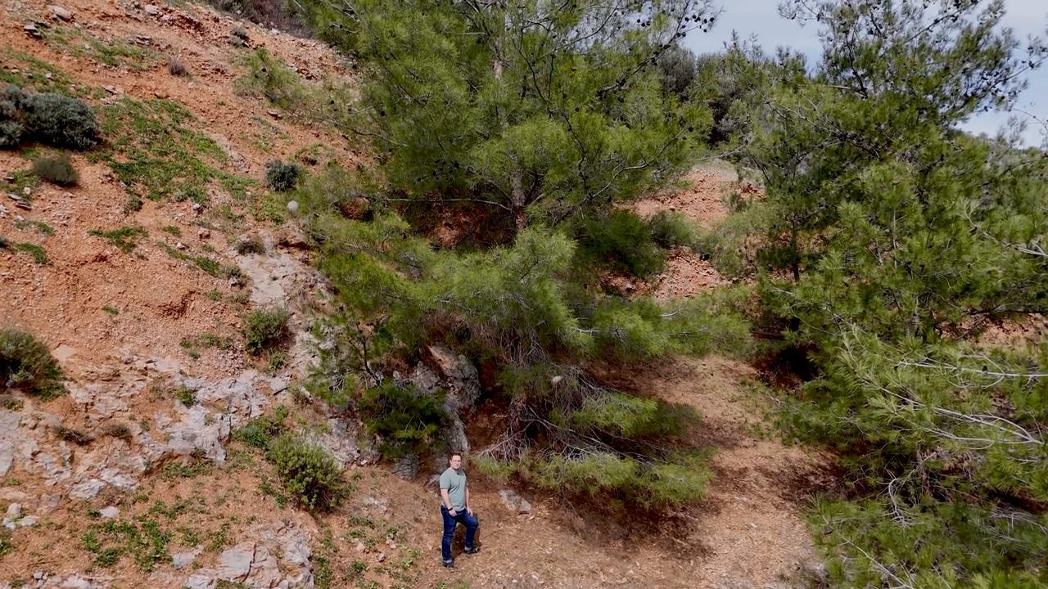
link

Platter

Video Content
(72 seconds)
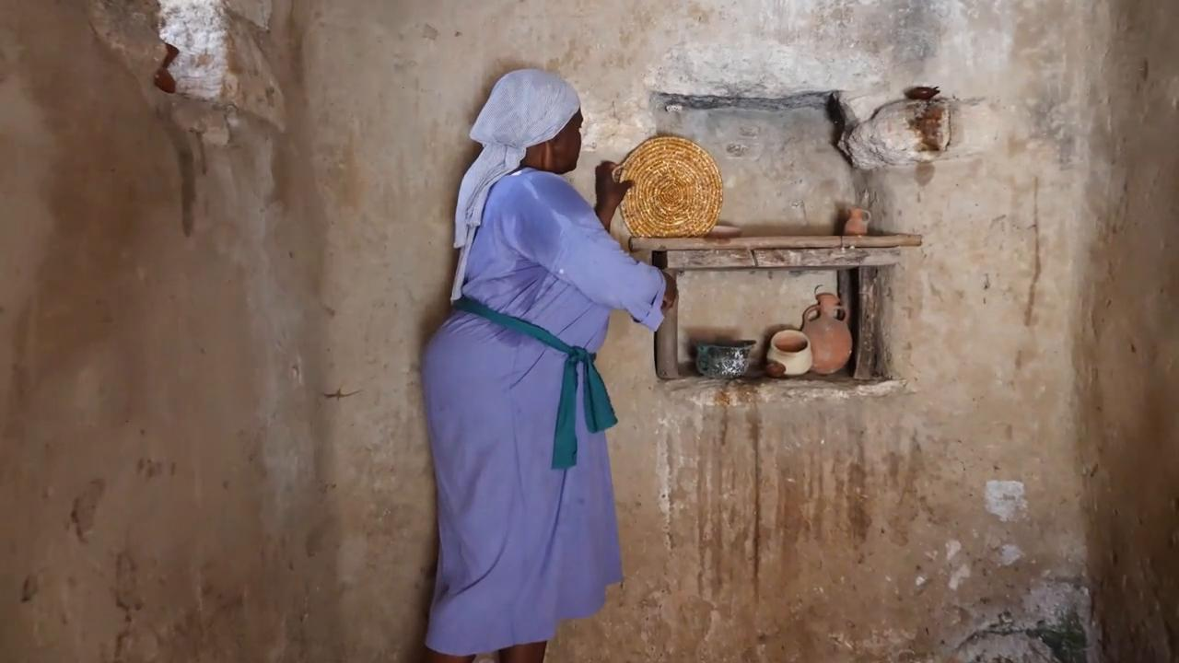
link

Plowing a Field

Video Content
(0 seconds)
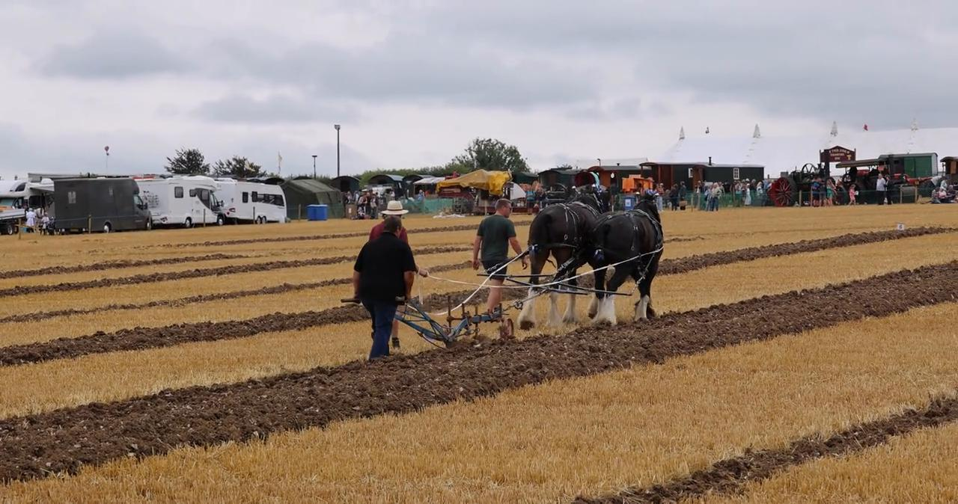
link

Purple Robe

Video Content
(89 seconds)
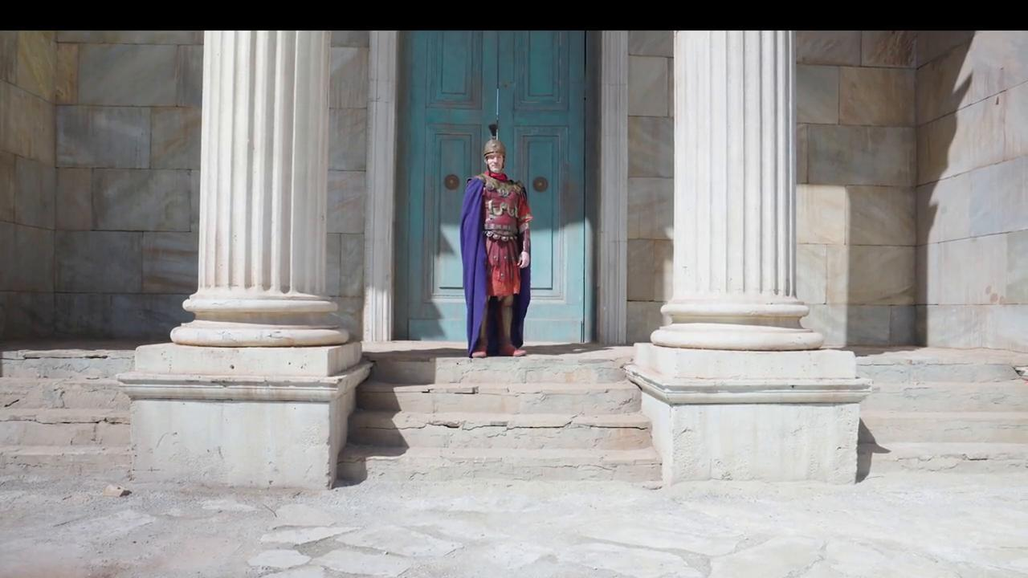
link

Purse

Video Content
(71 seconds)
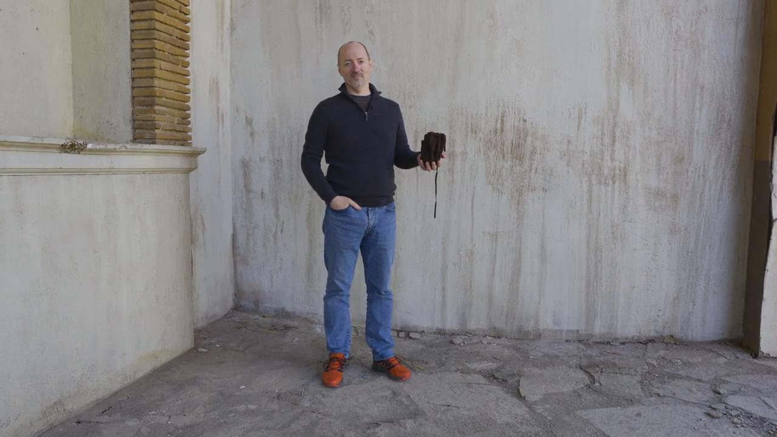
link

