Resource: Videos (Video Bible Dictionary)
Video Bible Dictionary © 2023 SRV Partners. Released under CC BY-SA 4.0 license. Video Bible Dictionary has been adapted in the following languages: Tok Pisin, عربي, Français, हिंदी, Bahasa Indonesia, Português, Русский, Español, Kiswahili, 简体中文 from Video Bible Dictionary © 2023 SRV Partners. Released under CC BY-SA 4.0 license by Mission Mutual

Videos (Video Bible Dictionary)

S

Sackcloth

Video Content
(70 seconds)
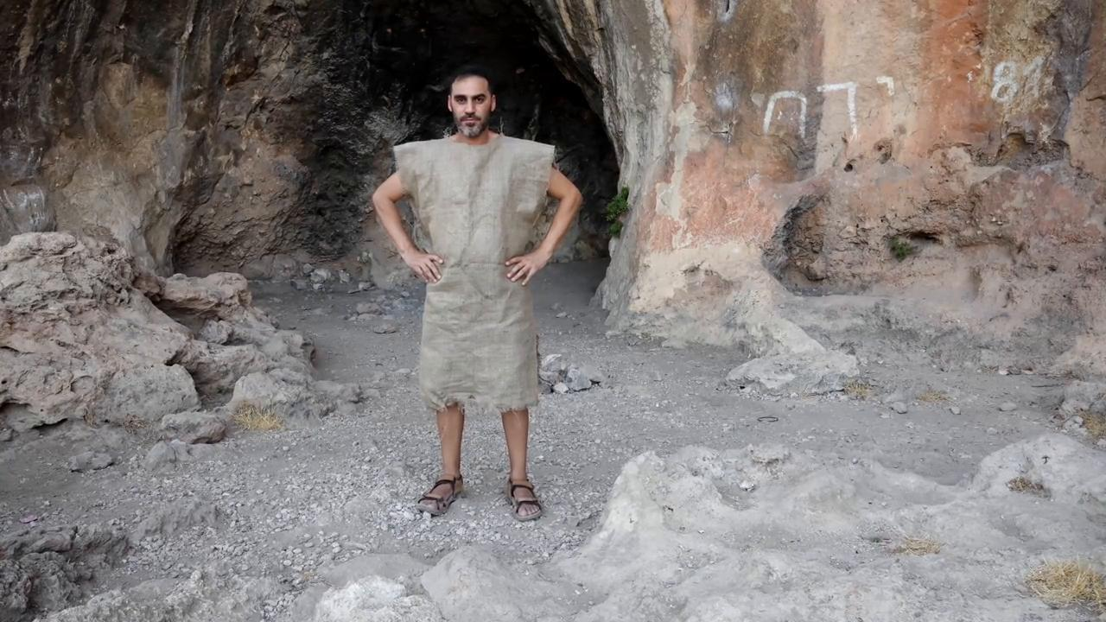
link

Sacrificial Animals

Video Content
(91 seconds)
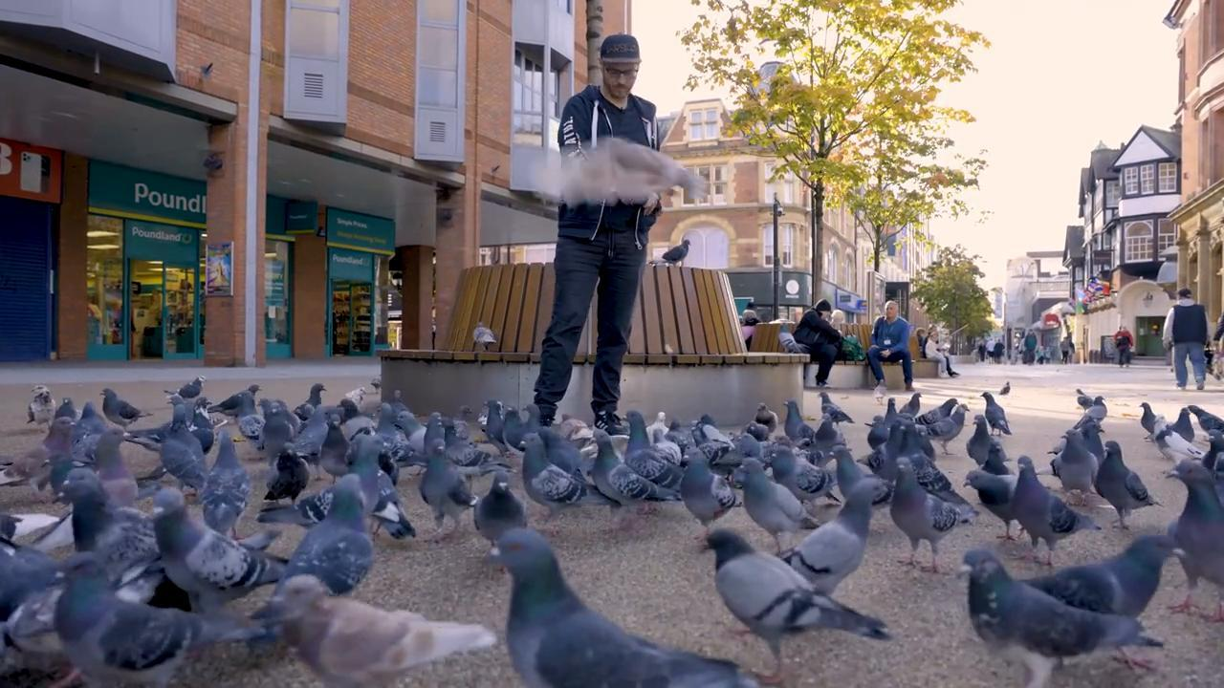
link

Sandals

Video Content
(56 seconds)
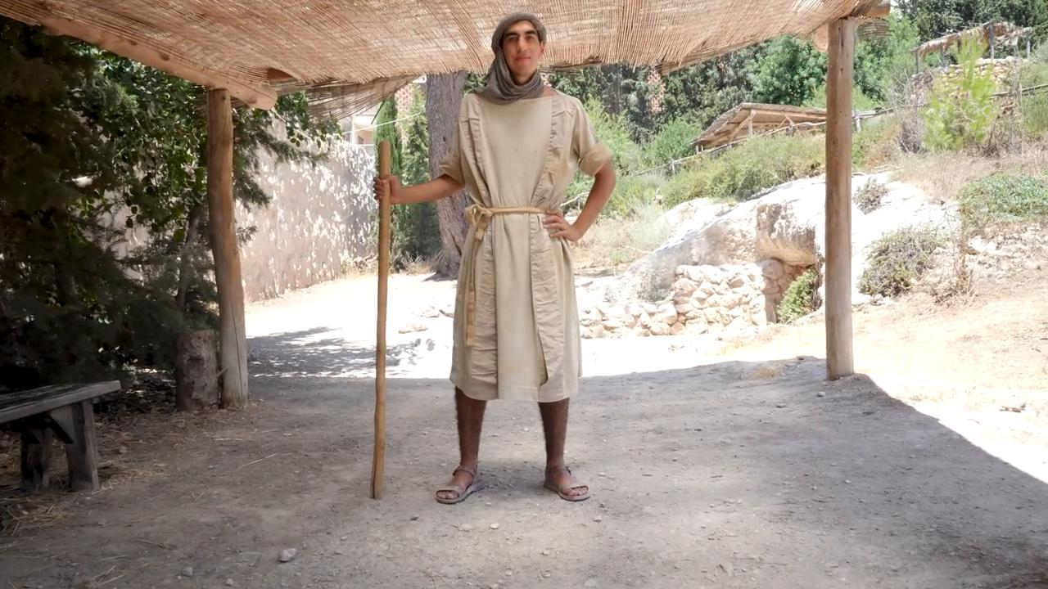
link

Sea of Galilee

Video Content
(114 seconds)
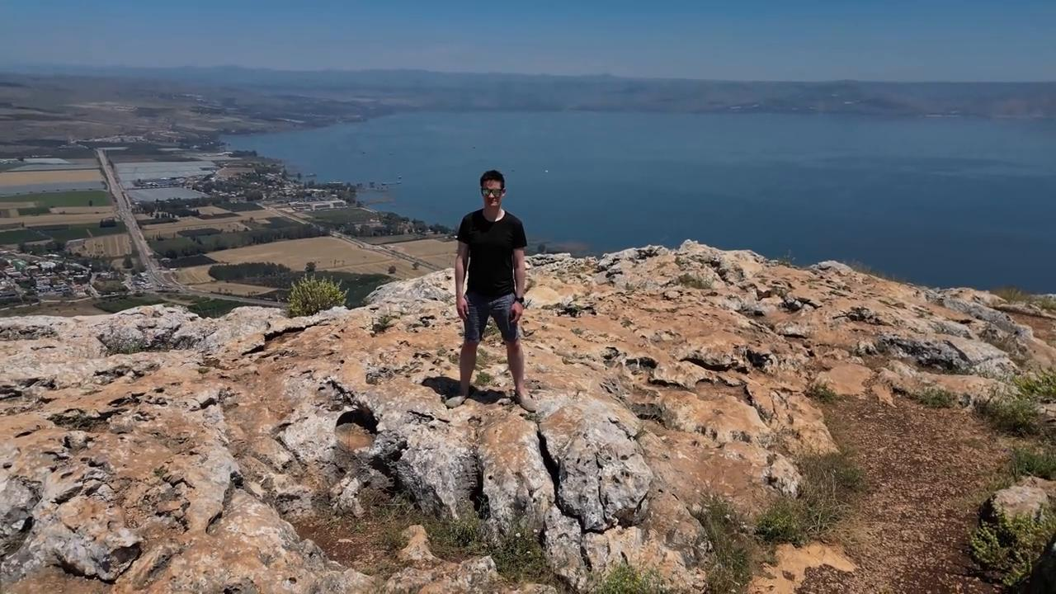
link

Seeds

Video Content
(74 seconds)
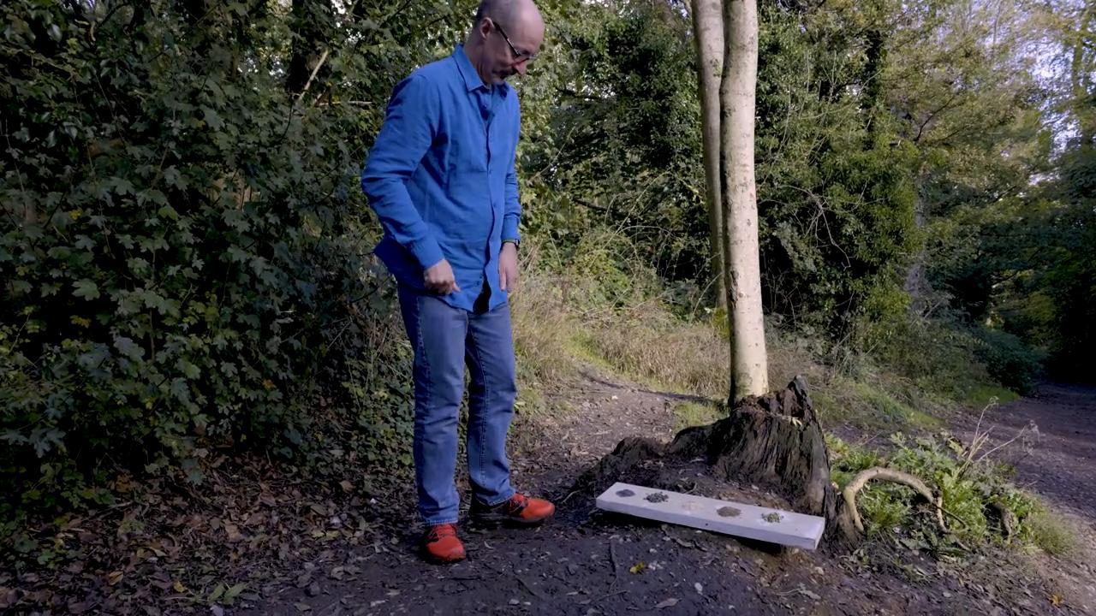
link

Sickle

Video Content
(68 seconds)
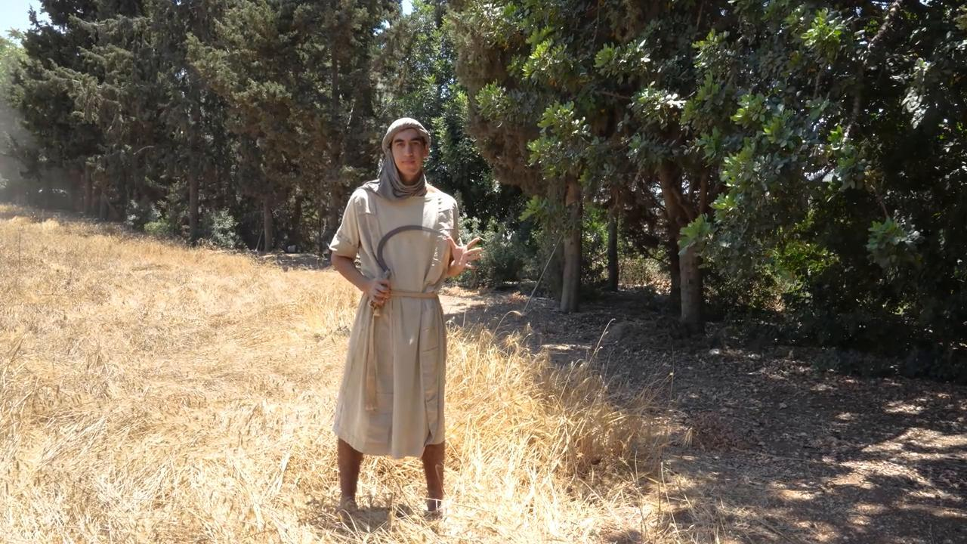
link

Sleeping Mat

Video Content
(59 seconds)
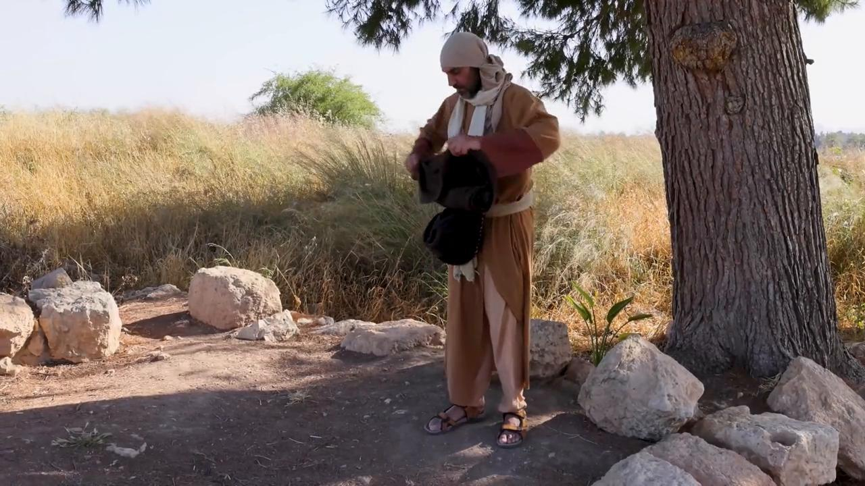
link

Snake

Video Content
(74 seconds)

link

Snow

Video Content
(79 seconds)
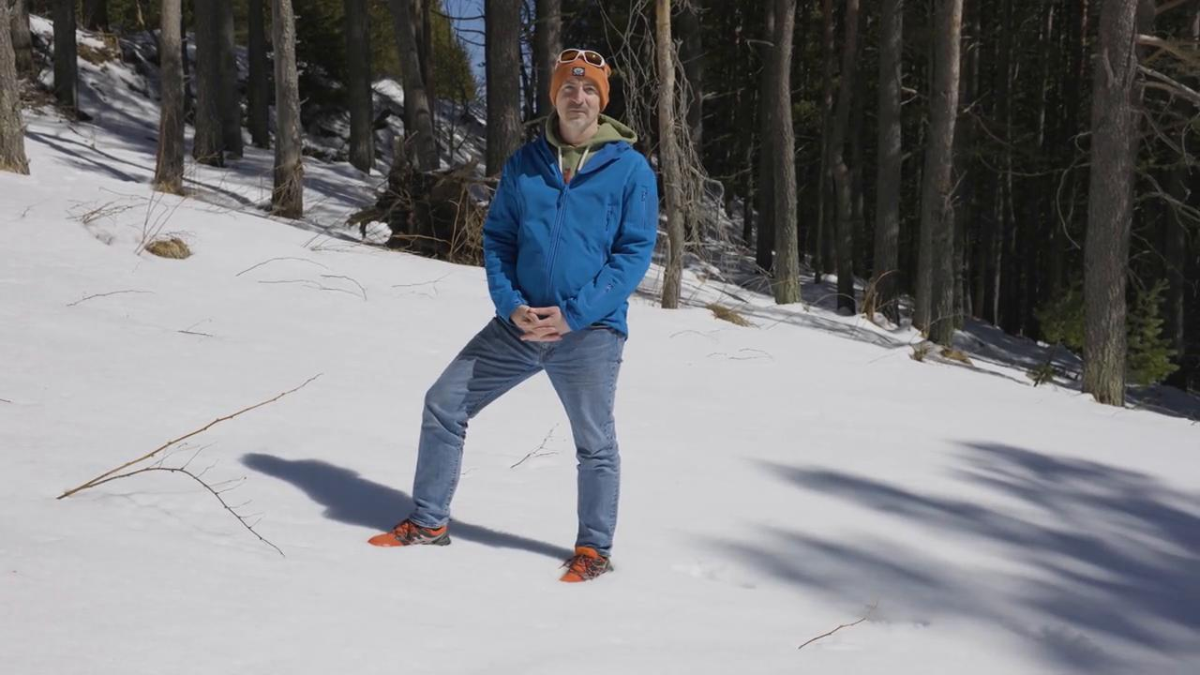
link

Sponge with Wine on a Stick

Video Content
(73 seconds)
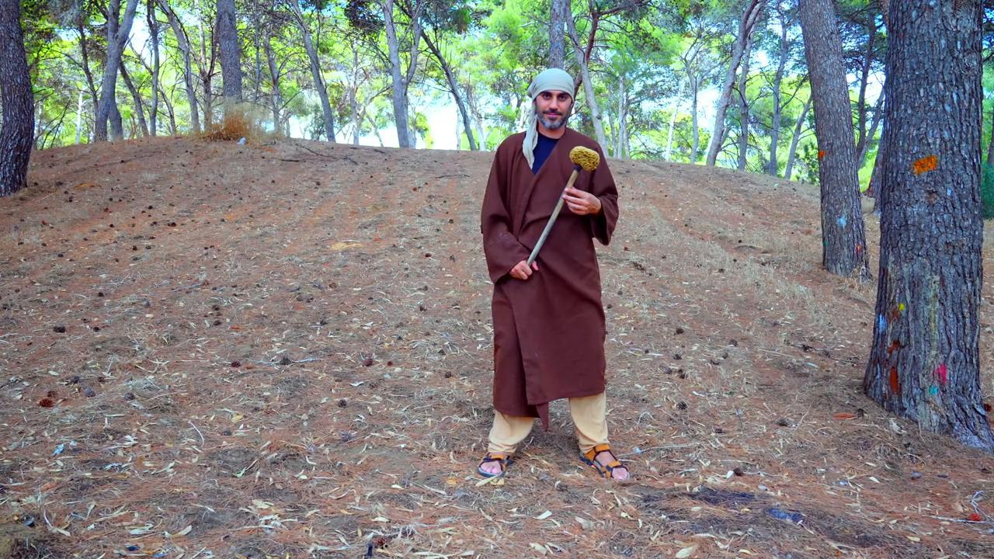
link

Staff

Video Content
(53 seconds)
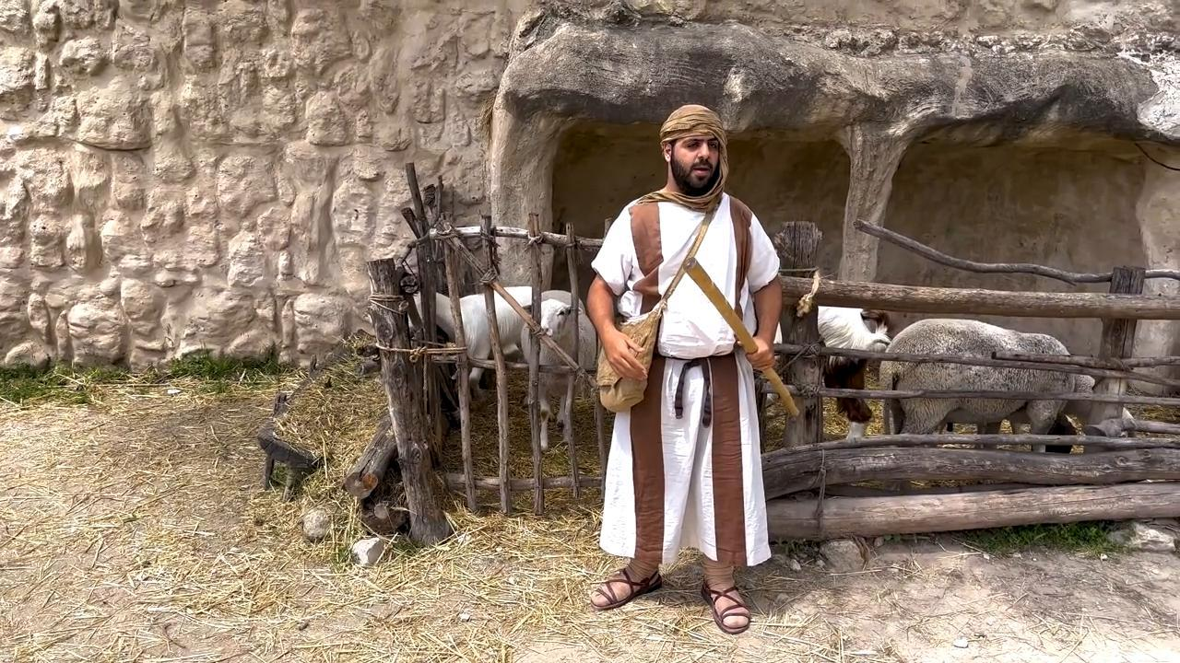
link

Stew

Video Content
(72 seconds)
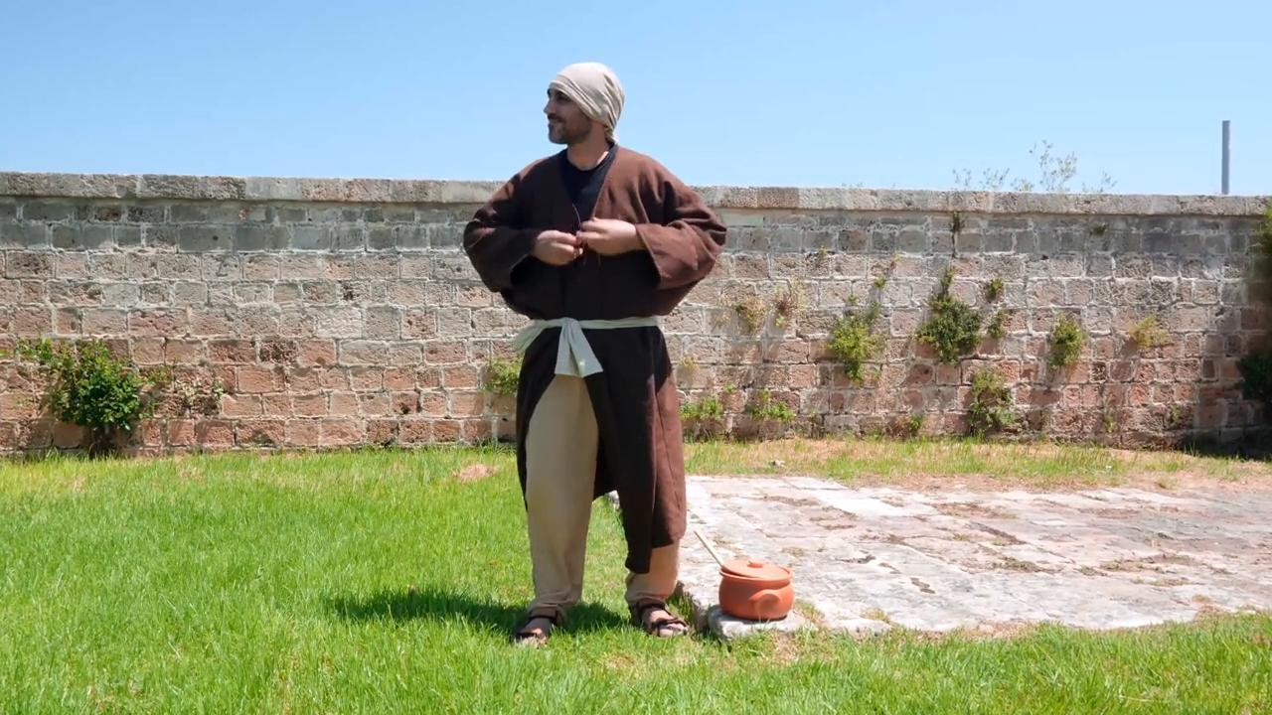
link

Stick

Video Content
(70 seconds)

link

Stone Wall Around a Vineyard

Video Content
(71 seconds)
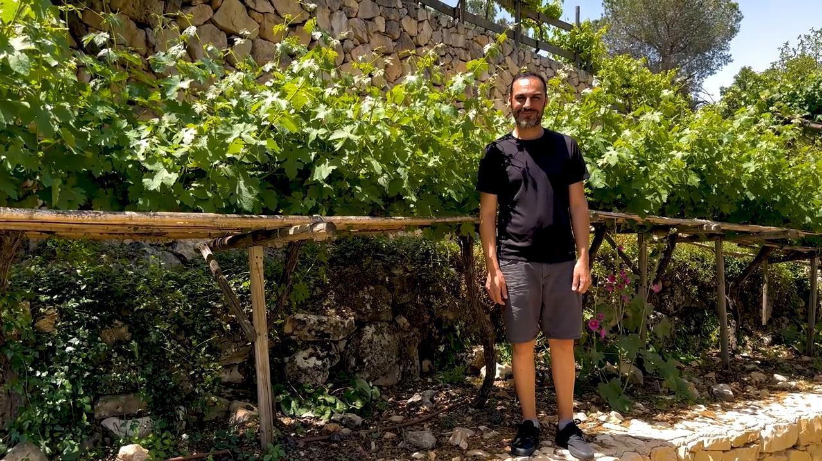
link

Synagogue

Video Content
(88 seconds)
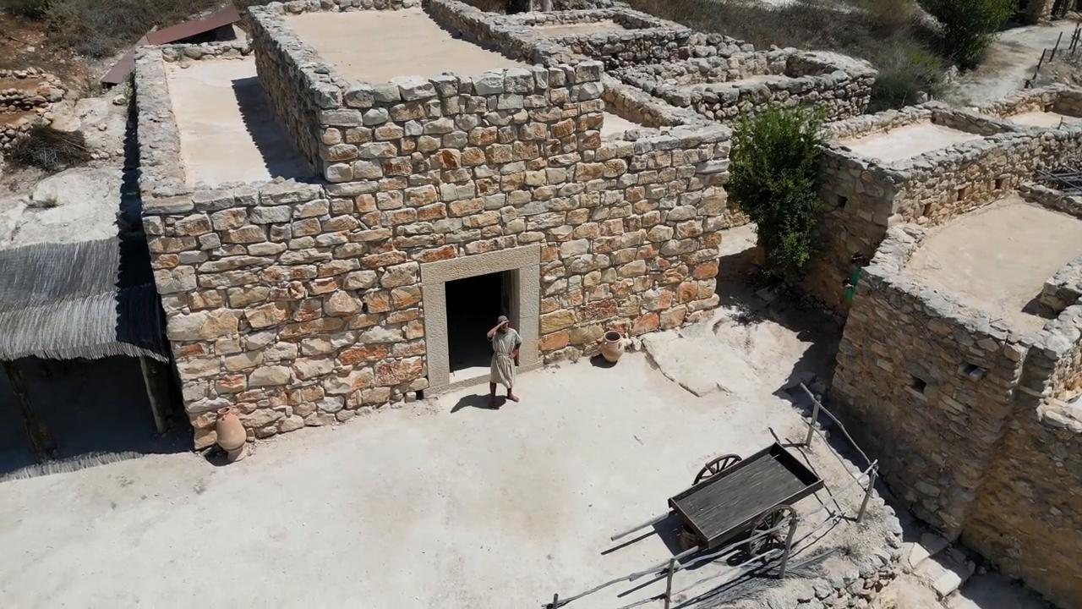
link

