Resource: Videos (Video Bible Dictionary)
Video Bible Dictionary © 2023 SRV Partners. Released under CC BY-SA 4.0 license. Video Bible Dictionary has been adapted in the following languages: Tok Pisin, عربي, Français, हिंदी, Bahasa Indonesia, Português, Русский, Español, Kiswahili, 简体中文 from Video Bible Dictionary © 2023 SRV Partners. Released under CC BY-SA 4.0 license by Mission Mutual

Videos (Video Bible Dictionary)

T

Tambourine

Video Content
(89 seconds)
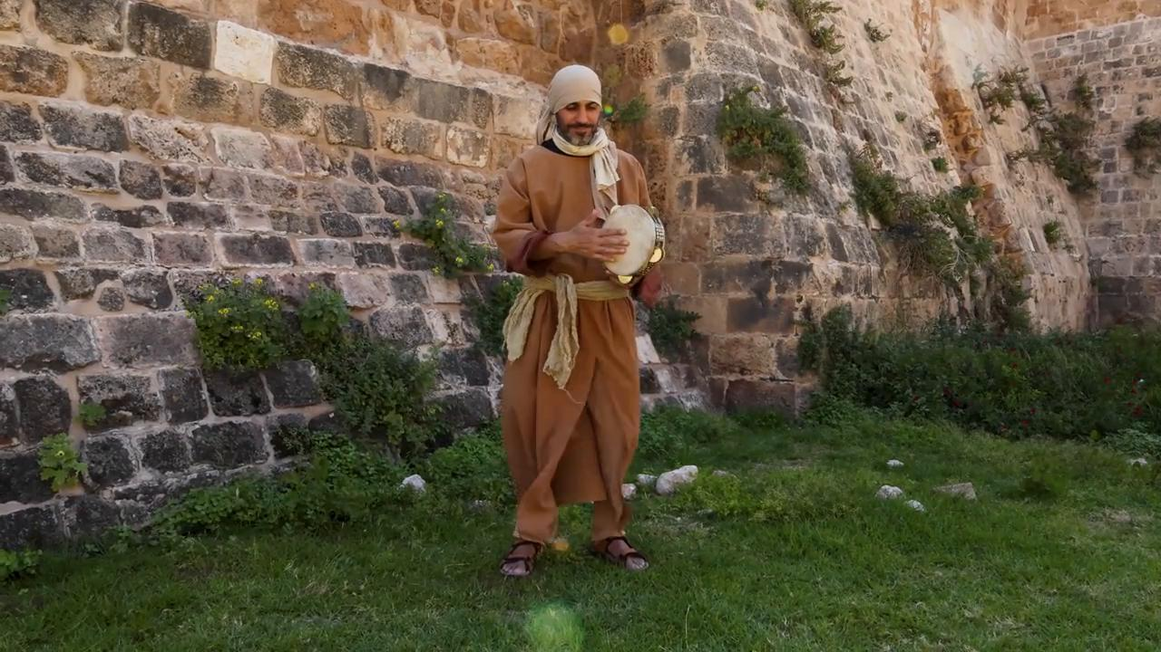
link

Tombs

Video Content
(93 seconds)
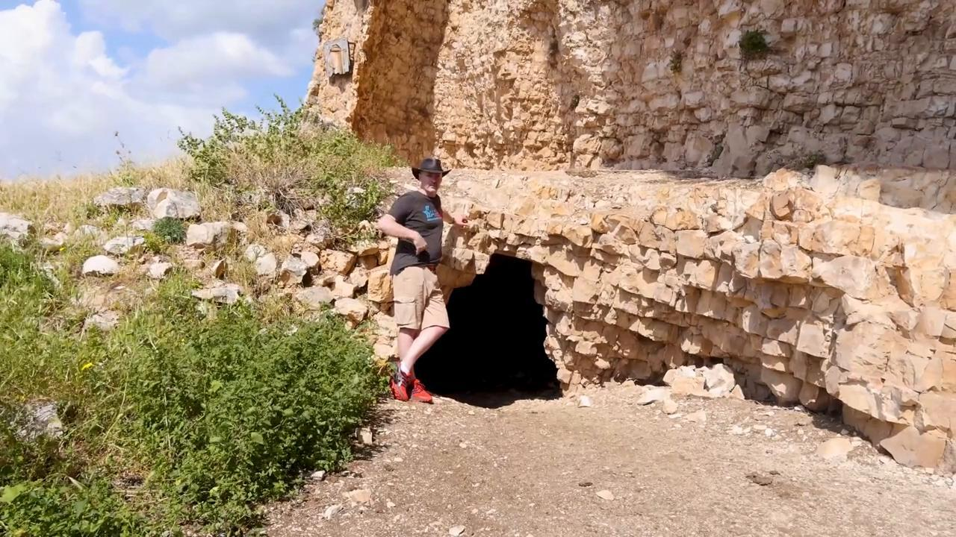
link

Town Gate

Video Content
(118 seconds)

link

Traveler's Bag

Video Content
(47 seconds)
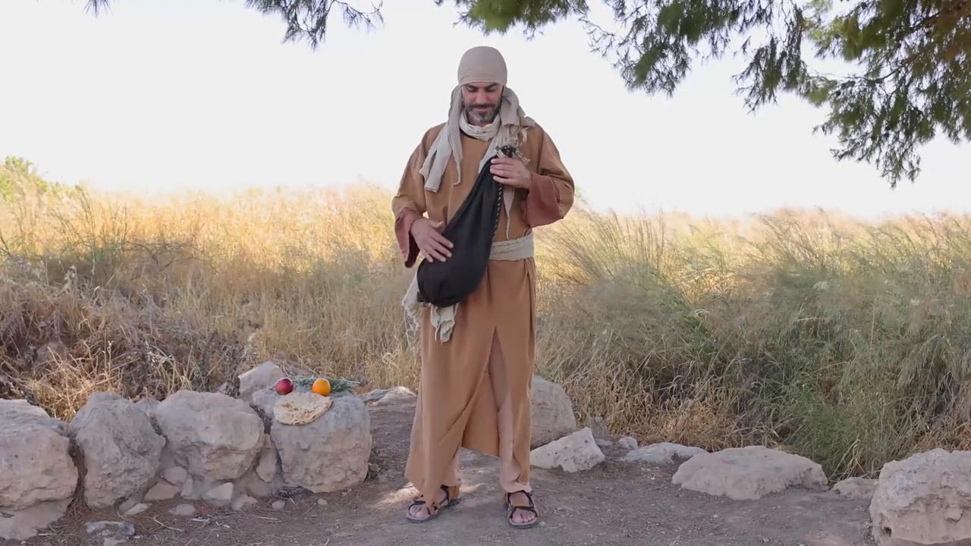
link

Tunic

Video Content
(82 seconds)
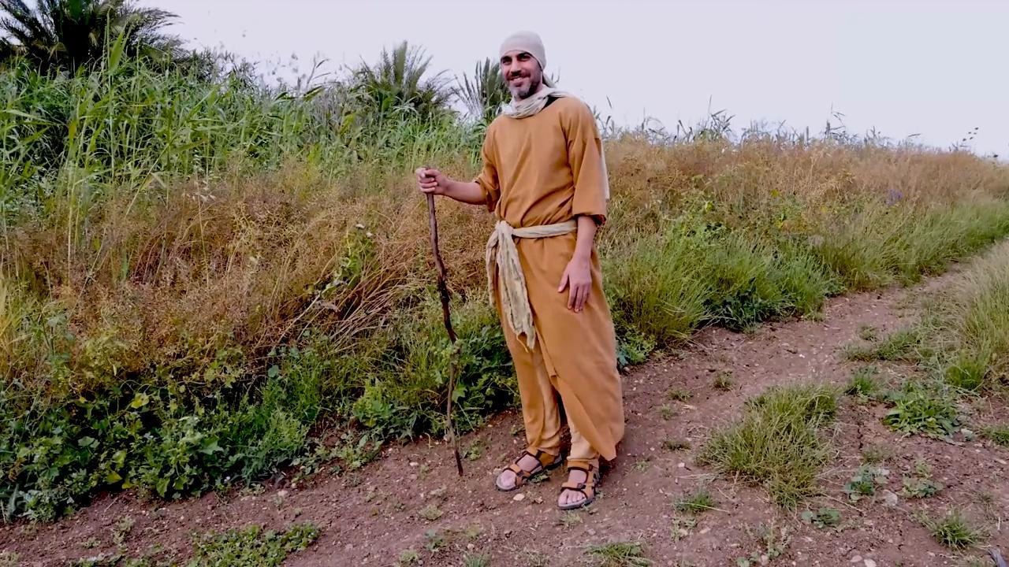
link

