Resource: Videos (Video Bible Dictionary)
Video Bible Dictionary © 2023 SRV Partners. Released under CC BY-SA 4.0 license. Video Bible Dictionary has been adapted in the following languages: Tok Pisin, عربي, Français, हिंदी, Bahasa Indonesia, Português, Русский, Español, Kiswahili, 简体中文 from Video Bible Dictionary © 2023 SRV Partners. Released under CC BY-SA 4.0 license by Mission Mutual

Videos (Video Bible Dictionary)

W

Watchtower for a Vineyard

Video Content
(97 seconds)
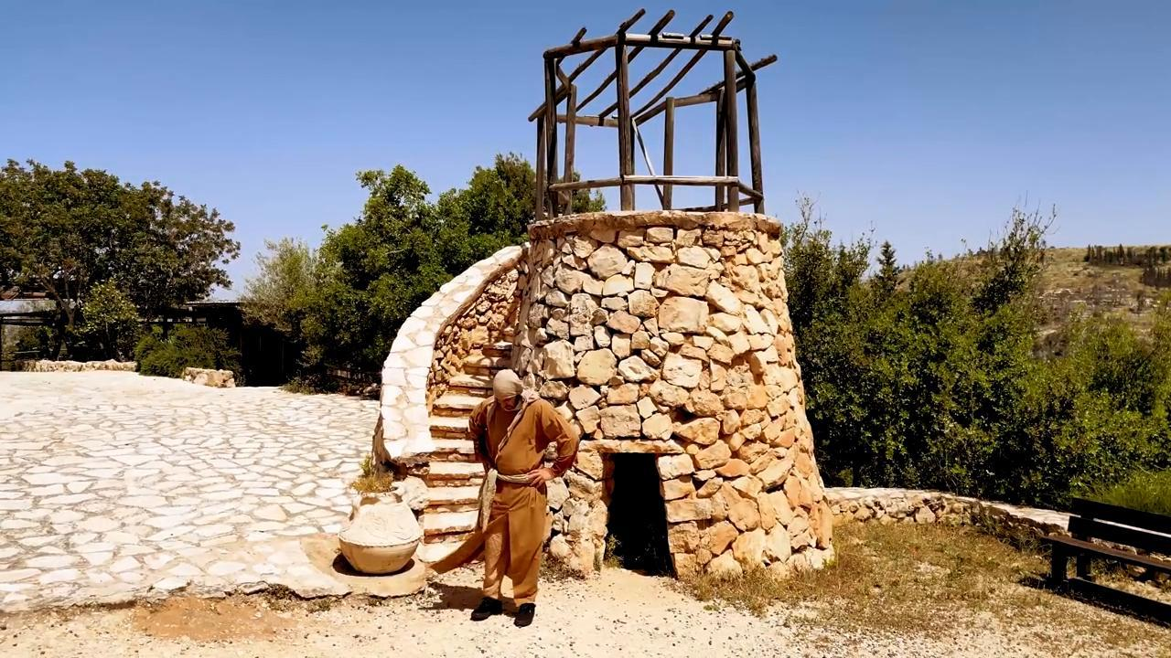
link

Water Jar

Video Content
(63 seconds)
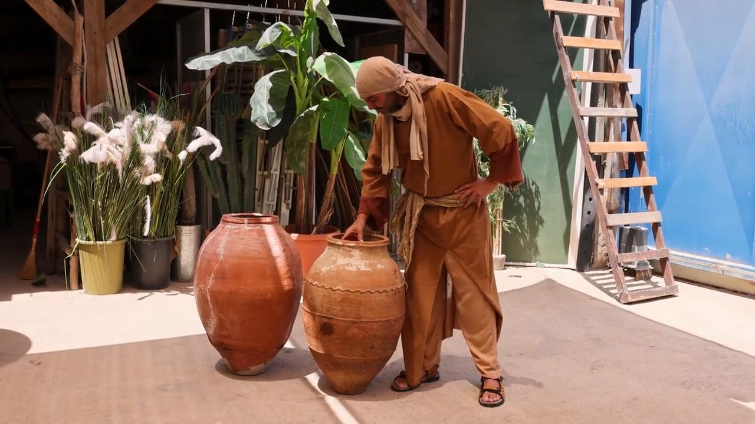
link

Wheat Ready For Harvest

Video Content
(79 seconds)
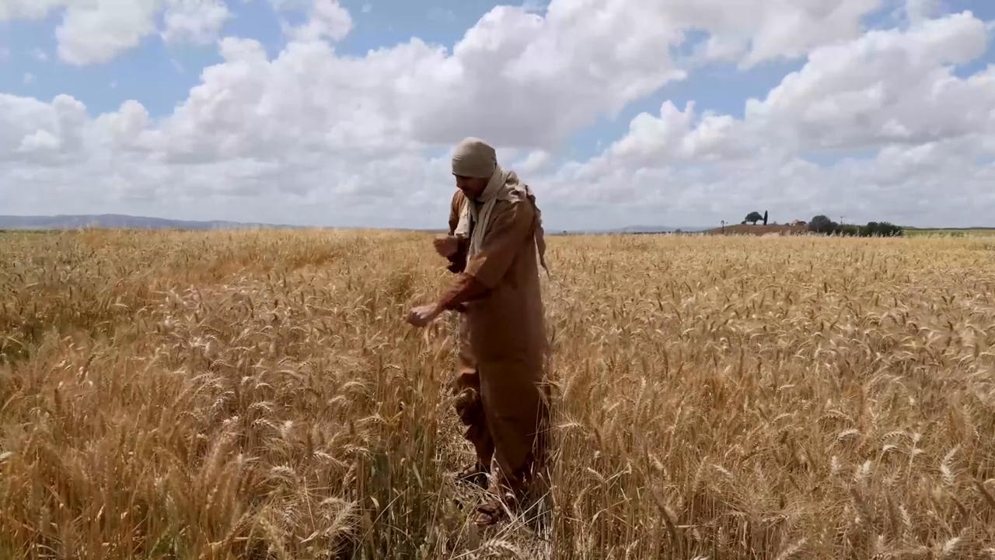
link

Wheat with Heads of Grain

Video Content
(131 seconds)
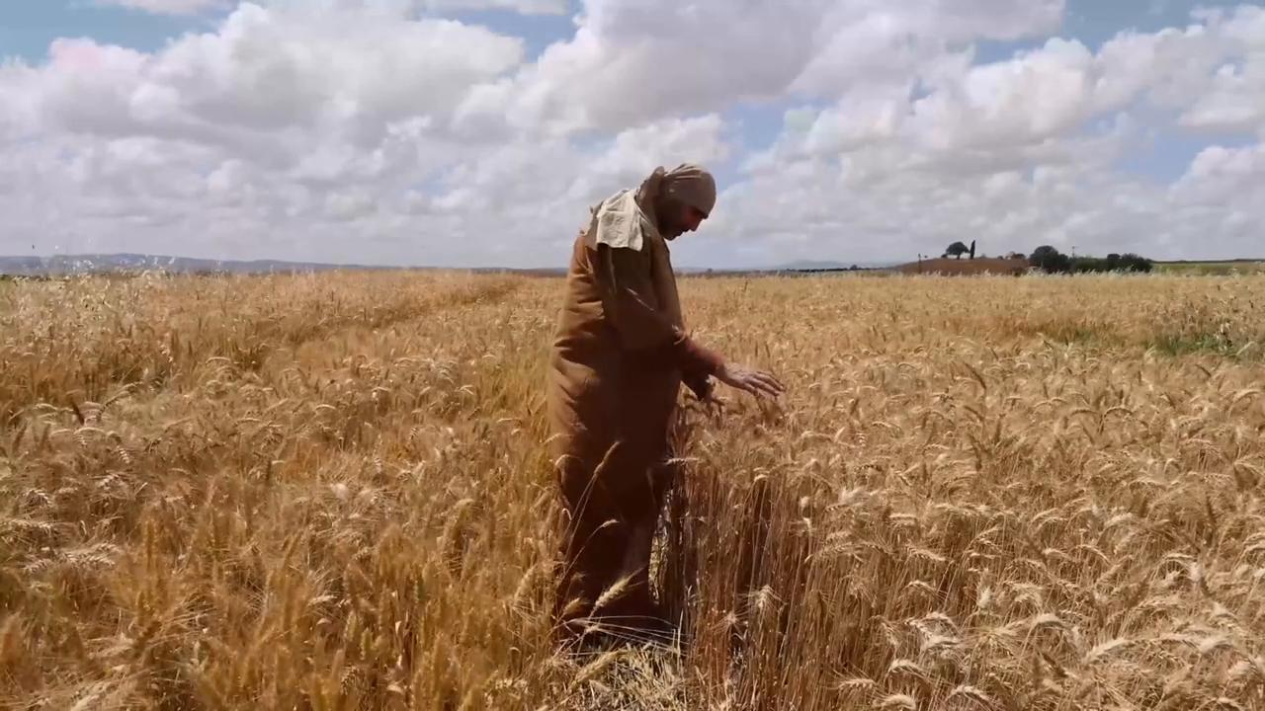
link

White Robe

Video Content
(76 seconds)
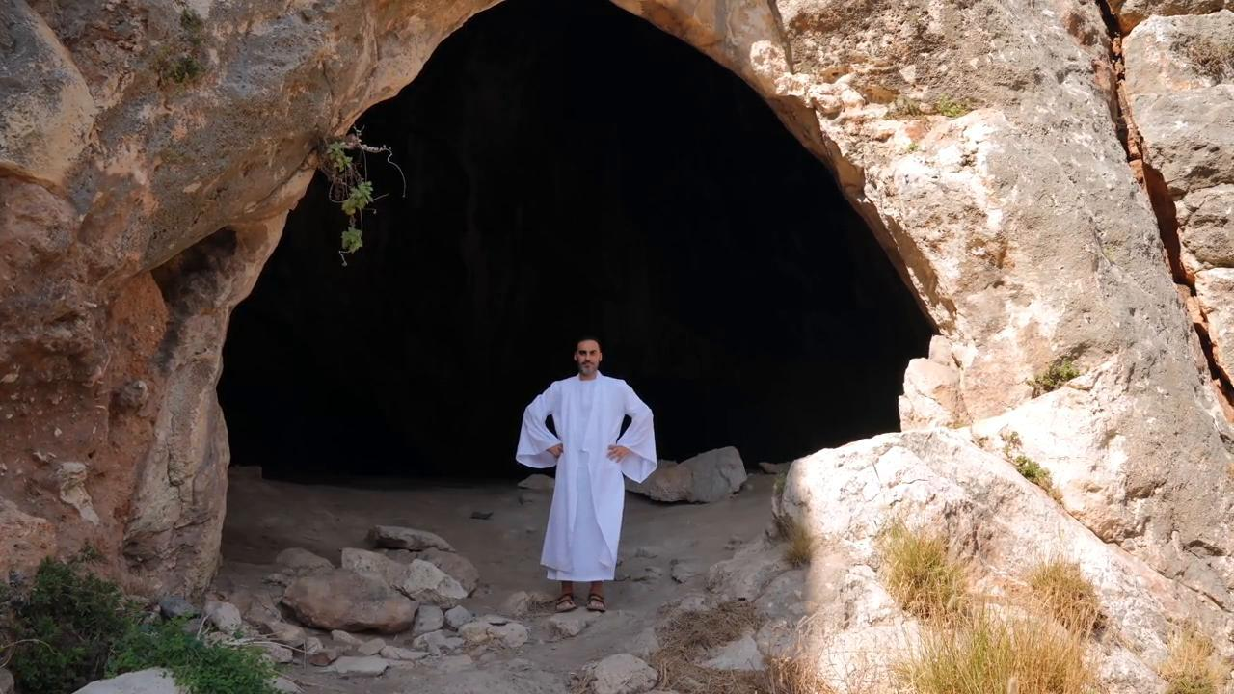
link

Wilderness or Desert

Video Content
(55 seconds)
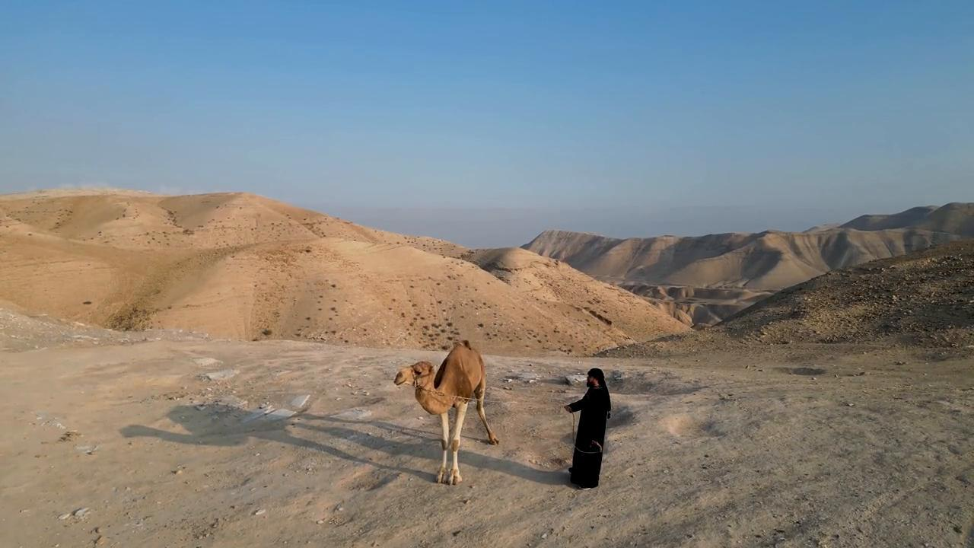
link

Wineskins

Video Content
(59 seconds)
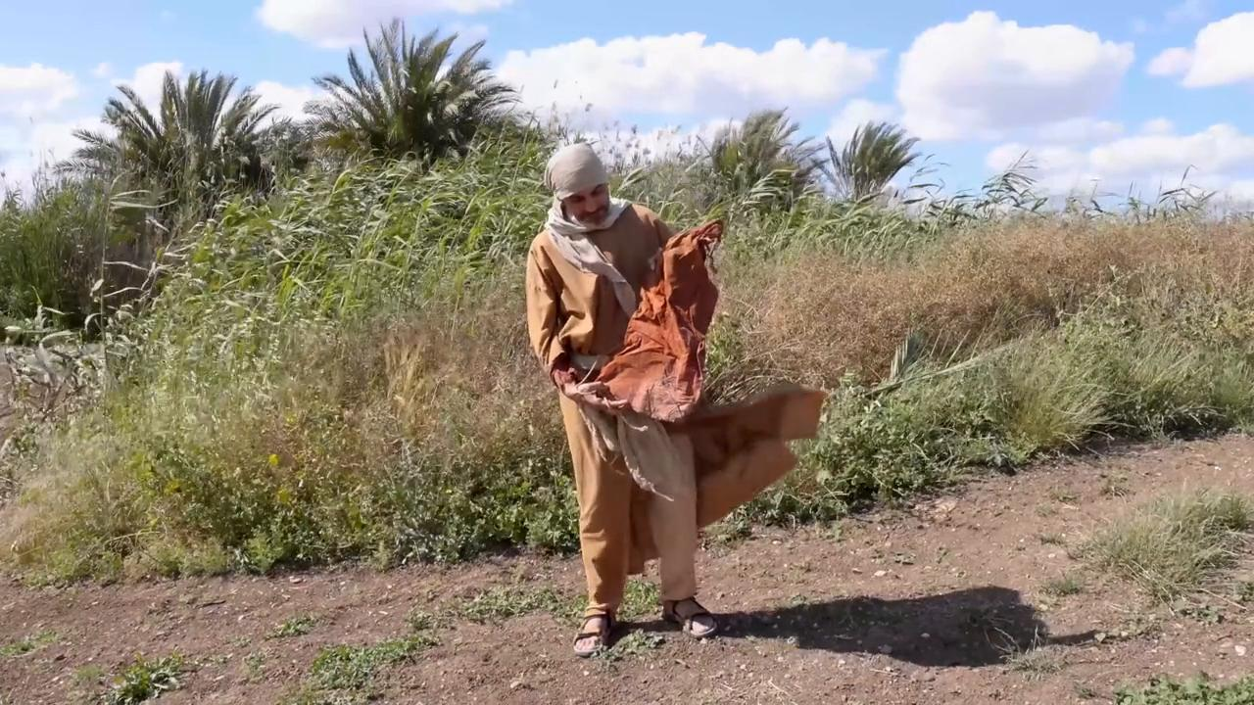
link

Winnowing Fork

Video Content
(75 seconds)
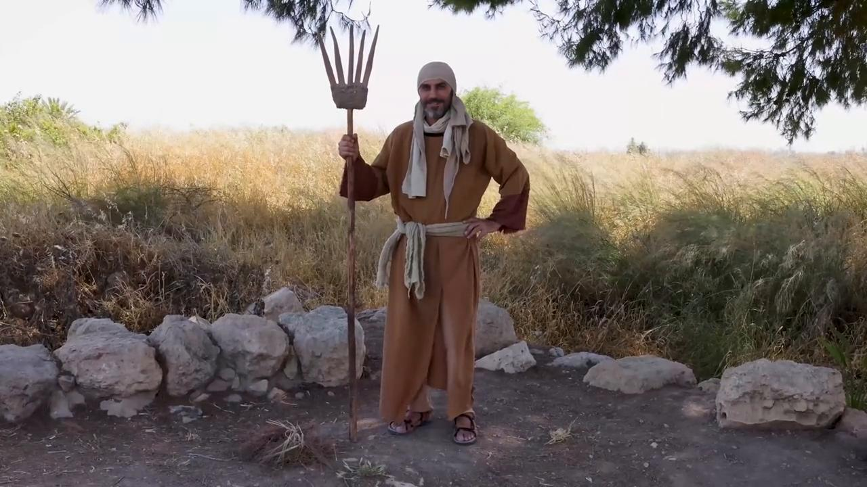
link

Writing Tablet

Video Content
(72 seconds)
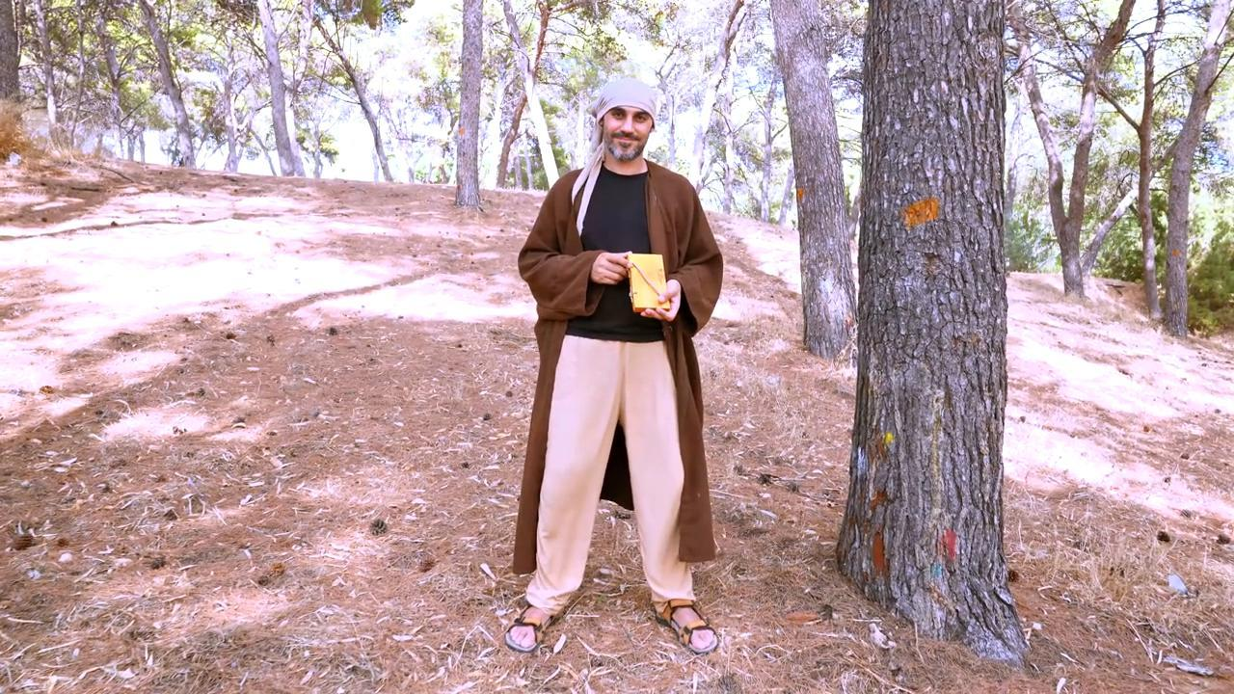
link

