

|  |
| --- |
|  |
| Related image  PUB LEASE CONTRACTS  Advanced Databases  PL/SQL Triggers  Assignment  By Yash Sinojia [A00268852] |
| MASTER OF SCIENCE IN DATA ANALYTICS  2019 - 2020  FACULTY OF BUSINESS AND HOSPITALITY  SEMESTER 2 |

CONTENTS

1. INTRODUCTION 2

2. PROJECT OUTLINE 4

3. ENTITY RELATIONSHIP DIAGRAM 5

4. TABLES 6

5. TRIGGERS 9

5.1 Before Insert On Lease_Agreement 9

5.2 Before Delete On Pub 11

5.3 After Insert On Letting_Agent 13

5.4 After Update On Lease_Agreement 15

5.5 After Delete On Pub 19

# INTRODUCTION

This assignment is an ambitious attempt to generate 5 distinct PL/SQL triggers on the set of Pub Lease Contracts (PLC) tables. This assignment also takes the challenge of understanding PL/SQL triggers on a limited time span, assimilating the knowledge and apply it on forming and testing triggers, making sure that all the possible case scenarios are covered within testing scope.

The triggers are categorized into Before and After Triggers and within that sub-categorized into Insert, Update and Delete triggers.

The 5 queries formed in this report are without any exception based on Intermediate Level Trigger Examples provided by quite informative screencasts of Noel Tierney. The practice and confidence gained from the resource materials provided has been appreciated and has been significantly helpful in completing this assignment within the short period of approaching deadline.

Note that all the sceanarios described here complies within the scopes of guidelines and limits as described in the project overview. All the queries have been executed on Oracle SQL+ Command Line.

# PROJECT OUTLINE

|  |  |  |  |  |
| --- | --- | --- | --- | --- |
| 21 | Yash | Sinojia | Pub Lease Contracts | PLC |

Historically pubs were owner operated. However, leasing pubs has become very common in recent years. Some years ago, the Vintners association commissioned a project (that remains unfinished) to design a database application that would capture details of pub leasing and the level of activity in the sector. Key details captured by systems analysts include:

* A landlord may own many pubs and each pub is owned by a single landlord
* A publican may participate in many lease agreements and a lease agreement involves a single publican
* A letting agent (auctioneer) may arrange many lease agreements and a lease agreement involves a single letting agent
* A solicitor may draw up many lease agreements and a lease agreement is drawn up by a single solicitor

Lease_Agreement

Lease_Agreement_Id

Pub_Id

Publican_Id

Start_Date

End_Date

Deposit

Instalment_Frequency

Payment_Method

Installment_Amount

Letting_Agent_Id

Solicitor_Id

Solicitor

Solicitor_Id

Fname

Sname

Address

County

Gender

Date_Of_Birth

Mobile_No

Email_Address

Qualifications

Letting_Agent

Letting_Agent_Id

Name

City

County

Specialism

Web_Site

Email

Year_Founded

Annual_Turnover

Reputation

Publican

Publican_Id

Fname

Sname

Address

County

Gender

Date_Of_Birth

Mobile_No

Email_Address

Qualifications

Specialism

Landlord

Landlord_Id

FName

Sname

Address

Town

County

Tel_No

Email

Specialism

Pub

Pub_Id

Name

Address

City

Country

Tel_No

Email

Capacity

Year_Built

Sq_Metres

Customer_Profile

Current_Value

Specialism

Location

Landlord_Id

# ENTITY RELATIONSHIP DIAGRAM

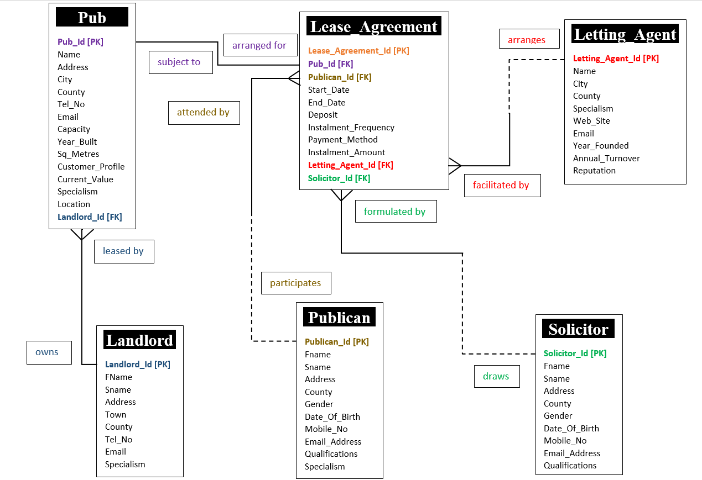

# TABLES

Select *

From Tab

Where Tname In ('LANDLORD', 'PUB', 'PUBLICAN', 'LETTING_AGENT', 'SOLICITOR','LEASE_AGREEMENT')

Order By Tname;

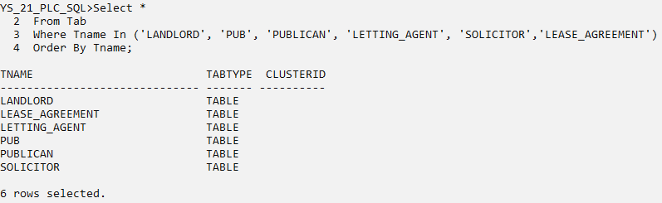

* Landlord

Select *

From LANDLORD;

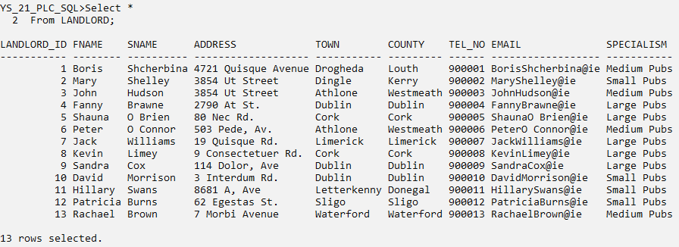

* Pub

Select *

From PUB;

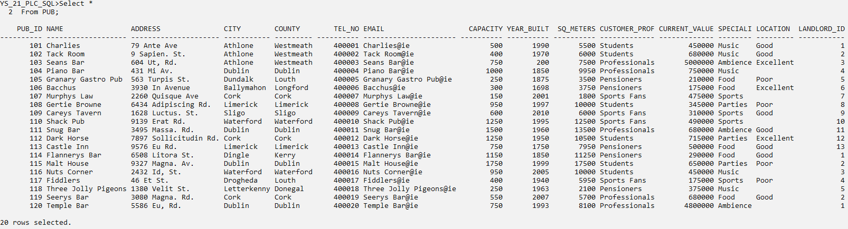

* Publican

Select *

From PUBLICAN;

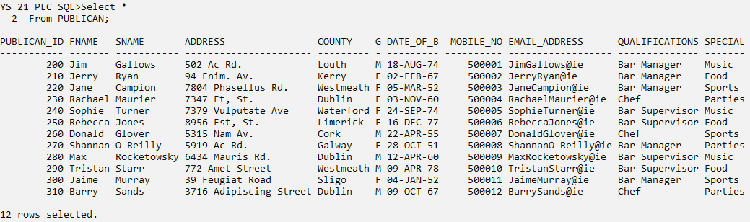

* Letting Agent

Select *

From LETTING_AGENT;

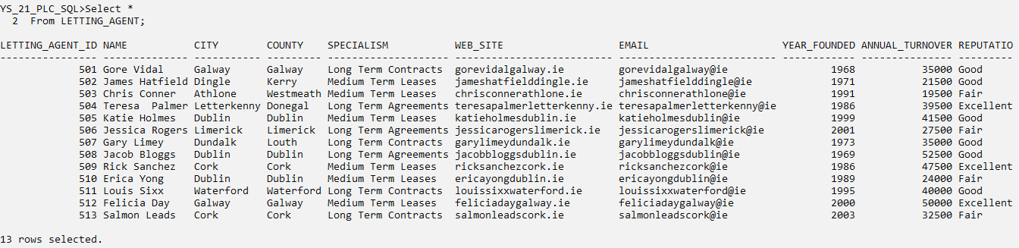

* Solicitor

Select *

From SOLICITOR;

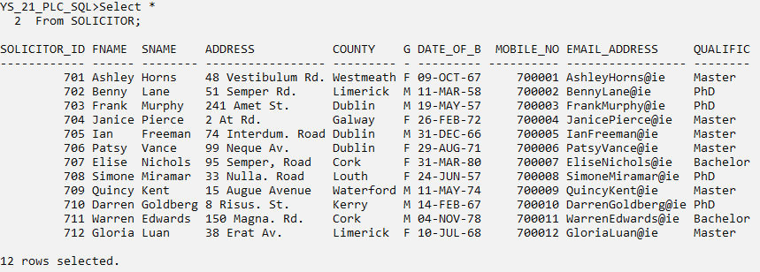

* Lease Agreement

Select *

From LEASE_AGREEMENT;

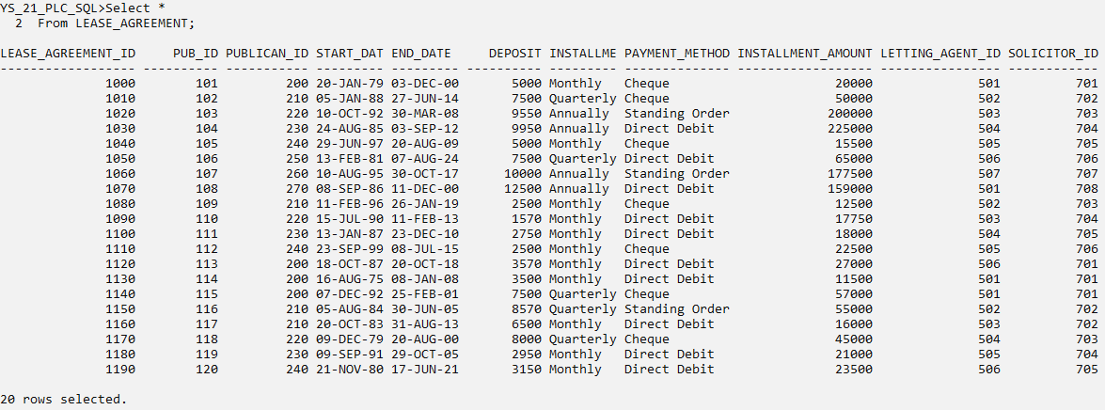

# TRIGGERS

Set Linesize 160

Set SQLPrompt YS_21SQL>

## **5.1 Before Insert On Lease_Agreement**

Question.1

Build an application called ‘Lease Pay Method Tracker’ that will help process to add new lease agreements and adding their details to the Lease Agreement table in the database. The implementation requirements are as follows:

1. Lease Agreement payed by Direct Debit may be added as an agreement provided the Installment Frequency is Monthly.
2. Lease Agreement payed by Cheque may be added as an agreement provided the corresponding Pub’s Customer Profile is Students.

Solution

Cl Scr

Set Serveroutput On Size 1000000

Create Or Replace Trigger Lease_Pay_Method_Tracker

Before Insert On Lease_Agreement

For Each Row

Declare

V_Cust_Profile Pub.Customer_Profile%Type;

Begin

If :New.Payment_Method = 'Direct Debit' And :New.Installment_frequency <> 'Monthly' Then

Raise_Application_Error(-20101, 'A - New Payment Must Be Paid Monthly');

End If;

If :New.Payment_Method = 'Cheque' Then

Select Customer_Profile Into V_Cust_Profile

From Pub

Where Pub.Pub_Id = :New.Pub_Id;

If V_Cust_Profile <> 'Students' Then

Raise_Application_Error (-20101, 'B - New Lease Agreement Customer Profile For Pub Must be Students');

End If;

End If;

End;

/

Show Err

Insert Into Lease_Agreement (Lease_Agreement_Id, Pub_Id, Publican_Id, Start_Date, End_Date, Deposit, Installment_frequency, Payment_Method, Installment_Amount, Letting_Agent_Id, Solicitor_Id) Values (1200, 120, 240, '15-Oct-19', '14-Oct-20', 7500, 'Quarterly', 'Direct Debit', 55000, 505, 705);

Insert Into Lease_Agreement (Lease_Agreement_Id, Pub_Id, Publican_Id, Start_Date, End_Date, Deposit, Installment_frequency, Payment_Method, Installment_Amount, Letting_Agent_Id, Solicitor_Id) Values (1200, 120, 240, '15-Oct-19', '14-Oct-20', 7500, 'Monthly', 'Direct Debit', 55000, 505, 705);

Insert Into Lease_Agreement (Lease_Agreement_Id, Pub_Id, Publican_Id, Start_Date, End_Date, Deposit, Installment_frequency, Payment_Method, Installment_Amount, Letting_Agent_Id, Solicitor_Id) Values (1201, 103, 210, '15-May-19', '14-May-20', 9500, 'Annually', 'Cheque', 25000, 505, 705);

Insert Into Lease_Agreement (Lease_Agreement_Id, Pub_Id, Publican_Id, Start_Date, End_Date, Deposit, Installment_frequency, Payment_Method, Installment_Amount, Letting_Agent_Id, Solicitor_Id) Values (1201, 116, 210, '15-May-19', '14-May-20', 9500, 'Annually', 'Cheque', 25000, 505, 705);

Rollback;

Drop Trigger Lease_Pay_Method_Tracker;

Snip

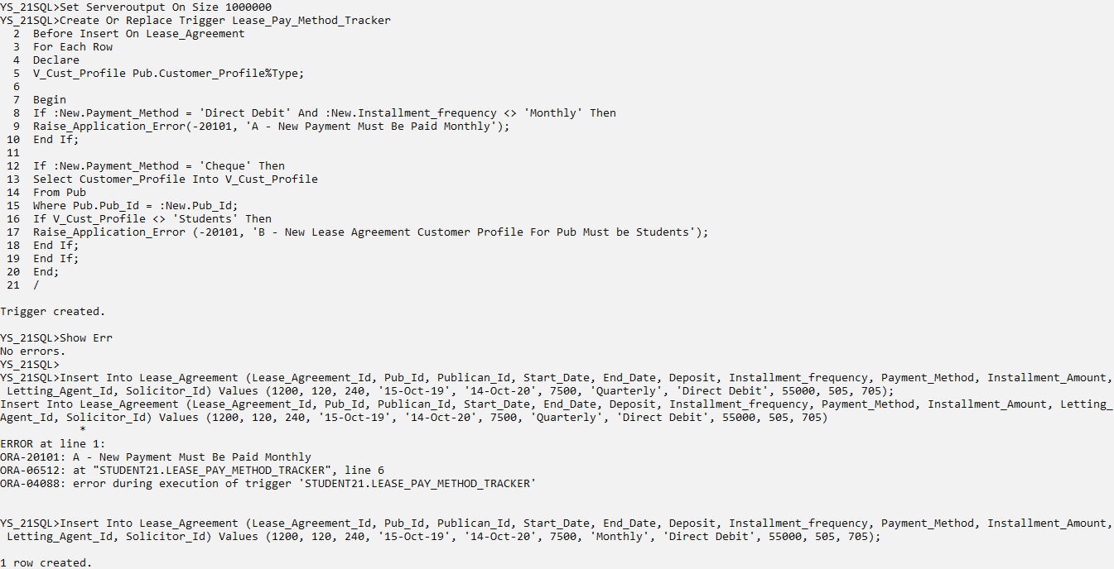

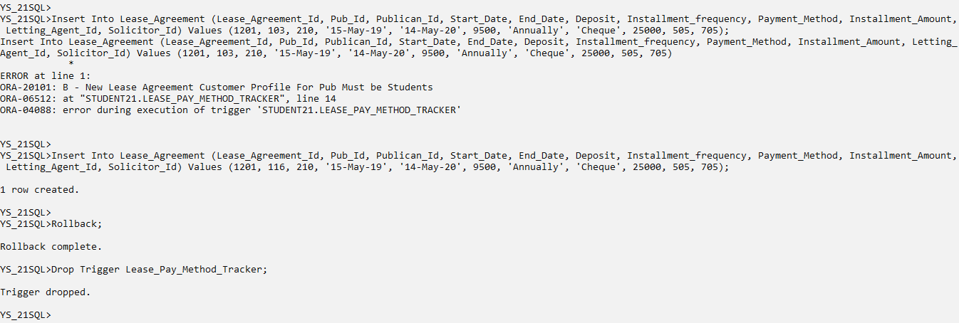

## **5.2 Before Delete On Pub**

Question.2

Build an application called Pub_Del_Checker that will implement the requirements outlined below regarding the removal of Pubs from the database:

1. Pub whose County is Westmeath may not be removed if it’s Landlord is in County Westmeath.
2. Pub whose Town is Athlone may not be removed if their Customers are Students.

Solution

Cl Scr

Set Serveroutput On Size 1000000

Create Or Replace Trigger Pub_Del_Checker

Before Delete On Pub

For Each Row

Declare

V_Landlord_Loc Landlord.County%Type;

Begin

If :Old.County = ’Westmeath’ Then

Select County Into V_Landlord_Loc

From Landlord

Where Landlord.Landlord_Id = :Old.Landlord_Id;

If V_Landlord_Loc = ’Westmeath’ Then

Raise_Application_Error (-20101, ’A – Westmeath Pub whose Landlord is in Westmeath may not deleted’);

End If;

End If;

If :Old.City = ’Athlone’ And :Old.Customer_Profile = ’Students’ Then

Raise_Application_Error (-20101, ’B – Athlonian Pub may not be removed if their customers are Students’);

End If;

End;

/

Show Err

Delete

From Pub

Where Pub_Id = 103;

Alter Table Lease_Agreement Disable Constraint Lease_Agreement_Pub_Id_Fk;

Delete

From Pub

Where Pub_Id = 106;

Delete

From Pub

Where Pub_Id = 101;

Rollback;

Drop Trigger Pub_Del_Checker;

Alter Table Lease_Agreement Enable Constraint Lease_Agreement_Pub_Id_Fk;

Snip

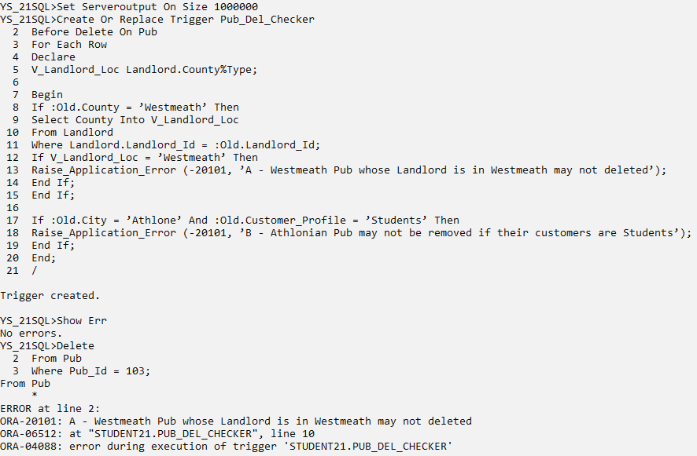

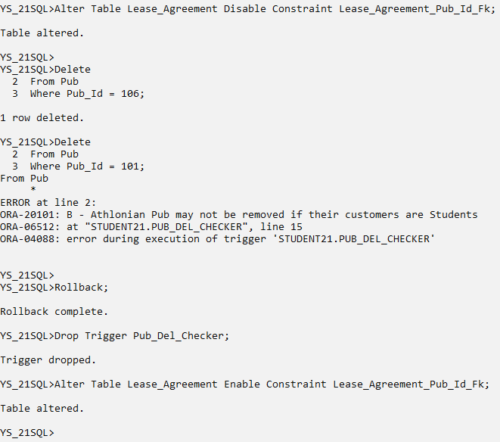

## **5.3 After Insert On Letting_Agent**

Question.3

Build an application called Lease_Completion that will help finalise the leasing process when Pubs are built and their details are added to the Pub table. The requirements that need to be implemented are as follows:

1. If the Annual_Turnover of the Letting Agent of the new Lease Agreement will be €30k or lower then the turnover will be increased by 20%.
2. If the Annual_Turnover of the Letting Agent of the new Lease Agreement is above €30k then the turnover will be increased by 10%.
3. Display the Annual_Turnover of the Letting Agent of the new Lease Agreement before and after the turnover is adjusted.

Solution

Cl Scr

Set Serveroutput On Size 1000000

Create Or Replace Trigger Lease_Completion

After Insert On Lease_Agreement

For Each Row

Declare

V_Turnover Letting_Agent.Annual_Turnover%Type;

Begin

Select Annual_Turnover Into V_Turnover

From Letting_Agent

Where Letting_Agent.Letting_Agent_Id = :New.Letting_Agent_Id;

Dbms_Output.Put_Line (’Turnover of Agent ’ || :New.Letting_Agent_Id || ’ Before Processing Of ’ || :New.Lease_Agreement_Id || ’ Was Found To Be €’ || V_Turnover);

If V_Turnover <= 30000 Then

Update Letting_Agent

Set Annual_Turnover = Annual_Turnover * 1.2

Where Letting_Agent.Letting_Agent_Id = :New.Letting_Agent_Id;

Elsif V_Turnover > 30000 Then

Update Letting_Agent

Set Annual_Turnover = Annual_Turnover * 1.1

Where Letting_Agent.Letting_Agent_Id = :New.Letting_Agent_Id;

End If;

Select Annual_Turnover Into V_Turnover

From Letting_Agent

Where Letting_Agent.Letting_Agent_Id = :New.Letting_Agent_Id;

Dbms_Output.Put_Line (’Turnover of Agent ’ || :New.Letting_Agent_Id || ’ After Processing Of ’ || :New.Lease_Agreement_Id || ’ Was Adjusted To €’ || V_Turnover);

End;

/

Sho Err

Insert Into Lease_Agreement (Lease_Agreement_Id, Start_Date, End_Date, Installment_frequency, Payment_Method, Installment_Amount, Letting_Agent_Id) Values (1200, ’11-Feb-19’, ’10-Feb-20’, ’Quarterly’, ’Standing Order’, 100000, 502);

Insert Into Lease_Agreement (Lease_Agreement_Id, Start_Date, End_Date, Installment_frequency, Payment_Method, Installment_Amount, Letting_Agent_Id) Values (1210, ’17-Apr-19’, ’16-Apr-20’, ’Monthly’, ’Cheque’, 10000, 501);

Rollback;

Drop Trigger Lease_Completion;

Snip

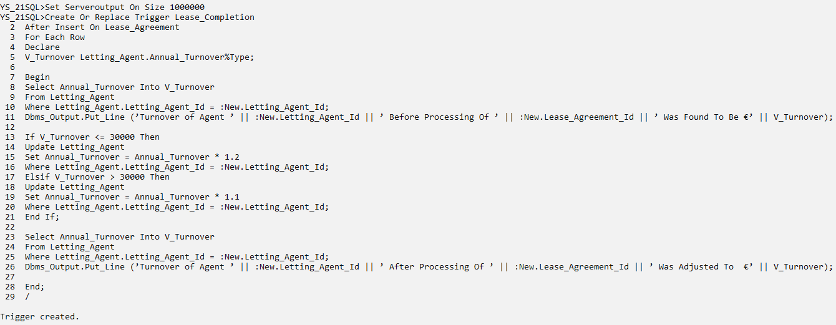

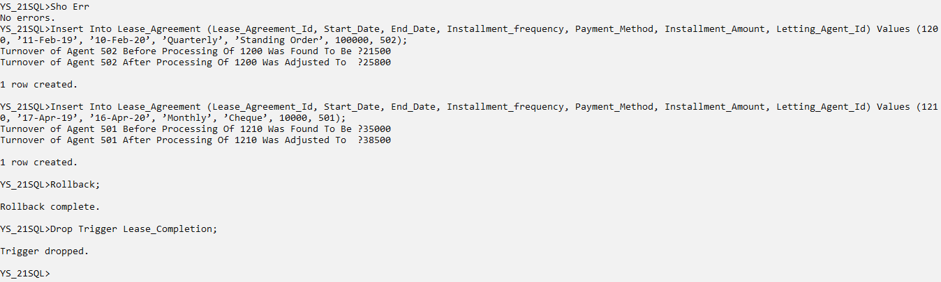

## **5.4 After Update On Lease_Agreement**

Question.4

When a user (successfully) makes changes to the details of a Lease_Agreement, some changes need be carried out on data in other tables. The details are:

1. If the Deposit for a Lease_Agreement has increased, then the Capacity of corresponding Pub will increase by 10% if the Pub is located in County Dublin.
2. If a Lease_Agreement changes Installment_frequency (but doesn’t change deposit), then the Capacity of Pub will increase by 20% if the Pub is located in County Cork.
3. Display the Lease_Agreement Id and the Location of the corresponding Pub.
4. In a table called Lease_Update_Log a record should be kept of:
5. Name of the user who added the row.
6. Date of update and
7. Lease_Agreement_Id of the agreement that will automatically implement the above requirements each time a row is added to the table.

Solution

Cl Scr

Set Serveroutput On Size 1000000

Drop Table Lease_Update_Log;

Create Table Lease_Update_Log (Oracle_User Varchar2(10), System_Date Date, Lease_Num Number(4), Pub_Loc Varchar2(10));

Create Or Replace Trigger Updated_Lease_Completion

After Update On Lease_Agreement

For Each Row

Declare

V_Location Pub.City%Type;

Begin

If :New.Deposit > :Old.Deposit Then

Select City Into V_Location

From Pub

Where Pub.Pub_Id = :New.Pub_Id;

Dbms_Output.Put_Line ('Pub In ' || V_Location || ' Is Where ' || :New.Lease_Agreement_Id || ' Is Based');

If V_Location = 'Dublin' Then

Update Pub

Set Capacity = Capacity * 1.1

Where Pub.Pub_Id = :New.Pub_Id;

End If;

End If;

If :New.Installment_frequency <> :Old.Installment_frequency And :New.Deposit = :Old.Deposit Then

Select City Into V_Location

From Pub

Where Pub.Pub_Id = :New.Pub_Id;

Dbms_Output.Put_Line ('Pub In ' || V_Location || ' Is Where ' || :New.Lease_Agreement_Id || ' Is Based');

If V_Location = 'Cork' Then

Update Pub

Set Capacity = Capacity * 1.2

Where Pub.Pub_Id = :New.Pub_Id;

End If;

End If;

Insert Into Lease_Update_Log Values (User, Sysdate, :New.Lease_Agreement_Id, V_Location);

End;

/

Sho Err

/* Increase Pub capacity by 10% if it’s deposit in the agreement has been increased and is in County Dublin*/

Select Pub_Id, Name, Capacity

From Pub

Where Pub_Id = 104;

Update Lease_Agreement

Set Deposit = Deposit + 100

Where Lease_Agreement_Id = 1030;

Select Pub_Id, Name, Capacity

From Pub

Where Pub_Id = 104;

Select * From Lease_Update_Log;

/* Increase Pub capacity by 20% if it’s Installment frequency has been changed to quarterly in the agreement has been increased and is in County Cork*/

Select Pub_Id, Name, Capacity

From Pub

Where Pub_Id = 107;

Update Lease_Agreement

Set Installment_frequency = 'Quarterly'

Where Lease_Agreement_Id = 1060;

Select Pub_Id, Name, Capacity

From Pub

Where Pub_Id = 107;

Select * From Lease_Update_Log;

Rollback;

Drop Trigger Updated_Lease_Completion;

Snip

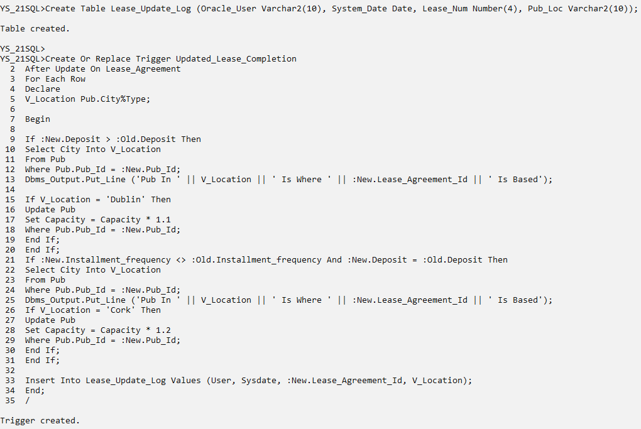

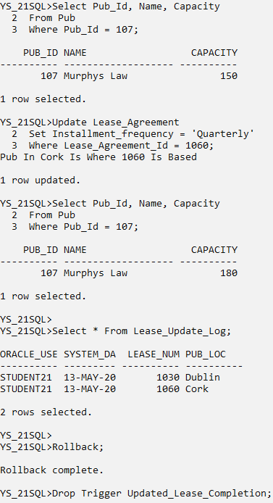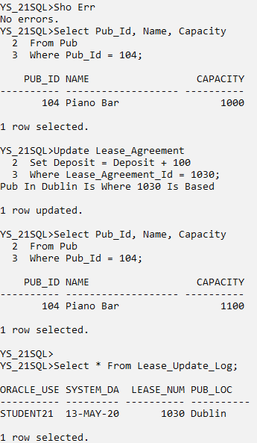

## **5.5 After Delete On Pub**

Question.5

When a user (successfully) removes a Lease Agreement, some changes need be carried out on data in other tables. The details are:

1. If the Installment frequency of a Lease Agreement is Monthly, then the Current Value of the corresponding Pub will decrease by 20% if it’s for Sports Fans.
2. If the Installment frequency of a Lease Agreement is Quarterly or Annually then the Current Value of the corresponding Pub will decrease by 10% if it’s for Students.
3. Display the Lease_Agreement_Id which has been deleted and the City of Pub on which the agreement is associated.
4. In a table called Lease_Delete_Log a record should be kept of:
5. Date of the removal,
6. Lease_Agreement_Id,
7. Start Date of the Agreement that’s just been deleted, and
8. Installment_frequency of the corresponding Pub

Solution

Cl Scr

Set Serveroutput On Size 1000000

Drop Table Lease_Delete_Log;

Create Table Lease_Delete_Log (Exe_Date Date, Lease_Num Number(4), Starting_From Date, Inst_Freq Varchar2(15));

Create Or Replace Trigger Del_Lease_Completion

After Delete On Lease_Agreement

For Each Row

Declare

V_Pub_Special Pub.Specialism%Type;

Begin

If :Old.Installment_frequency In ('Monthly') Then

Select Specialism Into V_Pub_Special

From Pub

Where Pub.Pub_Id = :Old.Pub_Id;

If V_Pub_Special = 'Sports Fans' Then

Update Pub

Set Current_Value = Current_Value*0.9

Where Pub.Pub_Id = :Old.Pub_Id;

End If;

End If;

If :Old.Installment_frequency In ('Quarterly', 'Annually') Then

Select Specialism Into V_Pub_Special

From Pub

Where Pub.Pub_Id = :Old.Pub_Id;

If V_Pub_Special = 'Students' Then

Update Pub

Set Current_Value = Current_Value*0.8

Where Pub.Pub_Id = :Old.Pub_Id;

End If;

End If;

Dbms_Output.Put_Line ('Pub Specialism Is ' || V_Pub_Special || ' Is On What Agreement ' || :Old.Lease_Agreement_Id || ' Was Made. ');

Insert Into Lease_Delete_Log Values (Sysdate, :Old.Lease_Agreement_Id, :Old.Start_Date, V_Pub_Special);

End;

/

Sho Err

Select Pub_Id, Specialism, Current_Value

From Pub

Where Pub_Id = 109;

Delete

From Lease_Agreement

Where Lease_Agreement_Id = 1080;

Select Pub_Id, Specialism, Current_Value

From Pub

Where Pub_Id = 109;

Select *

From Lease_Delete_Log;

Select Pub_Id, Specialism, Current_Value

From Pub

Where Pub_Id = 103;

Delete

From Lease_Agreement

Where Lease_Agreement_Id = 1020;

Select Pub_Id, Specialism, Current_Value

From Pub

Where Pub_Id = 103;

Select *

From Lease_Delete_Log;

Rollback;

Drop Trigger Del_Lease_Completion;

Snip

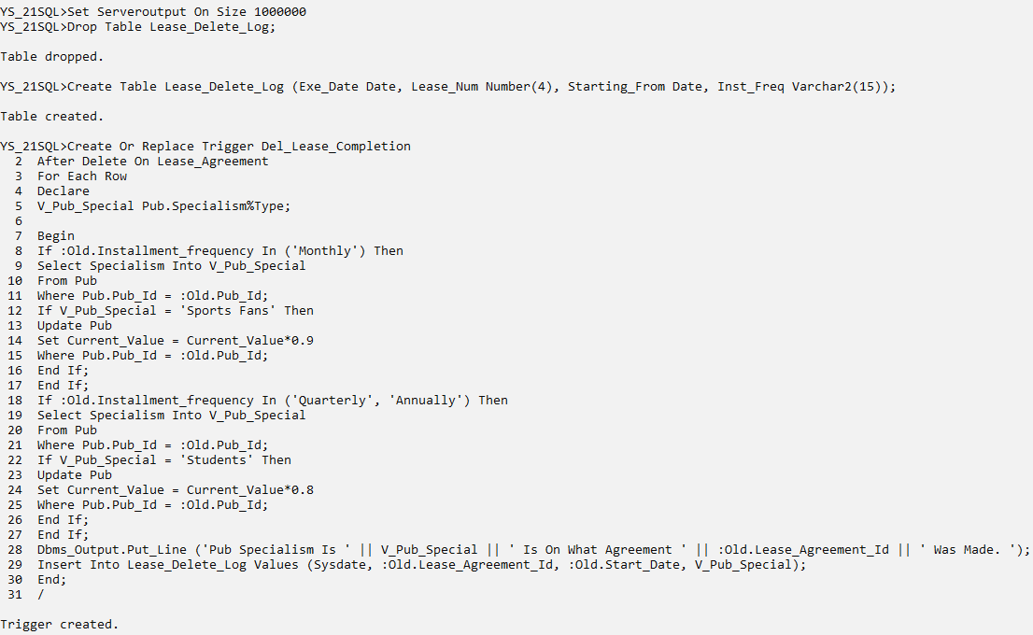

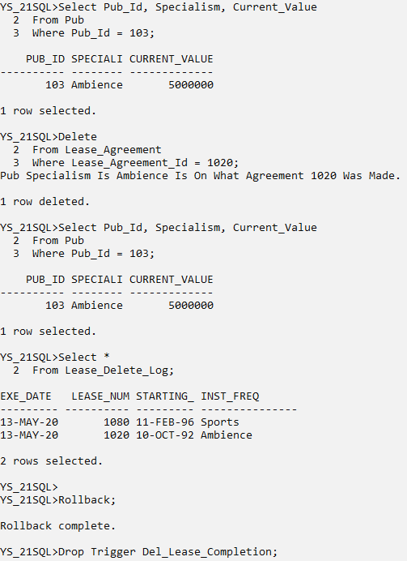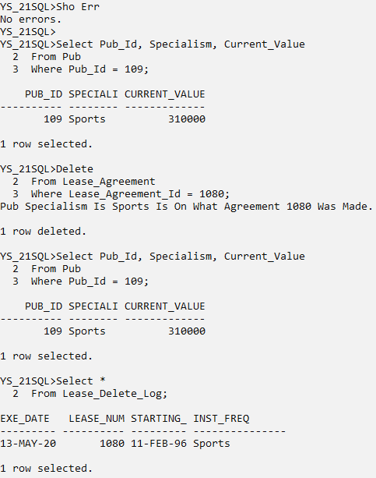

# YouTube Description

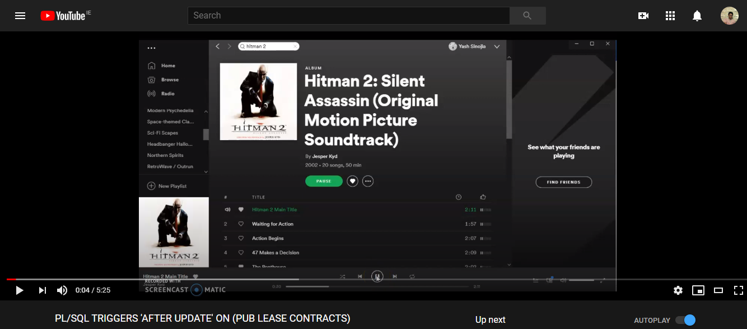

[Link to Trigger Screencast](https://youtu.be/fCOGQZgRfsE)