**1. Problem Statement**

I want to build a model that classifies American Sign Language letters inputted by a user. I plan on integrating my model with a web app that interacts with the user via video camera.

**2. Data Preprocessing**

As stated in deliverable 1, the dataset consists of American Sign Language images, each 200 x 200 RGB pixels. In total, there are 3000 labelled images per letter, resulting in 78 000 images in total. However, because the full dataset exceeded my computer memory and took too long to train, I limited training to 7 800 photos. Upon reading similar image classification posts, such as [this one](https://medium.freecodecamp.org/weekend-projects-sign-language-and-static-gesture-recognition-using-scikit-learn-60813d600e79), which classified non-ASL signing and ASL signing, as well as advice from John (MAIS Exec), I decided to pre-process my data using Histogram of Oriented Gradients (HOG). I decided to deviate from using PCA and convolutional neural networks because the image classification problem is not complex enough.

The 26 classes involved in ASL sign language all look relatively similar: for example, the visual differences between an A and a B are not comparable to the visual differences between a dog and a boat. As a result, the model doesn’t need to learn all the intricacies of each class via a neural network, it only needs to learn the silhouettes of each hand sign. This is why HOG is a much simpler, but still effective, alternative.

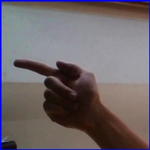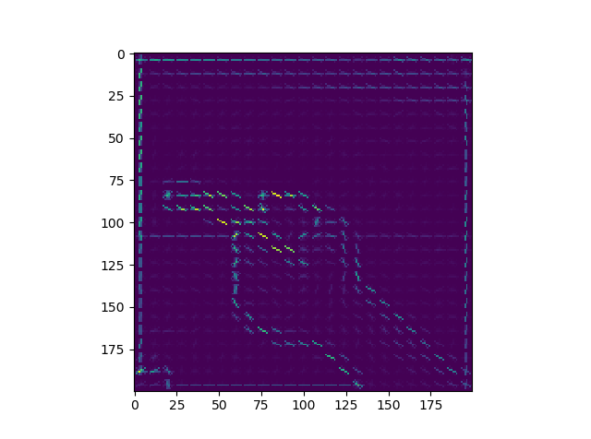I began my pre-processing by reading in each image with the Pillow library, converting it to gray scale, and calculating the HOG with scikit-learn, as per [this article](https://www.kaggle.com/manikg/training-svm-classifier-with-hog-features). This converted each image from a 3-dimensional array representation of an image, to a 1-dimensional vector of gradients. Visualizations of the pre-processing results can be seen in Fig. 1.

1. (b)

Fig. 1: (a) original image of G6.jpg from test set

(b) visualization of G6’s HOG

To convert the labels into values an SVM could interpret, I used scikit-learn’s LabelEncoder to transform them into categorical numerical values. Finally, I used scikit-learn to perform a 80-20 split on the pre-processed data and obtain my training and validation datasets.

**3.** **Machine Learning Model**

I used scikit-learn’s multi-classification SVM package to train the datasets. I assumed that when all the images are properly centered (as they are in the training data), the gradient vectors of the ASL hand sign’s outline are linearly separable. I based my assumption on the fact that the silhouettes for the ASL letters are all quite distinct from each other.

**4. Preliminary results**

The trained model has an accuracy of

While the model isn’t perfect, it manages to classify most letters correctly. I will try to fine-tune the hyperparameters to obtain a model that better identifies the differences between . However, if it doesn’t seem like the HOG data is sufficient enough to differentiate between these data points, I may have to try a CNN.

**5. Next Steps**

While the SVMs may not yet capture enough details within the letters, they are simple to train and predict fairly well. Going forward, I want to perform more hyperparameter tuning for the C (penalty parameter) of the SVM, as well as the type of SVM. If fine-tuning the parameters doesn’t work, I will try a CNN. Once I obtain an optimized model, I will begin to integrate it with my web app. In doing the latter, I plan on using a sliding window approach to locate the ASL hand sign within the image received by the webcam.