# Nodejs



As an asynchronous event-driven JavaScript runtime, Node.js is designed to build scalable network applications. In the following "hello world" example, many connections can be handled concurrently. Upon each connection, the callback is fired, but if there is no work to be done, Node.js will sleep.

# Website:

# dataHUB-Xi

# configuration

# debug

# wakeonlan

the wakeonlan module supports possibilities to scan a network for online Ethernet cards, after scan you can

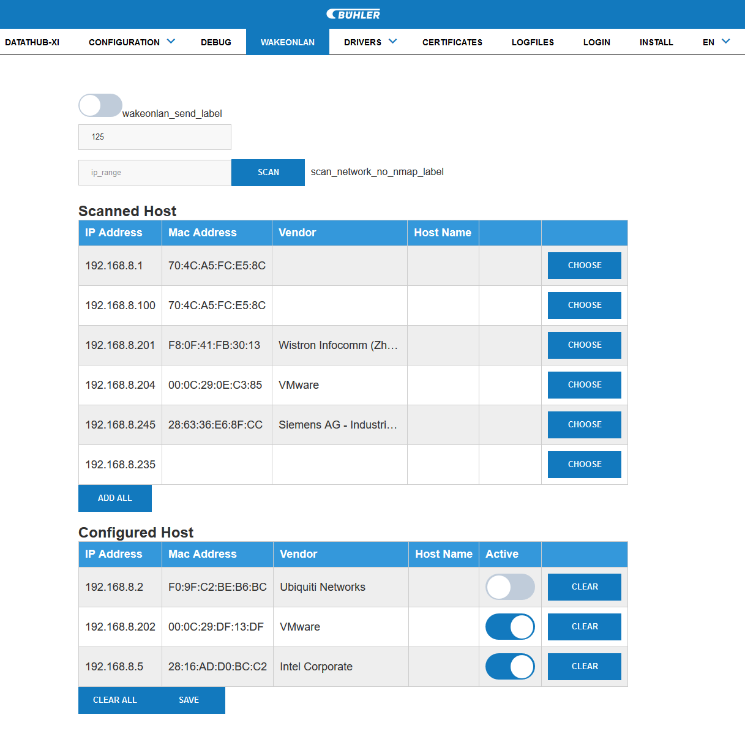

# Update module:

The update module supports functions to install individual modules to the dataHUB-Xi web-administration.  
These modules can be driver admin packages, language packages, css themes and so on.

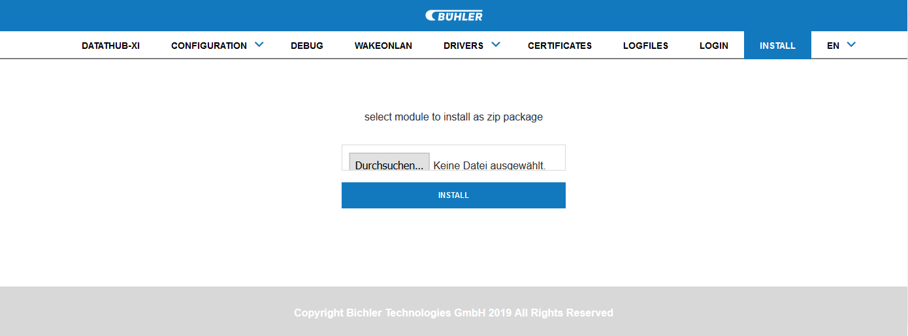

To install a new package, open the INSTALL-site via menu „INSTALL“, select a zip file and press install button. After installation of a new package, a reboot is required.