Name: Bechara El Helou (212000)

GitHub:

First I set up the database by adding users to my table. Then I display all the table on the screen.

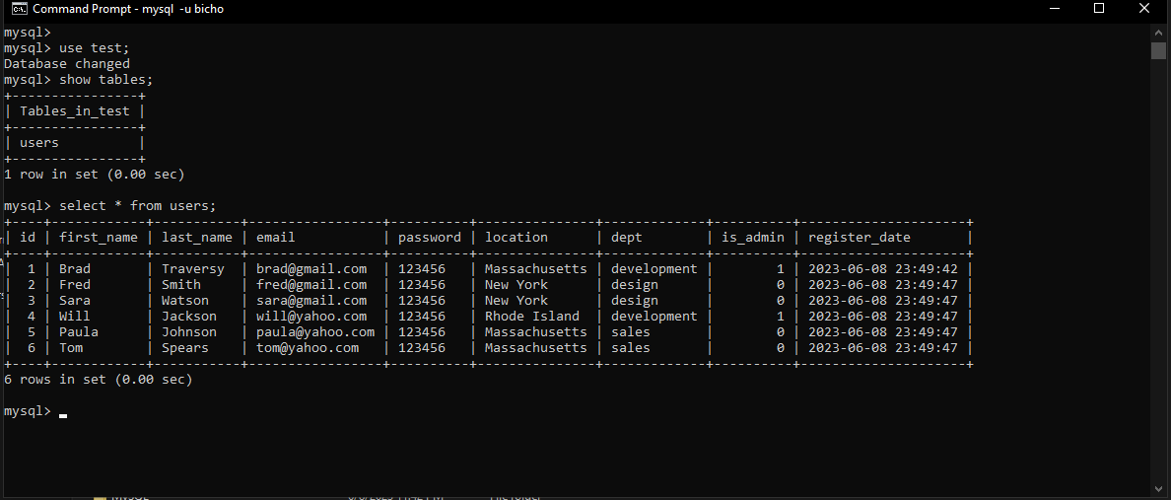

Here I wrote a settings.json file so that vscode can import the jar file that I will be using.

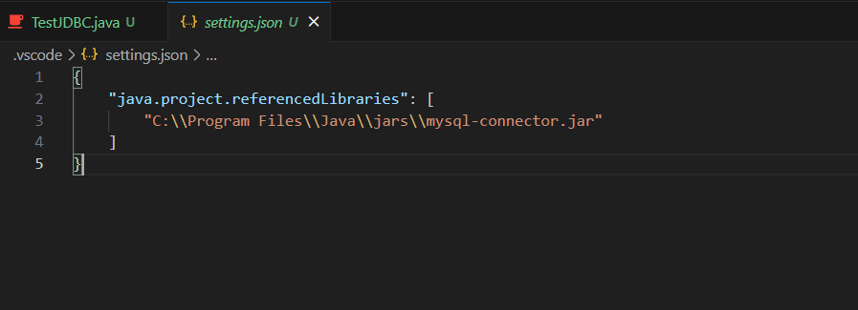

Then I wrote the TestJBDC.java file that initialize the connecting to the database and print the first name and locations of users.

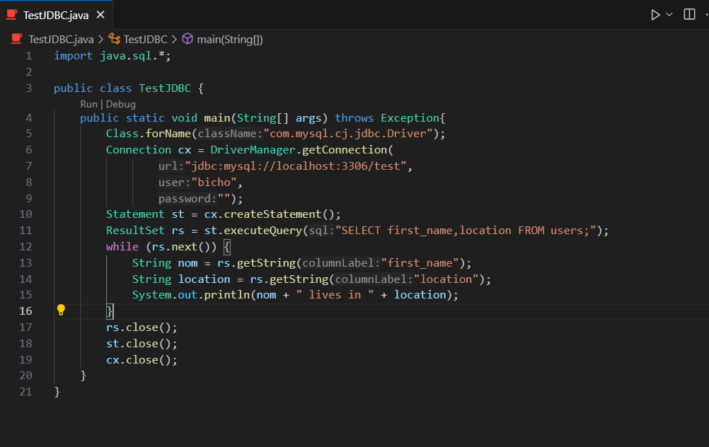

Here are the results after running:

