Name: Bechara El Helou (212000)  
Github: <https://github.com/Bicho15H/Servlet-exemple>

First we write a code that salute the user with his name and last name from the get request

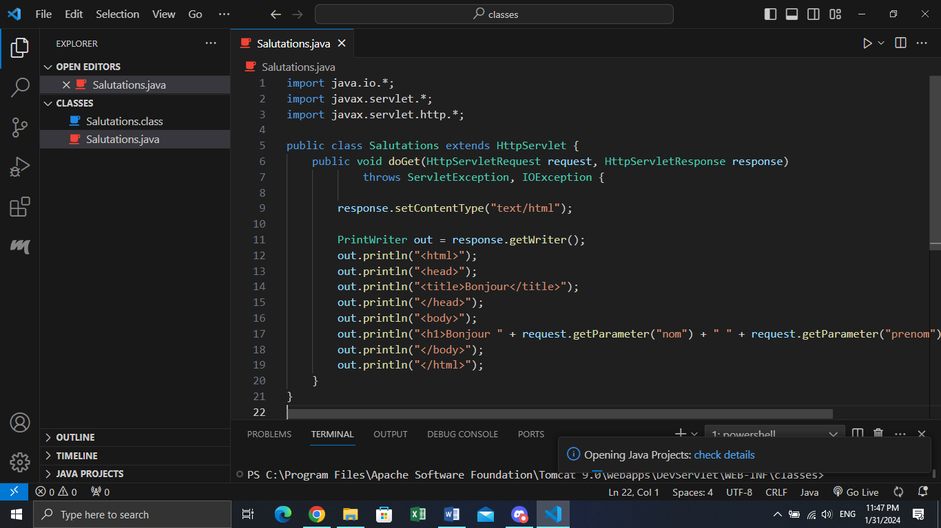

Then we compile the Salutations.java file and we put all these files in the classes folder in tomcat.

Now we create a static html file that link to the tomcat server.

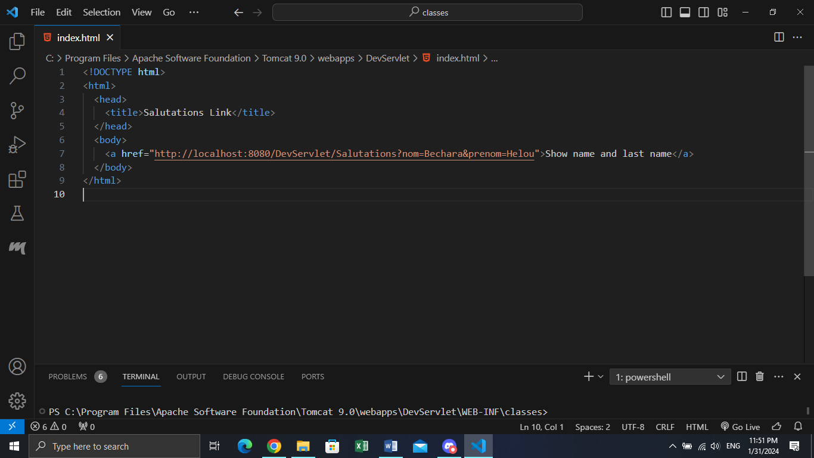

After that we run the tomcat server and we get this result:

