***ASSIGNMENT OF***

***IOS DEVELOPMENT -1***

***COURSE CODE:- MAD- 400***

***SUBMITTED TO:-MANHAR KAPOOR***

***STUDENT ID:- A00117738***

***SUBMITTED BY:- BICKY KAUR DHILLON***

**INDEX**

|  |  |  |
| --- | --- | --- |
| SERIAL NO | TOPIC | PAGE NO |
| 1 | WHAT IS SWIFT UI | 3-7 |
| 2 | WHAT IS OBJECTIVE –C AND TESTFLIGHT | 8-13 |
| 3 | WHAT IS THE APPLE INC. AND STEVE JOBS | 13-14 |
| 4 | USER EXPERIENCE USING APPLE PHONE | 15 |

**WHAT IS SWIFT UI**

Swift UI is defined as that it is very simple way to create the user interface that will work at all apple devices platforms with the help of power of swift and frame work was introduced by apple in 2019 and it has brought biggest change in the ecosystem of apple including IPADOS, MACOS, TVOS AND WATCHOS. UI code is very easy to write and understand for the users and comparison of the old version of UI kits it very convenient to create user interface in the swift UI. With swift UI and xcode11 it is very easy for the people to acquire all information about user interface while coding and in Xcode it was very difficult to get feedback about user interface until you did not load your application on stimulators.

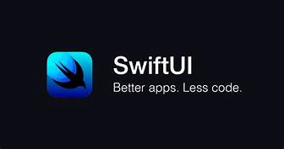

**ADVANCED APP EXPERIENCE AND TOOLS:** Swift UI provide the number of new features to the different apps such as better search experience, improved view and better support for controlling focus areas for different projects.

**ACCESSIBILITY IMPROVEMENTS**: By using the rotor API it enhance the speed of interaction on screen choosing the best suitable time.

**WIDGETS FOR IPADOS:** Widget can be drag at any place on the home screen and it also increases the widget size.

**Declarative syntax:** U ser can define very easily about their user interface because Swift UI use the declarative syntax and user can write the as per their requirements using the different text field, font and color.

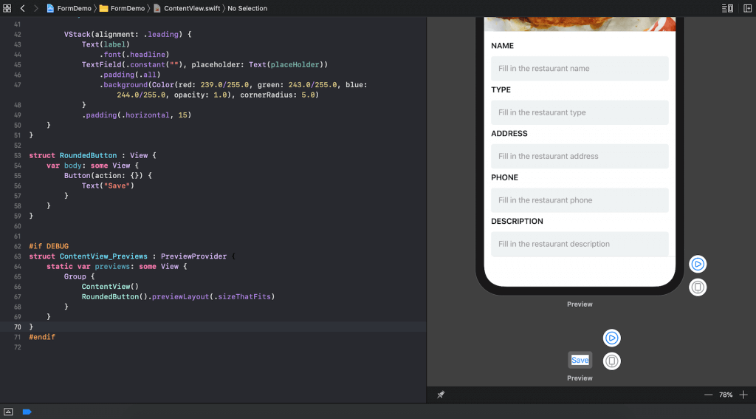

**DESIGN TOOLS**

**DRAG AND DROP:** user can arrange different component on the use interface using the dragging controls on the canvas and they can arrange text, color of font and size, alignment and size option with the help of the cursor.

**PERVIEWS**: user can create any number of previews in the swift UI in order to get sample of the data and also they can check everything about font size, locations in different mode.

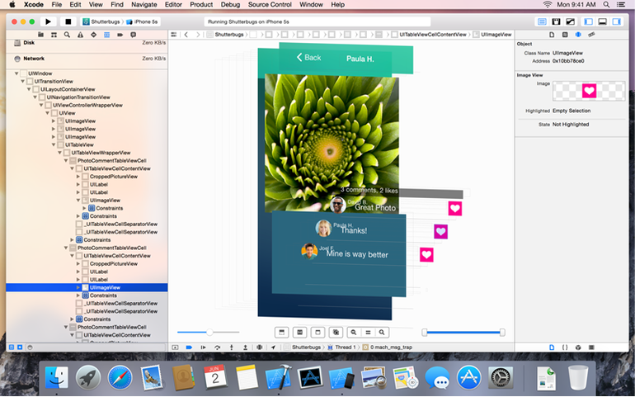

**2 OBJECTIVE-C**

It is the objective-oriented programming languages that use the Smalltalk –style for the messaging to the c programming language and it was designed by the Tom Love and Brad Cox and it was launched in the market in 1984 and it was not developed for Apple operating system. It belongs to the c language family and typing discipline is static, dynamic and weak.

**FEATURES AND LIBRARY USE:** It provides the very easy solution to all problems related to the programming.

Using the massage forwarding and categorie, issues like delegating methods and remote invocation can be implemented.

Nowadays it is often used in tandem with fixed library of the standard objects such as Cocoa and GNU step and it has operating system and cocoa comes with Mac Os and GNU step with linux libraries lot of code that were written in the on the objective c language in the past year now that can be installed using cocoa pods

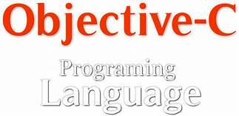

It use the thin run time for that is written in the c language for the implementations but most of the object oriented systems use the large virtual run time.

**TESTFLIGHT**

It is the online service that is use for the testing of the mobile application and installation and it was launched in the market on January 25 in 2021 and nowadays in is owned by apple inc and only offered to the developer within the IOS developer program and they sign up for the different services to beta testers or internal, who can send feedback about different application to the developers and it help the developer to gain the crash reports and tester feedback about the different projects.

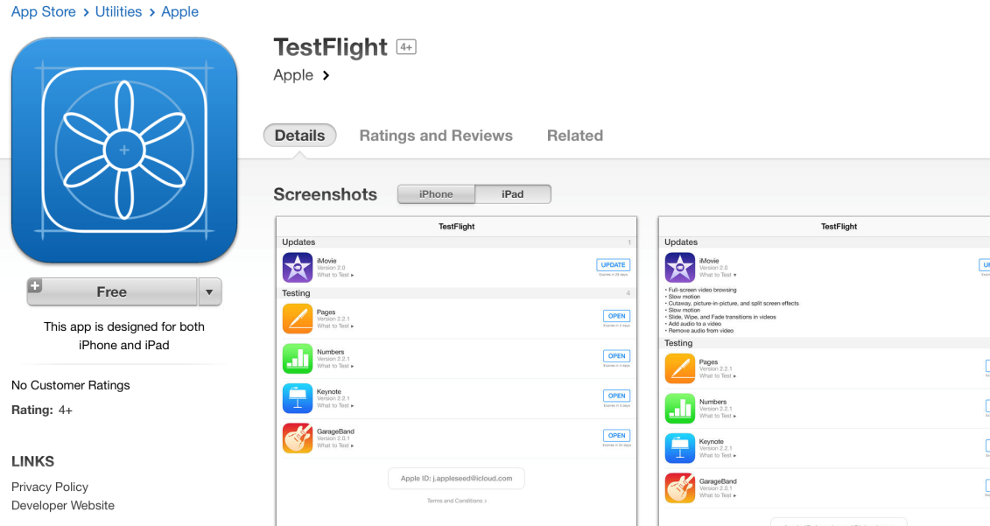

Initially it was developed for the testing of the android and IOS application in the year 2015 application were allow to use the test flight using the XCODE and more than 100 apps can be tested at single time in the test flight and tester can be grouped or separated in one team. Test flight application help for IOS testers to send the feedback to the developer.

**APPLE INC:**

It is the multinational company of technology and this company is specialized in the electronics devices, computersoftware, and also provides the online services. It is considered as the largest company in the world of technology and its estimated capital was about 275 billion in the year 2020 and it also has notch the top slot in among the biggest companies in America such as Amazon, Google Microsoft and Face book and it was founded by Steve jobs, Steve Wozniak, and Ronald Wayne on April 1 in the year 1976 and it has total 512 retail stores.

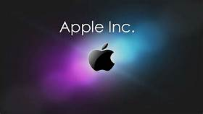

**PRODUCTS:**

IMac and Mac mini was introduced in the market in 1998, and 2005 and it falls in the category of desktop computer. Mac book air was launched in the market in 2008 and it was the ultra portable and ultra-thin and first generation of the apple I phone was released in the 2007 and second version with excellent feature was come in the market in next year with reduced. On the September 12 I phone 8 was released in 2017 and it has the better display technology, cameras quality and wireless charging. Apple watch for tracking fitness was released in the market in 2015 by apple and its latest series was launched in 2020 and it is capable to measure the blood and oxygen level and other measurements of body.

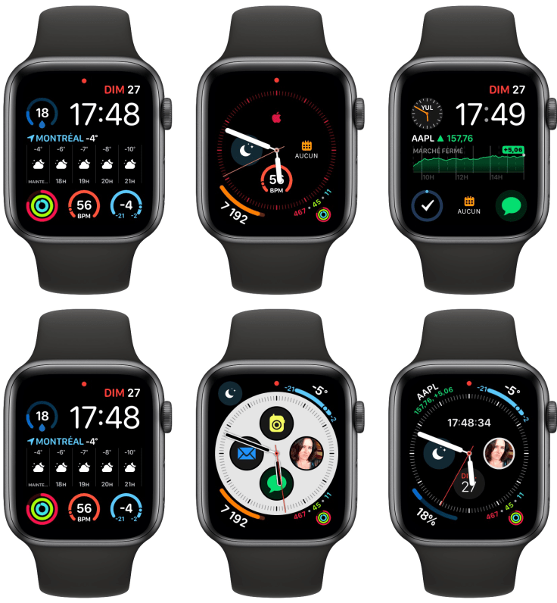

Home pod was released by apple in 2018 and it has six microphones to adjust the voice level and four inch woofer. Apple is working producing electric vehicles from the year 2020.this company has been criticized for unethical business practices ,sweat shop labor, for stealing the design, and for insufficient data security.

**STEVEN JOBS**

STEVEN PAUL JOBS was born on 24 February in 1955 in San Francisco, California U.S and he was American businessman, industrial designer, investor, and media proprietor. He was co funder of the apple inc, and chairman of the Pixer and also member of the Walt Disney Company board. He is also known as the pioneer of the computer revolution with Steve Wozniak and co – creator of the I phone, I pod, ipad, and the apple stores.

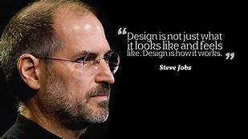

Apple1 was designed by the jobs and Wozniak by hand near about the 1976 and apple 2 bit that was 8 bit home computer designed by the Wozniak and it was introduced in the market in 1977 and in the same year west coast computer faire was sold by apple. apple Lisa was the personal computer that provide the graphical user interface was designed by apple in the 1980.when he joined the original Macintosh team and he developed the first mass personal computer in 1984 and later its name was changed because it was member of the apple family and it was updated model and it was expensive model. Finally Imac was launched in the market in 1998 and it has varied shape, design and color and lots of new feature was added in single design.

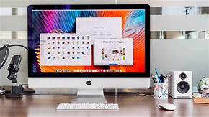

ITunes is a media player, mobile device management, online radio broadcaster application developed by apple and it is use for the download, maintaining the audio and video files on the iTunes and it was work on the Mac Os and Microsoft window operating system. First I pod was introduced in the market in 2001 and the most excellent feature of this was its compact size and other attracted feature of this model was that more than 100,000 I pods was sold before than end of this year. After this I pod mini,I pod nano and screenlesss ipod was released in market by apple in the next years.

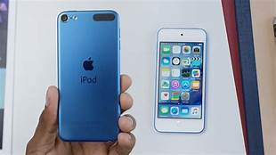

The year 2007 is considered as the year of innovation in by apple and first I phone was developed in this year and I phone 3g was launched in year2008 and it has excellent features such as supporting to the GPS, 3G data and some new features were added in this model such as better camera quality, faster processing speed in the next year. I phone 4S was develop in the year 2011 with feature of recognition.

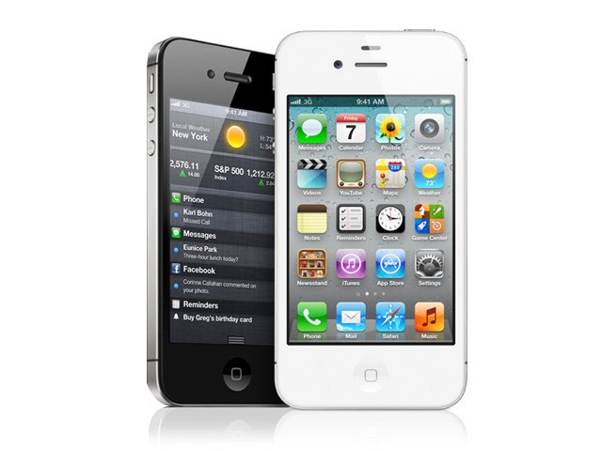

First ipad wads launched in the market by apple in 2010 it has the facility of in built user interface, multi touch screen and virtual keyboard also it has the cellar connectivity.

**HONORS AND AWARDS**

He was awarded with the national medal of technology by the president of US in 1985 and in the year of 1987 he was as the entrepreneur of the decade by inc Mazaine and 1991 he got award from reed college under the name Howard Vollum . In 2007 he got the award for most powerful person in the business by fortune magazine in 2012 he got honor for the influencing the music industry.

He was died on October 5 in 2011, Palo Alto, California, united status due to the pancreatic neuroendocrine tumor.

**USER EXPERIENCE USING APPLE PHONE:**

Apple iphone is an absolute pleasure to user. User can visualize and control voice message with elegant touch screen .each function of apple mobile from dynamic, technology to industrial design worked together in rewarding way. These phones has excellent hardware and software integration and imaging ios web world and cameras for front and back screen are comes with excellent quality and top quality user interface, and high security rate .these phone has very less operational issues and no clashes, sudden restarts and no delay in opening the activity.

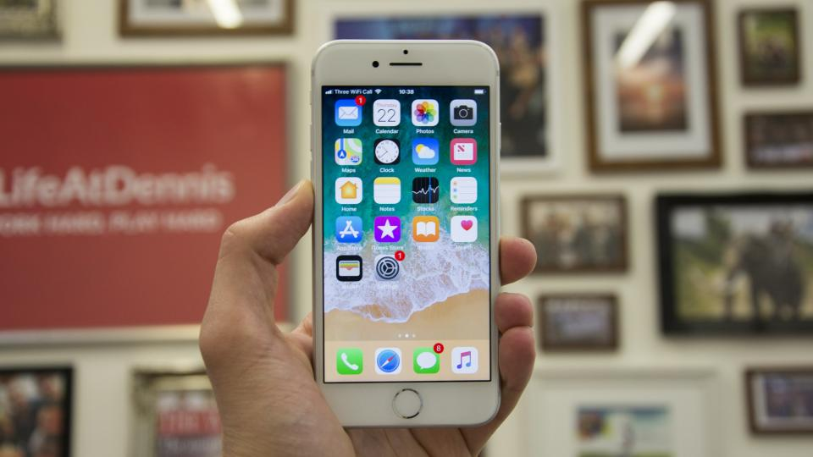

REFFERANCES:

en.wikipedia.org › wiki › Steve_Jobs

askinglot.com › what-is-swift-ui-in-ios

askingfact.com › what-is-ios-testfligh