**Nepal Heritage Documentation Project (NHDP)**

The Nepal Heritage Documentation Project (NHDP) is building comprehensive digital records of Nepal's endangered historical cultural monuments. These include temples, monasteries, palaces, as well as smaller shrines, arcaded platforms, fountains, and other historic buildings. NHDP is the first project to comprehensively photograph, record, describe, and analyse these structures and make the records available in a freely accessible [database](https://uni-heidelberg.de/danam). The project focuses on the Kathmandu Valley, western Nepal, and other sites culturally and historically associated with the Kathmandu Valley. It aims to document and inventory more than 2000 monuments, 2500 inscriptions, and 8000 objects, as well as the unique intangible cultural heritage associated with the monuments: rituals, festivals, and other social and religious events and practices.

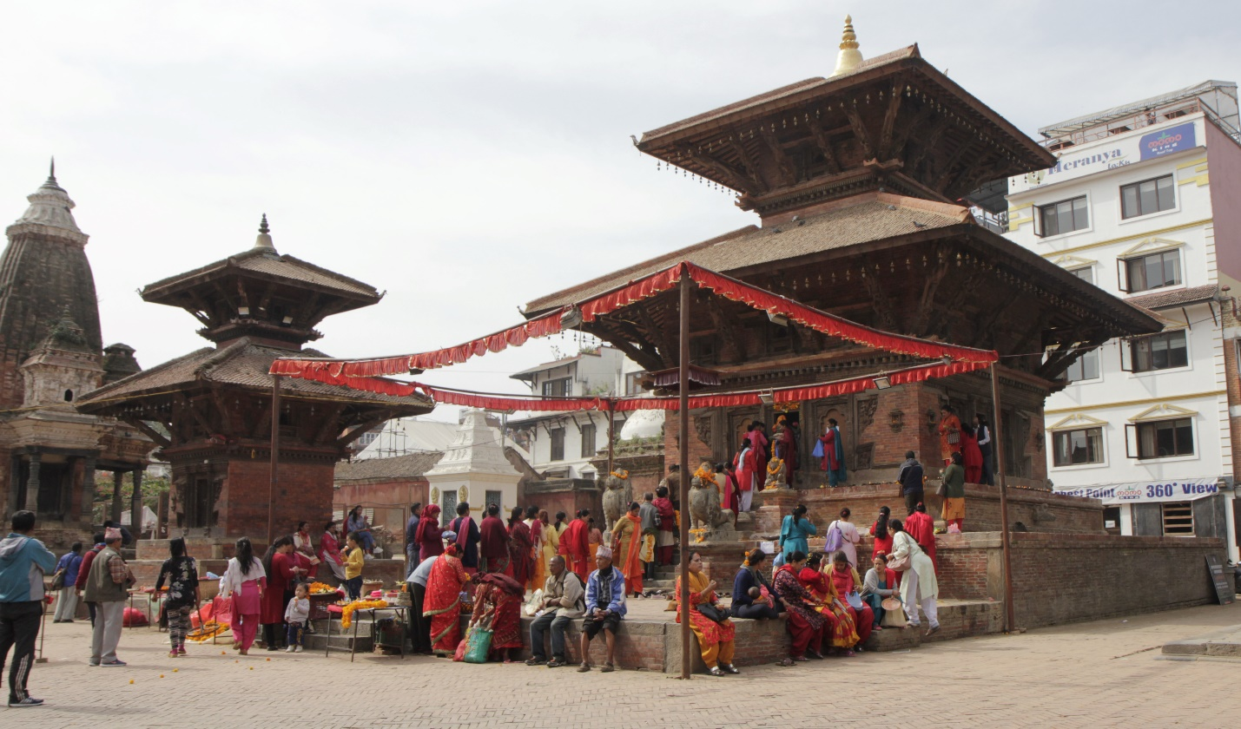

The data resulting from the documentation is added to the Digital Archive of Nepalese Arts and Architecture (DANAM) and Heidelberg University Library's image database, HeidICON, and on HeiDATA. The datasets contain structured information (in English and Nepali) about the monuments, i.e., information about their location, history, architectural structure, and religious and social activities. They also include historical and recent photographs, maps, plans and drawings, and transcriptions of inscriptions. The team in Germany and Nepal consists of about 20 experts from the fields of history, architecture, ethnology, Indology and heritage management. IT specialists ensure high-quality data management.

DANAM is based on Arches (v.4), an open-source software platform for cultural heritage inventory and management developed jointly by the Getty Conservation Institute and the World Monuments Fund. All content is available to the public free of charge.

* **Project website:** <https://uni-heidelberg.de/danam>, [heidICON](https://heidicon.ub.uni-heidelberg.de/pool/nhdp_monuments" \o "Object and media database heidICON, image pool NHDP)
* **Funded by:** [Arcadia Fund, UK](https://www.arcadiafund.org.uk/)
* **Duration of Project:** 2018-2026 (Pilotphase 2018-2020)
* **Head Office:** [Heidelberg Centre for Transcultural Studies (HCTS)](https://www.asia-europe.uni-heidelberg.de/en/) at Centre for Asian and Transcultural Studies (CATS)
* **Partners:** [Saraf Foundation for Himalayan Traditions and Culture, Kathmandu](http://thesaraffoundation.org/); [Heidelberger Akademie der Wissenschaften (HAdW)](https://www.hadw-bw.de/); [I3 Mainz](https://i3mainz.hs-mainz.de/); UB Heidelberg; UNESCO Nepal; [Kathmandu Valley Preservation Trust (KVPT)](https://kvptnepal.org/), Department of Archaeology (DoA), Nepal.
* **Contact in Heidelberg:** Prof. Dr. Christiane Brosius, Prof. Dr. Axel Michaels