OUTPUT LAB 1

OUTPUT LAB 2

OUTPUT LAB 3

OUTPUT LAB 4

OUTPUT LAB 5

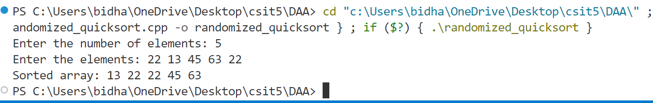

OUTPUT LAB 6

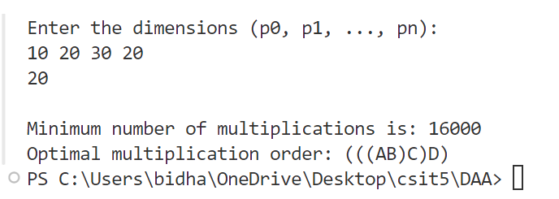

OUTPUT LAB 7

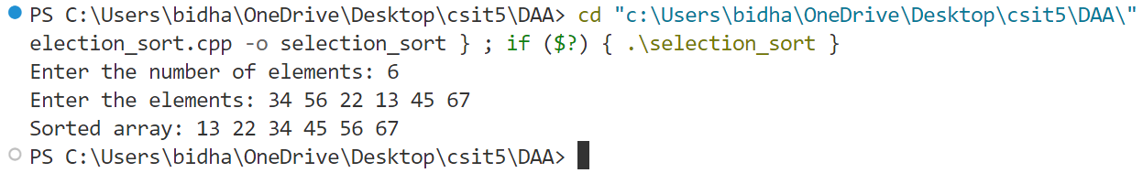

OUTPUT LAB 8

OUTPUT LAB 9

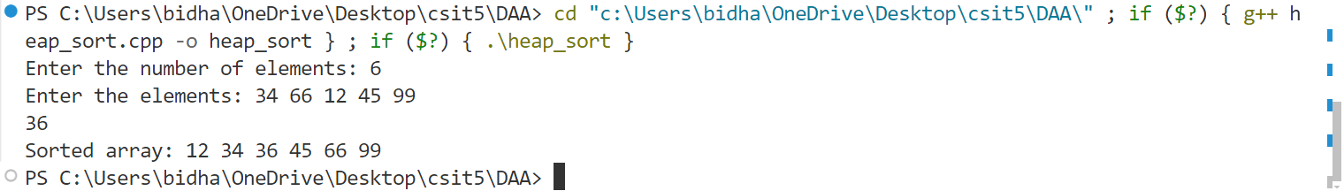

OUTPUT LAB 10

OUTPUT LAB11

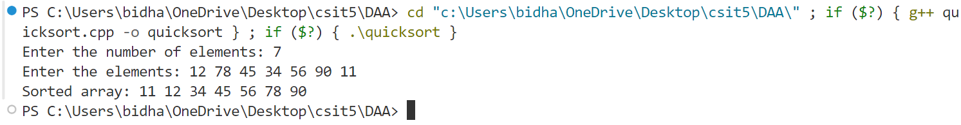

OUTPUT LAB 12

OUTPUT LAB 13

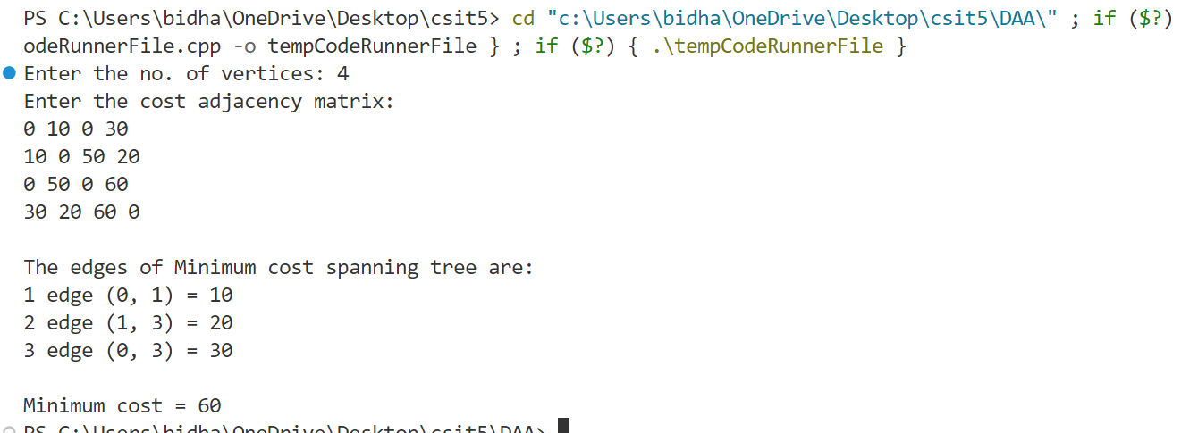

OUTPUT LAB 14

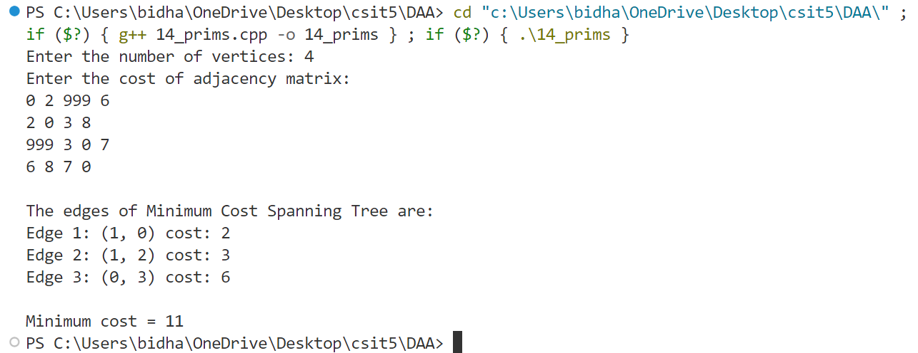

OUTPUT LAB 15

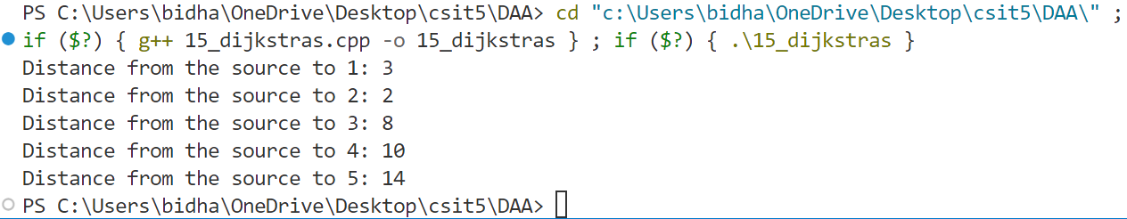

OUTPUT LAB 16

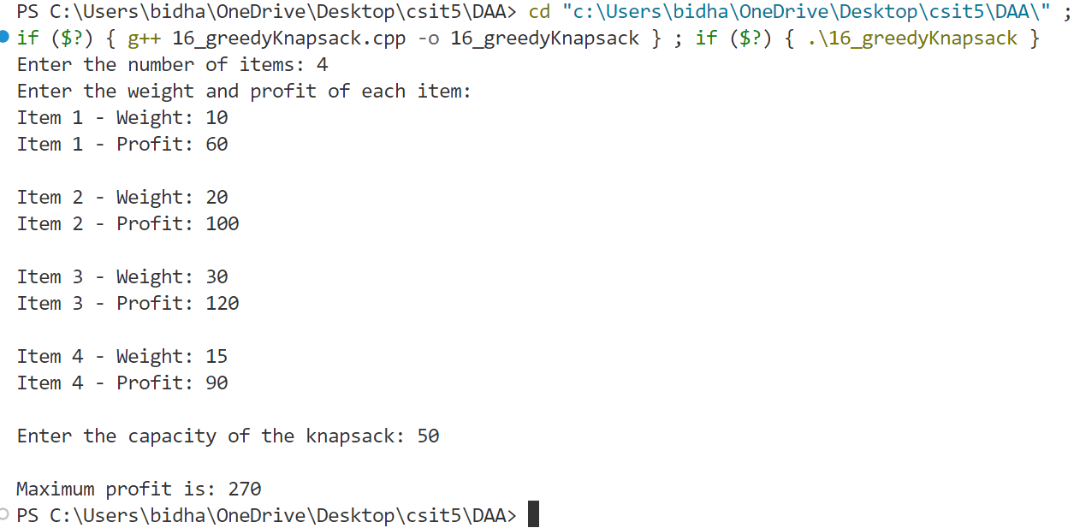

OUTPUT LAB 17

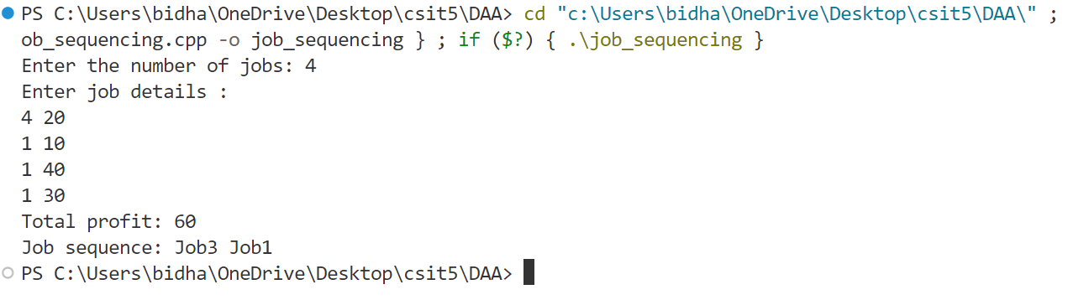

OUTPUT LAB 18

OUTPUT LAB 19

