

Module | Assessment Type
Project and Professionalism | Artifact Design and Test Plan

Project Title: BimbaSetu

Student Name: Bidhan Sapkota
Student ID: 2438398
Group: L6CG23
Supervisor: Nikunja Lamsal
Reader: Shiv Kumar Yadav
Table of Contents
1 Introduction 1
1.1 Purpose 1
1.2 Scope 1
2 System Overview 1
2.1 Identified Subsystems 1
2.2 Subsystem Diagram 2
3 Functional Decomposition Diagram (FDD) 2
3.1 Purpose 2
3.2 Subsystem Features 2
3.3 FDD Diagram 3
4 Software Requirement Specification (SRS) 4
4.1 Requirement Types 4
4.2 User Management System (UMS) 4
4.3 Billboard Management System (BMS) 5
4.4 Campaign & Pricing Management System (CPM) 5
4.5 Reporting & Analytics System (RAM) 5
4.6 Notification Management System (NMS) 6
5 MoSCoW Prioritization 6
5.1 MoSCoW Priority Table 7
6 Artefact Design 8
6.1 System Architecture 8
6.2 Use Case Diagrams 9
6.3 Activity Diagrams 13
6.4 Sequence Diagrams 14
6.5 Class Diagram 16
6.6 Object Diagram 17
6.7 Entity Relationship Diagram (ERD) 18
6.8 Component Diagram 19
6.9 Data Flow Diagram (DFD – Level 1) 19
7 Initial Designs 20
8 Test Plan 22
8.1 Test Strategy 22
8.2 Test Cases 23
8.2.1 Functional Test Cases 23
8.2.2 Non-Functional Test Cases 23
8.2.3 Usability Test Cases 23
9 Conclusion 24

Table of Figures
Figure 1: Subsystem Diagram 2
Figure 2: Functional Decomposition Diagram 3
Figure 3: System Architecture Diagram 8
Figure 4: Use Case for UMS 9
Figure 5: Use case for BMS 10
Figure 6: Use case for CPM 11
Figure 7: Use case for RAM 12
Figure 8: Use case for NMS 12
Figure 9: Activity Diagram for User Registration 13
Figure 10: Activity Diagram for Booking flow 14
Figure 11: Sequence Diagram for Login Flow 14
Figure 12: Sequence Diagram for Overall System 15
Figure 13: Class Diagram for the System 16
Figure 14: Object Diagram of the System 17
Figure 15: ERD of the System 18
Figure 16: Component Diagram of the system 19
Figure 17: Data flow diagram of the system 19
Figure 18: Initial design for Login Page 20
Figure 19: Initial design for Dashboard 21
Figure 20: Initial Design for ads listing 22

Introduction
BimbaSetu is a system of billboards and advertisements management in Nepal. The current process is largely manual, with a lot of delays, unclear prices, and lack of tracking about the performance of these ads. This system will enable a central system for billboard owners, advertisers and admins.
It will help the advertisers to find the available bills, book campaigns and track their ads. It will also help the billboard owners in managing their billboards and monitoring revenue. Admins will have control over the overall system and will verify the users and billboards

Purpose
The aim of this document is to illustrate the fact to which BimbaSetu will be designed, including the main parts of the system, the requirements and the test plan. This will help the developers and testers to understand what needs to be done and how to check that it works.

Scope
The system will include:
- User registration and user role-based login
- Managing and availability of billboards
- Campaign creation, pricing, approval & scheduling
- Reports and analytics of advertising campaigns
- Approval, payment, campaign notifications.

System Overview

Identified Subsystems
BimbaSetu has several parts (subsystems) which work in a coordinated manner. Each part has a clear role. The main subsystems are:
- User Management System (UM): Deals with the registration, login, roles (admin, advertiser, owner), and permissions of the users.
- Billboard Management System (BMS): Allows owners to add, edit and manage billboards. Shows for availability to advertisers.
- Campaign & Pricing Management (CPM): Manages campaign system, dynamic pricing, and approval system.
- Reporting & Analytics (RAM) Displays performance of ads, impressions and campaign revenue.
- Notification Management System (NMS): Sends alert for approval, payment and campaign update.

Subsystem Diagram
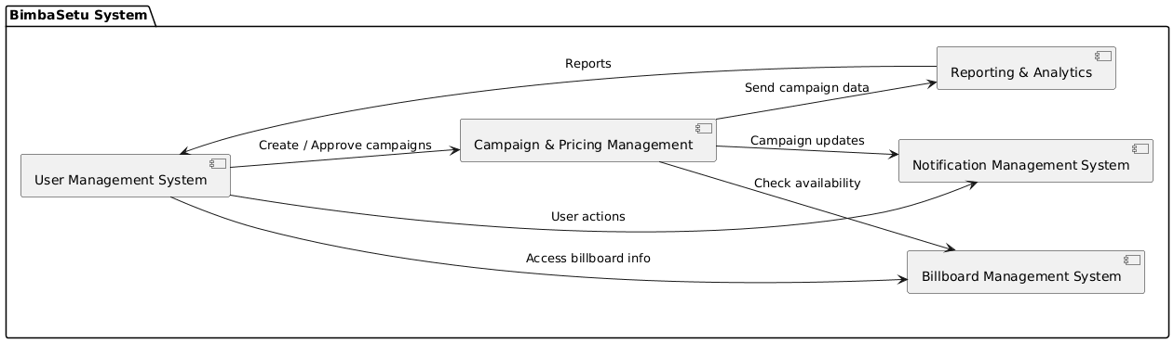
Figure 1: Subsystem Diagram

Functional Decomposition Diagram (FDD)

Purpose
FDD illustrates the key features of BimbaSetu and the grouping of each subsystem. It helps to get a clear picture of the structure of the system. The FDD helps the developer and the tester to understand what the system should do by breaking the system into smaller features which are easier to implement and test.

Subsystem Features
User Management System (UM):
- Register users
- Login and logout
- Role management
- Ban/unban users
Billboard Management System (BMS):
- Add/Edit/Delete billboards
- Demonstrating availability to advertisers
Campaign & Pricing Management (CPM):
- Create campaigns
- Approve campaigns
- Dynamic pricing according to duration, location, and frequency
Reporting & Analytics (RAM):
- Show impressions Revenue
- Export reports
Notification Management System (NMS):
- Notify users of approvals, payments and campaign start/end.

FDD Diagram
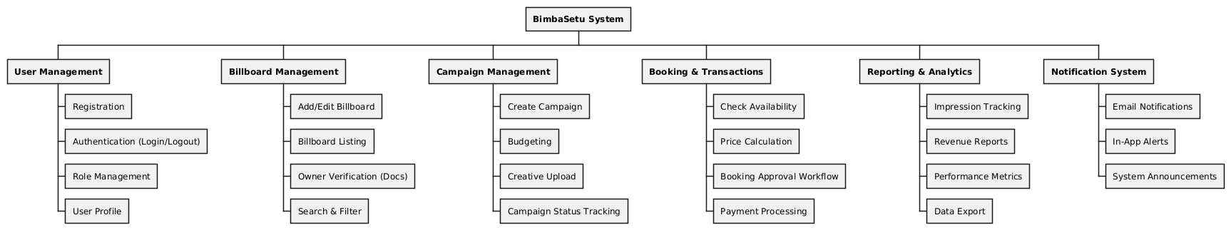.
Figure 2: Functional Decomposition Diagram

Software Requirement Specification (SRS)
The SRS basically defines what BimbaSetu should do (functional), how it should perform (non-functional) and how easy it should be to use (usability). Each requirement has their own unique code for traceability.

Requirement Types
Type | Description
F | Functional Requirement – what the system should do
NF | Non-Functional Requirement – performance, security, limits
UR | Usability Requirement – ease of use, interface design

User Management System (UMS)
Req Code | Type | Description
UM-F-1.0 | F | Users can register with email/social accounts
UM-F-2.0 | F | Users can login/logout
UM-F-3.0 | F | Admin can assign roles (admin/owner/advertiser)
UM-F-4.0 | F | Admin can ban/unban users
UM-NF-1.1 | NF | Passwords must be encrypted
UM-NF-1.2 | NF | Passwords must include letters, numbers, special chars
UM-UR-1.1 | UR | users can show/hide password field

Billboard Management System (BMS)
Req Code | Type | Description
BMS-F-1.0 | F | Owners can add, edit, delete billboards
BMS-F-2.0 | F | Advertisers can view available billboards
BMS-NF-1.1 | NF | Image size max 10 MB, resolution min 1024x768
BMS-UR-1.1 | UR | Drag-and-drop image upload supported

Campaign & Pricing Management System (CPM)
Req Code | Type | Description
CPM-F-1.0 | F | Advertisers can create campaigns
CPM-F-2.0 | F | Owners/admin can approve campaigns
CPM-F-3.0 | F | Pricing adjusts dynamically based on location, size, frequency
CPM-NF-1.1 | NF | Campaign start/end dates must be validated
CPM-UR-1.1 | UR | Simple interface for campaign creation

Reporting & Analytics System (RAM)
Req Code | Type | Description
RAM-F-1.0 | F | Show campaign impressions and revenue
RAM-F-2.0 | F | Export reports in CSV/PDF format
RAM-NF-1.1 | NF | Reports should load within 5 seconds
RAM-UR-1.1 | UR | Dashboard should be easy to read

Notification Management System (NMS)
Req Code | Type | Description
NMS-F-1.0 | F | Notify users on campaign approval/rejection
NMS-F-2.0 | F | Notify users on payments received
NMS-F-3.0 | F | Notify users on campaign start/end
NMS-NF-1.1 | NF | Notifications must be delivered within 1 min
NMS-UR-1.1 | UR | Notifications should be clear and concise

MoSCoW Prioritization
MoSCoW prioritization is used to select the most important requirements to the system. It helps to focus on the core features first and not go for unnecessary features during the development.
The requirements fall under four groups:
- Must Have - very important, system cannot work without these
- Should Have - important, but system can work without having them
- Could Have - features that may be added but may not have time for
- Won't Have - not in this version of the system.

MoSCoW Priority Table
Priority | Requirement Codes | Description
Must Have | UM-F-1.0, UM-F-2.0, BMS-F-1.0, BMS-F-2.0, CPM-F-1.0, CPM-F-2.0 | Core system features like user login, billboard management, and campaign creation.
Should Have | CPM-F-3.0, RAM-F-1.0, NMS-F-1.0 | Important features such as pricing logic, reports, and notifications.
Could Have | RAM-F-2.0, NMS-F-2.0 | Extra functionality such as exporting reports and payment alerts.
Won’t Have | Won't Have Advanced AI analytics, external ad network integration | Not included in the current version.
.

Artefact Design

System Architecture
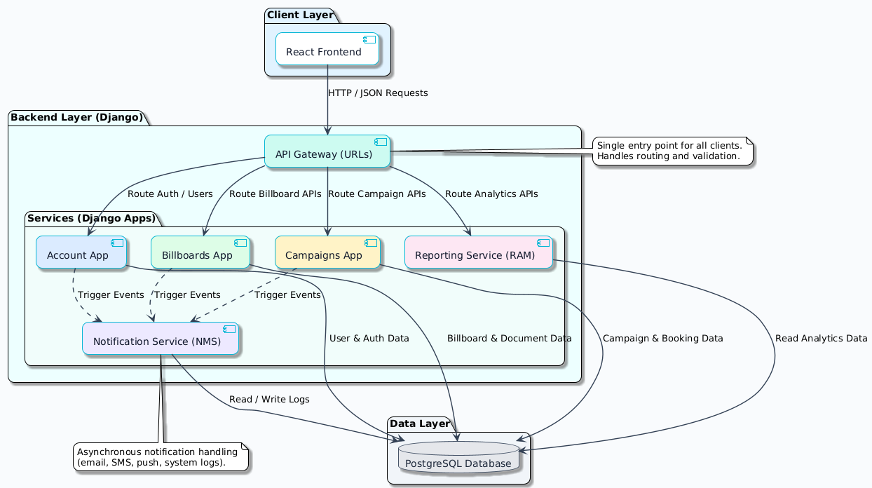
Figure 3: System Architecture Diagram

Use Case Diagrams
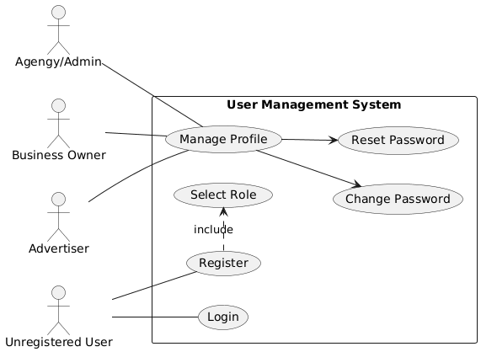
Figure 4: Use Case for UMS
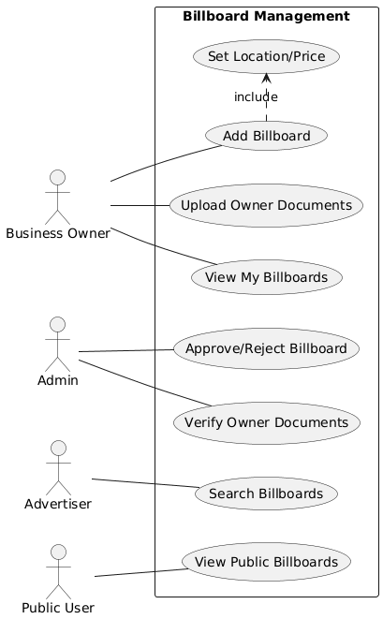
Figure 5: Use case for BMS
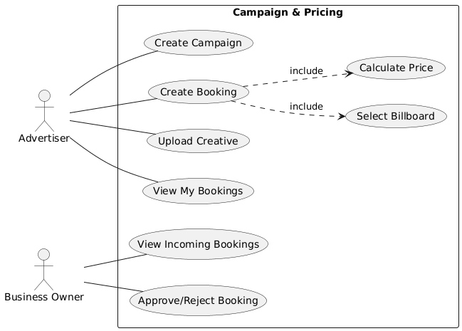
Figure 6: Use case for CPM
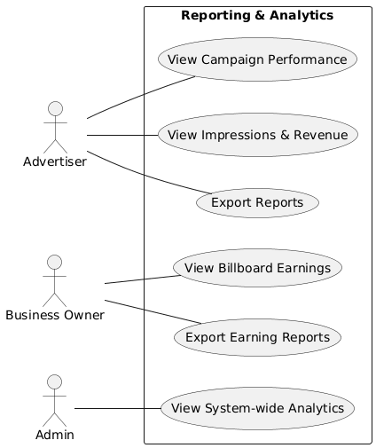
Figure 7: Use case for RAM
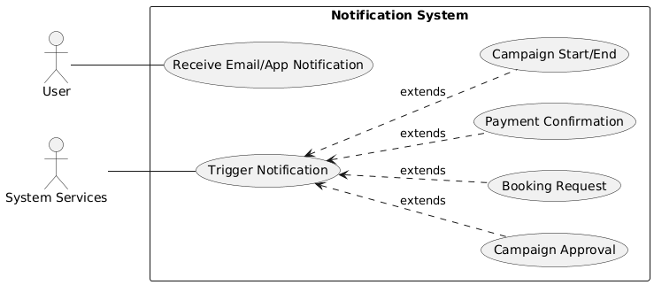
Figure 8: Use case for NMS

Activity Diagrams
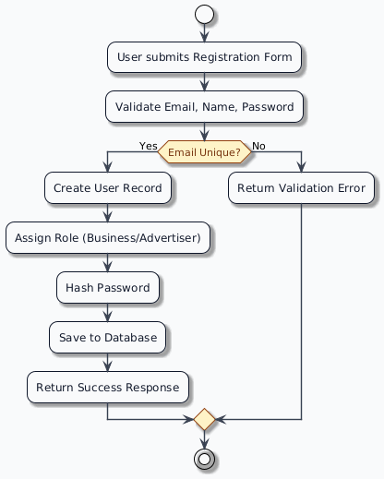
Figure 9: Activity Diagram for User Registration
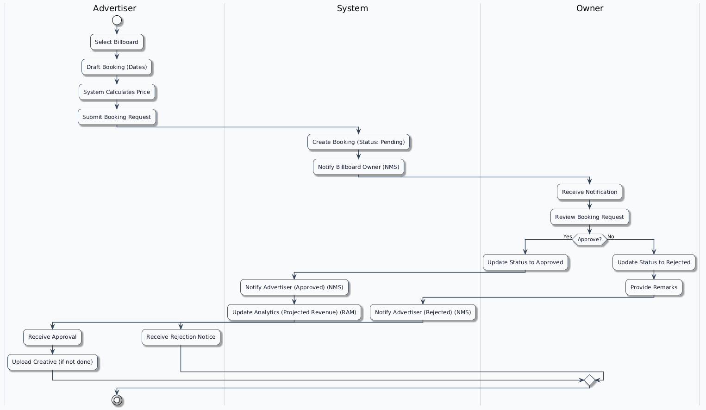
Figure 10: Activity Diagram for Booking flow

Sequence Diagrams
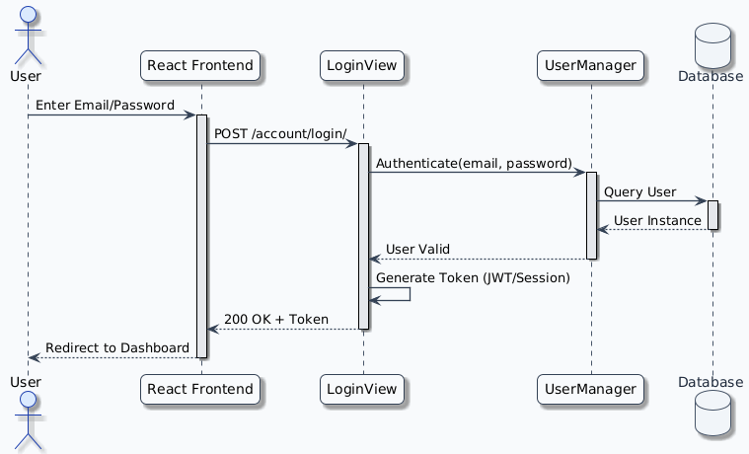
Figure 11: Sequence Diagram for Login Flow
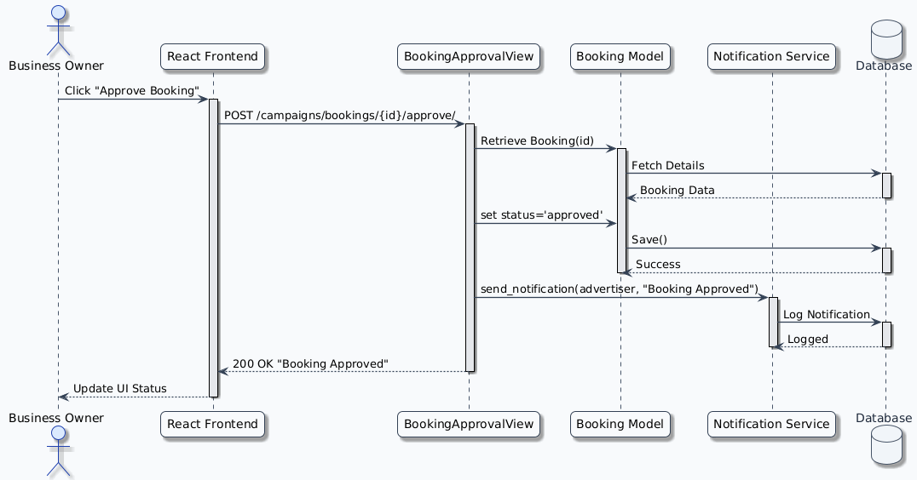
Figure 12: Sequence Diagram for Overall System

Class Diagram
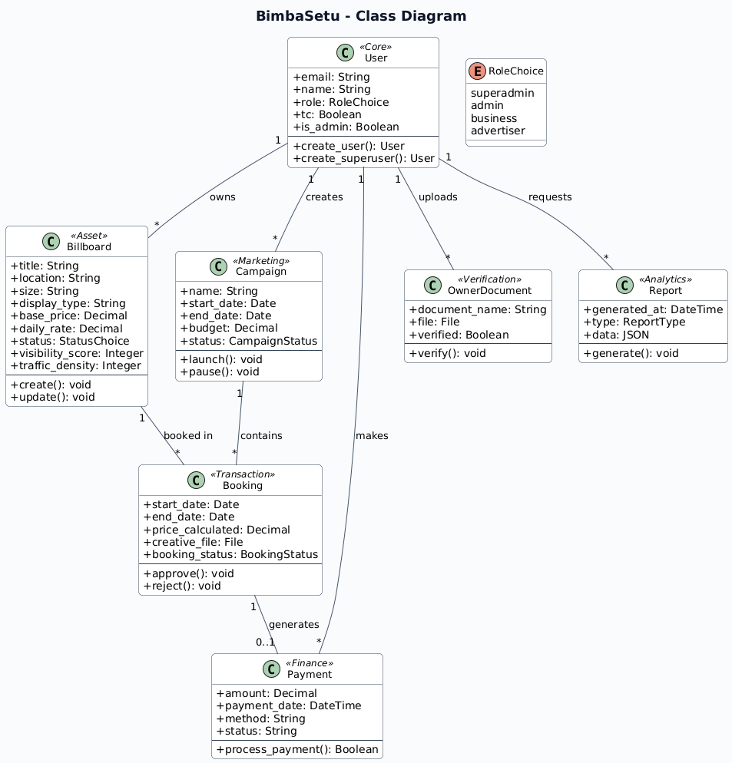
Figure 13: Class Diagram for the System

Object Diagram
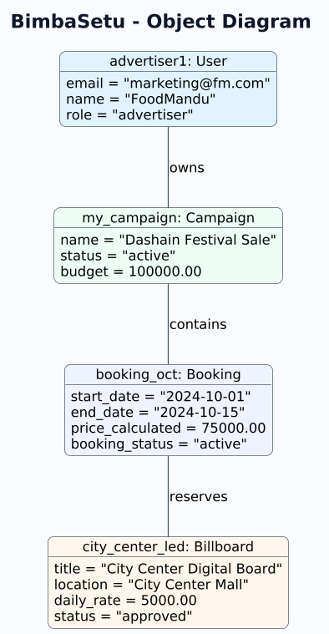
Figure 14: Object Diagram of the System

Entity Relationship Diagram (ERD)

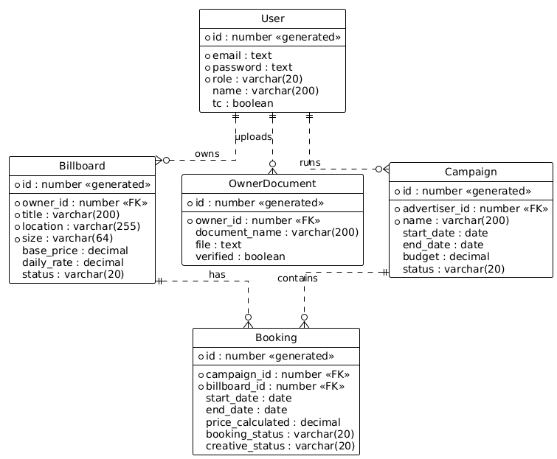
Figure 15: ERD of the System

Component Diagram
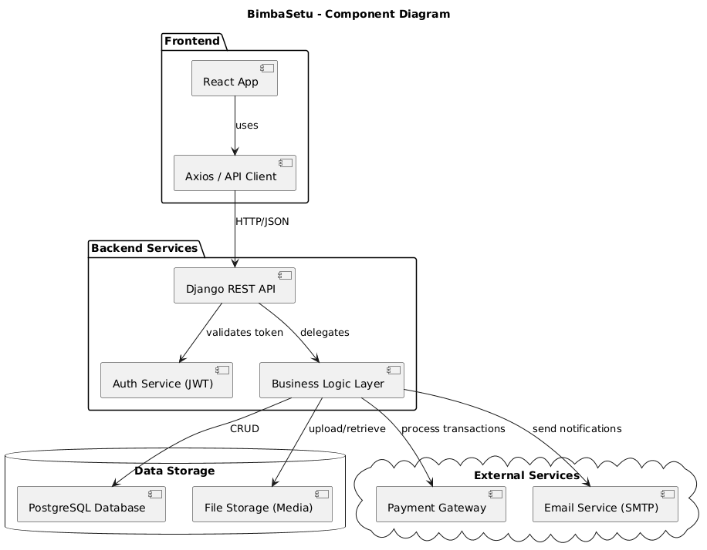
Figure 16: Component Diagram of the system

Data Flow Diagram (DFD – Level 1)
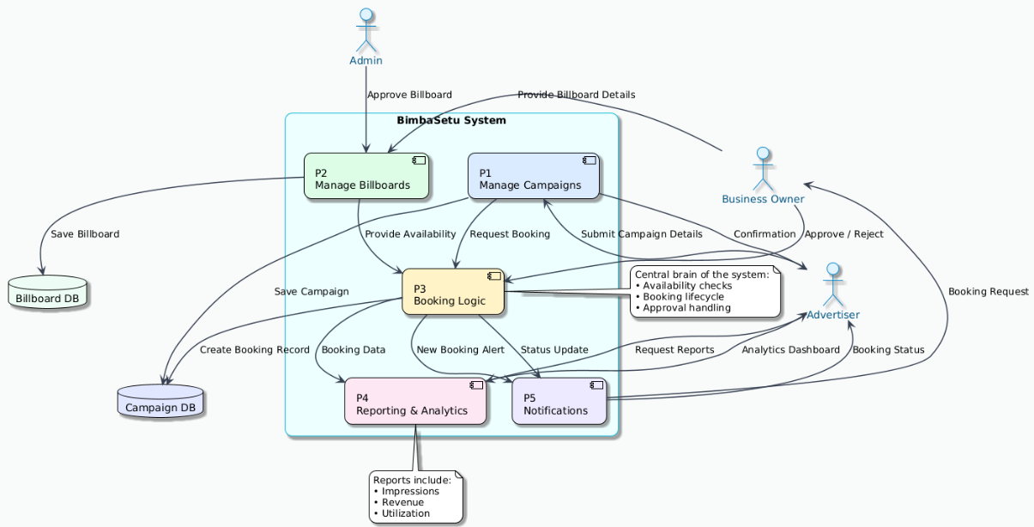
Figure 17: Data flow diagram of the system

Initial Designs
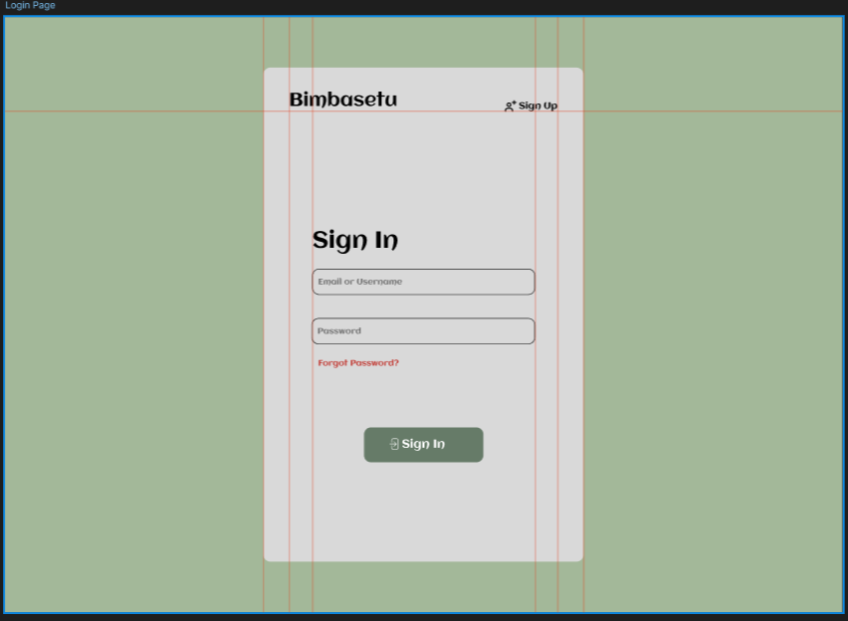
Figure 18: Initial design for Login Page
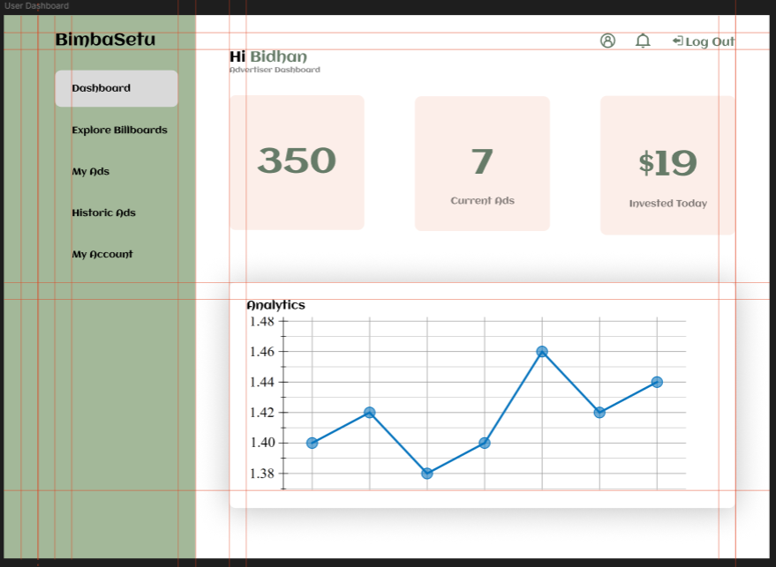
Figure 19: Initial design for Dashboard
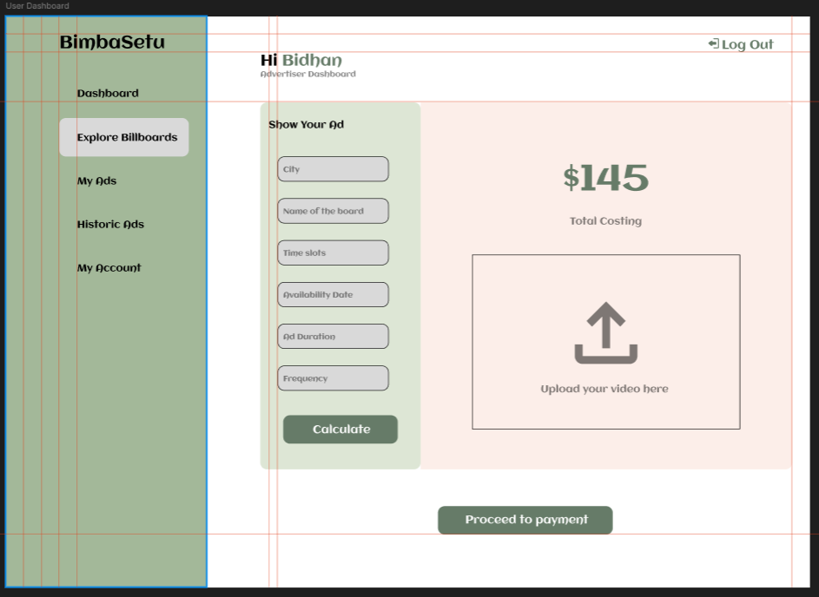
Figure 20: Initial Design for ads listing

Test Plan
The test plan outlines how the system will be tested to ensure that the system works correctly. Testing helps to check whether all requirements are met and the system behaves as expected.

Test Strategy
Testing will be done based on the requirements from the system. Each functional and non-functional requirements and usability requirements will be checked utilizing test cases. Both manual testing and basic automated testing can be used.

Test Cases

Functional Test Cases
Test Case ID | Requirement Code | Test Description | Expected Result
TC-F-01 | UM-F-1.0 | Register user with valid data | User account created
TC-F-02 | UM-F-2.0 | Login with valid credentials | User logged in
TC-F-03 | BMS-F-1.0 | Add new billboard | Billboard saved
TC-F-04 | CPM-F-1.0 | Create campaign | Campaign created

Non-Functional Test Cases
Test Case ID | Requirement Code | Test Description | Expected Result
TC-NF-01 | UM-NF-1.1 | Check password encryption | Password stored encrypted
TC-NF-02 | BMS-NF-1.1 | Upload image over size limit | Upload rejected
TC-NF-03 | RAM-NF-1.1 | Load report within time | Report loads in <5s

Usability Test Cases
Test Case ID | Requirement Code | Test Description | Expected Result
TC-UR-01 | UM-UR-1.1 | Hide/Unhide password on mobile | Option works correctly
TC-UR-02 | BMS-UR-1.1 | Drag and drop image upload | Image uploads easily
TC-UR-03 | RAM-UR-1.1 | Dashboard readability | Easy to understand

Conclusion
This document introduced the artefact design and testing plan for BimbaSetu system. The system was broken down into understandable subsystems and requirements were defined and ranked using the MoSCoW method. Different design artefacts like use case diagrams, activity diagrams, sequence diagrams, ERD and DFD were used to explain the system clearly. A test plan was also prepared to ensure that all the requirements can be tested properly.

