

Module | Assessment Type
Project and Professionalism | Draft Report

Project Title: BimbaSetu

Student Name: Bidhan Sapkota
Student ID: 2438398
Group: L6CG23
Supervisor: Nikunja Lamsal
Reader: Shiv Kumar Yadav

Abstract:
Outdoor advertising is the most prevalent type of advertising in Nepal, and one of the most widespread is the use of billboard advertising, the existing system is however disjointed and ineffective. The prices are not always steady, processes are not transparent and campaign performance cannot be easily monitored. BimbaSetu will address these issues by developing a centralized digital platform that will enable billboard owners and advertisers to meet at a common location. The system will have capabilities like booking and approval workflow system, flexible pricing model, campaign tracking, and role-based access. BimbaSetu aims at making the industry more transparent, efficient, and reliable by utilizing digital tools along with traditional outdoor advertising
Table of Contents
1 Introduction 1
1.1 Aim 1
1.2 Objectives 1
1.3 Academic Question 2
1.4 Problem Statement 2
1.5 Scope of the Project 2
1.6 Limitations of the Project 3
2 Literature Review 4
2.1 Research papers 4
2.1.1 Audience Measurement in Digital Signage (Ravnik & Solina, 2013) 4
2.1.2 Multi-Audience Tracking in Public Displays (Low et al., 2020) 5
2.1.3 Digital Signage Content Design and Engagement (Müller et al., 2015) 6
2.1.4 Consumer Behavior and Ad Effectiveness (Kim et al., 2012) 7
2.1.5 Ethical and Privacy Concerns in Smart Advertising (Wong et al., 2019) 8
2.1.6 Behavioral Analytics Using RGB-D Vision (Yang et al., 2020) 8
2.1.7 Emotion-Sensitive Advertising Systems (Garaus et al., 2021) 9
2.2 Similar System 10
2.2.1 Adomni 10
2.2.2 Broadsign 11
2.2.3 Vistar Media 11
2.2.4 VIOOH 11
2.3 Insights and Research Gap 12
3 Project Methodology 13
3.1 Project Methodology 13
3.2 Development Tools & Languages 13
4 Artefact Design 14
4.1 Identified Subsystems 14
4.2 Subsystem Diagram 14
4.3 Software Requirement Specification (SRS) 15
4.3.1 Requirement Types 15
4.4 User Management System (UMS) 15
4.4.1 Subsystem Features 15
4.4.2 Software Requirement Specification (SRS) 15
4.4.3 Use Case Diagram 16
4.4.4 Test Cases 17
4.5 Billboard Management System (BMS) 18
4.5.1 Subsystem Features 18
4.5.2 Software Requirement Specification (SRS) 18
4.5.3 Use Case Diagram 19
4.5.4 Test Cases 19
4.6 Campaign & Pricing Management System (CPM) 21
4.6.1 Subsystem Features 21
4.6.2 Software Requirement Specification (SRS) 21
4.6.3 Use Case Diagram 22
4.6.4 Test Cases 22
4.7 Reporting & Analytics System (RAM) 23
4.7.1 Subsystem Features 23
4.7.2 Software Requirement Specification (SRS) 24
4.7.3 Use Case Diagram 25
4.7.4 Test Cases 25
4.8 Notification Management System (NMS) 26
4.8.1 Subsystem Features 26
4.8.2 Software Requirement Specification (SRS) 26
4.8.3 Use Case Diagram 27
4.8.4 Test Cases 27
5 Functional Decomposition Diagram (FDD) 29
5.1 Purpose 29
5.2 FDD Diagram 29
6 MoSCoW Prioritization 29
6.1 MoSCoW Priority Table 29
7 Artefact Design 31
7.1 System Architecture 31
7.2 Activity Diagrams 32
7.3 Sequence Diagrams 33
7.4 Class Diagram 35
7.5 Object Diagram 36
7.6 Entity Relationship Diagram (ERD) 37
7.7 Component Diagram 38
7.8 Data Flow Diagram (DFD – Level 1) 38
8 Initial Designs 39
9 Conclusion 41
10 Evidence of Project Management 42
10.1 Project Meeting Logsheet 42
11 References 53

Table of Figures
Figure 1: Subsystem Diagram 14
Figure 2: Use Case for UMS 16
Figure 3: Use Case for BMS 19
Figure 4: Use Case for CPM 22
Figure 5: Use Case for RAM 25
Figure 6: Use Case for NMS 27
Figure 7: Functional Decomposition Diagram 29
Figure 8: System Architecture Diagram 31
Figure 9: Activity Diagram for User Registration 32
Figure 10: Activity Diagram for Booking flow 33
Figure 11: Sequence Diagram for Login Flow 33
Figure 12: Sequence Diagram for Overall System 34
Figure 13: Class Diagram for the System 35
Figure 14: Object Diagram of the System 36
Figure 15: ERD of the System 37
Figure 16: Component Diagram of the system 38
Figure 17: Data flow diagram of the system 39
Figure 18: Initial design for Login Page 39
Figure 19: Initial design for Dashboard 40
Figure 20: Initial Design for ads listing 41

Introduction
The Billboard advertisement has a long history of being one of the most accessible and apparent types of outdoor advertisements, and has served as an essential independent channel of input to the businesses, especially to reach a vast and varied mass of audience. This is the situation in Nepal where the advertising masses are pitched with traditional stand-still billboards specifically in the busy roads caused by urban centers, highways, and other places of trade. Nevertheless, the advertising industry painting the world over, is experiencing a paradigm shift into the digital billboards and centralized Ad management server (enabling specific ad scheduling, ability to precisely target the audience and real-time performance tracking).
BimbaSetu is a Centralized Billboard Ad Management Project that will enable a digital revolution in the outdoor advertisement industry in Nepal. It will serve as an online platform which will help unite the billboard owners and the advertisers on a single centralized system. The platform will offer services like submission of digital ads, approvals and flexible pricing due to various factors, role-based access control, and switching of reports in real time. The system will minimize inefficiencies, encourage transparency, and ensure billboard assets are fully utilized because it streamlines the advertising lifecycle.

Aim
The core objective of the project is to develop and lay out a centralized and automated system of managing billboard advertisement that would guarantee equitable pricing, operation, and determining results to both advertisers and billboard owner.

Objectives
The objectives of the project are:
- To develop a centralized platform where advertisers will be able to find available billboards, establish a campaign and receive performance reporting and analytics.
- In order to meet the goal of dynamic pricing model based on location, time, frequency and demand, secure fair and flexible location of the advertisement.
- In order to allow the billboard owners control of their inventory, and have the scaleable system, easy to use, and consistent with current trends in digital advertising.

Academic Question
The answers to the following research questions will also be tackled by the project:
- What is the possible use of technology to make the outdoor advertising in the Nepalese market transparent and effective?
- How can automation and data-based pricing help the billboard to maximise their usage?
- What role can a central database play in enhancing competence and trusting between billboard owners and advertisers?

Problem Statement
The current billboard advertising ecosystem in Nepal suffers from lack of centralization, transparency, and efficiency. The advertisers usually experience difficulties in the following:
- Problem in locating accessible billboards in sites.
- Absence of standardized pricing and performance metrics.
- Delays caused in the manual negotiation and approval.
- Lack of ad plays tracking and effectiveness of the ads.
Meanwhile, billboard owners have a hard time monetizing their property and usually only have access to traditional, one-to-one contracts without understanding about demand trends. It reduces the scope of scaling, generates inefficiencies, and prevents the further possible expansion of outdoor advertising industry in Nepal due to the lack of a centralized digital solution.

Scope of the Project
The scope of BimbaSetu focuses on the design and development of a centralized billboard advertisement management platform that suits the Nepalese market. The goal of the system is to digitally link advertisers and owners of billboards using a centralized web-based application. It comprises of basic functionalities like user registration & role-based access control, billboard listing & availability management, campaign creation & approval workflow, dynamic pricing based on predefined factors (location, duration & frequency), reporting and analytics dashboard, and notification management.
The project involves the full lifecycle of software engineering i.e. requirements analysis, system design, database modeling, interface prototyping, testing strategy. It supports three primary user roles: administrator; billboard owner and advertiser. The system focuses attention on transparency, structured campaign management and operational efficiency.
From a technical point of view, the scope is implementation using React.js as frontend development, Django (with Rest framework) as backend services and using the relational database, PostgreSQL. The system is designed as a Scalable web application in such a way that it will support multiple users and billboard records.
However, the project is limited to a centralized digital management platform and does not spread to the physical installation or hardware level integration of digital billboards. The focus is still on management, booking, pricing logic and reporting as opposed to real-time audience measurement via sensors.

Limitations of the Project
Although BimbaSetu brings a system of structured and transparent management of billboards advertisements, there are some limitations of the present version of the project.
First, advanced AI based analytics and audience measurement technologies like real-time computer vision, RGB-D computer tracking or emotion sensitive advertisement technologies are not implemented in this version. While such features may be greatly beneficial to improve targeting of advertisements and analyzing engagement, they demand specialized hardware, high computational resources, approval by regulations and extra development time. Therefore, these features go under the "Won't Have" category in the prioritization of MoSCoW.
Second, the system is not integrated with external digital advertising networks and global programmatic advertising platforms. Although incorporation with international Demand-Side Platforms (DSPs), could create a broader reach of the market and automation, this would add on to the complexities regarding API integration, standards of compliance and financial transactions, which fall outside the scope of the current project.
Third, the dynamic pricing model is rule-based and therefore is not the result of full demand driving, or algorithmic optimization. While the pricing takes into account some consideration as location, size, and duration, it does not yet provide the real-time demand forecasting nor the machine learning models. Such enhancements could be used to optimize revenues and it needs historical data in large amounts and advanced analytics capabilities.
Additionally, the system assumes access to dependable internet and digital readiness for the billboard owners and advertisers. In some parts of Nepal, where there is an infrastructure issue, there could be a problem of adoption. The project also does not take into account the mobile applications deployment, but is only for a web-based platform.

Literature Review

Research papers

Audience Measurement in Digital Signage (Ravnik & Solina, 2013)
Audience measurement plays an important role while determining the effectiveness digital billboard. Ravnik and Solina (2013) performed research aimed to assess the feasibility of measuring demographics of the audience and attention of viewers using computer vision techniques in real-world environments. For this work, their system was able to determine attributes like age, gender, and time spent dwelling on a display, to give quantitative insights into the way that people interact with digital displays. The research underlined that dynamic content, which is designed to adapt depending on audience characteristics, engages the audience to such an extent to an increase of upto 43% than through static advertisements.
The methodology employed in this is to use cameras and image processing application for the detection of presence and classification of the viewer in front of the digital billboards. This way, the researchers were able to collect reliable data on the size and composition of the audience without having to obtain direct feedback from the people watching the content. The system also kept track of how long the viewers watched the content, which is a useful metric in understanding the effectiveness of the ads, and planning future campaigns.
While the study was able to establish the technical feasibility of audience measurement, the research had limitations. The research was limited to gathering audience data and did not consider the integration of economic factors like pricing, ad scheduling and campaign management. Besides, the verification of ownership and integration at a platform level were not addressed, features that are important for a complete digital billboard management system.
The work by Ravnik and Solina provides a foundation to understand the role of audience metrics in improving the engagement of ads. It demonstrates that measures of viewer interactions are valuable information for the advertiser, but the study also highlights a gap in bridging the divide between these measurements and actual campaign operations. This insight is especially relevant for emerging markets, where the combination of audience measurement and centralized ad management would create great trust and transparency, efficiency, and higher ROI.

Multi-Audience Tracking in Public Displays (Low et al., 2020)
Low et al. (2020) explored multi-audience track for digital signage using RGB-D cameras, which collect both color and depth data. This technology enables digital displays to track several different viewers in 3D space to provide information, not only on the number of viewers, but also their spatial movement, positioning, and engagement. The research strongly emphasized the importance of understanding audience behavior in public spaces, so as to optimize the placement of content and increase the effectiveness of advertisements.
The research entailed the placement of RGB-D cameras around public displays to record information on viewer presence and attention time, and interaction with the digital billboards. Unlike traditional systems that use a single camera and may not distinguish multiple viewers at a time, the system could also distinguish between multiple viewers at the same time, with more accurate and detailed analytics than single-camera systems. These insights can enable advertisers to personalize content in a dynamic way, depending on the density of people, their movement patterns, and viewing positions, which may lead to more engagement and relevance.
However, the study had a focus more on the technical feasibility and behavioral tracking. Economic integration such as integrating audience data with campaign pricing or with ad inventory management was not addressed. Additionally, the research failed to take ownership verification, centralized management of campaigns or the practical implementation of such systems in emerging markets into account. These gaps underscore the need for a platform that does not simply track the behavior of an audience but also links this with operational, financial and regulatory functions.
Low et al.'s effort shows the power of sophisticated sensing technologies to improve audience analytics for digital billboards. By monitoring various viewers and knowing how they interact with their space, advertisers can better understand engagement patterns. For applications such as BimbaSetu in Nepal, combining such tracking capabilities, with centralized management, can make digital billboard advertising capabilities more transparent, efficient, and effective, for measurable benefits to both advertisers and billboard owners.

Digital Signage Content Design and Engagement (Müller et al., 2015)
Muller et al. (2015) investigated the impact of digital signage content design on audiences' engagement in retail settings. Their research was concerned with the visual and interactive elements of the digital advertisement in order to understand which kinds of contents generate attention and interest among the viewers. The research laid stress on the format and style of the content making a big difference to audience perception and recall and hence, being perfectly effective in terms of advertising.
The study considered testing different types of content such as moving images, animations, and static graphic visuals and across age-groups. Findings presented that younger audiences were more responsive to short videos or animated information while static content was still relevant in some cases, such as by older audiences or simple informational messages. The study also highlighted the importance of content clarity, color contrast and readability as it showed that poorly designed advertisements can decrease engagement despite its optimal placement.
However, the research was mainly confined to controlled indoor retail applications and had not been expanded onto large-scale outdoor applications. The study did not discuss how content effectiveness could be incorporated in operational systems for campaign management, inventory and pricing decisions. Moreover, it did not take into account use of engagement metrics tied to real-time analytics to optimize content on the fly based on audience behavior.
Muller et al.'s results offer useful information on designing content to help increase viewer engagement. For practical uses such as BimbaSetu in Nepal, it might be to collect more ultimate knowledge in advertising effectiveness by combining these design principles and audience measuring systems. By combining content optimization's opportunity with centralized features and functionality of platforms, advertisers are able to ensure that their advertising campaigns are not only beautiful, but strategic in their timings and targeted optimization, bridging the gap between creative design and measurable advertising outcomes.

Consumer Behavior and Ad Effectiveness (Kim et al., 2012)
Kim, Park and Choi (2012) studied the influences of consumer behavior on the effect of digital signage advertisement. Their research was aimed at how often a person is exposed to an advertisement, and how repeated contact affects what the viewer remembers, prefers, and does in response. They argued that an understanding of the behavior of audiences is an essential to designing campaigns that make the maximum impact and deliver measurable returns on advertising investment.
The study was based on survey data collected from participants, who were exposed to different campaigns of digital signage in different retail environments. Findings showed that repeated exposure to the same advertisement increased both recall and preference, which suggested that the frequency and timing of campaigns by advertisers should be considered, in order to optimize results. The research also indicated that situational factors like the context of where the digital signage is placed holds powerful influence over the success of the messages received. High traffic areas or those with longer dwell time were related to better recall.
Despite these useful findings, there were some limitations to the study. The research was largely based on self-reported survey data, which may not always serve as proper or objective metrics of actual engagement. Additionally, the study did not connect consumer behavior to operational campaign metrics, such as cost, ad inventory management or dynamic adjustment of advertising schedule based on audience behavior. Therefore, the study provides insight, but does not contain an integrated strategy for digital billboard platforms on content exposure.
For practical purposes such as BimbaSetu, the results can help guide the way in which advertising is scheduled and exposed to consumers in order to match patterns of consumer's engagement. But by integrating behavioral insights with platform analytics, digital signage campaigns are able to be creative as well as data-driven. This integration will ensure that advertisers will be able to see higher impact, while platform owners will be able to maximize the usage of billboards, ultimately bridging the gap between consumer behavior research and operational system design.

Ethical and Privacy Concerns in Smart Advertising (Wong et al., 2019)
Wong, Leow, Ong and Lau (2019) addressed how camera embedded digital signage is viewed by the public and the ethical and privacy issues raised in response to using such technology. Their study emphasized that while smart advertising systems can offer individualized and engaging experiences that their users better interact with, there are also important questions of consent, data collection and user trust.
The research included surveying participants to learn their attitudes regarding the use of cameras for tracking and targeting advertisements. The results showed that many people accepted camera-based systems if they felt that the ads were relevant, helpful or entertaining. However, there were issues raised with privacy, as participants were often unsure of how their data might be collected, stored and used. The study highlighted the importance of transparent and clear communication from companies running digital signage networks.
Additionally, Wong et al. (2019) pointed out that the ethical deployment of audience-aware systems should involve measures, such as anonymizing data, opt-in or opt-out choices, and compliance with local regulations. Without these safeguards, the practice of smart advertising could cause public distrust and even regulation backlash. The study also highlighted those ethical issues are not only about privacy, but include fairness and manipulative advertising practices.
While this study makes important contributions to public attitudes and ethics requirements, it lacks to integrate with the practical design of a system or with operational decision-making. For platforms such as BimbaSetu, these findings are of great relevance as they help direct how audience tracking and ad personalization should be applied in a manner which respects user rights. Keeping things ethical and ensuring privacy will not only help to ensure public acceptance but will also give the platform credibility and reliability.

Behavioral Analytics Using RGB-D Vision (Yang et al., 2020)
Yang, Lu, Yu, and Zhou (2020) studied how RGB-D vision technology can be used to analyze shopper’s behavior and interactions in indoor retail environments. RGB-D camera contains color images and depth information, which makes it possible to identify people, their movements and spatial interactions. This is used to enable a detailed analysis of how an audience interacts with displays or products.
The study emphasized that RGB-D vision could be used to accurately quantify such metrics as the number of visitors, movement paths, and length of time they spend looking at specific points of interest. Such insights are beneficial to advertisers and store managers to understand audience involvement, avoid poor layouts, and design better marketing strategies. By combining the depth and visual information, RGB-D systems reduce errors caused by occlusion or overlapping people which occur very commonly in crowded spaces.
Yang et al. (2020) too, highlighted the opportunities provided for the data driven decision making in the advertising and marketing industries, through behavioral analytics using RGB-D technology. For example, digital signage can be deployed in areas of high traffic that are identified by movement analysis, or content can be adjusted based on dwell time in order to engage more. However, the research was restricted to indoor commercial environments and did not cover outdoor applications on a large scale such as city billboards or public transport displays. This means that although the technology shows promise, the challenge ahead is adapting it to outdoor or semi-public spaces that present additional research challenges in areas of visibility, lighting and privacy.
For systems such as BimbaSetu, these results show that RGB-D vision can be a useful tool in understanding the behavior of the audience if properly done. Integrating this technology into digital billboards could be used for a better collection of data and analyzing performance, which in turn helps both advertisers and owners optimize campaigns. Ethical guidelines and privacy protections could have to be stringently adhered to, particularly to be used in public open spaces.

Emotion-Sensitive Advertising Systems (Garaus et al., 2021)
In a recent article, Garaus, Wagner, and Rainer (2021) investigated the impact of emotion-sensitive advertising systems based on facial recognition for better engagement from the audience at the point of sale. These systems use facial expressions to understand viewers' feelings like joy, astonishment, or confusion so that they can change the content of the information displayed on the screen as necessary. The main Idea is that personalized, emotionally driven content can help boost attention, recall and purchase intention.
The study revealed that subjects exposed to emotion-driven content were more engaged than those exposed to static content or generic content. The tech provides the possibility to detect the emotional reactions in real time, so advertisers can adapt the messaging, visuals, or promotions to how the audience is reacting. This makes the experience more interactive and immersive, which can help to increase the effectiveness of campaigns. The study also pointed out that such systems can be valuable to retailers and advertisers to optimize their investment by displaying ads that have higher chances of evoking positive reactions.
However, Garaus et al. (2021) also listed important challenges. Privacy is of particular concern, especially if the application is in a public or semi-public location, where the presence of emotion tracking would not be known to viewers. Some of the ethical considerations are consent, storage of data, misuse of sensitive information, etc. In addition, most experiments were done in a controlled retail environment, making it difficult to draw conclusions for large-scale outdoor display applications, such as digital signage in high traffic streets or transportation hubs.
For an app like BimbaSetu, the infuse of emotion-sensitive systems could better understand the audience and increase the effectiveness of the campaign. However, it would be critical to enforce stringent privacy policies and data handling standards. However, as it sounds encouraging, such an approach has to strike a balance between technological opportunities and ethical priming to ensure the public trust as well as compliance with standards and regulations.

Similar System

Adomni
Adomni is a global Digital Out-of-Home (DOOH) Advertising Platform which provides advertisers access to large networks of digital screens, campaign buying unification, self-service campaign setup, and audience targeting (Adomni, 2023). For example, their "Jeen AI" tool allows small as well as mid-market advertisers to launch DOOH campaigns quickly, with only a credit card, in minutes, taking away many entry barriers for non-enterprise users. However, the overall structure of Adomni's system remains based on the concept of existing media owner networks, with a lesser focus on local ownership verification, local ownership transparency in pricing terms. It is based on contextual factors and in certain cases assumes a mature media infrastructure with a large number of digital screens.
BimbaSetu can achieve even better performance through incorporating here fine-grained local data, registration/verification of the owner and price of product based on local market situation with Nepal.

Broadsign
Broadsign is a DOOH platform which includes powerful campaign scheduling, creative management, content targeting by time/daypart, and centralized tools for owners and advertisers to manage creatives and ad inventory (Broadsign, 2022). Their most recent updates offer greater specs for targeting and better UI/user experience in planning campaigns. Yet, Broadsign still shows limitations in relation to digital inventory in emerging markets: the cost, complexity, and dependence on static vs digital hybrid environments can make flexible pricing harder.
As many static inventory workflows remain semi-manual, and features like dynamic pricing based on local demand, visibility, or frequency are less emphasized. BimbaSetu can address this by making these pricing factors explicit and automating many of the workflows that remain manual in Broadsign.

Vistar Media
Vistar Media offers tools for ad inventory management, venue restrictions, creative resizing (letterboxing) and supports auction style for DOOH inventory access (Vistar Media, 2023). They enable the media owners to impose limitations on when ads can appear, what content is accepted and use the digital screens of different type sizes to target the advertisers. However, Vistar's system, often developer systems, often are focused on working within existing digital networks, and Vistar's solutions may lack (qualitative) customer targeting as well as marginal pricing mechanisms that are both highly transparent and more locally based on visibility or local demand which is accessible to small advertisers and ownership in the less connected world.
This makes it more difficult for markets such as Nepal where the infrastructure, regulate environment and screen density vary to quite a large extent. BimbaSetu is able to fill that in by building in location-based visibility scoring and having a transparent model of pricing even if smaller and less central screens.

VIOOH
VIOOH is a Worldwide Digital out of home marketplace aimed at connecting media owners and advertisers by means of programmatic trading. It provides the features of automation, demand-side platform (DSP) integration, and a great inventory booking experience for multiple locations (VIOOH, 2022). Its greatest strength is to offer flexibility for advertisers to book campaigns across borders of standardized processes. However, VIOOH is still strongly aligned with programmatic purchasing models that are suitable for advanced digital economies.
This reduces the adaptability for the local billboard owners in emerging markets who do not necessarily possess the digital capacity or do not want to be controlled by digital means necessarily. BimbaSetu is an upgrade from this as this system provide hybrid workflows, where owners can approve their campaigns manually and yet get the transparency and automation.

Insights and Research Gap
From the reviewed studies and systems, it can be stated that digital signage has evolved from conventional static displays to smart and data-driven display options. Research by Ravnik and Solina (2013), Low et al. (2020) demonstrates the use of computer vision and RGB-D cameras for estimating audience attention, age, and interest for them, and enables dynamic responsiveness of advertisements to the viewers. Similarly, Müller et al. (2015) and Kim et al. (2012) emphasize that content design and display frequency are very important for audience interest and recollection.
However, most of these studies are directed to the indoor retail environments in which light and spatial conditions are controllable. This lack of control means that the same kinds of approaches are tricky to use out-of-doors on billboards which suffer from fluctuating weather and lack of regulation. Other platforms like Adomni, Broadsign and Vistar Media have advanced features but cater to well-developed markets. Corporate systems and technologies do not allow for the easy customization and pricing for smaller firms in a developing country like Nepal.
From these comparisons, three major gaps are identified. First, little research has been done on outdoor audience measurement using smart technology. Second, there is a disconnect in between data analytics and billboard management systems with regards to a single platform. Third, ethical and privacy issues are poorly considered, at least in public spaces. These gaps represent an obvious need for localized business-analytics, management and ethical design solutions like BimbaSetu.

Project Methodology
This section describes the approach used for the design, development, and evaluation of BimbaSetu. It describes the methodology of the project and the tools which have been used in order to ensure efficiency of the system.

Project Methodology
The project development approaches are Agile (Scrum) based. There can be iteration and continuous improvement using the presented feedback.
- Sprints: Development broken up in units of small time-boxes (2-3 weeks).
- Scrum Roles: Developer being myself, Supervisor (acting as Product Owner), and Reader (reviewer).
- Deliverables per Sprint: Incremental features like user management, campaign booking and reporting capabilities.
- Advantages: Flexibility, cooperation and adaptation to changing requirements and periodic evaluation to ensure that project goals are being achieved.
This approach is able to guarantee that BimbaSetu develops in an incremental and consistent way with both academic and practical objectives.

Development Tools & Languages
BimbaSetu will be developed using a well-established and strong capability stack to deliver performance, scalability and maintainability:
- Frontend: React.js used for building a dynamic, responsive and interactive user experience. Built on a component-based architecture, it supports the modular development and easy reusability of UI components.
- Backend: Django (Python) The backend will be primarily based on Django, a reliable, secure and robust Python web tool that offers out-of-the-box behaviors, including authentication, admin support. Django's REST framework (DRF) will be used to build scalable APIs to interact with frontend app.
- Database: PostgreSQL will be the main database implementation, which was selected because of its robust feature, ACID and its suitability for complex queries, relational data, scalability manipulation.
- Version Control: The version control, repository and tracking system will be GitHub, which will provide continuous integration and progressive development.

Artefact Design

Identified Subsystems
BimbaSetu has several parts (subsystems) which work in a coordinated manner. Each part has a clear role. The main subsystems are:
- User Management System (UM): Deals with the registration, login, roles (admin, advertiser, owner), and permissions of the users.
- Billboard Management System (BMS): Allows owners to add, edit and manage billboards. Shows for availability to advertisers.
- Campaign & Pricing Management (CPM): Manages campaign system, dynamic pricing, and approval system.
- Reporting & Analytics (RAM) Displays performance of ads, impressions and campaign revenue.
- Notification Management System (NMS): Sends alert for approval, payment and campaign update.

Subsystem Diagram
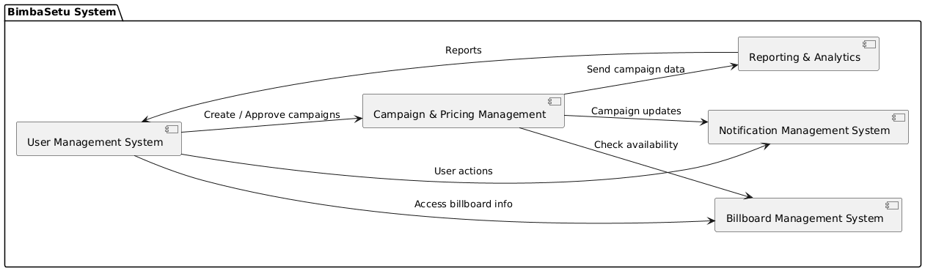
Figure 1: Subsystem Diagram

Software Requirement Specification (SRS)
The SRS basically defines what BimbaSetu should do (functional), how it should perform (non-functional) and how easy it should be to use (usability). Each requirement has their own unique code for traceability

Requirement Types
Type | Description
F | Functional Requirement – what the system should do
NF | Non-Functional Requirement – performance, security, limits
UR | Usability Requirement – ease of use, interface design

User Management System (UMS)

Subsystem Features
- Register users
- Login and logout
- Role management
- Ban/unban users

Software Requirement Specification (SRS)
Req Code | Type | Description
UM-F-1.0 | F | Users can register with email/social accounts
UM-F-2.0 | F | Users can login/logout
UM-F-3.0 | F | Admin can assign roles (admin/owner/advertiser)
UM-F-4.0 | F | Admin can ban/unban users
UM-NF-1.1 | NF | Passwords must be encrypted
UM-NF-1.2 | NF | Passwords must include letters, numbers, special chars
UM-UR-1.1 | UR | users can show/hide password field

Use Case Diagram
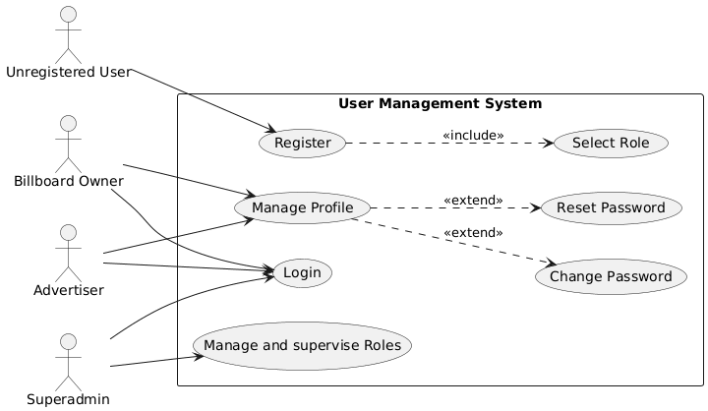
Figure 2: Use Case for UMS

Test Cases

Functional Test Cases
Test Case ID | Requirement Code | Test Description | Expected Result
TC-UM-F-01 | UM-F-1.0 | Register user with valid email and password | User account successfully created
TC-UM-F-02 | UM-F-1.0 | Register user with already existing email | Registration rejected with error message
TC-UM-F-03 | UM-F-2.0 | Login with valid credentials | User successfully logged in
TC-UM-F-04 | UM-F-2.0 | Login with invalid password | Login rejected with error message
TC-UM-F-05 | UM-F-3.0 | Admin assigns role to user | Role updated successfully
TC-UM-F-06 | UM-F-4.0 | Admin bans a user | User account disabled
TC-UM-F-07 | UM-F-4.0 | Admin unbans a user | User account restored

Non-Functional Test Cases
Test Case ID | Requirement Code | Test Description | Expected Result
TC-UM-NF-01 | UM-NF-1.1 | Verify password encryption in database | Password stored in hashed format
TC-UM-NF-02 | UM-NF-1.2 | Register with weak password | Registration rejected
TC-UM-NF-03 | UM-NF-1.1 | Attempt SQL injection in login field | Attack prevented

Usability Test Cases
Test Case ID | Requirement Code | Test Description | Expected Result
TC-UM-UR-01 | UM-UR-1.1 | Show/hide password toggle | Password visibility toggles correctly
TC-UM-UR-02 | UM-UR-1.1 | Form validation messages clarity | Clear and understandable error messages

Billboard Management System (BMS)

Subsystem Features
- Add/Edit/Delete billboards
- Demonstrating availability to advertisers.

Software Requirement Specification (SRS)
Req Code | Type | Description
BMS-F-1.0 | F | Owners can add, edit, delete billboards
BMS-F-2.0 | F | Advertisers can view available billboards
BMS-NF-1.1 | NF | Image size max 10 MB, resolution min 1024x768
BMS-UR-1.1 | UR | Drag-and-drop image upload supported

Use Case Diagram
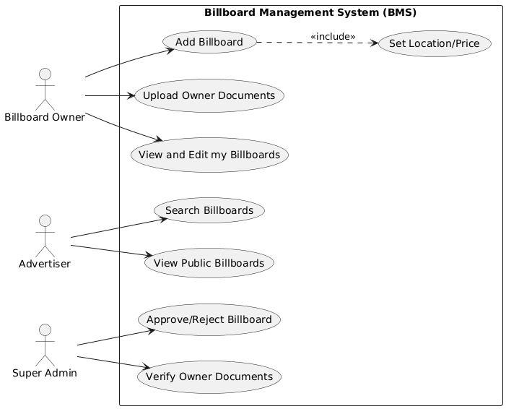
Figure 3: Use Case for BMS

Test Cases

Functional Test Cases
Test Case ID | Requirement Code | Test Description | Expected Result
TC-BMS-F-01 | BMS-F-1.0 | Owner adds new billboard with valid data | Billboard saved successfully
TC-BMS-F-02 | BMS-F-1.0 | Owner edits billboard details | Billboard updated
TC-BMS-F-03 | BMS-F-1.0 | Owner deletes billboard | Billboard removed
TC-BMS-F-04 | BMS-F-2.0 | Advertiser views available billboards | List displayed correctly
TC-BMS-F-05 | BMS-F-2.0 | Filter billboard by location | Filtered results shown

Non-Functional Test Cases
Test Case ID | Requirement Code | Test Description | Expected Result
TC-BMS-NF-01 | BMS-NF-1.1 | Upload image larger than 10MB | Upload rejected
TC-BMS-NF-02 | BMS-NF-1.1 | Upload image lower than required resolution | Upload rejected
TC-BMS-NF-03 | BMS-NF-1.1 | Load billboard listing with 100+ entries | Loads within acceptable time

Usability Test Cases
Test Case ID | Requirement Code | Test Description | Expected Result
TC-BMS-UR-01 | BMS-UR-1.1 | Drag and drop image upload | Image uploads smoothly
TC-BMS-UR-02 | BMS-UR-1.1 | Billboard listing layout clarity | Layout easy to understand

Campaign & Pricing Management System (CPM)

Subsystem Features
- Create campaigns
- Approve campaigns
- Dynamic pricing according to duration, location, and frequency.

Software Requirement Specification (SRS)
Req Code | Type | Description
CPM-F-1.0 | F | Advertisers can create campaigns
CPM-F-2.0 | F | Owners/admin can approve campaigns
CPM-F-3.0 | F | Pricing adjusts dynamically based on location, size, frequency
CPM-NF-1.1 | NF | The system shall validate campaign dates and prevent overlapping bookings for the same billboard.
CPM-UR-1.1 | UR | The system shall provide a simple campaign creation interface with clear pricing breakdown.

Use Case Diagram
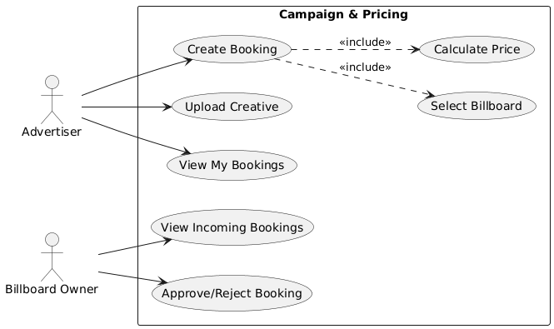
Figure 4: Use Case for CPM

Test Cases

Functional Test Cases
Test Case ID | Requirement Code | Test Description | Expected Result
TC-CPM-F-01 | CPM-F-1.0 | Advertiser creates campaign | Campaign created
TC-CPM-F-02 | CPM-F-2.0 | Owner approves campaign | Campaign status updated to Approved
TC-CPM-F-03 | CPM-F-2.0 | Owner rejects campaign | Campaign status updated to Rejected
TC-CPM-F-04 | CPM-F-3.0 | Calculate pricing based on location & duration | Correct dynamic price displayed
TC-CPM-F-05 | CPM-F-3.0 | Modify campaign duration | Price recalculated correctly

Non-Functional Test Cases
Test Case ID | Requirement Code | Test Description | Expected Result
TC-CPM-NF-01 | CPM-NF-1.1 | Enter invalid start/end date | Validation error shown
TC-CPM-NF-02 | CPM-NF-1.1 | Campaign overlap check | Overlapping booking prevented

Usability Test Cases
Test Case ID | Requirement Code | Test Description | Expected Result
TC-CPM-UR-01 | CPM-UR-1.1 | Create campaign using UI | Interface intuitive and simple
TC-CPM-UR-02 | CPM-UR-1.1 | Display price breakdown | Pricing details clearly visible

Reporting & Analytics System (RAM)

Subsystem Features
- Show impressions Revenue
- Export reports.

Software Requirement Specification (SRS)
Req Code | Type | Description
RAM-F-1.0 | F | Show campaign impressions and revenue
RAM-F-2.0 | F | Export reports in CSV/PDF format
RAM-NF-1.1 | NF | Reports should load within 5 seconds
RAM-UR-1.1 | UR | Dashboard should be easy to read

Use Case Diagram
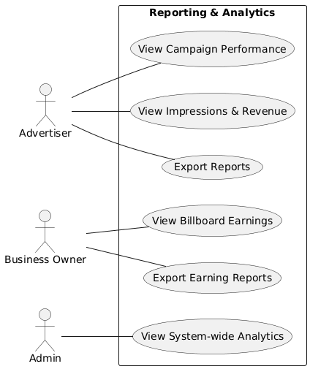
Figure 5: Use Case for RAM

Test Cases

Functional Test Cases
Test Case ID | Requirement Code | Test Description | Expected Result
TC-RAM-F-01 | RAM-F-1.0 | View campaign impressions | Correct data displayed
TC-RAM-F-02 | RAM-F-1.0 | View campaign revenue | Correct revenue calculated
TC-RAM-F-03 | RAM-F-2.0 | Export report as CSV/PDF | File downloaded successfully

Non-Functional Test Cases
Test Case ID | Requirement Code | Test Description | Expected Result
TC-RAM-NF-01 | RAM-NF-1.1 | Load report dashboard | Loads within 5 seconds
TC-RAM-NF-02 | RAM-NF-1.1 | Test with large dataset | System remains responsive

Usability Test Cases
Test Case ID | Requirement Code | Test Description | Expected Result
TC-RAM-UR-01 | RAM-UR-1.1 | Dashboard layout readability | Data easily interpretable
TC-RAM-UR-02 | RAM-UR-1.1 | Graph and metrics clarity | Clear visualization

Notification Management System (NMS)

Subsystem Features
- Notify users of approvals, payments and campaign start/end.

Software Requirement Specification (SRS)
Req Code | Type | Description
NMS-F-1.0 | F | Notify users on campaign approval/rejection
NMS-F-2.0 | F | Notify users on payments received
NMS-F-3.0 | F | Notify users on campaign start/end
NMS-NF-1.1 | NF | Notifications must be delivered within 1 min
NMS-UR-1.1 | UR | Notifications should be clear and concise

Use Case Diagram
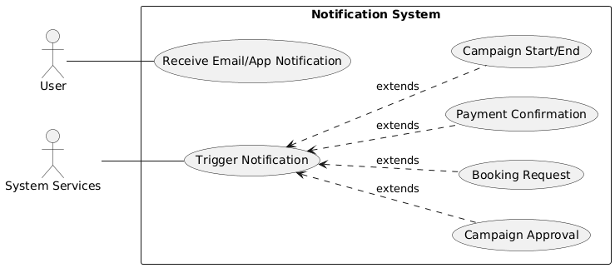
Figure 6: Use Case for NMS

Test Cases

Functional Test Cases
Test Case ID | Requirement Code | Test Description | Expected Result
TC-NMS-F-01 | NMS-F-1.0 | Campaign approval notification sent | Notification delivered
TC-NMS-F-02 | NMS-F-2.0 | Payment confirmation notification | User notified
TC-NMS-F-03 | NMS-F-3.0 | Campaign start notification | User notified at correct time
TC-NMS-F-04 | NMS-F-3.0 | Campaign end notification | User notified

Non-Functional Test Cases
Test Case ID | Requirement Code | Test Description | Expected Result
TC-NMS-NF-01 | NMS-NF-1.1 | Notification delivery time | Delivered within 1 minute
TC-NMS-NF-02 | NMS-NF-1.1 | Multiple notifications triggered | All delivered correctly

Usability Test Cases
Test Case ID | Requirement Code | Test Description | Expected Result
TC-NMS-UR-01 | NMS-UR-1.1 | Notification message clarity | Message concise and understandable
TC-NMS-UR-02 | NMS-UR-1.1 | Notification UI placement | Easily visible to user

Functional Decomposition Diagram (FDD)

Purpose
FDD illustrates the key features of BimbaSetu and the grouping of each subsystem. It helps to get a clear picture of the structure of the system. The FDD helps the developer and the tester to understand what the system should do by breaking the system into smaller features which are easier to implement and test.

FDD Diagram
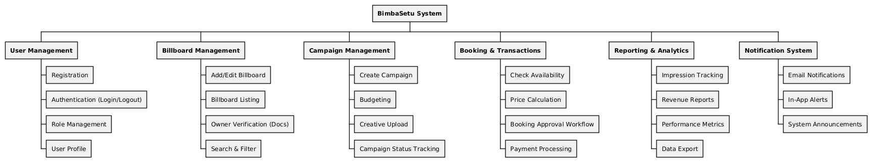
Figure 7: Functional Decomposition Diagram

MoSCoW Prioritization
MoSCoW prioritization is used to select the most important requirements to the system. It helps to focus on the core features first and not go for unnecessary features during the development.
The requirements fall under four groups:
- Must Have - very important, system cannot work without these
- Should Have - important, but system can work without having them
- Could Have - features that may be added but may not have time for
- Won't Have - not in this version of the system.

MoSCoW Priority Table
Priority | Requirement Codes | Description
Must Have | UM-F-1.0, UM-F-2.0, BMS-F-1.0, BMS-F-2.0, CPM-F-1.0, CPM-F-2.0 | Core system features like user login, billboard management, and campaign creation.
Should Have | CPM-F-3.0, RAM-F-1.0, NMS-F-1.0 | Important features such as pricing logic, reports, and notifications.
Could Have | RAM-F-2.0, NMS-F-2.0 | Extra functionality such as exporting reports and payment alerts.
Won’t Have | Won't Have Advanced AI analytics, external ad network integration | Not included in the current version.
.

Artefact Design

System Architecture
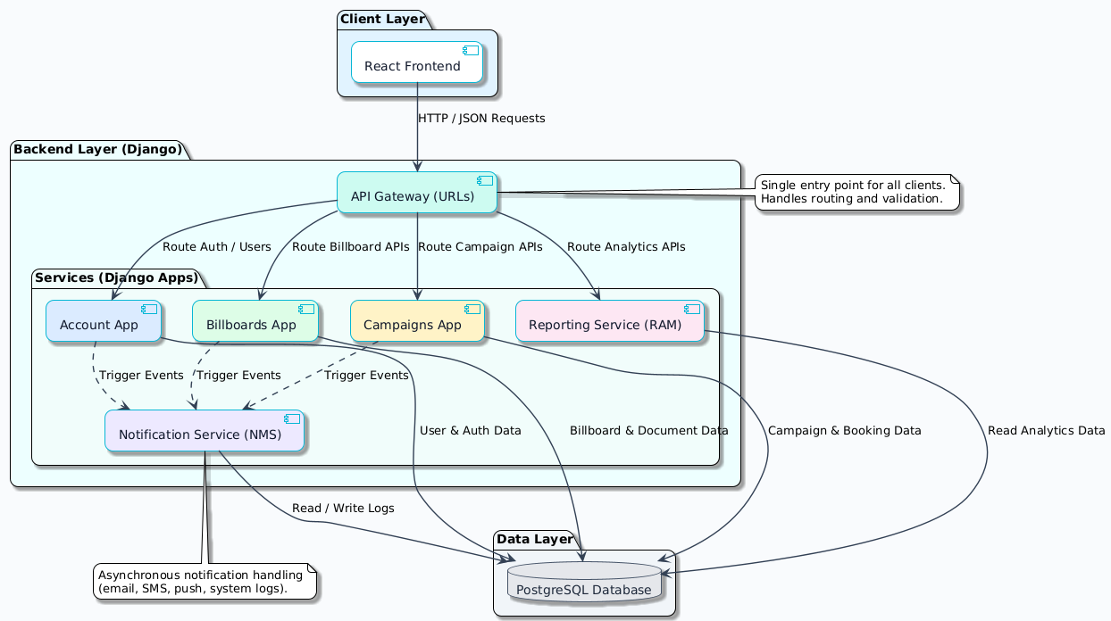
Figure 8: System Architecture Diagram

Activity Diagrams
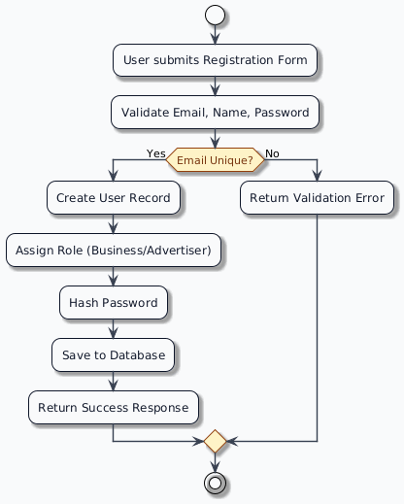
Figure 9: Activity Diagram for User Registration
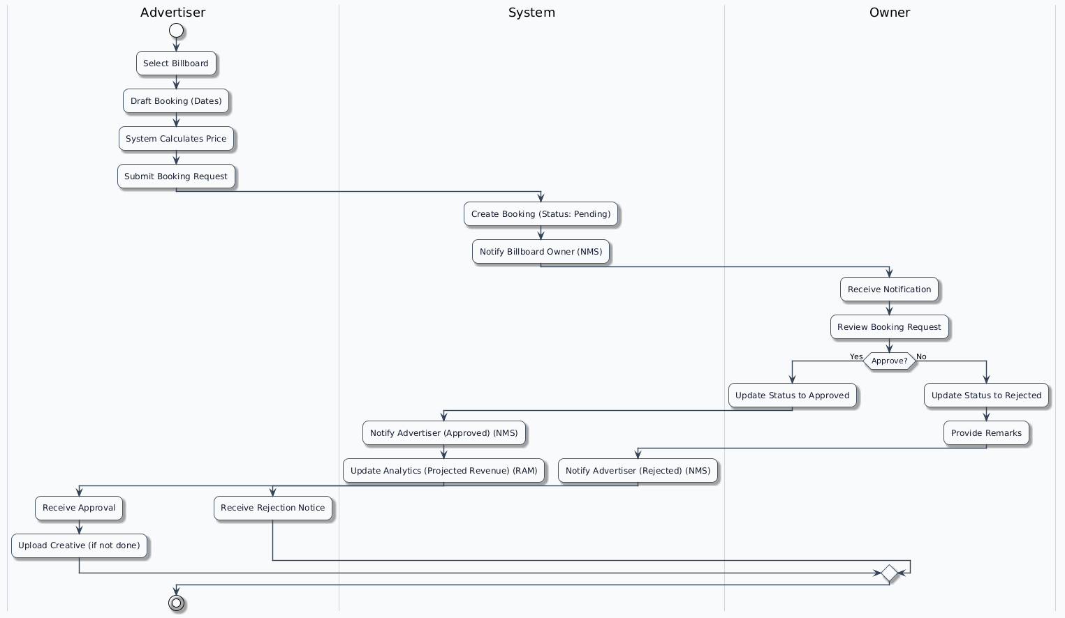
Figure 10: Activity Diagram for Booking flow

Sequence Diagrams
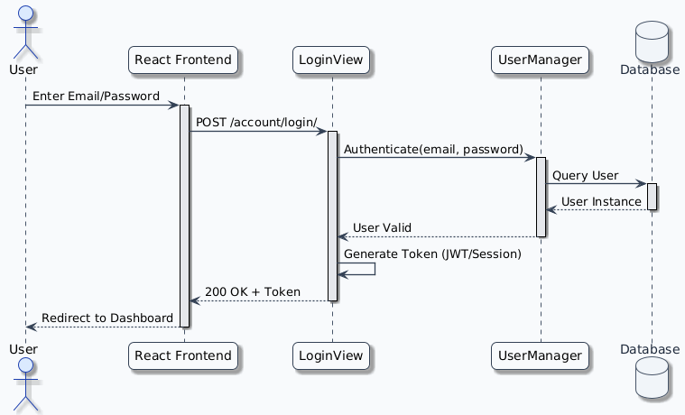
Figure 11: Sequence Diagram for Login Flow
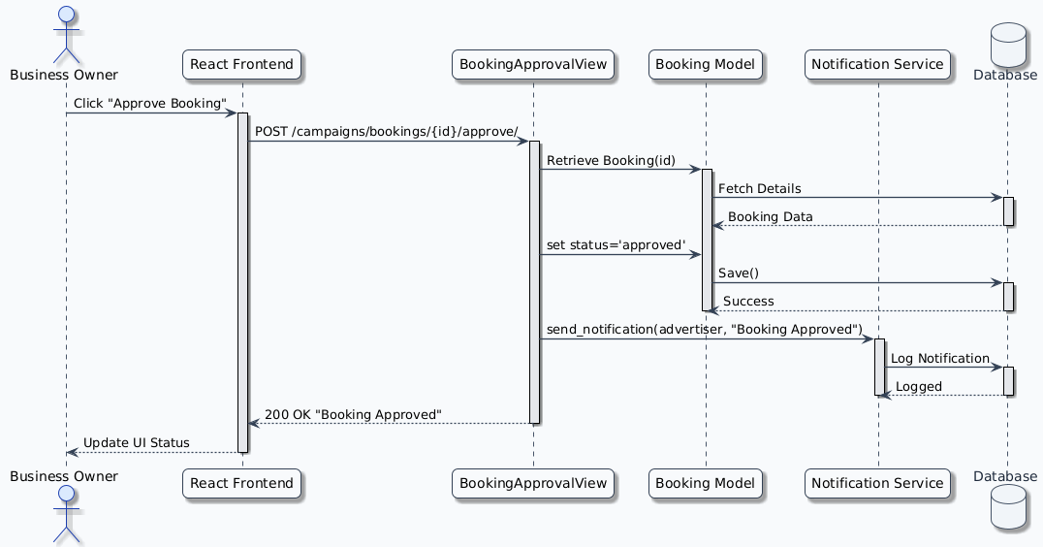
Figure 12: Sequence Diagram for Overall System

Class Diagram
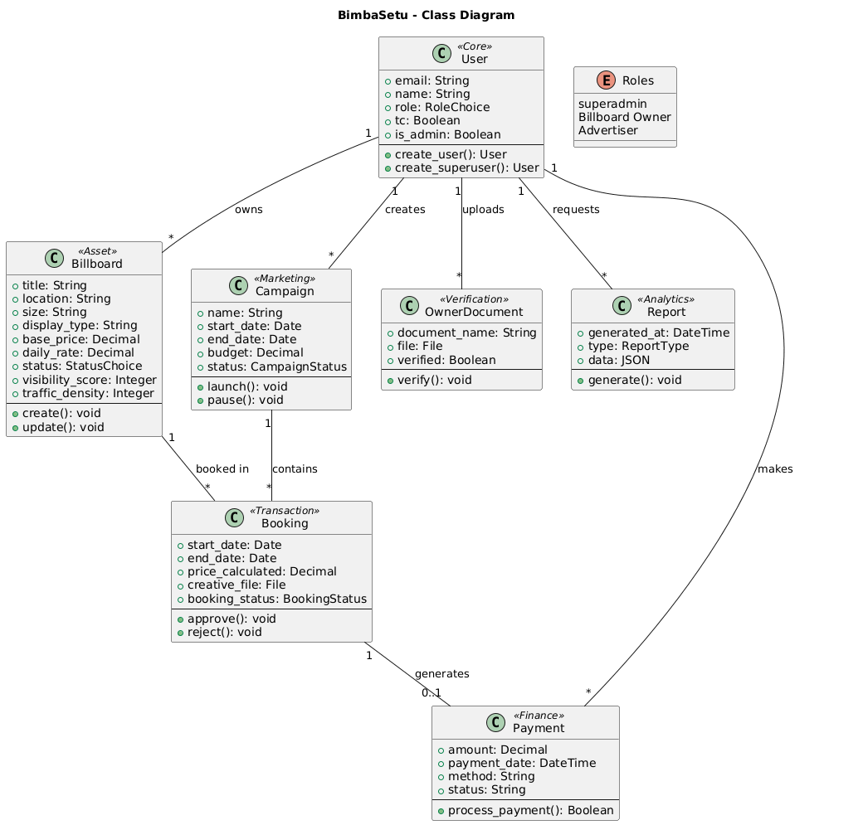
Figure 13: Class Diagram for the System

Object Diagram
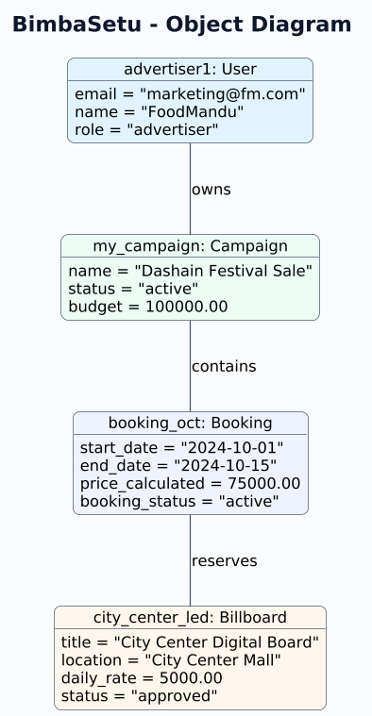
Figure 14: Object Diagram of the System

Entity Relationship Diagram (ERD)

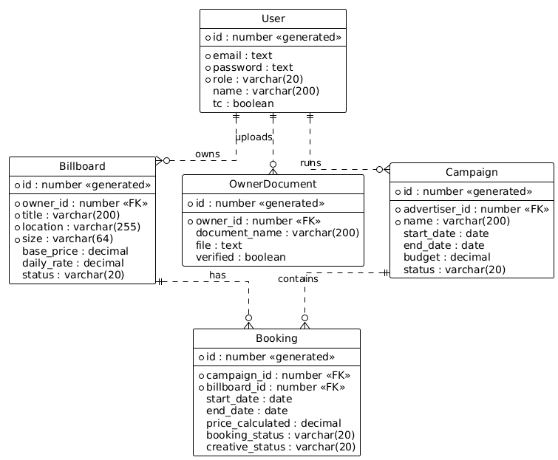
Figure 15: ERD of the System

Component Diagram
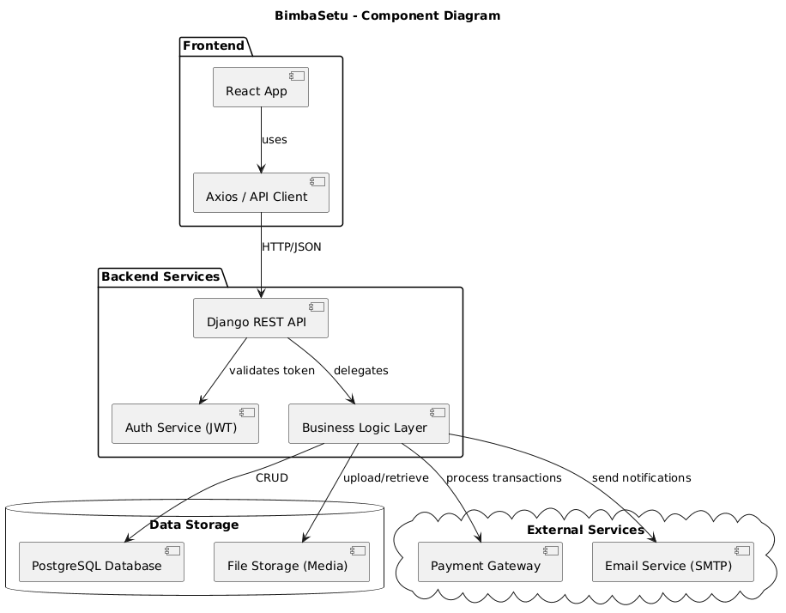
Figure 16: Component Diagram of the system

Data Flow Diagram (DFD – Level 1)
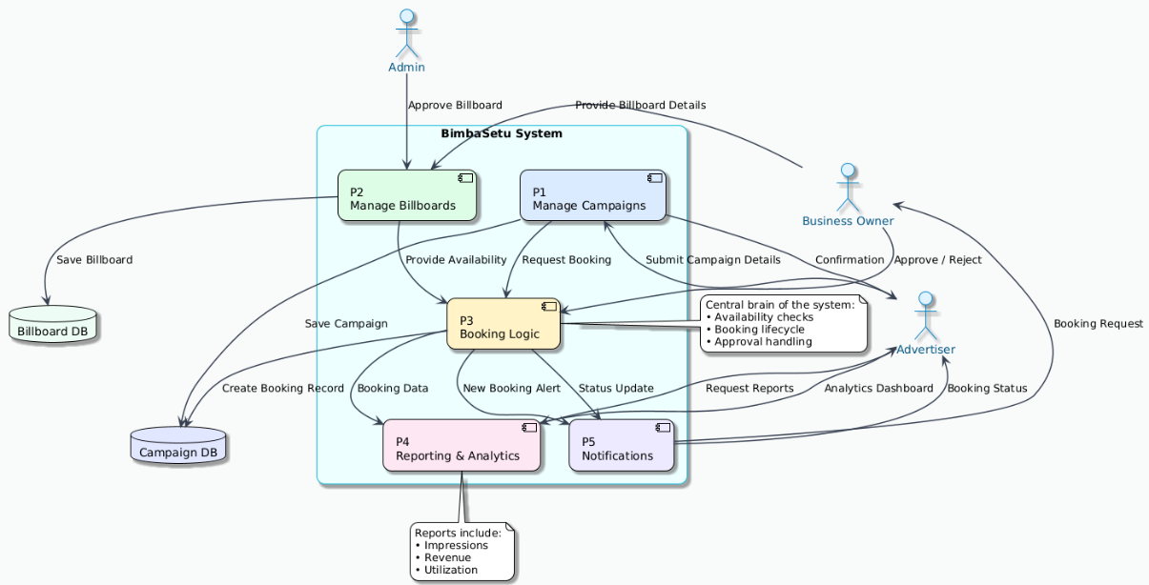
Figure 17: Data flow diagram of the system

Initial Designs
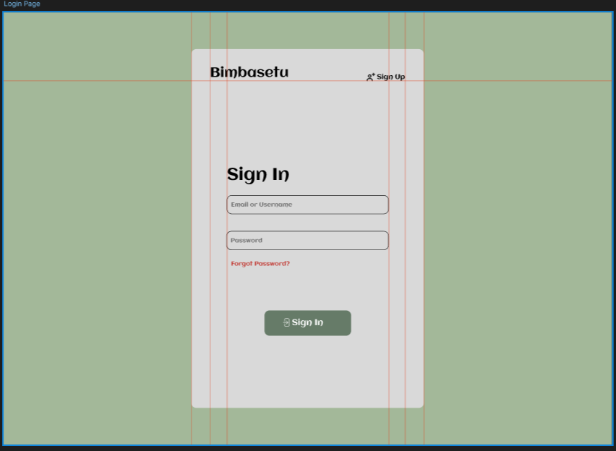
Figure 18: Initial design for Login Page
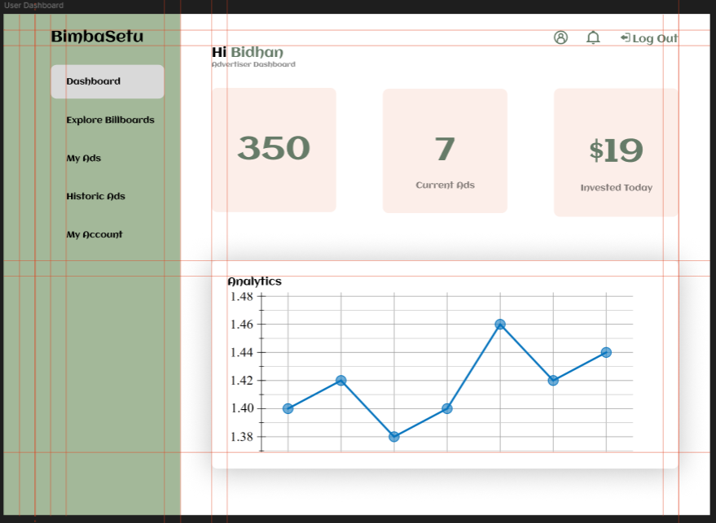
Figure 19: Initial design for Dashboard
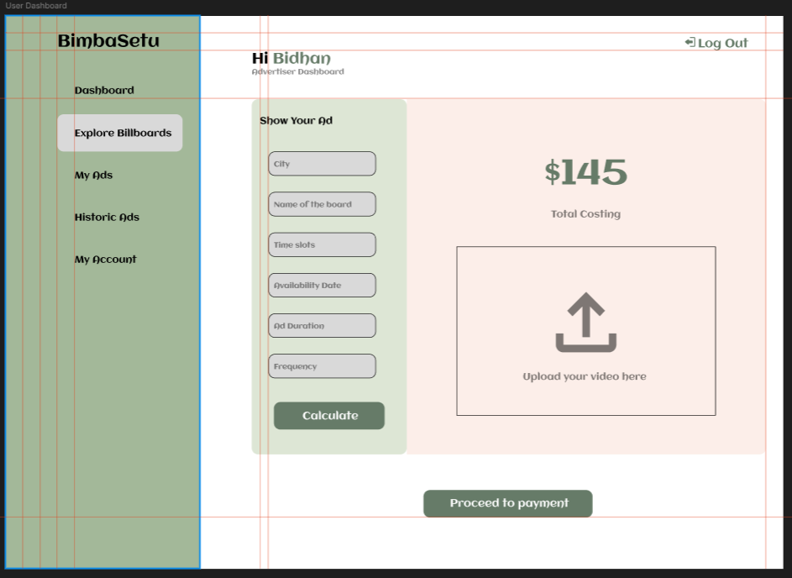
Figure 20: Initial Design for ads listing

Conclusion
BimbaSetu's vision is to modernize billboard systems of advertising in Nepal by developing a centralized and transparent platform to address issues of fragmentation, inefficiency, and lack of accountability in the billboard systems. With features such as access roles, ownership check and standardized approbations, it provides trust among the advertisers, owners and administrators. The project focuses heavily on usability, security of data, and ethics too. Academically, it uses software engineering, agile approach, and user interface usability testing to a local issue and practically, bridges the old media and digital transformation. Overall, BimbaSetu has great potential for scaling and long-term innovation in the advertising industry of Nepal.

Evidence of Project Management

Project Meeting Logsheet






















References
- Garaus, M., Wagner, U. and Rainer, R.C., 2021. Emotional targeting using digital signage systems and facial recognition at the point-of-sale. Journal of Business Research, 131, pp.747–762.
- Kim, S., Park, H. and Choi, J., 2012. A study of contact frequency and consumer preference for digital signage advertisement. In: International Conference on Human–Computer Interaction. Springer, pp.206–214.
- Low, C.-C., Ong, L.-Y., Koo, V.-C. and Leow, M.-C., 2020. Multi-audience tracking with RGB-D camera on digital signage. Sensors, 20(18), p.5351.
- Müller, J., Alt, F. and Michelis, D., 2015. Designing digital signage content to influence audiences in retail stores. In: Human-Computer Interaction – INTERACT 2015. Springer, pp.442–449.
- Ravnik, R. and Solina, F., 2013. Audience measurement of digital signage: Quantitative study in a real-world environment using computer vision. International Journal of Advanced Robotic Systems, 10(1), pp.1–14.
- Wong, S.-H.S., Leow, M.-C., Ong, L.-Y. and Lau, S.-H., 2019. Public responses towards camera-embedded digital signage advertising. JOIV: International Journal on Informatics Visualization, 3(2), pp.177–184.
- Yang, F., Lu, J., Yu, Q. and Zhou, J., 2020. A deep understanding of shopper behaviours and interactions using RGB-D vision. Machine Vision and Applications, 31(6).
- Adomni (2023) Adomni – Digital Out of Home Advertising Platform. Available at: https://adomni.com
- Broadsign (2022) Broadsign – Digital Out of Home Advertising Software. Available at: https://broadsign.com
- Vistar Media (2023) Vistar Media – Programmatic DOOH Platform. Available at: https://vistarmedia.com
- VIOOH (2022) VIOOH – The Global Digital Out of Home Marketplace. Available at: https://www.viooh.com

