

Module | Assessment Type
Project and Professionalism | Project Proposal

Project Title: BimbaSetu

Student Name: Bidhan Sapkota
Student ID: 2438398
Group: L6CG23
Supervisor: Nikunja Lamsal
Reader: Shiv Kumar Yadav
Abstract:
Outdoor advertising is the most prevalent type of advertising in Nepal, and one of the most widespread is the use of billboard advertising, the existing system is however disjointed and ineffective. The prices are not always steady, processes are not transparent and campaign performance cannot be easily monitored. BimbaSetu will address these issues by developing a centralized digital platform that will enable billboard owners and advertisers to meet at a common location. The system will have capabilities like booking and approval workflow system, flexible pricing model, campaign tracking, and role-based access. BimbaSetu aims at making the industry more transparent, efficient, and reliable by utilizing digital tools along with traditional outdoor advertising.
.
Table of Contents
1 Introduction 1
1.1 Background 1
1.2 Problem Statement 1
1.3 Significance of the Project 2
2 Project Briefing 2
2.1 Project Overview 2
2.2 Aim of the Project 2
2.3 Objectives 2
2.4 Academic Question(s) 3
3 Problem Analysis 3
3.1 Current Scenario of Billboard Advertising in Nepal 3
3.2 Key Challenges 3
3.3 Gap in Existing Systems 4
4 Proposed Solution 4
4.1 System Concept 4
4.2 Key Features 5
4.2.1 Centralized Portal 5
4.2.2 Ad Submission & Approval Workflow 5
4.2.3 Pricing Model (with all factors explained) 5
4.2.4 Tracking & Reporting 5
4.2.5 Role-Based Access 5
4.2.6 Transparency & Efficiency 6
4.3 Expected Outcomes and impact 6
5 System Artifacts 6
5.1 Major Subsystems 7
5.1.1 User Management System 7
5.1.2 Advertisement & Pricing Engine 7
5.1.3 Reporting & Analytics System 7
5.1.4 Notification & Communication System 7
5.2 System Architecture 7
5.3 Use Case Diagrams 9
5.3.1 Admin 9
5.3.2 Billboard Owner 10
5.3.3 Advertisers 11
6 Literature Review 12
6.1 Review of Similar Systems 12
6.2 Review from Research Papers / Journals 12
6.3 Outdoor Advertising and Regulatory Context in Nepal 12
6.4 Research Gap 12
7 Methodology 13
7.1 Project Methodology 13
7.2 Development Tools & Languages 13
8 Project Management 14
8.1 Work Breakdown Structure (WBS) 14
8.2 Gantt Chart 14
9 Ethical Considerations 15
10 Conclusion 15
11 References 16

Table of Figures
Figure 1: Use case Diagram for Admin 8
Figure 2: Use case Diagram for Billboard Owner 9
Figure 3: Use case Diagram for Advertisers 10
Figure 4: Work Breakdown Structure of Project 13
Figure 5: Gannt chart 13

Introduction

Background
The Billboard advertisement has a long history of being one of the most accessible and apparent types of outdoor advertisements, and has served as an essential independent channel of input to the businesses, especially to reach a vast and varied mass of audience. This is the situation in Nepal where the advertising masses are pitched with traditional stand-still billboards specifically in the busy roads caused by urban centers, highways, and other places of trade. Nevertheless, the advertising industry painting the world over, is experiencing a paradigm shift into the digital billboards and centralized Ad management server (enabling specific ad scheduling, ability to precisely target the audience and real-time performance tracking).
Although this is an international trend, the billboard advertising industry in Nepal is very dispatched and manual. The position of the advertisers requires them to negotiate widely to have placements with all adverts meant to run on billboards, very little standardization is possible in price models or performance monitoring because the operators of such advertisement are alone in business. These poor efficiencies result in squandered resources, low transparency, and lost privilege of tapping the advertising potential. As the market is increasingly demanding of experience (measurable) in promoted marketing investments, a gateway between the owner of the billboard and the company that advertises is increasingly desired, as it brings in transparency, automation as well as data driven insights into the market.

Problem Statement
The current billboard advertising ecosystem in Nepal suffers from lack of centralization, transparency, and efficiency. The advertisers usually experience difficulties in the following:
- Problem in locating accessible billboards in sites.
- Absence of standardized pricing and performance metrics.
- Delays caused in the manual negotiation and approval.
- Lack of ad plays tracking and effectiveness of the ads.
Meanwhile, billboard owners have a hard time monetizing their property and usually only have access to traditional, one-to-one contracts without understanding about demand trends. It reduces the scope of scaling, generates inefficiencies, and prevents the further possible expansion of outdoor advertising industry in Nepal due to the lack of a centralized digital solution.

Significance of the Project
The suggestions comprise the proposed BimbaSetu -A Centralized Billboard Ad Management Platform, which aims to transform outdoor advertising in Nepal and have a built-in, transparent, and data-driven ecosystem. The platform will eliminate the need for advertisers to manually run campaigns and give owners the chance to optimize use of billboards by:
- Increasing operational efficiency and transparency.
- Negotiating reasonable and adaptable prices on the concept of various situations (location, size, duration, frequency, etc).
- Providing measurable insights through reporting and analytics.
- Bringing the practices of Align Nepal in line with the world digital transformation trends.

Project Briefing

Project Overview
The project naming BimbaSetu, a Centralized Billboard Ad Management Project that will enable a digital revolution in the outdoor advertisement industry in Nepal. It will serve as an online platform which will help unite the billboard owners and the advertisers on a single centralized system. The platform will offer services like submission of digital ads, approvals and flexible pricing due to various factors, role-based access control, and switching of reports in real time. The system will minimize inefficiencies, encourage transparency, and ensure billboard assets are fully utilized because it streamlines the advertising lifecycle.

Aim of the Project
The core objective of the project is to develop and lay out a centralized and automated system of managing billboard advertisement that would guarantee equitable pricing, operation, and determining results to both advertisers and billboard owner.

Objectives
The objectives of the project are:
- To develop a centralized platform where advertisers will be able to find available billboards, establish a campaign and receive performance reporting and analytics.
- In order to meet the goal of dynamic pricing model based on location, time, frequency and demand, secure fair and flexible location of the advertisement.
- In order to allow the billboard owners control of their inventory, and have the scaleable system, easy to use, and consistent with current trends in digital advertising.

Academic Question(s)
The answers to the following research questions will also be tackled by the project:
- What is the possible use of technology to make the outdoor advertising in the Nepalese market transparent and effective?
- How can automation and data-based pricing help the billboard to maximise their usage?
- What role can a central database play in enhancing competence and trusting between billboard owners and advertisers?

Problem Analysis

Current Scenario of Billboard Advertising in Nepal
Billboards continue to be one of the most commanding advertisement media in Nepal. Businesses of both small local shops and large corporations are common users of them. Nevertheless, the existing system remains very manualistic. Advertisers usually make direct calls to the owners of billboards or their agents, and negotiate fees informally and they do not have the efficient means of tracking up campaigns. This approach often results in inconsistent pricing, limited availability of data, and lack of measurable outcomes. As pressure on digital transformation rises, a lack of coherent system restrains the effectiveness as well as expansion in the sector.

Key Challenges
The billboard advertising industry undergoes a number of challenges:
- Fragmentation: Centralized database of billboards is not available. Advertisers have to depend on personal contacts or occasional information.
- Inefficiency: The booking process, approval and payment is manual and occupies time and is likely to miscommunication.
- Absence of Transparency: Pricing is usually arbitrary and there so there is distrust between advertisers and people who own the bills boards.
- Limited Tracking: Advertisers cannot receive the performance data of the campaigns much or not at all.
- Revenue Loss: Billboard owners can experience poor visibility of availability which means that they can neither utilize their assets optimally.
All these problems ensure that billboard advertising is less attractive compared to more measurable digital media including social media or searches advertising.

Gap in Existing Systems
There are also some foreign sites to coordinate outdoor advertisements, but these are generalized and hardly used in Nepal because of higher costs and other differences considering the local context. Having one common system managing billboards in Nepal with centralized, transparent prices and tracking of the campaigns is currently not in place. Advertisers are deprived of predictable means of measuring returns and owners are deprived of technology of conducting assets effectively.
This is the existing gap that is lifted in order to produce a solution that is locally more developed, that is more affordable, transparent, and scalable. Such a platform as BimbaSetu can fill this gap as it would integrate both automation and localized business practices by providing advantages to both stakeholders.

Proposed Solution

System Concept
The suggested solution is the centralized organization of billboard advertising management system called BimbaSetu which is needed to suit the Nepali market. The system will create an interface between billboard owners and advertisers where the digitization of the whole workflow of booking to payment and tracking is done. The platform will create an automated approach that removes inefficiencies, improves the use of assets and allow advertisers to make decisions based on data.

Key Features

Centralized Portal
There will be only one online system on which people owning billboards can post their spaces (location, size, price, and entry-level) in availability detail. These listings allow advertisers to see the options, compare one with another, and complete their bookings without any problems.

Ad Submission & Approval Workflow
The platform will have a systematic system through which advertisers will submit creatives. Owners will be able to review, approve or ask changes online without a need of physical meetings or written approvals.

Pricing Model (with all factors explained)
The system will include a dynamic pricing engine which will take into consideration:
- Duration of ad playtime (e.g., 10s–45s)
- Billboard size and location
- Seasonal demand (festivals, elections, peak times)
- Time of day (rush hours vs. off-peak)
- Frequency of ad display per hour
- Visibility factors (traffic density, landmark proximity)
This brings in equality, openness, and dynamic responsiveness to market fluctuations.

Tracking & Reporting
The dashboards will allow advertisers to access ad play counts, impressions (on the basis of the traffic estimates) and duration of the campaign. The reports can be exported to the analysis of ROI, getting outdoor advertising closer to the requirements of digital marketing.

Role-Based Access
The system will offer individual access levels and each stakeholder will only be able to carry out the tasks that are directly related to his or her position:
- Billboard Owners: Must first request registration on the platform. The administrators will confirm ownership papers (legal permits, land lease contracts or municipality registration) and then allow you to proceed. After confirmation, owners should be able to add billboards, control inventory, approves advertiser creatives, and capitalize on earnings.
- Advertisers: View validated billboard spaces, compare rates, reserve ad campaign, upload content to approve, pay, and track campaign results.
- Admin: It is the role of the admin to ensure the ownership of billboards, hold and/or reject owner registrations, monitor the work of the platform, reconcile conflicts and products in line with regulations.

Transparency & Efficiency
It uses the platform to remove middlemen and negotiating informally. Everyone works on the basis of a standardized and verifiable system, enhancing trust and decrease in time wasted on miscommunication.

Expected Outcomes and impact
The following outcomes are expected to be achieved through implementation of BimbaSetu:
- For Advertisers: Uncomplicated access to billboard locations, clear pricing, real-time tracking and enhanced ROI.
- For Owners: improved asset visibility, lowered vacancy rates and competitive pricing, and more predictable revenue.
- For the Market: A digital revolution in outdoor advertisement, using the global trend in outdoor advertisement in favor of Nepal.
- Academic and Research outcome: A practical case study for building a web application by implementing computing science principles software engineering, system design, and usability to solve a real-world problem.
Regardless, BimbaSetu will fill the gap that currently exists within the advertisement ecosystem in Nepal, providing a new cost-effective modern approach to billboard management, and offering data and data-driven solutions.

System Artifacts
This section is the specification of the key elements of the intended system and their interaction with one another. The aim is to illustrate the internal architecture of BimbaSetu, and how the solution will provide desired functionality.

Major Subsystems

User Management System
- Manages registration, authentication, and role-based access to all the stakeholders.
- Billboard owners request registration and present ownership reports.
- These requests are checked and approved/rejected by the administrators.
- Accounts registered by advertisers permit access to features of booking and management of campaigns.

Advertisement & Pricing Engine
This is the very essence of the system that will setup ad campaigns, pricing, and schedule these campaigns.
- Advertisers choose billboards, set the term of the Ads, and post contents.
- Pricing is computed on a dynamic basis according to the duration, frequency and size, location and seasonality of demand.
- The submitted contents are permitted by owners prior to the Ads being launched.
- Ensures efficient use of inventory and fair pricing transparency.

Reporting & Analytics System
The System provides performance insights for all the stakeholders
- Advertisers are able to monitor the impressions, time periods with which campaign works, and approximate reach.
- Report on revenues and utilization is communicated to the owners.
- Administrators receive performance and compliance system-wide analytics.

Notification & Communication System
The application maintains communication and involvement of stakeholders including automated notifications for approvals, payments, campaign start/end dates, and account activities. Also there will be email alerts for critical updates.

System Architecture
The entire system will have three-layer architecture:
- Presentation Layer (Frontend): This is a web-based interface through which advertisers, owners and administrators access the system.
- Application Layer (Backend): Business logic, as it deals with campaign pricing, workflow management procedure, and intersystem communication.
- Data Layer (Database): Data is stored safely beyond the access of everyone by user profiles, billboard data, campaign details, financial transactions and analytics.

Use Case Diagrams

Admin
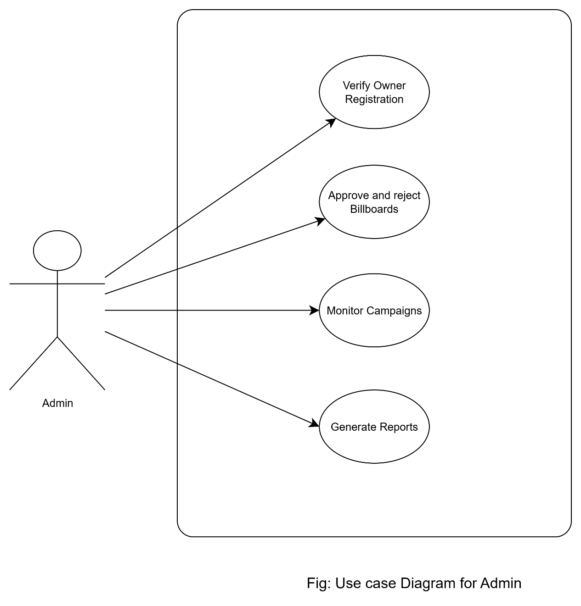
Figure 1: Use case Diagram for Admin

Billboard Owner
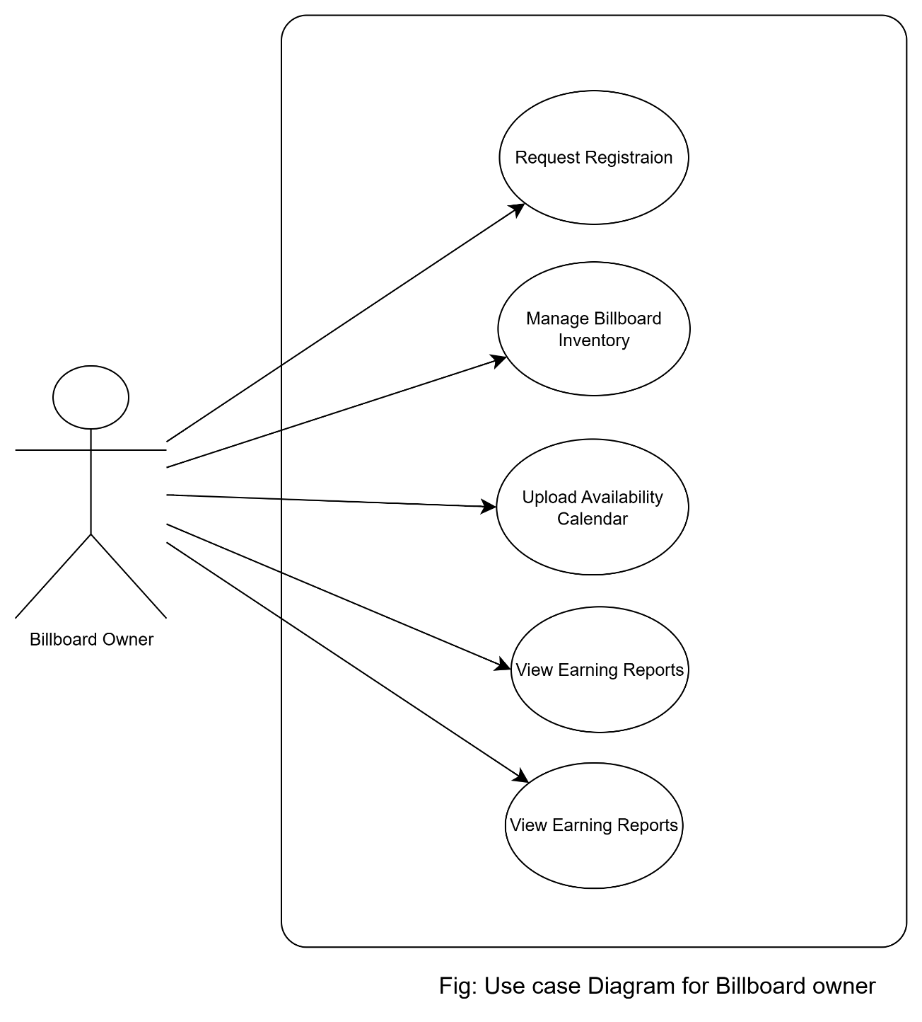
Figure 2: Use case Diagram for Billboard Owner

Advertisers
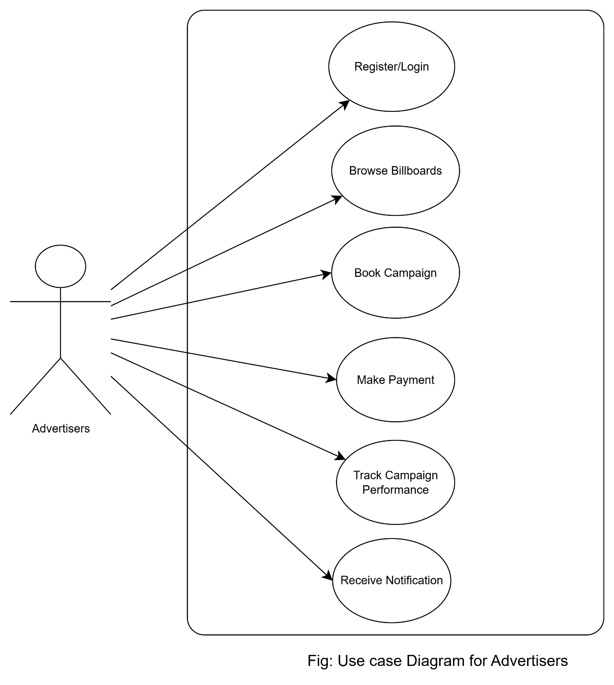
Figure 3: Use case Diagram for Advertisers

Literature Review

Review of Similar Systems
Digital advertising platforms like Broadsign and Adomni can provide easy experiences to book and control financial campaigns in a worldwide market, however, these Systems tend to be based on programmatic or traditional pricing conventions that are suited to developed infrastructures, rather than dynamic, focused-on-context pricing required in new market environments. Studies indicate that regional and situational conditions, like viewership, traffic, and schedule (patterns), can be adopted to determine the coverage and further-increase cost component in digital signage systems to be more accommodative of the real environment (Ravnik & Šolina, 2013).

Review from Research Papers / Journals
Audience-aware billboards are being made possible through technological discoveries. Digital signage using computer vision has been demonstrated to measure age, gender and attention span (dwell time) of viewers accurately and using dynamically changing content on the display can be 43% more engaging than static displays (Ravnik & Šolina, 2013). A second solution involves co-location of RGB-D cameras and digital signage to monitor more than one viewer in three-dimensional environments to enhance analytics on audience behavior in uncontrolled settings like public space. These abilities are the foundation of intelligent pricing optimization that considers real-time viewer indicators.

Outdoor Advertising and Regulatory Context in Nepal
There is a regulatory and urban planning issue with billboard advertisements in the Nepal environment. In Kathmandu, the city officials have removed thousands of illegal billboards that are considered aesthetically cluttered according to Supreme Court rulings and city legislation about where, how big and visible signs could be placed (Khanal, 2017; Editorial, 2019; Shrestha, 2022). Even tax structures are uneven: an example is advertising tax rates in Kathmandu being at the incredibly high rate of Rs 1,000 per square foot, and at the same time adjacent Lalitpur being at an almost equal low rate of Rs 200 per square foot as a deterrent to using outdoor media. Moreover, bureaucracy and bad urban coordination usually hinder compliance with the display standards.

Research Gap
Review of literature and systems has identified areas of weakness: Dynamic pricing and audience cognizing signage are both technologically possible at the international scales; however, only a handful of to these systems are tailored to the regulatory and infrastructure environments of Nepal. There is no localized platform to consolidate centralized access, dynamic price, campaign analytics or regulatory compliance in the market. BimbaSetu then seeks to bridge such a gap by combining adaptive pricing mechanisms, ownership authentication, central listings, and performance monitoring, adapting advanced ideas to the context of the Nepal outdoor advertising market.

Methodology
This section describes the approach used for the design, development, and evaluation of BimbaSetu. It describes the methodology of the project and the tools which have been used in order to ensure efficiency of the system.

Project Methodology
The project development approaches are Agile (Scrum) based. There can be iteration and continuous improvement using the presented feedback.
- Sprints: Development broken up in units of small time-boxes (2-3 weeks).
- Scrum Roles: Developer being myself, Supervisor (acting as Product Owner), and Reader (reviewer).
- Deliverables per Sprint: Incremental features like user management, campaign booking and reporting capabilities.
- Advantages: Flexibility, cooperation and adaptation to changing requirements and periodic evaluation to ensure that project goals are being achieved.
This approach is able to guarantee that BimbaSetu develops in an incremental and consistent way with both academic and practical objectives.

Development Tools & Languages
BimbaSetu will be developed using a well-established and strong capability stack to deliver performance, scalability and maintainability:
- Frontend: React.js used for building a dynamic, responsive and interactive user experience. Built on a component-based architecture, it supports the modular development and easy reusability of UI components.
- Backend: Django (Python) The backend will be primarily based on Django, a reliable, secure and robust Python web tool that offers out-of-the-box behaviors, including authentication, admin support. Django's REST framework (DRF) will be used to build scalable APIs to interact with frontend app.
- Database: PostgreSQL will be the main database implementation, which was selected because of its robust feature, ACID and its suitability for complex queries, relational data, scalability manipulation.
- Version Control: The version control, repository and tracking system will be GitHub, which will provide continuous integration and collaborative development.

Project Management

Work Breakdown Structure (WBS)
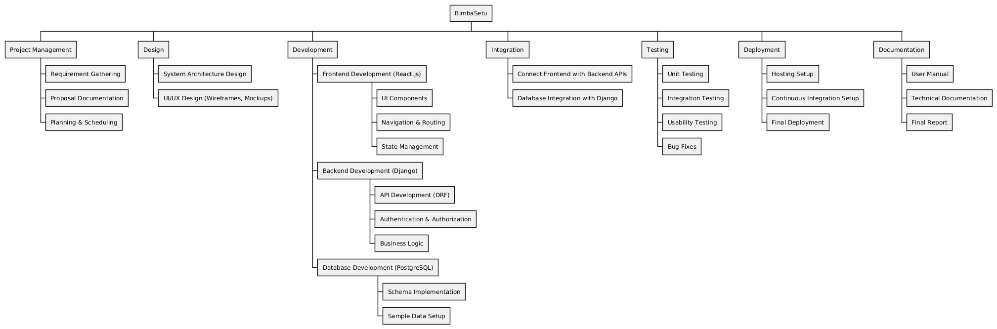
Figure 4: Work Breakdown Structure of Project

Gantt Chart
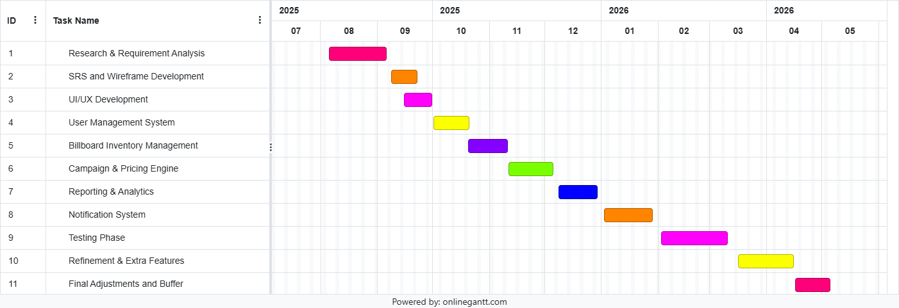
Figure 5: Gannt chart

Ethical Considerations
Ethical considerations play a pivotal role in the development and deployment of BimbaSetu, ensuring that the solution is developed fairly, transparently, and with responsible use of technology. There are the following considerations taken into account for this project:
- Data Privacy: Privacy is maintained as sensitive data like advertiser details, campaign budgets, and financial transactions are archived in the platform. All information will be treated with confidentiality and in accordance with normal data protection procedures.
- Transparency & Fair Access: Billboard owners and advertisers will be treated equally in a non-discriminatory fashion. Robot reporting and styling more transparent pricing models will inhibit bias, and promote fair treatment.
- Consent & Ownership Validation: Billboard owners are required to submit a verifiable proof of ownership prior to the approval of registration. This helps to ensure that only valid stakeholders are engaged and fraudulent claims are avoided.
- Content Moderation: Content in the forms of advertisements need to align with legal, ethical, and cultural practices of Nepal. Any type of content which could be harmful, misleading, or offensive to others will be strictly prohibited.
- Exploitation Prevention: The platform will ensure that no unfair price manipulation takes place by standardization of rules in the pricing engine. Billboard space will be allocated in a fair way to small and large advertisers.
Through taking these matters into consideration, BimbaSetu will seek to be not just technically sound, but also socially responsible and ethically aligned.

Conclusion
BimbaSetu is an initiative to revolutionize billboard advertising in Nepal through a centralized, transparent and technology-based platform. By offering curated marketplaces of information providers, transparent pricing structures, and strong data reporting, our platform tackles the major issues of fragmentation, inefficiency, and lack of accountability in today's industry
With features like role-based access, ownership verification, and a standardized approval process, the platform maintains trust and fairness among advertisers, billboard owners, and administrators. Further, its focus on usability, data security, and ethical compliance means that it is both practical and responsible for usage in real-world applications.
Academically, this project contributes by bringing the computer science knowledge of software engineering principles, agile methodologies, system design, and usability testing to an actual and local problem domain. Practically, it can possibly redefine the outdoor advertisement practices in Nepal by bridging the gap between the traditional media and the Digital transformation. In conclusion, BimbaSetu has scaling potential for commercial adaptation with long-term prospects for innovation and modernizing the advertising industry.

References
- Ravnik, R. & Šolina, F. (2013) Interactive and Audience Adaptive Digital Signage Using Real-Time Computer Vision, In: Digital Signage, InTech. Available at: link
- Low, C.-C. et al. (2020) ‘Multi-audience tracking with RGB-D camera on digital signage’, Heliyon, 6(9), e05107. Available at: link
- Khanal, S. (2017) ‘KMC starts crackdown on illegal billboards’, The Kathmandu Post, 5 March. Available at: link
- Editorial (2019) ‘Billboard jungle’, The Kathmandu Post, 21 August. Available at: link
- Shrestha, A. (2022) ‘Ban on outdoor advertising in Kathmandu’, Nepal News, 21 September. Available at: link

