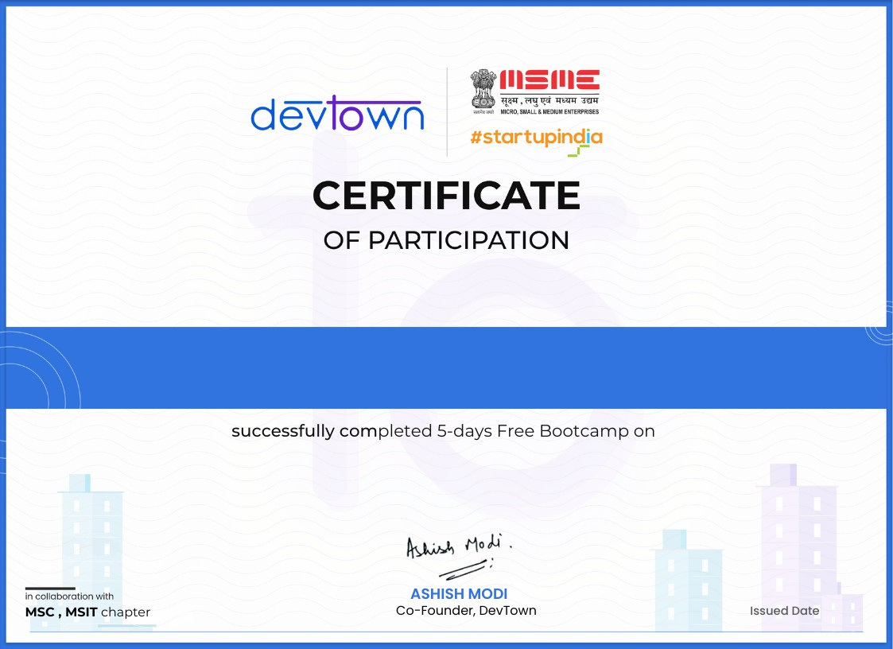
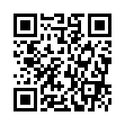
BIDHYA DIANA U
06
Jul
2025

Scan the QR code to verify
or visit:
https://cert.devtown.in/verify/17Iy9
9

