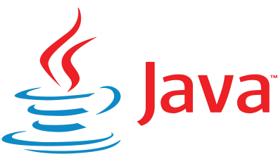

**Workshop on JAVA and C language**