1 задание
static public void Solve1()
{
char st = (Console.ReadLine().ToString())[0];
double a = Convert.ToDouble(Console.ReadLine());
double b = Convert.ToDouble(Console.ReadLine());
string result = "";
switch (st)
{
case '+': result = $"{a}{st}{b} = {a + b}"; break;
case '-': result = $"{a}{st}{b} = {a + b}"; break;
case 'x': result = $"{a}{st}{b} = {a + b}"; break;
case '/': result = $"{a}{st}{b} = {a + b}"; break;

}
Console.WriteLine(result);
}

2 задание
static public void Solve2()
{
unsafe {
int[] numbers = new int[10];

Console.WriteLine("Input 10");
for (int i = 0; i < numbers.Length; i++)
{
Console.Write($"Number {i + 1}: ");
numbers[i] = Convert.ToInt32(Console.ReadLine());
}

fixed (int* ptr = numbers)
{
Console.WriteLine("ODD NUMBERS;");
for (int i = 0; i < numbers.Length; i++)
{
int currentValue = *(ptr + i);
if (currentValue % 2 == 0)
{
Console.Write($"{currentValue} ");
}
}
}
Console.WriteLine();
}
}

3 задание
internal static void Solve3()
{
unsafe
{
int[,] grades = new int[2, 5];

Console.WriteLine("Enter 10 grades (5 for Group 1, then 5 for Group 2):");

for (int i = 0; i < 2; i++)
{
for (int j = 0; j < 5; j++)
{
grades[i, j] = int.Parse(Console.ReadLine());
}
}

fixed (int* ptr = grades)
{
for (int group = 0; group < 2; group++)
{
int sum = 0;
for (int student = 0; student < 5; student++)
{
sum += *(ptr + group * 5 + student);
}
double average = sum / 5.0;
Console.WriteLine($"Group {group + 1}: {average:F1}");
}
}
}
}

4 задание
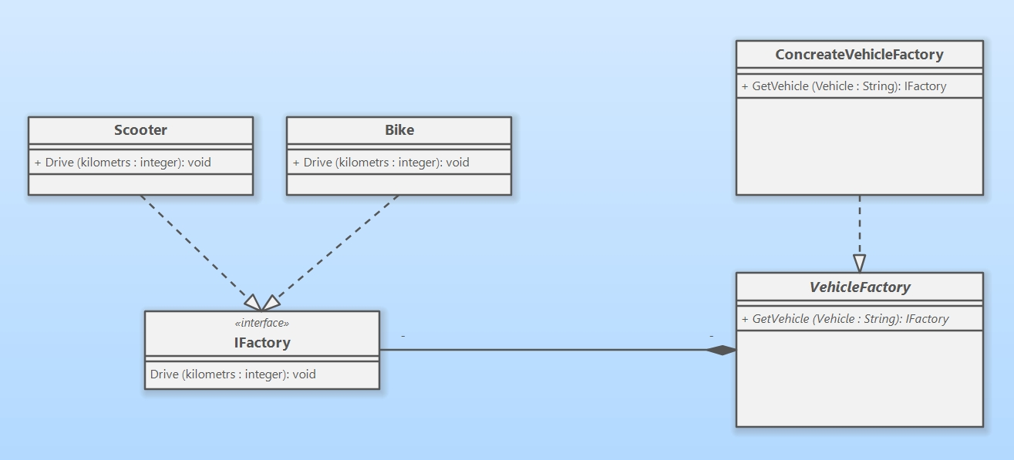

5 задание

6 задание
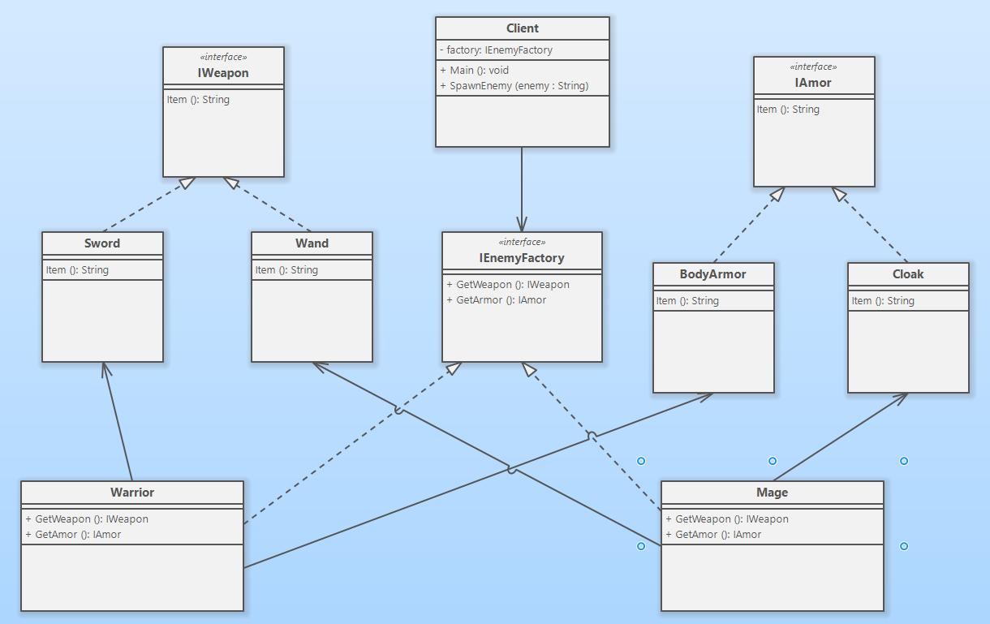

7 задание
using System;

public interface IWeapon
{
string Item();
}

public interface IAmor
{
string Item();
}

public class Sword : IWeapon
{
public string Item()
{
return "Sword";
}
}

public class Wand : IWeapon
{
public string Item()
{
return "Wand";
}
}

public class BodyArmor : IAmor
{
public string Item()
{
return "Steel Body Armor";
}
}

public class Cloak : IAmor
{
public string Item()
{
return "Cloak";
}
}

public interface IEnemyFactory
{
IWeapon GetWeapon();
IAmor GetAmor();
}

public class Warrior : IEnemyFactory
{
public IWeapon GetWeapon()
{
return new Sword();
}

public IAmor GetAmor()
{
return new BodyArmor();
}
}

public class Mage : IEnemyFactory
{
public IWeapon GetWeapon()
{
return new Wand();
}

public IAmor GetAmor()
{
return new Cloak();
}
}

class Client
{
IEnemyFactory factory = null;

public void SpawnEnemy(string enemy)
{
switch (enemy)
{
case "Warrior":
factory = new Warrior();
Console.WriteLine(factory.GetWeapon().Item());
Console.WriteLine(factory.GetAmor().Item());
break;
case "Mage":
factory = new Mage();
Console.WriteLine(factory.GetWeapon().Item());
Console.WriteLine(factory.GetAmor().Item());
break;
default:
Console.WriteLine("Wrong Type");
break;
}
}

static void Main(string[] args)
{
Client client = new Client();
client.SpawnEnemy("Mage");
client.SpawnEnemy("Warrior");
}
}

8 задание
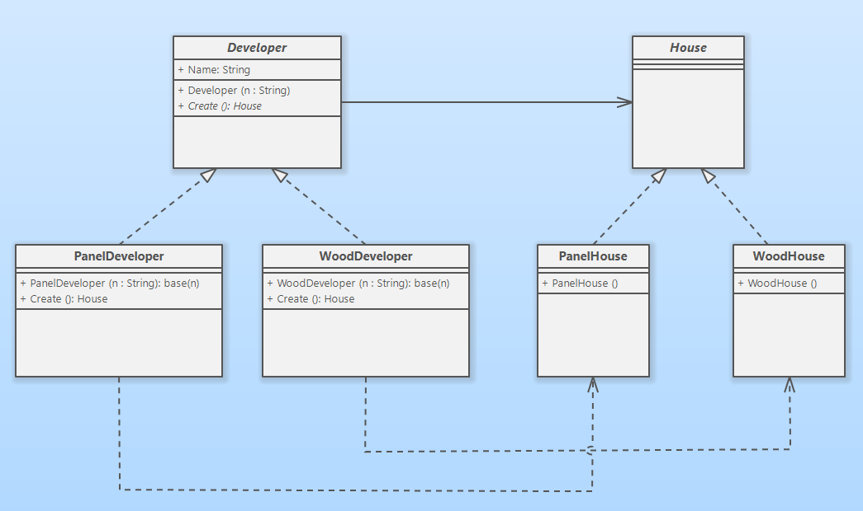

9 задание