1 задание
class Program
{
public static void Main(string[] args)
{
float radius = Convert.ToSingle(Console.ReadLine());
double surface = 4 * Math.PI * (radius*radius);
double volume = (4/3) * Math.PI * (radius*radius*radius);
Console.WriteLine("Surface: " + surface);
Console.WriteLine("Volume: " + volume);
}
}

2 задание
class Program
{
public static void Main(string[] args)
{
double distance = Convert.ToDouble(Console.ReadLine());
double h = Convert.ToDouble(Console.ReadLine());
double m = Convert.ToDouble(Console.ReadLine());
double s = Convert.ToDouble(Console.ReadLine());
double timeBySec = (h * 3600) + (m * 60) + s;

double mps = distance / timeBySec;
double kph = (distance / 1000) / (timeBySec / 3600);
double mph = kph / 1.609;

Console.WriteLine("Speed in meters/sec is " + mps);
Console.WriteLine("Speed in km/h is " + kph);
Console.WriteLine("Speed in miles/h is " + mph);
}
}

3 задание
class Program
{
static void Main(string[] args)
{
List<Person> list = new List<Person>();

for (int i = 0; i < 3; i++)
{
string name = Console.ReadLine()!;
int age = int.Parse(Console.ReadLine()!);
list.Add(
new Person()
{
Name = name,
Age = age
});
}
foreach (Person per in list)
{
Console.WriteLine(per.ToString());
}
}
}
class Person
{
public string Name { get; set; }
public int Age { get; set; }
public override string ToString()
{
return Name + " - " + Age;
}
}

4 задание
class Program
{
public static void Main(string[] args)
{
Animal dog = new Dog();
dog.SetName(Console.ReadLine()!);
Console.WriteLine(dog.GetName());
dog.Eat();
}
}
public class Dog : Animal
{
public override void Eat()
{
Console.WriteLine("Eating");
}
}
public abstract class Animal
{
private string Name { get; set; }
public void SetName(string name)
{
Name = name;
}
public string GetName()
{
return Name;
}
public abstract void Eat();
}

5 задание
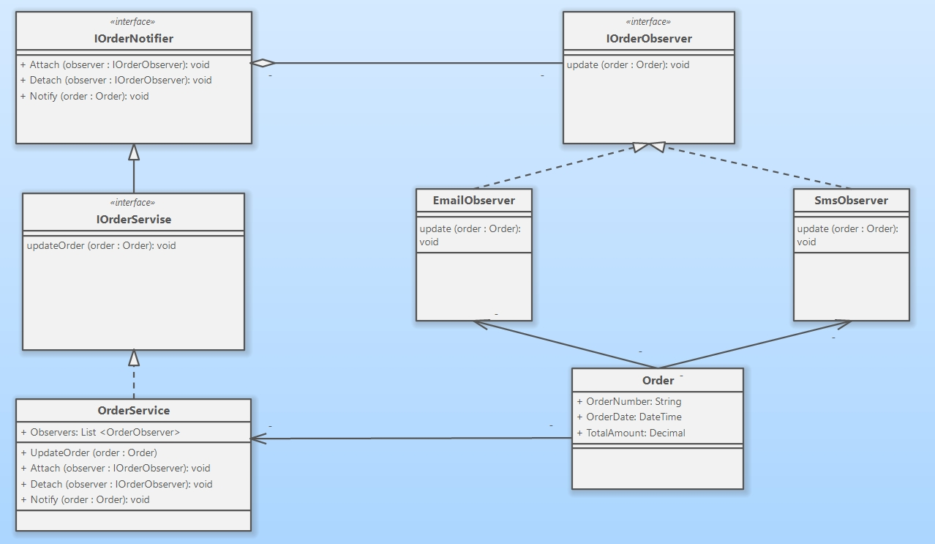

6 задание
internal class Program
{
static void Main(string[] args)
{
var order = new Order()
{
OrderNumber = "131232",
OrderDate = DateTime.Now,
TotalAmount = 10.01m
};
var smsObserver = new SmsObserver();
var emailObserver = new EmailObserver();

var orderService = new OrderServer();

orderService.Attach(smsObserver);
orderService.Attach(emailObserver);

orderService.UpdateOrder(order);
}
}

public class Order
{
public string OrderNumber { get; set; }
public DateTime OrderDate { get; set; }
public decimal TotalAmount { get; set; }
}

public interface IOrderObserver
{
void Update(Order order);
}

public class EmailObserver : IOrderObserver
{
public void Update(Order order)
{
Console.WriteLine("Order status is updated. Emails: {0}", order.OrderNumber);
}
}

public class SmsObserver : IOrderObserver
{
public void Update(Order order)
{
Console.WriteLine("Order status is updated. Sms: {0}", order.OrderNumber);
}
}
public interface IOrderNotifier
{
void Attach(IOrderObserver observer);
void Detach(IOrderObserver observer);
void Notify(Order order);
}

public class OrderServer : IOrderNotifier
{
private List<IOrderObserver> Observers = new List<IOrderObserver>();

public void Attach(IOrderObserver observer)
{
Observers.Add(observer);
}

public void Detach(IOrderObserver observer)
{
Observers.Remove(observer);
}

public void Notify(Order order)
{
foreach (IOrderObserver observer in Observers)
{
observer.Update(order);
}
}

public void UpdateOrder(Order order)
{
Notify(order);
}
}

7 задание
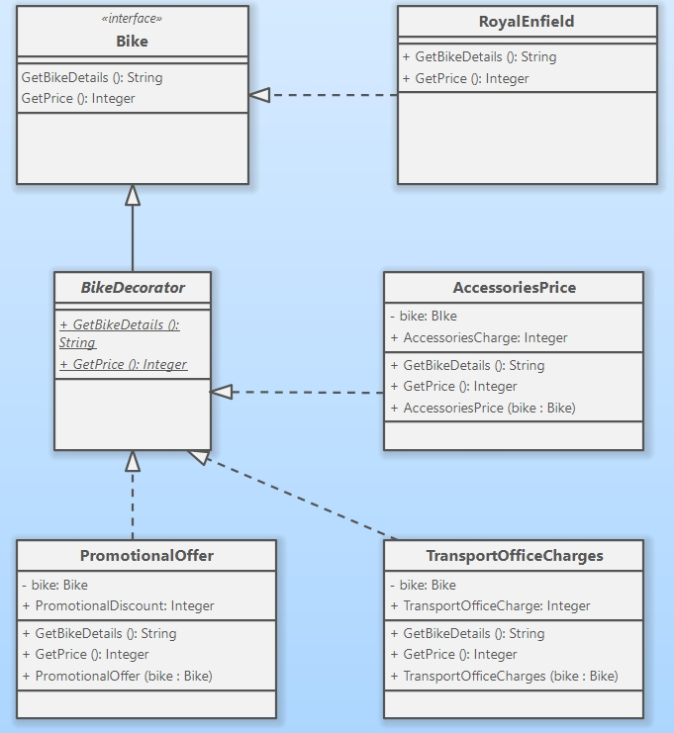

8 задание
namespace ObserverPattern
{
internal class Program
{
static void Main(string[] args)
{
RoyalEnfield royalEnfield = new RoyalEnfield();
Console.WriteLine(royalEnfield.GetBikeDetails());
Console.WriteLine(royalEnfield.GetPrice().ToString());

PromotionalOffer promotionalOffer = new PromotionalOffer(royalEnfield);
promotionalOffer.PromotionalDiscount = 25000;
Console.WriteLine(promotionalOffer.GetBikeDetails());
Console.WriteLine(promotionalOffer.GetPrice().ToString());

// Optional: Example with AccessoriesCharges
AccessoriesCharges accessoriesCharges = new AccessoriesCharges(royalEnfield);
accessoriesCharges.AccessoriesCharge = 5000;
Console.WriteLine(accessoriesCharges.GetBikeDetails());
Console.WriteLine(accessoriesCharges.GetPrice().ToString());
}
}

public interface Bike
{
string GetBikeDetails();
int GetPrice();
}

public class RoyalEnfield : Bike
{
public string GetBikeDetails()
{
return "Royal Enfield 150 F Stepway";
}

public int GetPrice()
{
return 150000;
}
}

public abstract class BikeDecorator : Bike
{
public abstract string GetBikeDetails();
public abstract int GetPrice();
}

public class PromotionalOffer : BikeDecorator
{
private Bike bike;
public int PromotionalDiscount;

public PromotionalOffer(Bike bike)
{
this.bike = bike;
}

public override string GetBikeDetails()
{
return bike.GetBikeDetails() + ". Promotional Offer";
}

public override int GetPrice()
{
return bike.GetPrice() - PromotionalDiscount;
}
}

public class AccessoriesCharges : BikeDecorator
{
private Bike bike;
public int AccessoriesCharge;

public AccessoriesCharges(Bike bike)
{
this.bike = bike;
}

public override string GetBikeDetails()
{
return bike.GetBikeDetails() + ". Accessories Charges";
}

public override int GetPrice()
{
return bike.GetPrice() + AccessoriesCharge;
}
}
}

9 задание
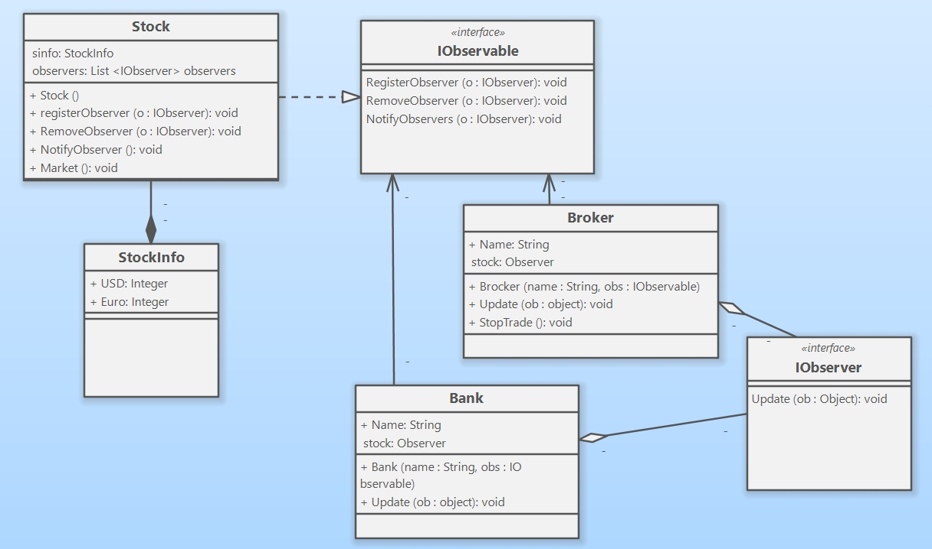

10 задание
