1, 2 задания
Установлено

3 задание
public class Program
{
public static void Main()
{
Person person = new Person();
person.greet();

Student student = new Student();
student.greet();
student.SetAge(18);
student.Study();
student.showage();

Teacher teacher = new Teacher();
teacher.greet();
teacher.Explane();
}
}

public class Person
{
protected int age;
public void greet(){
Console.WriteLine("Hello!");
}
public void SetAge(int n)
{ age = n; }
}

class Student : Person
{
public void Study()
{ Console.WriteLine("I'm studying");
}
public void showage()
{
Console.WriteLine("My age id " + age + "years old");
}
}

public class Teacher: Person
{
public void Explane()
{
Console.WriteLine("I'm explaining");
}
}

4 задание
using System;
using System.ComponentModel;
using System.Security.Cryptography.X509Certificates;

using System.Collections;
using System.Numerics;
public class FirstInterface
{
public static void Main(string[] args)
{
Car car = new Car(0);

int fuel = int.Parse(Console.ReadLine());
if (car.Refuel(fuel))
{
car.Drive();
}
}
public interface IVeicle
{
void Drive();
bool Refuel(int amount);
}
public class Car : IVeicle
{
public int Fuel { get; set; }

public Car(int fuel)
{
Fuel = fuel;
}
public void Drive()
{
if (Fuel > 0)
{
Console.WriteLine("Driving");
}
else
{
Console.WriteLine("Not fuel");
}
}

public bool Refuel(int refuel)
{
Fuel = refuel;
return true;
}

}
}

5 задание
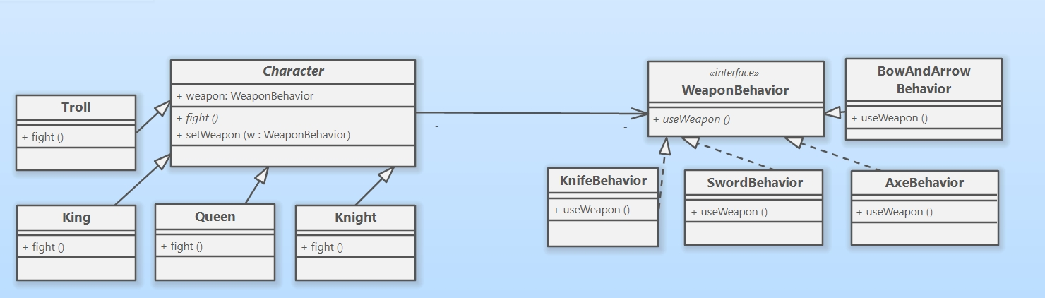
6 задание
Абстрактные суперклассы | Классы, наследуемые от суперкласса | Интерфейсы | Классы реализующие интерфейс
Character | Knight | WeaponBehavior | BowAndArrowBehavior
 | Troll |  | KnifeBehavior
 | Queen |  | SwordBehavior
 | King |  | AxeBehavior

7 задание
Включен в диаграмму в 5 задании

8 задание
class Program
{
public static void Main(string[] args)
{
Character king = new King();
WeaponBehavior weaponBehavior = new SwordBehavior();
king.SetWeapon(weaponBehavior);
king.fight();

WeaponBehavior weaponBowSndArrowBehavior = new BowAndArrowBehavior();
king.SetWeapon(weaponBowSndArrowBehavior);
king.fight();
}
public interface WeaponBehavior
{
void UseWeapon();
}
public class SwordBehavior : WeaponBehavior
{
public void UseWeapon()
{
Console.WriteLine("Attack with sword");
}

}
public class KnightBehavior : WeaponBehavior
{
public void UseWeapon()
{
Console.WriteLine("Attack with knife");
}

}
public class BowBehavior : WeaponBehavior
{
public void UseWeapon()
{
Console.WriteLine("Attack with bow");
}

}

public class AxeBehavior : WeaponBehavior
{
public void UseWeapon()
{
Console.WriteLine("Attack with axe");
}

}
public class BowAndArrowBehavior : WeaponBehavior
{
public void UseWeapon()
{
Console.WriteLine("Attack with bow and arrow");
}

}

public abstract class Character
{
public WeaponBehavior weapon;

public void SetWeapon(WeaponBehavior w)
{
weapon = w;
}
public abstract void fight();
}
public class King : Character
{
public override void fight()
{
Console.WriteLine("King: ");
weapon.UseWeapon();
}
}

public class Queen : Character
{
public override void fight()
{
Console.WriteLine("Queen: ");
}
}

public class Knight : Character
{
public override void fight()
{
Console.WriteLine("Knight: ");
}
}

public class Troll : Character
{
public override void fight()
{
Console.WriteLine("Troll: ");
}
}
}

9 задание
