1 задание
using System;

public class task1 {
public class Car {
public string Model;
public int YearOfProduction;
}

static void Main(string[] args) {
int total = 3;
Car[] car = new Car[total];

for (int i = 0; i < total; i++) {
car[i] = new Car()
{
Model = Convert.ToString(Console.ReadLine()),
YearOfProduction = int.Parse(Console.ReadLine()),
};
}

for (int i = 0; i < total - 1; i++) {
for (int j = i+1; j < total; j++) {
car temp = car[i];
car[i] = car[j];
car[j] = temp;
}
}

for (int i = 0; i < total; i++) {
Console.WriteLine("Model: {0}, YearOfProduction: {1}", car[i].Model, car[i].YearOfProduction);
}
}
}

2 задание
using System;
using System.Threading;

public class Vote {
private static Vote _instance = null;
private int _totalVotes = 0;
private static readonly object lockObj = new object();
private static readonly object voteLockObj = new object();

private Vote() {}

public static Vote Instance
{
get {
if (_instance == null) {
lock (lockObj) {
if (_instance == null) {
_instance = new Vote();
}
}
}
return _instance;
}
}

public void RegisterVote() {
lock (voteLockObj) {
_totalVotes += 1;
Console.WriteLine("Registered Vote: " + _totalVotes);
}
}

public int TotalVotes {
get {
lock (voteLockObj) {
return _totalVotes;
}
}
}
}

public class task2 {
public static void Main(string[] args) {
Thread thread1 = new Thread(() => Vote.Instance.RegisterVote());
Thread thread2 = new Thread(() => Vote.Instance.RegisterVote());
Thread thread3 = new Thread(() => Vote.Instance.RegisterVote());

thread1.Start();
thread2.Start();
thread3.Start();

thread1.Join();
thread2.Join();
thread3.Join();

Console.WriteLine("Total Votes: {0}", Vote.Instance.TotalVotes);
}
}

3 задание
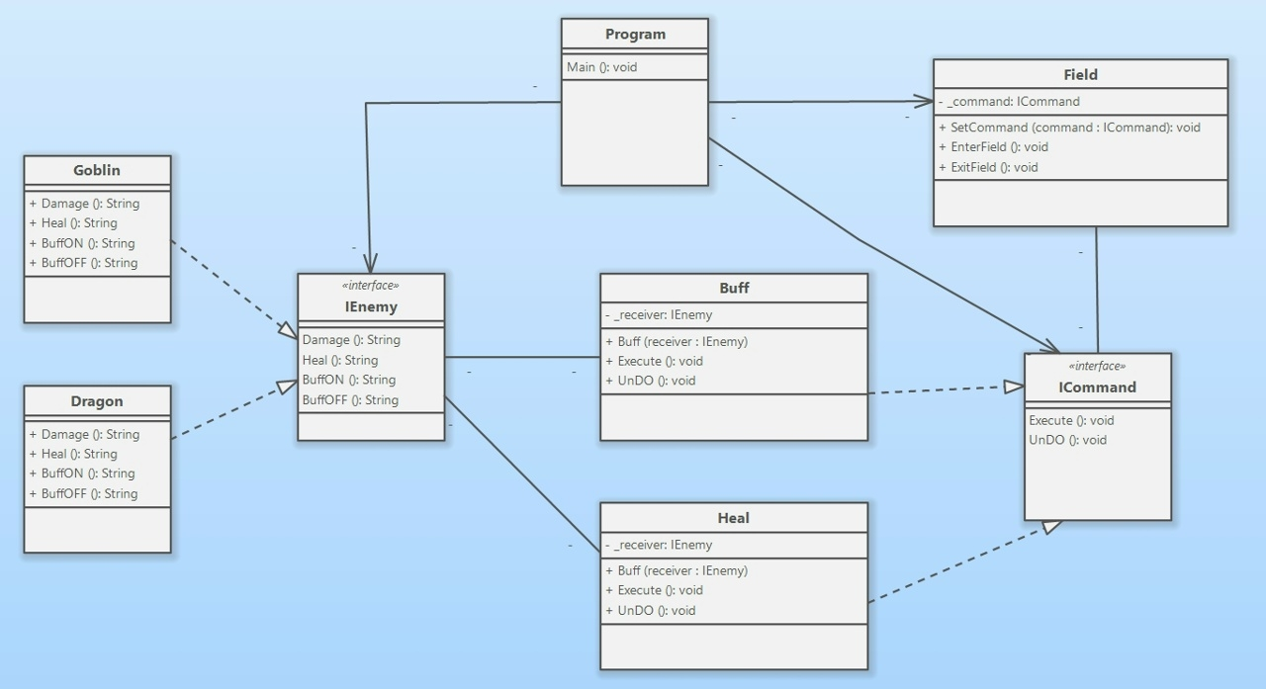

4 задание
using System;

public class task3 {
public interface IEnemy {
string Damage();
string Heal();
string BuffON();
string BuffOFF();
}

public class Goblin : IEnemy {
public string BuffOFF() {
return "Goblin enter the field - BuffOFF is ON";
}
public string BuffON() {
return "Goblin enter the field - BuffON is ON";
}
public string Damage() {
return "Goblin enter the field - takes damage";
}
public string Heal() {
return "Goblin enter the field - stop taking damage";
}
}

public class Dragon : IEnemy {
public string BuffOFF() {
return "Dragon enter the field - BuffOFF is ON";
}
public string BuffON() {
return "Dragon enter the field - BuffON is ON";
}
public string Damage() {
return "Dragon enter the field - takes damage";
}
public string Heal() {
return "Dragon enter the field - stop taking damage";
}
}

public interface ICommand {
void Execute();
void UnDO();
}

public class Heal : ICommand {
private IEnemy _reciever;

public Heal(IEnemy reciever) {
_reciever = reciever;
}

public void Execute() {
Console.WriteLine(_reciever.Heal());
}

public void UnDO() {
Console.WriteLine(_reciever.Damage());
}
}

public class Damage : ICommand {
private IEnemy _reciever;

public Damage(IEnemy reciever) {
_reciever = reciever;
}

public void Execute() {
Console.WriteLine(_reciever.Damage());
}

public void UnDO() {
Console.WriteLine(_reciever.Heal());
}
}

public class Buff : ICommand {
private IEnemy _reciever;

public Buff(IEnemy reciever) {
_reciever = reciever;
}

public void Execute() {
Console.WriteLine(_reciever.BuffON());
}

public void UnDO() {
Console.WriteLine(_reciever.BuffOFF());
}
}

public class Field {
private ICommand _command;

public void SetCommand(ICommand command) {
_command = command;
}

public void EnterField() {
_command.Execute();
}

public void ExitField() {
_command.UnDO();
}
}

static void Main(string[] args) {
Field field = new Field();

IEnemy goblinReciever = new Goblin();
ICommand command1 = new Heal(goblinReciever);
field.SetCommand(command1);
field.EnterField();
field.ExitField();

IEnemy dragonReciever = new Dragon();
ICommand command2 = new Heal(dragonReciever);
field.SetCommand(command2);
field.EnterField();
field.ExitField();

ICommand command3 = new Buff(goblinReciever);
field.SetCommand(command3);
field.EnterField();
field.ExitField();
}
}

5 задание
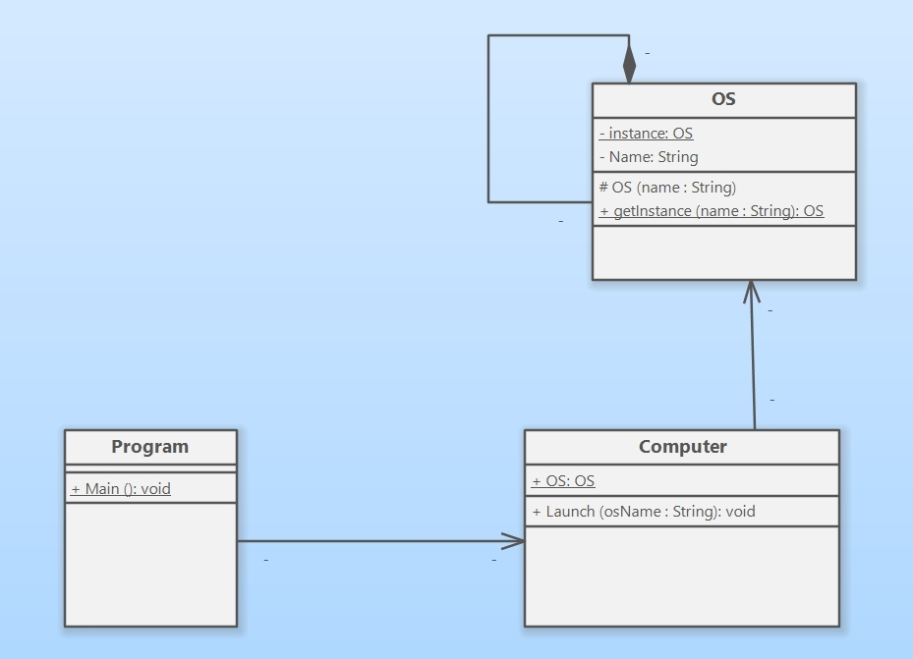

6 задание