FLASK AND
MONGODB ATLAS
Application Development Documentation

Submitted By: Bidyakar Bhatta

1. Project Overview
This project is a small web application built with Flask. It demonstrates two backend tasks: serving JSON data through an API endpoint and accepting information from an HTML form, then storing that information in a MongoDB Atlas database.
The application provides a contact form with Name, Email, and Message fields. When a valid submission is saved successfully, the user is redirected to a success page. If validation or database insertion fails, the form page is rendered again with an error message.

2. Objectives
- Create a Flask application and run it locally.
- Read a JSON list from a backend data file and return it from a JSON API route.
- Build an HTML form and receive its data through a POST route.
- Connect the Flask application to MongoDB Atlas using PyMongo.
- Store submitted form data as a document in a MongoDB collection.
- Redirect to a success page after a successful database insertion.
- Display an error on the same form page when validation or database insertion fails.

3. Technologies and Tools
Technology / Tool | Purpose | Used for
Python 3.13.5 | Programming language | Backend application logic
Flask 3.1.3 | Python web framework | Routes, requests, templates, responses
PyMongo 4.19.0 | MongoDB Python driver | Database connection and document insertion
MongoDB Atlas | Cloud database service | Stores form submissions
HTML | Markup language | Contact form and success page
CSS | Styling language | Form presentation
python-dotenv | Environment configuration | Loads the MongoDB URI from .env
PowerShell / VS Code | Development tools | Commands and source-code editing

4. Project Folder Structure
Flask_and_MongoDB_BidyakarBhatta/
│
├── app.py
├── config.py
├── requirements.txt
├── .env
├── .gitignore
├── README.md
│
├── data/
│ └── data.json
│
├── templates/
│ ├── index.html
│ └── success.html
│
├── static/
│ └── style.css
│
└── documentation/
└── Flask_MongoDB_Documentation.docx
The .venv folder is created locally to isolate Python packages. It should not be included in the GitHub repository or final ZIP because it can be recreated from requirements.txt.

5. Application Components

5.1 JSON data file
The file data/data.json contains a JSON array of sample records. Each record includes an id, name, email, and role. Keeping this data in a separate file demonstrates how a backend route can read structured data rather than hard-coding the response.
[
{
"id": 1,
"name": "John",
"email": "john@example.com",
"role": "Admin"
},
{
"id": 2,
"name": "Sarah",
"email": "sarah@example.com",
"role": "Manager"
},
{
"id": 3,
"name": "David",
"email": "david@example.com",
"role": "Staff"
}
]

5.2 Flask routes
Route | Method | Function
/ | GET | Renders the contact form (index.html).
/api | GET | Reads data/data.json and returns it as JSON.
/submit | POST | Validates form values, inserts a document, then redirects or renders an error.
/success | GET | Renders the success page.

5.3 Form and templates
The index.html template contains three required fields: name, email, and message. Its form submits using the POST method to the Flask endpoint /submit. Flask uses Jinja templating to display an error message when an error value is passed to the template. The success.html template displays the required message: “Data submitted successfully”.
The CSS file in static/style.css controls the visual appearance of the form, including spacing, input borders, button styling, and the error message.

5.4 MongoDB configuration
The config.py module loads MONGO_URI from the .env file with python-dotenv. PyMongo uses this URI to connect to the MongoDB Atlas cluster. The application selects the database flask_mongodb_db and the collection submissions.
# config.py (configuration overview)
load_dotenv()
MONGO_URI = os.getenv("MONGO_URI")
client = MongoClient(MONGO_URI, serverSelectionTimeoutMS=5000)
db = client["flask_mongodb_db"]
submissions_collection = db["submissions"]
The .env file contains the real Atlas connection URI and must remain private. It should be excluded from Git using .gitignore. A safe .env.example file can be provided with a placeholder value to show which environment variable is required.

6. How Form Submission Works
- A visitor opens the home page. Flask handles GET / and renders templates/index.html.
- The visitor enters a name, email address, and message, then submits the form.
- The browser sends the values to POST /submit.
- Flask reads the submitted fields and removes leading and trailing whitespace.
- The backend checks that all required values are present. If a value is missing, Flask renders the same form with an error message and an HTTP 400 response.
- If the values are valid, Flask creates a document with the form fields and a UTC created_at timestamp.
- PyMongo inserts the document into the submissions collection.
- If insertion succeeds, Flask redirects the browser to /success.
- If a PyMongo database error occurs, Flask logs the exception and renders the original form with a user-friendly error message and an HTTP 500 response.

7. Database Document Structure
Each successful form submission is stored as a MongoDB document similar to the following:
{
"_id": "MongoDB-generated ObjectId",
"name": "Test User",
"email": "test@example.com",
"message": "Testing MongoDB Atlas connection",
"created_at": "UTC date and time"
}
MongoDB automatically generates the _id field. The created_at field records the submission time in UTC. The database name is flask_mongodb_db and the collection name is submissions.

8. Setup and Run Instructions

8.1 Requirements
- Python 3 installed.
- A MongoDB Atlas account and an active cluster.
- Internet access for connecting to Atlas.
- PowerShell or another terminal.

8.2 Create and activate a virtual environment (Windows PowerShell)
cd C:\Users\bhatt\Desktop\Flask_and_MongoDB_BidyakarBhatta
python -m venv .venv
.\.venv\Scripts\Activate.ps1

8.3 Install dependencies
python -m pip install -r requirements.txt
If requirements.txt has not yet been generated from the active environment, run python -m pip freeze > requirements.txt after installing the required packages.

8.4 Configure MongoDB Atlas
- Create or select the Atlas cluster used by the project.
- Create a database user and grant appropriate database access.
- Add the current development IP address under Network Access.
- Copy the Python driver connection URI from Atlas.
- Put the URI in the project-root .env file using the variable name MONGO_URI.
- Keep the actual URI and password private; do not paste them into source code or public repositories.
# .env format (use your own Atlas URI; never copy this placeholder literally)
MONGO_URI=mongodb+srv://<username>:<password>@<cluster-address>/?retryWrites=true&w=majority

8.5 Start the application
python app.py
Open the application in a browser at http://127.0.0.1:5000.

9. Testing and Results
The following tests were performed during development. The results below distinguish confirmed tests from an additional failure-path test that should be completed before final submission.
Test | Expected result | Observed result | Status
Open home page | Contact form is displayed. | Contact form displayed in browser. | Passed
GET /api | JSON array from data/data.json is returned. | Task 1 was completed; attach API screenshot. | Confirm screenshot
Valid form submission | Redirect to success page. | Success page displayed the required message. | Passed
MongoDB storage | Document appears in submissions collection. | Submitted document was found in Atlas. | Passed
Empty form submission | Same form returned with validation error and HTTP 400. | curl.exe returned HTTP/1.1 400 BAD REQUEST and the expected message. | Passed
MongoDB unavailable | Same form returned with database error message and no success redirect. | Run the temporary connection-failure test and capture screenshot/log. | Passed

9.1 Commands used for testing
MongoDB connection ping:
python -c "from config import client; print(client.admin.command('ping'))"
# Expected: {'ok': 1.0}
Submit an empty form directly to test backend validation:
curl.exe -i -X POST http://127.0.0.1:5000/submit -d "name=&email=&message="
# Expected: HTTP/1.1 400 BAD REQUEST
# Response body contains: Please fill in all fields.
The MongoDB-unavailable test should be done only temporarily: stop Flask, save a secure copy of the Atlas URI, temporarily use a deliberately unavailable local URI in .env, restart Flask, and submit valid data. After testing, immediately restore the Atlas URI and verify the Atlas connection again. Never commit the temporary URI or real credentials.

10. Screenshots to Include
Add the following screenshots to this report before submitting. Use clear screenshots that show the relevant browser page, terminal output, or Atlas collection. Avoid showing passwords or the full MongoDB connection URI.
- Project folder structure in VS Code or File Explorer.
- data/data.json showing the sample JSON records.
- app.py showing the Flask routes.
- Browser showing the /api JSON response.
- Contact form page.
- Success page after a valid submission.
- MongoDB Atlas Browse Collections showing the saved submissions document (hide sensitive information if any).
- Terminal or browser showing the HTTP 400 validation error.
- Database failure message on the form page, if the failure-path test is completed.

10.1 Success page screenshot
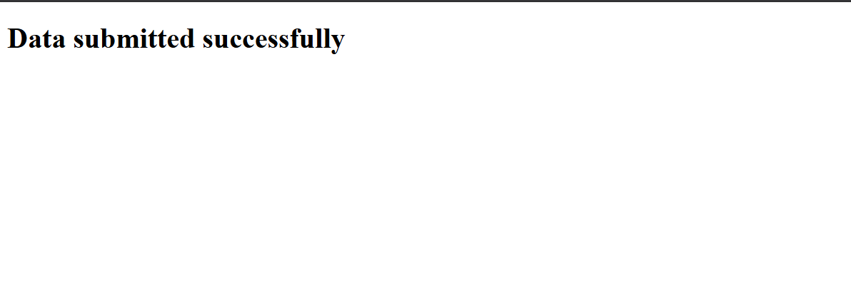

10.2 Error page screenshot
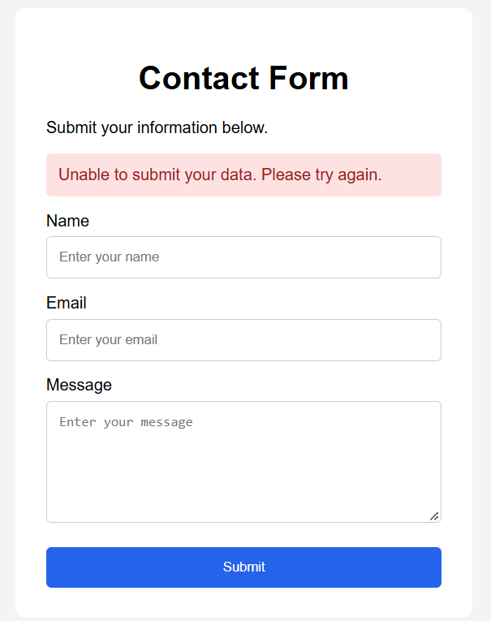

11. Security and Good Practices
- Never upload .env or expose the MongoDB username, password, or connection URI.
- Ensure .gitignore includes .venv/, __pycache__/, *.pyc, and .env.
- Use a least-privilege MongoDB database user rather than broad administrative permissions for a production application.
- Do not expose internal database exception details to website visitors. Log details on the server and show a generic message to users.
- Disable Flask debug mode when deploying publicly. Debug mode is intended only for local development.
- Use server-side validation even when HTML fields have the required attribute, because browser validation can be bypassed.

13. Conclusion
The project demonstrates a basic Flask backend, a JSON API endpoint, HTML form handling, and cloud database integration with MongoDB Atlas. The successful form test and database inspection confirm that valid form data can be stored in Atlas. The empty-form test confirms that server-side validation returns the form with an error instead of redirecting. The API screenshot, Atlas screenshot, and remaining documentation screenshots are also in the screenshot folder.

