Pangilinan, Bien Gabrielle M.  
WD-301

WCSERVER

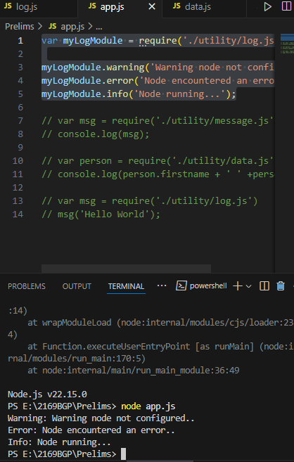

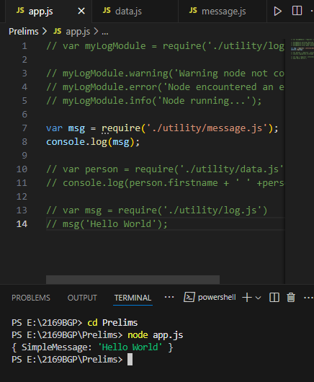

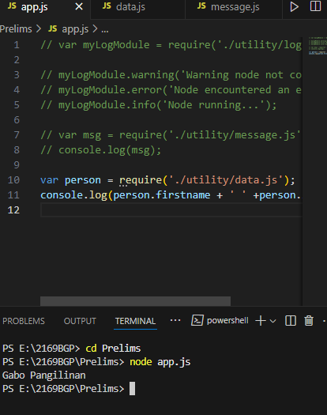

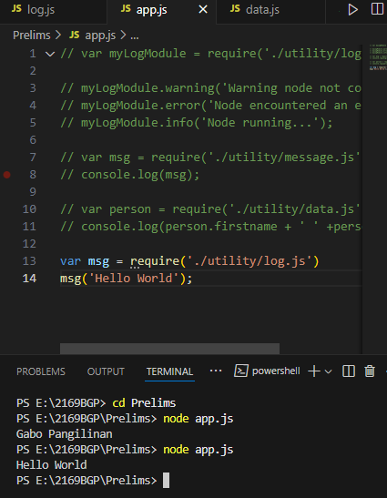

REFLECTION:

Today’s lesson/discussion made me learn new things about Javascript(.js), it was quite difficult to follow the discussion at first, but I managed to complete every code that was done today.