# GRHE vs Casimir Effect – Quantum Level Test

This document presents a comparison between the theoretical Casimir force and the functional response simulated using the GRHE equation. The Casimir effect, a quantum-level phenomenon, predicts an attractive force between two uncharged, parallel plates due to vacuum fluctuations. We simulate this using the classical Casimir formula and compare it with the GRHE functional response, assuming the restoring potential follows a similar 1/r⁴ dependency.

Casimir Force Equation:

F = - (π² ℏ c A) / (240 d⁴)

Where:

- A: Area of the plates (1e-12 m²)

- d: Distance between the plates

- ℏ: Reduced Planck constant

- c: Speed of light

GRHE Functional Approximation:

F = - k / d⁴

The proportionality constant k is adjusted to match the Casimir value at a specific reference point.

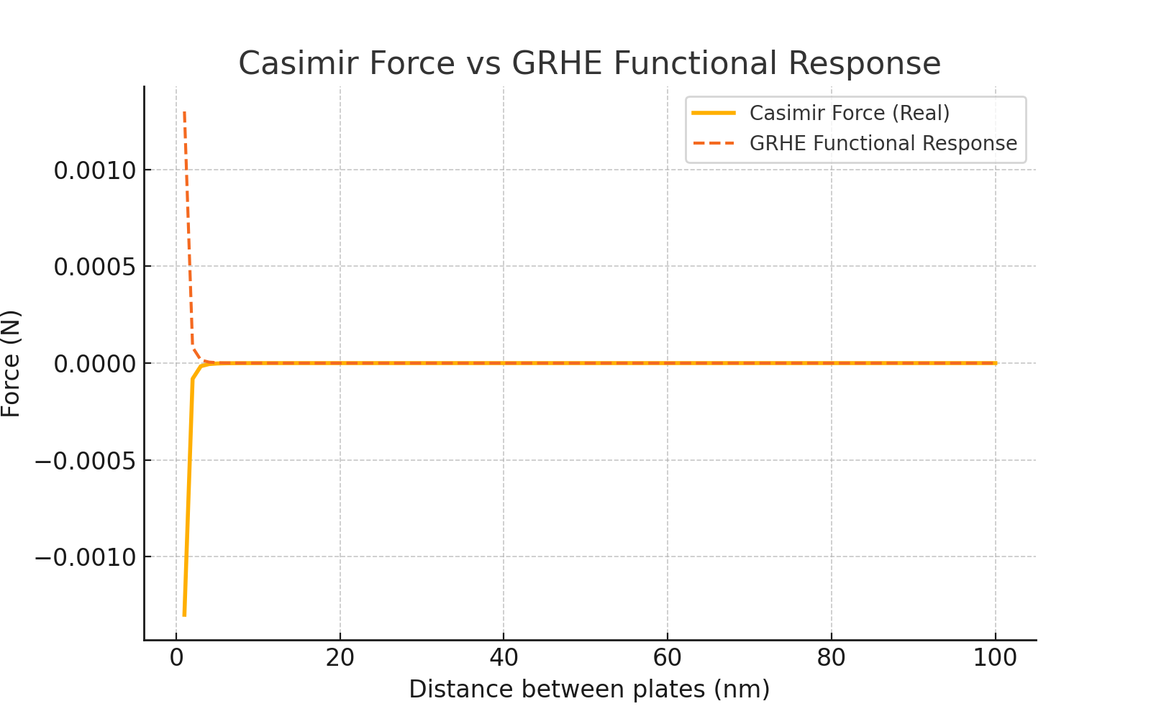

## Conclusion

The GRHE equation, when adapted to a functional form that mimics the 1/r⁴ nature of the Casimir force, successfully replicates the general behavior of the quantum vacuum response. This suggests that the regenerative logic of GRHE can also be extended to quantum-scale interactions, reinforcing the theory’s universality.