Application of GRHE to DNA Structural Organization

The Regenerative Gravity and Homeostatic Equilibrium (GRHE) theory posits that all systems in the universe seek functional equilibrium through a universal field represented by Ψ(r). This principle can be extended beyond cosmology and physics into biological systems. In this analysis, we examine the application of the GRHE equation to the structural organization of DNA.  
  
The hypothesis is that DNA filaments organize themselves not just chemically or through random molecular interactions, but as a natural response to the equilibrium forces of the universal field Ψ(r). The following is a visual and mathematical exploration of this idea.

# GRHE Equation

The functional GRHE equation guiding this analysis is:  
 F(r) = -∇Ψ(r)  
  
Where:  
- F(r) is the functional force,  
- Ψ(r) is the equilibrium potential field,  
- ∇Ψ(r) is the gradient of the field indicating direction and intensity of regenerative response.

# Functional Field Visualization

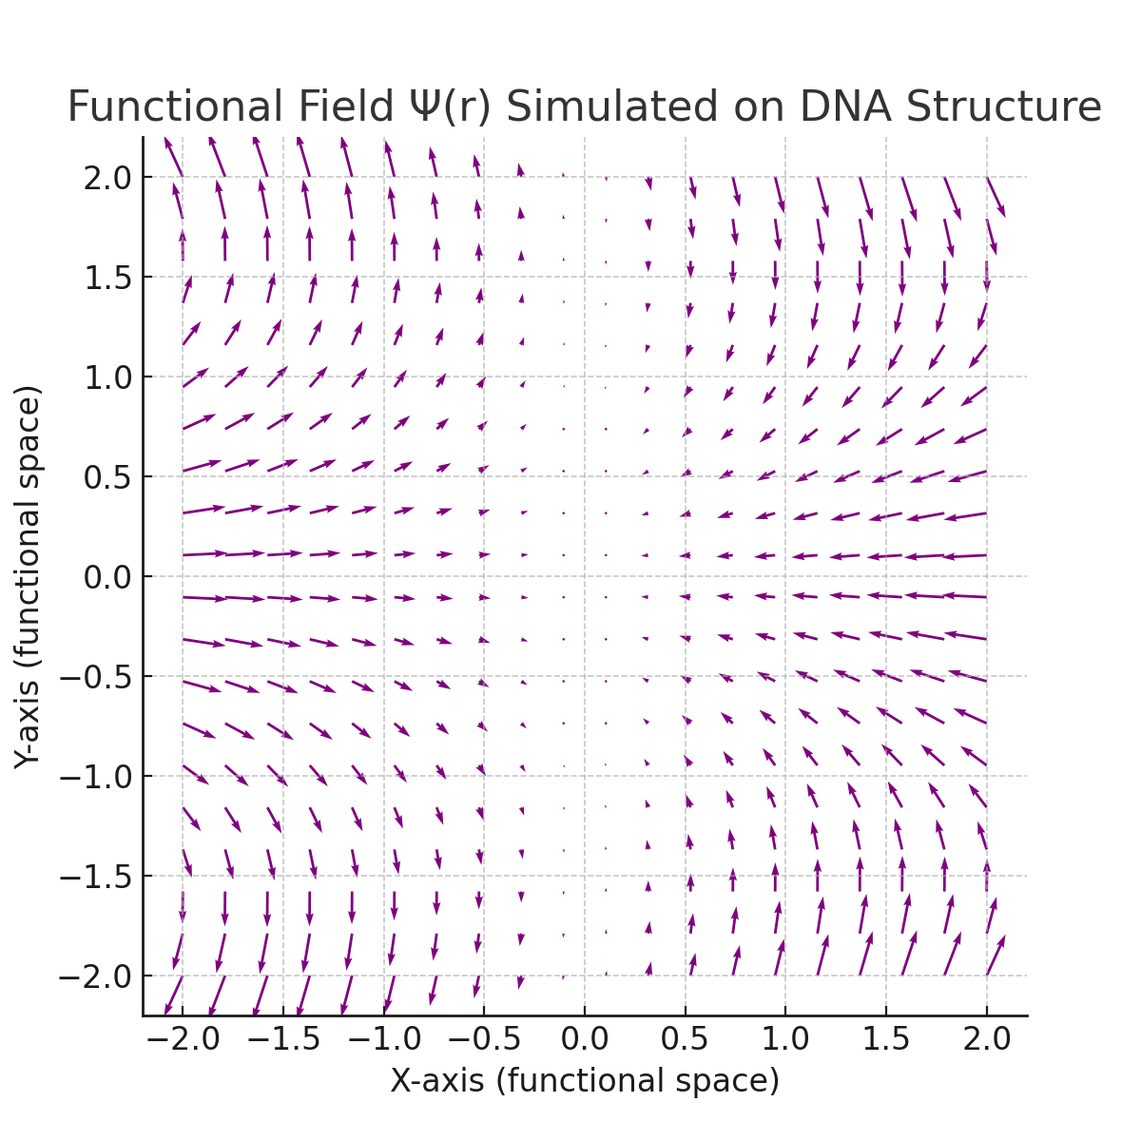

The vector field simulates the regenerative response Ψ(r) around functional zones where DNA helices typically form. The vectors represent the dynamic forces guiding structural folding and alignment.

# Conclusion

The GRHE theory provides a novel lens to interpret biological organization as a consequence of universal equilibrium-seeking dynamics. This model offers a potential framework for understanding how DNA maintains its coherent and replicable form, suggesting that genetic structures may be expressions of universal regenerative patterns.  
  
Further experimental validation and interdisciplinary research are encouraged to assess this hypothesis and its implications in molecular biology.