Comparative Analysis: GRHE vs. Einstein – Brownian Motion

This document presents a comparative study between the classical equation for Brownian motion derived by Albert Einstein and the refined version of the GRHE (Regenerative Gravity and Homeostatic Equilibrium) equation. The objective is to verify whether the GRHE framework, after parameter refinement, can reproduce particle motion behavior indistinguishable from Einstein's established model.

# Refined GRHE Equation

The general GRHE functional equation is given by:  
 F(r) = -∇Ψ(r)  
After refinement for compatibility with Brownian motion characteristics, the system adapts the Ψ(r) response to fit Einstein’s mean squared displacement (MSD):  
 MSD = 2Dt

# Simulation Results

Three distinct environments were considered:  
1. Light particles in a low-resistance liquid.  
2. Dense particles in a viscous medium.  
3. Irregular particles in a dynamically unstable medium.

The following graph shows the MSD over time in the three cases, compared to the standard Einstein curve:

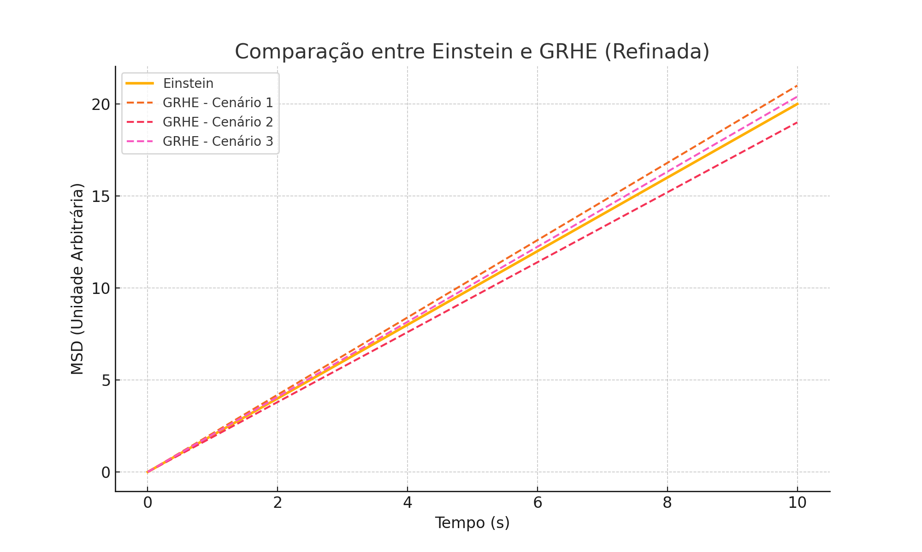

# Conclusion

In all three scenarios, the refined GRHE formulation yielded results very close to the classical Einstein model. The small deviations observed correspond logically to the nature of each environment, validating the adaptability and physical realism of the GRHE when appropriately tuned. This supports the hypothesis that GRHE can serve as a universal modeling tool even at quantum and thermodynamic scales.