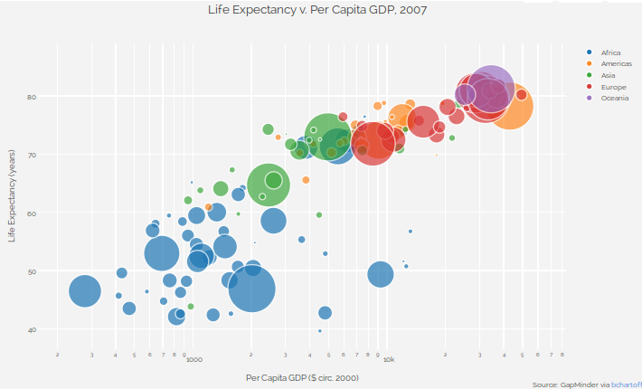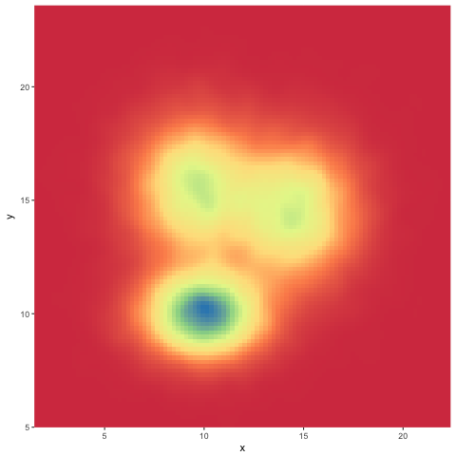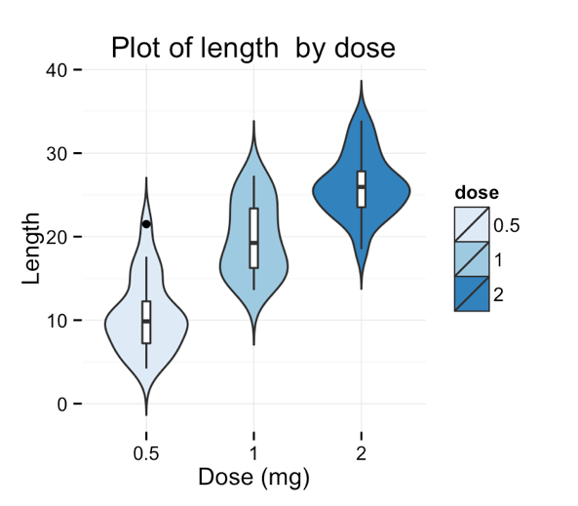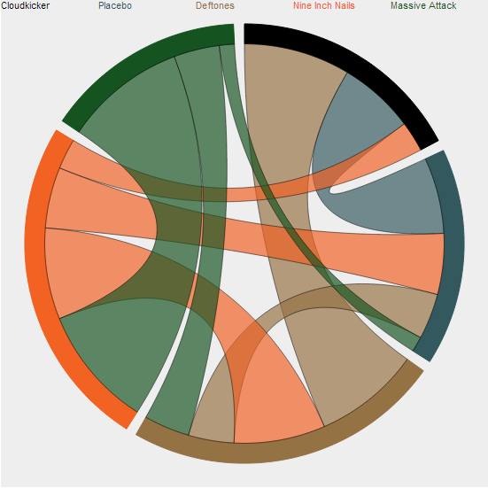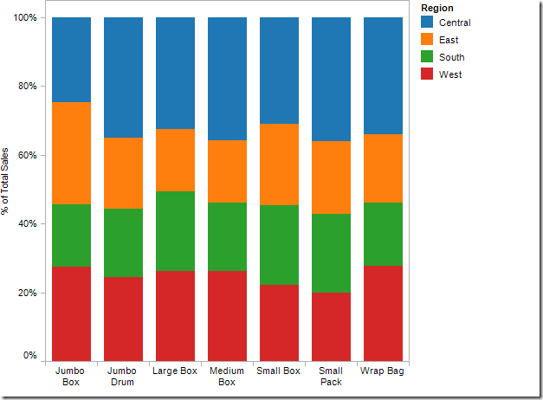

You want to visualize human migration patterns in and out of the countries of Syria, Western Africa and Myanmar.

You have data on the average amount of sleep different mammal species from a bunch of different families – you want to examine the relationship between sleep time, brain size and number of species in a family.

You’re comparing the growth rate of 3 types of genetically modified sorghum treated with 7 different fertilizers – in each treatment, you have a sample size of around 25.

You have spatial data within an experimental plot about the distribution of behavioral interactions between mantids and herbivorous prey insects.

You surveyed a population of beetles with 5 different horn phenotypes during the rainy season and dry season for five years.