Exam 3

3/11/2020

## Exam 3 - Seals, seals, seals as far as the eye can see

### Question 1

What are TWO mistakes from the code below, designed to create a color-coded scatterplot from two columns of data from our aquaculture team that plots the growth of tilapia in an aquaculture tank over time?

ggplot(aes(x = time, y = weight, color = fish_id)) +  
 geom_point(shape = 16, size = 4) +  
 theme_classic() +  
 xlab("Fish weight (g)") +  
 ylab("Time (hours)") +  
 scale_color_discrete(name = "Fish ID")

### Question 2

Briefly describe (2-5 sentences) some problems with the figure below, and how you would modify or change the figure to improve it. 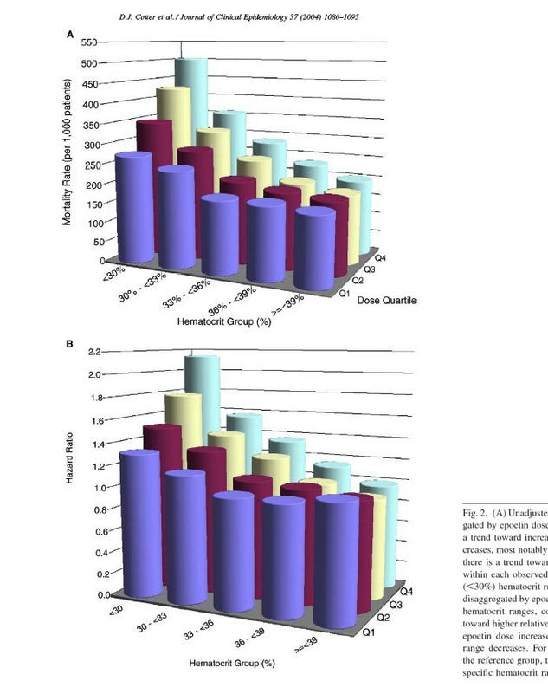

### Question 3

Write some psuedo-code (it doesn’t have to be syntaxically perfect, but it should generally convey your thought process) to solve the following challenge. You have a dataframe called seal_data that contains 5 columns:  
1. IDs for individual seals (data for 76 seals in total) - seal_id  
2. Seal weight (taken multiple times over the course of a year) - weight  
3. Seal sex (M or F) - sex  
4. Testosterone levels - test_level  
5. Location captured (a general location for where each seal was captured and measurements were taken) - loc

You’re interested in two things: 1) finding the average weight of male and female seals from each location (don’t separate by sex here), and 2) determining whether or not there is a significant difference in testosterone between male and female seals across all locations.

### Question 4

Using the same hypothetical data set, write code using tidyverse/dplyr syntax that computes a summary of the dataframe that includes an average weight and testosterone level for each seal over the course of the year and the standard deviation of weight and testosterone level for each seal. Account for the fact that there is some missing data in the weight and testosterone columns (some seals escaped capture and researchers were unable to get this information).

### Question 5

Imagine that you’re talking to a colleague who is interested in learning more about machine learning and applying it to their research. In your own words, and in plain English, describe what machine learning is, and how the k-nn algorithm we built in class functions (4-10 sentences).

### Question 6

What type of join would you use in the following scenario? You have two data frames that you want to combine - one that contains biometric information on team Antartica members (height, weight, gender, blood tests) and another that has medical and dietary data (percentage of diet from different sources, caloric intakes, exercise regime). Each data set has one column in common, the team member ID column (names are messed up as one database has the names people go by, while another has folks’ names that are on their Social Security Cards).

You’re interested in finding data on people that appear in one data table but not the other (some data has gone missing, and you’re trying to track down whose data we need to complete the database).

1. anti-join
2. full-join with filters
3. semi-join
4. left-join then right-join
5. inner-join

### Question 7

Briefly (3-5 sentences) explain the difference between a classification problem (like the one we tackled in class using k-nn) and a regression problem (feel free to use the web and note that this exam is open book, open note, open everything!). Cite your sources appropriately if you use them!

### Question 8

Imagine that you want to create the figure below using ggplot2 syntax. What are the different components? What geom would you use? Can you interpret what the pointed bubbles (violins) are depicting? (5-7 sentences)

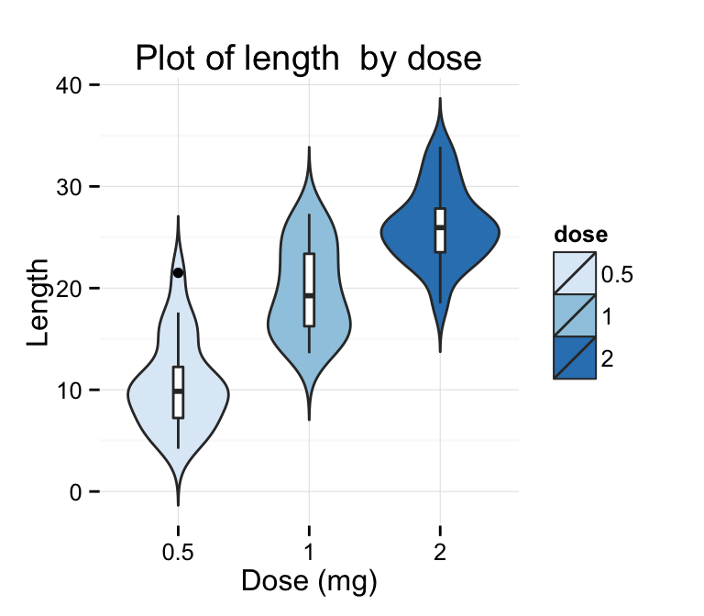

### 

### Question 9

You have examined a data set that has values for testosterone levels for male leopard seals that inhabit two different locales. One of the main research questions the team wants to answer with this data is whether or not there is a significant different in testosterone between these populations, and whether we can link this to agressive behavior towards the fishing team.

You ran a t-test to compare the means of testosterone levels between the two groups and were presented with the output below. How would you interpret the output of this test and communicate your findings to others?

##   
## Welch Two Sample t-test  
##   
## data: test_level by location  
## t = -4.2877, df = 182.08, p-value = 2.923e-05  
## alternative hypothesis: true difference in means is not equal to 0  
## 95 percent confidence interval:  
## -0.10827756 -0.04003074  
## sample estimates:  
## mean in group Lost Cove mean in group Western Reach   
## 1.130741 1.204896

### 

### Question 10

We’ve worked our way through three modules of material now since the beginning of the semester. Pick one topic we’ve covered so far (e.g. machine learning, joins, data visualization, summarizing, t-tests) and briefly describe how it might be useful to you in your future work (3-7 sentences).