Velg to språk

Welcome to a place of knowledge Frontpage

Learn more Frontpage

We have created an app that makes learning fun and exciting, where there is no restriction of knowledge.

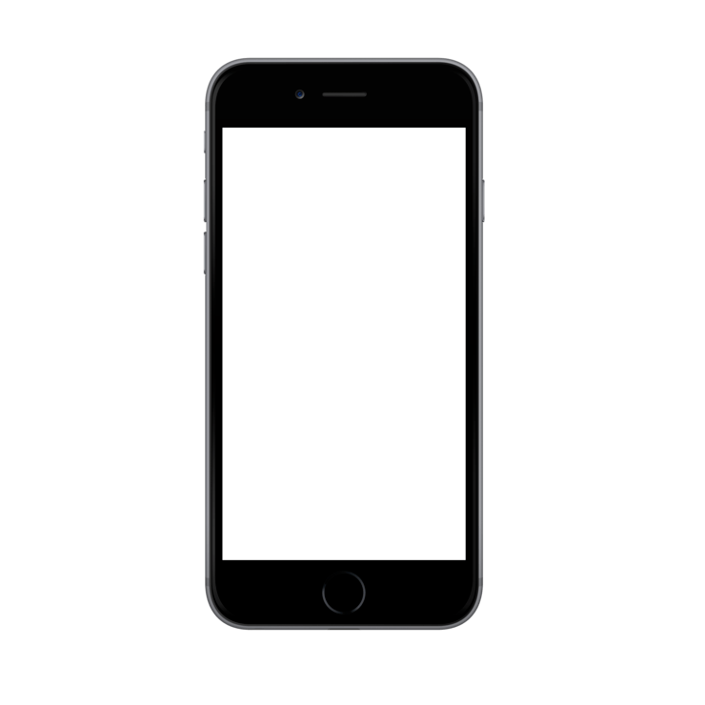**One div for all the paragraphs**

We have made the games for kids, making them easy to play and easy to learn based, but if you feel the necessity for a more intermediate experience you can change the difficulty.



**One div for the right side and one for left**

The app has several different games with different

Tasks, the first game is math based and will help kids learn

Numbers, addition, subtractions, multiplications and divisions.



The second game is based on language, here you can learn how to write sentences, use grammar and different rules of the English language. The exercises vary from translation to I input of correct grammar.



The third game is based on geography and the

Goal here is to learn about continents, countries,

Cities and whatever you want to learn about the world.



For people with bad vision we have created an option with voice command, where the questions are read out to the user. Making the application able to work for everyone is what we strive for.

The world of knowledge should be available for everyone and the world of technology should make it easy accessible for everyone. That’s what our goal is.

About us:

We are an independent game creator company who wants to provide fun ways of learning to everyone, our apps are easy to use and easy to access, meaning there is no requirement to create an account or to pay for the app. We started out as three people from The University of Don with degrees in programming and development, we made a plan to give out all the knowledge we have gained during our lives blab la bla.

