Title

Abstract
Setting:
Intervention:
Outcomes:
Implication:
Keywords:

Résumé
État Actuel:
Intervention:
Résultats:
Implication:
Mots clés:

Introduction (heading #1)
Block quote
Main text

Background (heading #1)

Sub-heading (heading #2)
More text

Methods (heading #1)

Sub-heading (heading #2)

Results

Discussion

References
Example of a reference (Bibliography style)

Appendix
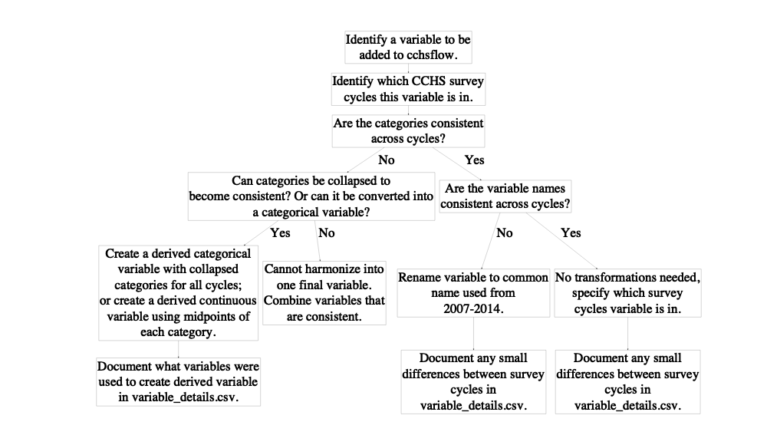
Figure 1: Flowchart of how CCHS variables were added to cchsflow. Users can add variables using the same approach.
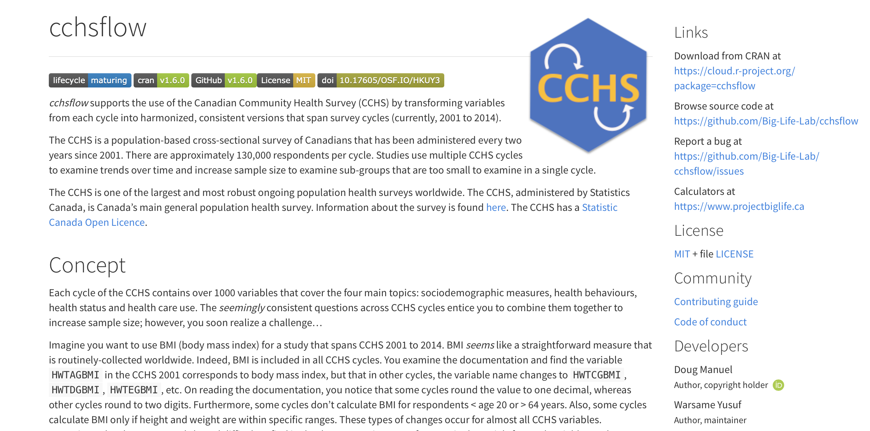
Figure 2: The homepage for the cchsflow website.
install.packages("cchsflow")
Figure 3a: The command line to install the cchsflow package that is currently saved on CRAN.
devtools::install_github("Big-Life-Lab/cchsflow")

