# Title

## Abstract

**Setting:**

**Intervention:**

**Outcomes:**

**Implication:**

**Keywords:**

## Résumé

**État Actuel:**

**Intervention:**

**Résultats:**

**Implication:**

**Mots clés:**

## Introduction (heading #1)

Block quote

Main text

## Background (heading #1)

### Sub-heading (heading #2)

More text

## Methods (heading #1)

### Sub-heading (heading #2)

## Results

## Discussion

## References

Example of a reference (Bibliography style)

## Appendix

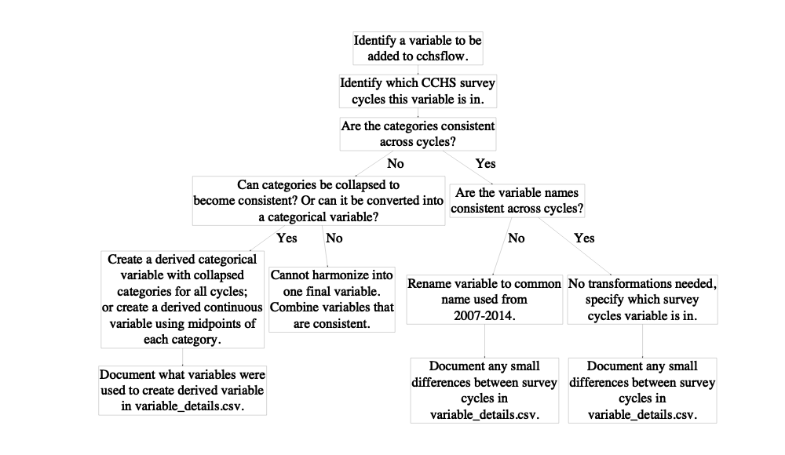

**Figure 1**: Flowchart of how CCHS variables were added to *cchsflow*. Users can add variables using the same approach.

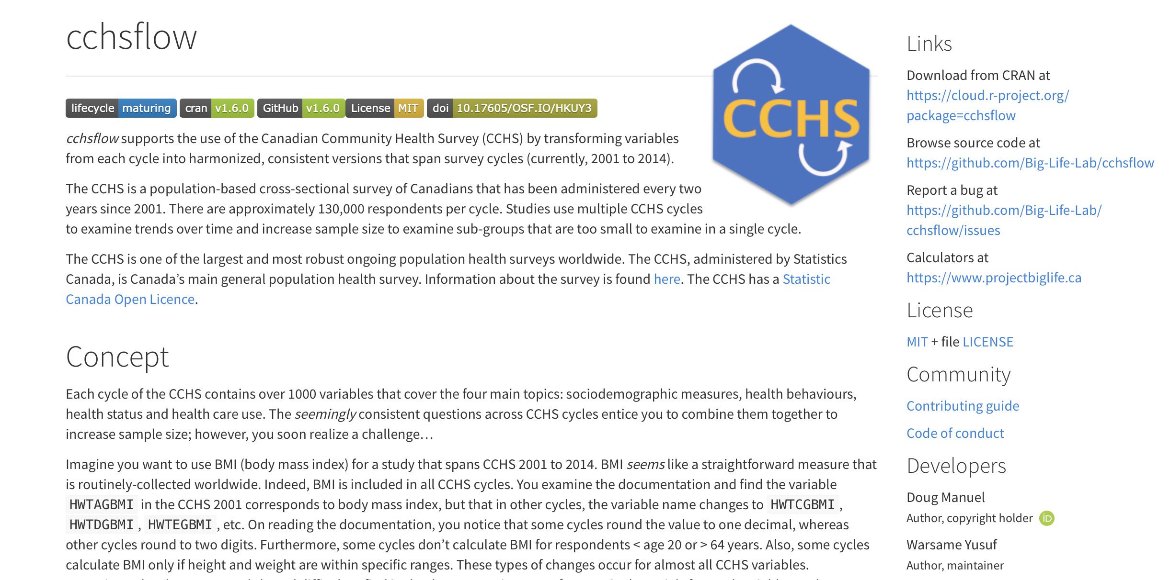

**Figure 2:** The homepage for the *cchsflow* website.

install.packages("cchsflow")

**Figure 3a:** The command line to install the *cchsflow* package that is currently saved on CRAN.

devtools::install_github("Big-Life-Lab/cchsflow")