AI-POWERED PNEUMONIA SCREENING FROM CHEST X-RAYS
A Deep Learning Classifier with Dual Visual Explainability, Multi-Architecture Benchmarking, and a Full-Stack Web Application
Group 7
NITDA Data Science Advanced (Machine Learning)
Okoli Praise Daniel (Group Leader)
Fatimat Ismaila(Assistant)
Faruk Muhammed
Muhammad Abdulazeez
Sefinatu Abdulai
Kammaluchuckwu Amah

Abstract
Pneumonia remains a leading cause of global infectious morbidity and mortality, placing immense diagnostic pressure on radiology departments and acute-care units. Chest radiography (CXR) is the primary frontline imaging tool; however, high daily scan volumes frequently lead to radiologist fatigue and delayed triage. This study presents an end-to-end, explainable AI decision-support platform that classifies chest X-rays as NORMAL or PNEUMONIA, substantiates its predictions visually, and serves them through a full-stack clinical web interface. The dataset consists of approximately 5,800 chest X-rays (Kermany et al., 2018), selected for its public accessibility, which supports reproducibility and open auditing. To correct validation instability caused by an undersized default split, the data was restructured into a working split of 4,412 training, 794 validation, and 618 held-out test images.
To select the classification engine on empirical evidence, a multi-architecture benchmark was conducted under identical data splits, loss functions, and hyperparameters, evaluating MobileNetV2, DenseNet121, and ResNet50. MobileNetV2 was selected as the core backbone for its strong balance of high diagnostic sensitivity and computational efficiency, achieving 91.3% accuracy and 95.6% pneumonia recall on the held-out test set. To address the black-box nature of neural networks, a dual explainability pipeline combining Grad-CAM and LIME was integrated, allowing clinicians to cross-verify model activations over pulmonary regions. The model was embedded in a deployed full-stack web application (a Next.js/React frontend with a FastAPI backend over a shared Python core, backed by an SQLite database), featuring clinician authentication, patient screening logs, interactive confidence-threshold and heatmap-opacity controls, exportable PDF reports, 62 automated tests, and public deployment via a hosted frontend and a secure tunnel. The system is positioned strictly as a clinical triage aid designed to accelerate radiologist review, not to replace medical expertise.
Keywords: Deep Learning, Transfer Learning, MobileNetV2, DenseNet121, ResNet50, Pneumonia Detection, Chest Radiography, Grad-CAM, LIME, Explainable AI (XAI), Streamlit, Full-Stack Healthcare Deployment.

1. Introduction
Chest radiography (CXR) is the most frequent, cost-effective, and rapidly accessible diagnostic imaging modality in clinical medicine, and the primary frontline tool for detecting lower respiratory tract infections such as pneumonia. Despite its availability, interpreting radiographs in high-throughput settings presents operational bottlenecks: high patient volume subjects radiologists to diagnostic fatigue, increasing the risk of missing early, subtle, or low-density consolidations, and in acute care, delays in triage can worsen outcomes (Siddiqi & Javaid, 2024).
To alleviate this burden, deep convolutional neural networks (CNNs) have emerged as powerful tools for medical image classification (Salehi et al., 2023; Siddiqi & Javaid, 2024). Through transfer learning — fine-tuning feature extractors pre-trained on large image repositories — deep models achieve strong classification performance without requiring millions of expert-annotated medical scans (Avola et al., 2022; Al Reshan et al., 2023). However, translating these models into functional healthcare tools requires overcoming four gaps evident in the literature:
- The deployment and usability gap: most medical image classifiers remain inside offline notebooks; clinicians need usable web interfaces that handle uploads, persist patient logs, and display real-time inferences.
- The single-explainability limitation: standalone methods such as Grad-CAM give coarse heatmaps; coupling gradient-based with perturbation-based methods (LIME) provides dual verification that can increase clinician trust (Muhammad & Bendechache, 2024).
- Lack of architectural benchmarking: many works adopt heavy networks without testing whether lightweight models match them at lower cost (Al Reshan et al., 2023; Yao et al., 2025).
- Data accessibility and auditability: public datasets (e.g. Kermany et al., 2018) enable reproducibility and honest reporting of population biases (Catalá et al., 2021).
This project presents an end-to-end screening platform that bridges these gaps: a MobileNetV2 transfer-learning backbone benchmarked against DenseNet121 and ResNet50, dual explainability via Grad-CAM and LIME, and a full-stack Streamlit + SQLite application deployed via an ngrok tunnel. It is designed strictly as a decision-support triage tool that highlights high-risk cases for rapid radiologist review, not as a replacement for clinical authority.
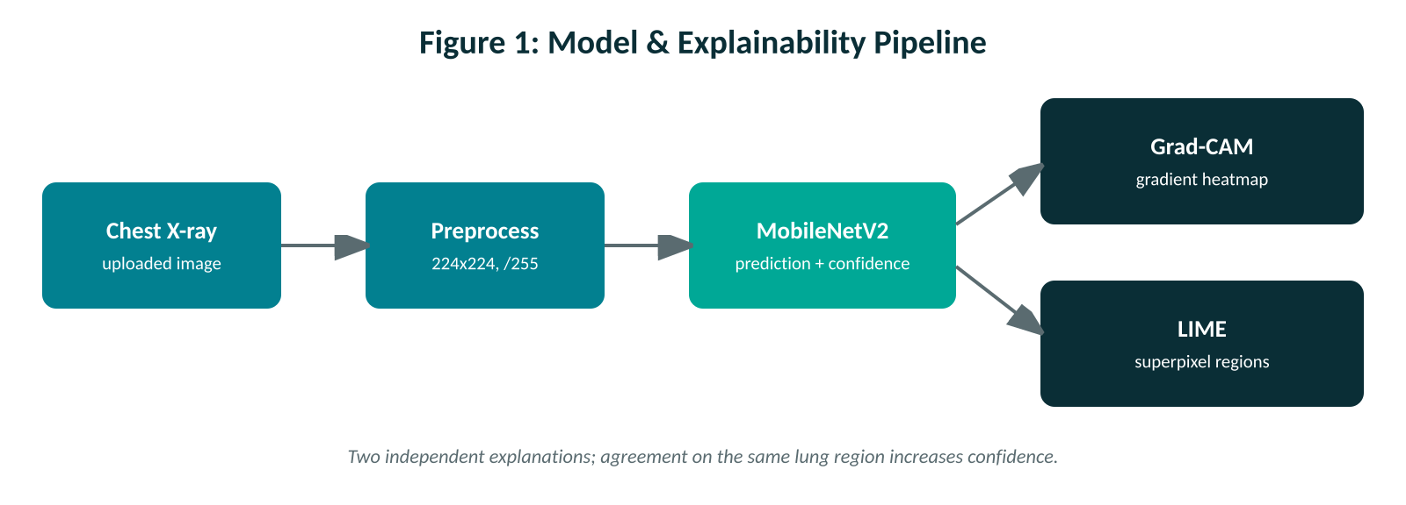
Figure 1: Model and Explainability Pipeline.

2. Problem Statement
Radiologists reviewing high volumes of chest radiographs face diagnostic fatigue and cognitive overload, particularly during peak respiratory seasons. Subtle or early-stage opacities can be overlooked, leading to delayed intervention. While automated models show promise, existing solutions exhibit four limitations: opaque black-box predictions without visual evidence; the absence of full-stack clinical workflows (database, authentication, history, interactive controls); unjustified architectural choices made without benchmarking lightweight against heavier networks; and unmitigated class imbalance that can yield dangerous false-negative rates. There is a need for an automated, highly sensitive, benchmarked, and dual-explainable screening framework that rapidly flags chest X-rays for pneumonia, visually substantiates its decisions, and provides a full-stack interface for triage support.

3. Objectives
- Multi-architecture benchmarking: train and compare MobileNetV2, DenseNet121, and ResNet50 under identical conditions to select the optimal model on evidence.
- Prioritising disease recall: apply class-weighted loss to mitigate imbalance and maximise pneumonia sensitivity, avoiding dangerous false negatives.
- Dual explainability: integrate Grad-CAM and LIME so clinicians can cross-verify model attention over anatomical lung regions.
- Full-stack web application: build a Streamlit app backed by SQLite/SQLAlchemy with authentication, patient persistence, interactive controls, and PDF export.
- Deployment and open benchmarking: deploy publicly via an ngrok tunnel using a public dataset to ensure reproducibility and transparent bias reporting.

3.1 Research Questions
- How effectively can a lightweight model (MobileNetV2) classify chest X-rays while maintaining high pneumonia recall?
- How does MobileNetV2 compare with DenseNet121 and ResNet50 on accuracy, recall, and AUC under identical conditions?
- How does class-weighted loss mitigate imbalance without discarding training samples?
- To what extent do Grad-CAM and LIME corroborate each other in identifying pathological lung regions?
- How effectively can the classifier be wrapped in a database-backed web interface and served publicly for triage?
- What population and technical biases exist in public CXR datasets, and how do they affect generalisability?

4. Scope and Boundaries

4.1 In Scope
- Binary classification of chest X-rays (NORMAL vs PNEUMONIA).
- Empirical benchmarking of MobileNetV2, DenseNet121, and ResNet50.
- Dual explainability via Grad-CAM heatmaps and LIME superpixel visualisations.
- A full-stack Streamlit application with SQLite/SQLAlchemy: authentication, patient history, threshold/opacity controls, PDF export.
- Public deployment via an ngrok secure tunnel, with transparent reporting of trade-offs and dataset bias.

4.2 Out of Scope
- Lesion localization / bounding boxes or segmentation (the dataset is folder-annotated for classification).
- Bacterial/viral/fungal subtype differentiation or co-occurring pathologies.
- Other modalities (CT, MRI, ultrasound).
- Autonomous diagnosis — the system is strictly decision-support.

5. Background and Literature Review
The integration of deep learning into chest radiography has progressed from standard CNNs to transfer learning, dual explainability, and full-stack deployment. This section reviews literature published between 2021 and 2026, together with the original dataset source (Kermany et al., 2018).

5.1 Deep Learning and Transfer Learning in Medical Imaging
Training deep networks from scratch on limited medical data frequently causes overfitting. Transfer learning overcomes this by transferring knowledge from models pre-trained on large datasets such as ImageNet. Surveys by Salehi et al. (2023) and Siddiqi and Javaid (2024) indicate that fine-tuning pre-trained models yields higher sensitivity and faster convergence than custom CNNs. Kundu et al. (2021) showed transfer-learning ensembles achieving over 98% accuracy on benchmark data, reinforcing that pre-trained extractors preserve discriminative features across imaging domains.

5.2 Architectural Selection: MobileNetV2 vs DenseNet121 vs ResNet50
Selecting an architecture requires balancing precision against memory and speed. Higher-capacity networks such as ResNet50 (~23.5M parameters) and DenseNet121 (~7.0M parameters) offer deep feature hierarchies but impose larger footprints and higher latency. Yao et al. (2025) compared VGG16, MobileNet, and ResNet152 for multi-class CXR classification and found the deeper network strongest on that dataset, while Al Reshan et al. (2023) evaluated eight networks across two CXR datasets and found MobileNet gave the best accuracy (94.23% and 93.75%). These mixed findings show the best backbone depends on dataset and task, which motivates the direct, identical-condition benchmark reported here. MobileNetV2 (~2.2M parameters), with depthwise-separable convolutions and linear bottlenecks, achieves strong accuracy with minimal overhead (Al Reshan et al., 2023; Avola et al., 2022), making it practical for cloud-hosted web platforms.

5.3 Preprocessing, Channel Formatting, and Augmentation
Chest X-rays are single-channel grayscale, but pre-trained architectures expect 3-channel RGB input (224x224x3); replicating the grayscale channel across three channels lets the network reuse pre-trained low-level filters. Standard pipelines often use horizontal flipping, but this must be avoided in chest radiography because thoracic anatomy has a fixed left-right orientation (e.g. cardiac position); flipping creates anatomically non-viable scans. Safe augmentations are restricted to small rotations (+/-10 degrees), minor brightness changes, and limited zoom.

5.4 Dual Explainability (Grad-CAM and LIME)
Clinical adoption depends on transparency. Literature emphasises combining gradient-based and model-agnostic methods to increase credibility (Muhammad & Bendechache, 2024). Grad-CAM produces a heatmap from gradients into the final convolutional layer, giving broad focus areas; LIME segments the image into superpixels and perturbs them to identify localised regions driving the prediction. When both highlight the same opacity, clinician confidence can increase.

5.5 Dataset Accessibility and Bias
The public collection of Kermany et al. (2018) is an open benchmark for binary pneumonia classification, enabling auditing and prototyping without restrictive data-access protocols. However, public datasets carry biases: Catalá et al. (2021) showed these collections are predominantly pediatric and single-centre, and that networks can learn background padding, borders, or text markers rather than true pathology. Reporting these biases openly and pairing predictions with visual explainability guards against misplaced trust.
Table 1: Summary of Literature Support (2021–2026)
Research Domain | Referenced Studies | Key Findings / Relevance
Transfer learning in CXR | Salehi et al. (2023); Kundu et al. (2021); Siddiqi & Javaid (2024) | Fine-tuning pre-trained weights outperforms CNNs trained from scratch.
Architectural selection | Avola et al. (2022); Al Reshan et al. (2023); Yao et al. (2025) | Lightweight backbones can match heavier ones, but results vary by dataset/task.
Preprocessing & channels | Project design decision | Grayscale→3-RGB preserves pre-trained weights; horizontal flips excluded (anatomy).
Dual explainability | Muhammad & Bendechache (2024) | Grad-CAM + LIME give complementary visual verification of lung regions.
Dataset bias audit | Catalá et al. (2021); Siddiqi & Javaid (2024) | Public datasets aid reproducibility but carry pediatric skew and artifact-leakage risks.

6. Methodology
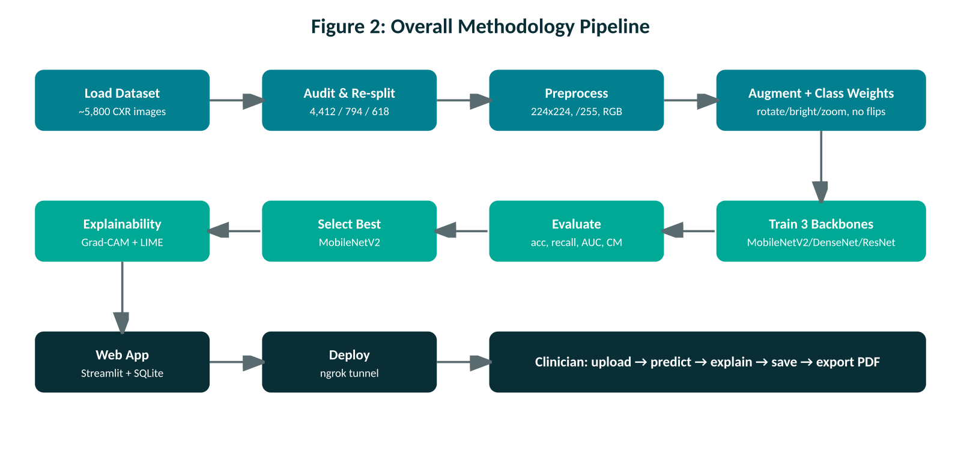
Figure 2: Overall Methodology Pipeline.

6.1 Dataset Restructuring and Audit
The dataset consists of approximately 5,800 chest X-rays in two folders, NORMAL and PNEUMONIA (Kermany et al., 2018), selected for public accessibility and reproducibility. An initial audit revealed that the default validation split contained only 16 images, causing extreme validation-metric fluctuation. A portion of the training set was reallocated to validation, producing a working split of 4,412 training, 794 validation, and 618 held-out test images. The dataset exhibits class imbalance, with more pneumonia than normal scans.

6.2 Handling Class Imbalance and Data Augmentation
To address imbalance without deleting images, class weighting was applied within the binary cross-entropy loss, computed inversely proportional to class frequencies so the minority (NORMAL) class receives higher loss weight. All images were resized to 224x224 and converted from grayscale to 3-channel RGB by replicating the channel. Training augmentations were constrained to medical-domain rules: small rotations (+/-10 degrees), minor brightness adjustment, and limited zoom (0.9x–1.1x). Horizontal flips were deliberately excluded because thoracic anatomy has a fixed left-right orientation.

6.3 Model Architectures and Multi-Model Comparison
To select the backbone on empirical evidence, three pre-trained CNNs were evaluated under identical conditions. In each case the base layers were frozen as a feature extractor and a custom head was appended: Global Average Pooling, a Dense layer (64 units, ReLU), Dropout (p = 0.3), and a Sigmoid output neuron.
- MobileNetV2 (primary): a lightweight network using depthwise-separable convolutions and linear bottlenecks.
- DenseNet121: a densely connected network testing whether dense feature reuse improves subtle-opacity detection.
- ResNet50: a deep residual network testing whether residual representations yield higher recall.
All models were trained with the Adam optimiser and binary cross-entropy loss with class weighting, for 5 epochs each, under the same data generators and augmentation, so that any performance difference reflects the architecture alone. Trained weights were serialized in the .keras format.

6.4 Dual Explainability Engine (Grad-CAM and LIME)
Grad-CAM computes gradients of the predicted class with respect to the feature maps of the model's final convolutional layer. Because nested transfer-learning models cause duplicate-layer-name errors during standard re-instantiation, Grad-CAM was implemented via a manual layer-by-layer forward pass inside a tf.GradientTape() context; feature maps are weighted by pooled gradients, passed through ReLU, normalised, upsampled to 224x224, and overlaid as a colormap on the original X-ray. LIME segments the X-ray into superpixels, generates many perturbed variants by turning superpixel clusters on and off, passes them through the model, and fits a linear surrogate to quantify each superpixel's contribution. The two methods are presented together so their agreement can corroborate the explanation.

6.5 Full-Stack Web Application
The classifier is delivered as a deployed full-stack web application built around a shared Python core of UI-independent modules (model loading, preprocessing, Grad-CAM, LIME, PDF generation, database access, and authentication). Two interfaces run over this same core: an initial Streamlit application (retained as a fallback), and the deployed production interface, which pairs a Next.js and React frontend with a FastAPI backend. Keeping all logic in the shared core allowed roughly 70% of the code to be reused unchanged when the second interface was built. The backend uses SQLAlchemy over an SQLite database (and is Postgres-ready). Each screening persists the uploaded image, the predicted label, the raw pneumonia probability, the decision threshold, the clinician identifier, and a timestamp; storing the raw probability makes every saved result reproducible and re-thresholdable. The application provides clinician authentication, per-patient history, interactive confidence-threshold and heatmap-opacity controls, and exportable PDF reports. The codebase comprises roughly 4,350 lines across the backend, machine-learning layer, and frontend, and is covered by 62 automated tests.

6.6 Security, Privacy, and Testing
Because the system handles clinical data, security and privacy were treated as core requirements rather than afterthoughts. Passwords are stored only as bcrypt hashes with per-password salts and are never logged. Sessions use a signed JWT held in an HTTP-only, Secure, SameSite cookie that JavaScript cannot read; changing a password invalidates sessions on other devices. Every database query is scoped to the logged-in clinician, so one user cannot access another's patients or scans. Uploaded images are validated for type, size, and dimensions, re-encoded under random filenames to strip identifying EXIF metadata, and guarded against path-traversal. Account registration is gated by an invite code to prevent strangers creating accounts on a public URL, and no secrets are hard-coded. In the current deployment, all patient data and inference remain on the host machine; no image or patient data is sent to any external inference service. The application is verified by 62 automated tests covering authentication, preprocessing and threshold logic, upload rejection, per-user scoping, Grad-CAM and LIME outputs, and the generated PDF (including an automated check that forbidden diagnostic wording never appears).

6.7 Deployment
Achieving a public, zero-cost deployment was non-trivial because the backend requires full TensorFlow (for gradient-based Grad-CAM), roughly 2 GB of memory, and a long-running process — requirements that typical free serverless tiers do not meet. Several options were evaluated: a serverless-only host could not run the heavy backend; a container hosting service required a paid tier; and a managed cloud platform was blocked at payment verification (the code remains container-ready for that platform). The adopted solution runs the frontend on a free hosting tier (Vercel) and exposes the backend, running on a host machine, through a secure ngrok tunnel with a permanent URL. The frontend forwards interface requests to the backend through a same-origin server-side proxy, which keeps the login cookie same-origin and avoids cross-site cookie restrictions. The main trade-off of this tunnel approach is availability — the service is reachable only while the host machine is online — but its advantage is strong privacy, since patient data never leaves that machine. Permanent managed hosting is identified as the next deployment step.
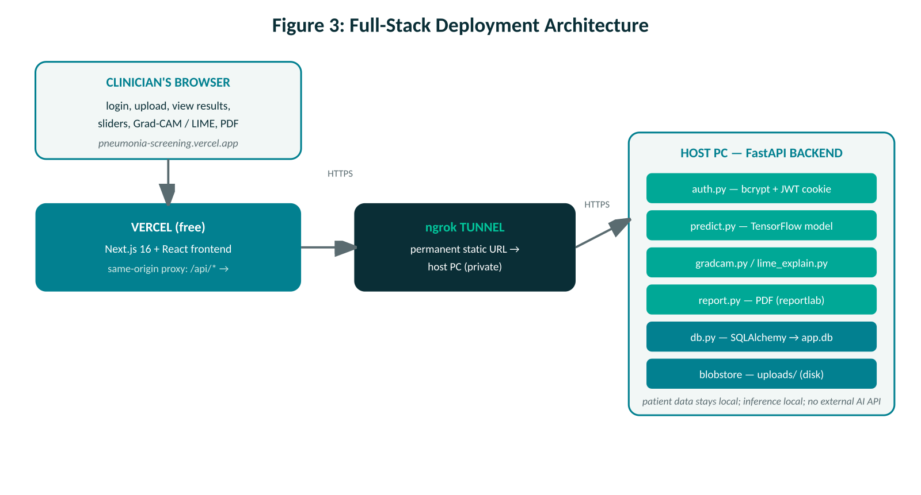
Figure 3: Full-Stack System Architecture.

6.6 Cloud Deployment via ngrok
The application was executed in Google Colab and exposed publicly using an ngrok secure tunnel, which maps the local Streamlit port (8501) to a public HTTPS URL, allowing remote access from any browser without software installation. This is appropriate for a prototype; the tunnel is temporary, so a production deployment would use permanent hosting such as Streamlit Community Cloud or Hugging Face Spaces.

7. Results and Findings

7.1 Primary Model Performance (MobileNetV2)
Evaluated on the 618 held-out test images, MobileNetV2 achieved an overall accuracy of 91.3%, with a pneumonia recall (sensitivity) of 95.6%, correctly identifying the large majority of active cases. Detailed metrics are shown below.
Table 2: Classification Metrics (MobileNetV2 Test Set)
Class | Precision | Recall (Sensitivity) | F1-Score | Support
NORMAL | 0.93 | 0.84 | 0.88 | 231
PNEUMONIA | 0.91 | 0.96 | 0.93 | 387
Overall Accuracy | — | — | 0.913 | 618

Table 3: Confusion Matrix Breakdown (MobileNetV2 Test Set)
Actual Class | Predicted NORMAL | Predicted PNEUMONIA
True NORMAL (231) | 194 (True Negatives) | 37 (False Positives)
True PNEUMONIA (387) | 17 (False Negatives) | 370 (True Positives)
Note: confusion-matrix counts are from the benchmark run that produced the metrics in Table 4; minor run-to-run variation from training randomness is expected.

7.2 Multi-Architecture Benchmark Comparison
To justify model selection, MobileNetV2, DenseNet121, and ResNet50 were trained and evaluated under identical conditions. The results are shown below.
Table 4: Empirical Architectural Benchmark
Model | Parameters | Accuracy | Pneumonia Recall | Normal Recall | AUC-ROC
MobileNetV2 | ~2.2M | 0.913 | 0.956 | 0.840 | 0.968
DenseNet121 | ~7.0M | 0.892 | 0.907 | 0.866 | 0.953
ResNet50 | ~23.5M | 0.765 | 0.891 | 0.554 | 0.851

MobileNetV2 was the strongest performer across the most important metrics, achieving the highest accuracy (91.3%), the highest pneumonia recall (95.6%), and the highest AUC (0.968) — while also being by far the smallest model (~2.2M parameters versus ~7.0M for DenseNet121 and ~23.5M for ResNet50). DenseNet121 performed comparably and achieved the best normal recall, but did not surpass MobileNetV2 on pneumonia recall or AUC. ResNet50 underperformed notably; as a deeper network, it typically requires more training epochs or partial unfreezing to converge, and with a frozen base and only 5 epochs it did not reach its potential, whereas the lighter MobileNetV2 adapted faster. These results confirm MobileNetV2 as the optimal choice for this task and for web deployment — it is simultaneously the lightest and the best-performing model under these conditions.

7.3 Explainability Findings and Shortcut-Learning Analysis
Beyond headline accuracy, the dual-explainability pipeline was used to interrogate WHY the model makes its predictions, and this analysis produced an important and cautionary finding that the project reports openly. On sample test images, although the classifications were correct, the explanations frequently did not centre on the lungs: Grad-CAM sometimes highlighted image borders, the diaphragm, or the upper abdomen rather than pulmonary fields, and for pneumonia cases LIME found only weak supporting evidence (top superpixel weights around 0.004-0.006, compared with roughly 0.16 for a normal case), meaning that hiding any single region barely changed the prediction. The two methods also agreed only weakly (approximately 0-26% overlap on the predicted class).
Taken together, these signals suggest the model may be relying in part on non-clinical cues in the image rather than on genuine pathology — a phenomenon known as shortcut learning, and a well-documented risk for the pediatric, single-source dataset used here, where networks can latch onto borders, padding, or text markers (Catala et al., 2021). Rather than conceal this, the application surfaces it directly: it displays a weak-evidence warning when the strongest region's influence is negligible, and reports a quantitative agreement score between Grad-CAM and LIME. This is precisely the value of integrating two independent explanation methods — their disagreement is itself diagnostic of an unreliable rationale. The appropriate remedies lie in the data-science pipeline rather than the application: segmenting or cropping the lung fields before training, and training on more diverse, multi-institution, adult-inclusive data. This finding reframes the project's high recall as necessary but not sufficient: a model can be accurate on a biased dataset while reasoning for the wrong reasons, and honest explainability is what makes that visible.

8. Project Contributions
- Dual explainability integration: combines Grad-CAM and LIME in a single clinician interface for cross-verification of lung regions.
- Full-stack clinical system: a multi-screen web platform with SQLite persistence, authentication, patient logs, and downloadable PDF reports.
- Interactive clinical controls: real-time confidence-threshold and heatmap-opacity sliders.
- Empirical architectural benchmarking: three backbones compared under identical conditions to justify model choice on measured evidence.
- Honest trade-off and bias reporting: pediatric cohort bias, false-negative rates, and deployment limitations documented transparently.

9. Limitations and Discussion
- Diagnostic trade-offs: the model misses a small number of pneumonia cases; it is a triage aid, not an autonomous authority.
- Pediatric dataset bias: sourced primarily from pediatric patients at a single centre, limiting direct generalisability to adults without fine-tuning.
- Coarse heatmap resolution: Grad-CAM highlights broad pulmonary fields rather than exact lesion boundaries.
- Possible shortcut learning: explainability analysis indicates the model may partly rely on non-clinical image cues rather than lung pathology; the app flags this, and the remedy (lung segmentation and more diverse data) is a data-science next step.
- Deployment availability: the current tunnel deployment is reachable only while the host machine is online; permanent managed hosting is the next step.

10. Conclusion and Future Work

10.1 Conclusion
This project developed and deployed a full-stack, dual-explainable AI decision-support platform for pneumonia screening from chest X-rays. MobileNetV2 achieved 91.3% accuracy and 95.6% pneumonia recall, outperforming the heavier DenseNet121 and ResNet50 on the most important metrics while using a fraction of their parameters. Dual visual explanations (Grad-CAM + LIME) provide diagnostic transparency, and a full-stack Streamlit/SQLite interface enables clinician authentication and patient-record tracking. The system is honest about its trade-offs and dataset bias.

10.2 Future Work
- Permanent cloud hosting: migrate from the temporary ngrok tunnel to Streamlit Community Cloud or Hugging Face Spaces.
- Batch triage workflow: a multi-file upload queue ranking scans by disease probability for emergency prioritisation.
- Address shortcut learning: apply lung segmentation/cropping before training so the model attends to pulmonary fields, directly targeting the bias revealed by the explainability analysis.
- Multi-centre adult validation: train and validate on adult cohorts (e.g. NIH ChestX-ray14) to improve multi-hospital generalisability.

11. Clinical Use-Case Scenario
- A clinician opens the web link and logs into their secure dashboard.
- They upload a patient's chest radiograph.
- The app outputs a classification (NORMAL or PNEUMONIA) with a confidence percentage.
- They examine side-by-side Grad-CAM and LIME overlays, adjusting opacity to inspect underlying structures.
- For subtle presentations, they lower the threshold slider to increase screening sensitivity.
- The screening is logged to the patient database and a PDF summary is exported for records.

References
Al Reshan, M. S., Gill, K. S., Anand, V., Gupta, S., Alshahrani, H., Sulaiman, A., & Shaikh, A. (2023). Detection of pneumonia from chest X-ray images utilizing MobileNet model. Healthcare, 11(11), 1561.
Avola, D., Bacciu, A., Cinque, L., Fagioli, A., Marini, M. R., & Taiello, R. (2022). Study on transfer learning capabilities for pneumonia classification in chest X-ray images. Computer Methods and Programs in Biomedicine, 221, 106833.
Catalá, O. D. T., Igual, I. S., Pérez-Benito, F. J., Escrivá, D. M., Castelló, V. O., Llobet, R., & Pérez-Cortés, J.-C. (2021). Bias analysis on public X-ray image datasets of pneumonia and COVID-19 patients. IEEE Access, 9, 42370–42383.
Kermany, D., Zhang, K., & Goldbaum, M. (2018). Labeled optical coherence tomography (OCT) and chest X-ray images for classification. Mendeley Data, v3.
Kundu, R., Das, R., Geem, Z. W., Han, G.-T., & Sarkar, R. (2021). Pneumonia detection in chest X-ray images using an ensemble of deep learning models. PLOS ONE, 16(9), e0256630.
Muhammad, D., & Bendechache, M. (2024). Unveiling the black box: A systematic review of explainable artificial intelligence in medical image analysis. Computational and Structural Biotechnology Journal, 24, 542–560.
Salehi, A. W., Khan, S., Gupta, G., Alabduallah, B. I., Almjally, A., Alsolai, H., Siddiqui, T., & Mellit, A. (2023). A study of CNN and transfer learning in medical imaging: Advantages, challenges, future scope. Sustainability, 15(7), 5930.
Siddiqi, R., & Javaid, S. (2024). Deep learning for pneumonia detection in chest X-ray images: A comprehensive survey. Journal of Imaging, 10(8), 176.
Sandler, M., Howard, A., Zhu, M., Zhmoginov, A., & Chen, L.-C. (2018). MobileNetV2: Inverted residuals and linear bottlenecks. IEEE CVPR, 4510–4520.
Yao, Y., Li, Y., Zheng, S., & Zhu, T. (2025). Deep learning models for multi-class pneumonia detection in chest X-rays: A comparative study of VGG16, MobileNet, and ResNet152 [Preprint]. Preprints.org.

