

assignment 1

Muhammad Umair Shakoor



https://github.com/Big-Raga/Assignment1.git

**TASK 1**

Approach- In this implementation, I created a circular doubly linked list to manage CPU processes. Each process is represented as a node containing attributes such as process ID, name, execution time, and remaining time. The `CLL` class provides various functionalities, including adding processes, executing them in cycles, and removing completed processes. During execution, each process's remaining time is decremented by a specified cycle time, allowing for efficient process management and scheduling. The approach effectively allows for dynamic process addition, showcasing how the list adapts to changes while ensuring that completed processes are promptly removed, thereby maintaining an accurate representation of the current workload.

**Assumptions**

I assumed that time shouldn’t be taken into account.

Also I assumed that I would have to enter the process myself

**Screenshots**

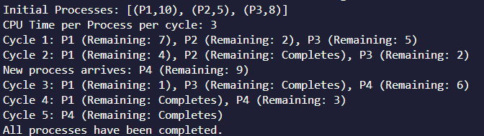

\

**TASK 2**

**Approach-**

In this implementation of the `LargeNumber` class, I adopted a linked list approach to efficiently manage and perform arithmetic operations on large numbers that exceed standard data type limits. Each digit of the number is stored as a node in the linked list, allowing for dynamic memory management and simplified manipulation of individual digits during operations such as addition, subtraction, multiplication, and division. The methods leverage comparisons between linked list representations to accurately execute arithmetic, ensuring that operations handle numbers of varying lengths. Additionally, I incorporated a primality test using the Rabin-Miller algorithm, enhancing the class's functionality for mathematical computations involving large numbers. However my laptop crashed often so the accuracy cannot be guaranteed.

**Assumptions**

We have to operate node by node

**Challenges Faced**

Implementing arithmetic operations and

My laptop kept crashing a lot

**Screenshots**

