Twisted Fusionz web design assessment documentation

The website is a mock up for a small homegrown business I run with my finds. This will also be the theme for the finished website.The web page is split into 5 sub sections that will each focus on different aspects of the business.

Home

The home page, known as the index page in the code, will be the landing page for the website and currently has a mock content video of ryan reynolds that will be replaced by a professional showcase of the products and services. Throughout the website I have chosen a 4 part color scheme using blue or rgba(17, 76, 153, 0.473) as our primary coloring and a contrasting colour on the opposite side of the color spectrum as the secondary color which is a light grey or rgba(87, 63, 35, 0.589). Then finally a simple black text on white background for body text. The positioning of the video was done using bootstrap linked to the code here

<link href="https://cdn.jsdelivr.net/npm/bootstrap@5.1.1/dist/css/bootstrap.min.css" rel="stylesheet" integrity="sha384-F3w7mX95PdgyTmZZMECAngseQB83DfGTowi0iMjiWaeVhAn4FJkqJByhZMI3AhiU" crossorigin="anonymous">

<body>

By applying the class="position-absolute top-50 start-50 translate-middle" I was able to center the video in the middle of the page that still works mostly when shrunken down to mobile sizes(see later stage for more details)

About us

The about us page is currently very empty and filled with lorem ipsum mock text thats been formated under the class .bodyText which reads as,

.bodyText{

font-family: 'Playfair Display', serif;

text-align: center;

}

This is the main font for the website and was chosen for its simple but not basic look. This will definitely be the font for all headers and bold text but large amounts of small text may still be changed out for a different font to provide a 2 tonne feel to the site and make it less uniform.

Products

The about us page is currently very empty and filled with lorem ipsum mock text thats been formated under the class .bodyText which reads as,

.bodyText{

font-family: 'Playfair Display', serif;

text-align: center;

}

This is the main font for the website and was chosen for its simple but not basic look. This will definitely be the font for all headers and bold text but large amounts of small text may still be changed out for a different font to provide a 2 tonne feel to the site and make it less uniform. The chosen font Playfair display that was found in google fonts and linked into the page with a link before the head

<link rel="preconnect" href="https://fonts.googleapis.com">

<link rel="preconnect" href="https://fonts.gstatic.com" crossorigin>

<link href="https://fonts.googleapis.com/css2?family=Playfair+Display&display=swap" rel="stylesheet">

Contact us

This is by far the busiest page by far involves the form and the map. The map was as simple as copying and pasting the HTML insert on google maps and styling in html with a class to set the font and the alignment for the text to go with it.

<div>

<div>

<p class="FormMap">Find us at any of our locations on the map below</p>

<div class="map" >

<iframe src="https://www.google.com/maps/embed?pb=!1m18!1m12!1m3!1d3156.5302622374124!2d176.2845790155994!3d-37.707229479771755!2m3!1f0!2f0!3f0!3m2!1i1024!2i768!4f13.1!3m3!1m2!1s0x6d6e764d59b14025%3A0x29650b5d8ee3c3f7!2s14%20Doncaster%20Drive%2C%20Papamoa%20Beach%2C%20Papamoa%203118!5e0!3m2!1sen!2snz!4v1629684586457!5m2!1sen!2snz" width="400" height="250

" style="border:0;" allowfullscreen="" loading="lazy"></iframe>

<div>

The next stage of the page is the form which is a very simple form consisting of labels then br’s and input tag thats then styled using the FormFont class found under the /\* form \*/ section of the css page.

/\* form \*/ css

input, textarea{

width: 50%;

padding: 12px 20px;

margin: 8px 0;

box-sizing: border-box;

}

-----

<!--Form html -->

<div class="center">

<form>

<h3>Contact form</h3>

<label class="FormFont" >Full Name</label>

<br>

<input style="width: 25%;" type="text" name="Fullname">

<br>

<label class="FormFont" >Email Adress</label>

<br>

<input style="width: 25%;" type="email" name="email">

<br>

<label class="FormFont" >Breif describtion of what you want</label>

<br>

<textarea name="message" rows="5"></textarea>

<br>

<input type="submit" name="submit" value="submit">

</form>

<div>

Services

The Services page is still work in progress and currently filled with Lorum Ipsum mock text that will have a functional online shop by the end of the next assessment.

Navbar

The navbar was the largest part of this project and was done with an unorder list <li> with list contents that link to each page of the webpage mentioned above the navbar is then styled in the .navlist class in the css code under the comment navigation bar top.

The html for the list is as follows: <!--navlist top-->

<div>

<ul class="navlist">

<li><a class="active" href="index.html">HOME</a></li>

<li><A href="about us.html">ABOUT US</A></li>

<li><a href="Products.html">PRODUCTS</a></li>

<li><a href="Contact us.html">CONTACT US</a></li>

<li><a href="Tattoos.html">SERVICES</a></li>

</ul>

<div>

The styling in the css uses the float left feature to align the text as a bar and looks like this

/\* navagation bar top\*/

.navlist li{

float: left;

}

.navlist li a {

display: block;

padding: 20px;

text-decoration: none;

text-align: center;

color:white;

}

.navlist{

background-color:rgba(17, 76, 153, 0.473);

margin: 0%;

padding: 0%;

width: 100%;

overflow: hidden;

font-family: 'Playfair Display', serif;

list-style-type: none;

}

.navlist li a:hover{

background-color: rgba(87, 63, 35, 0.589)

}

li a :hover:not(.active),.active{

background-color: rgba(87,63, 35,0.589);

}

Nav bar bottom

The navbar bottom uses all the same principles as the navbar top with the exception of text size and the hover and active classes.

Uploaded below is screenshots of the 5 webpages in both full screen monitor size and a smaller mobile representation. See annotations above each screenshot for notes

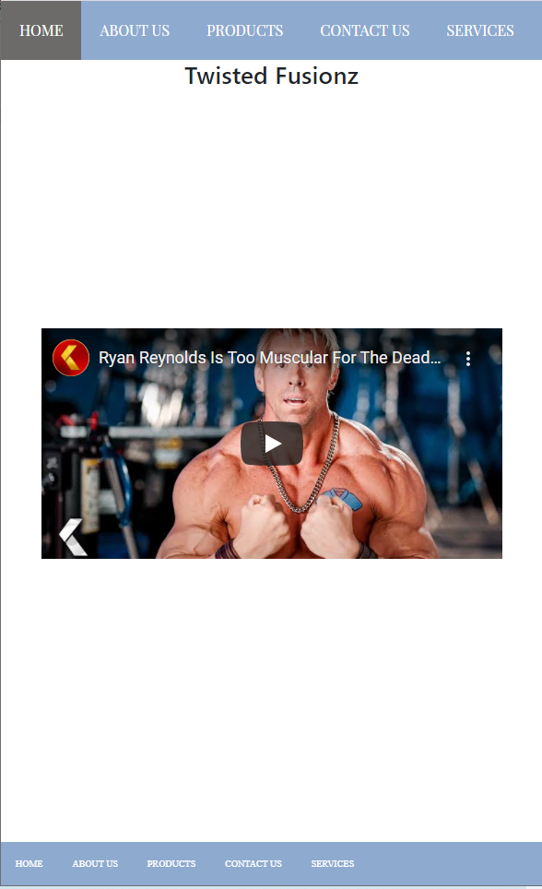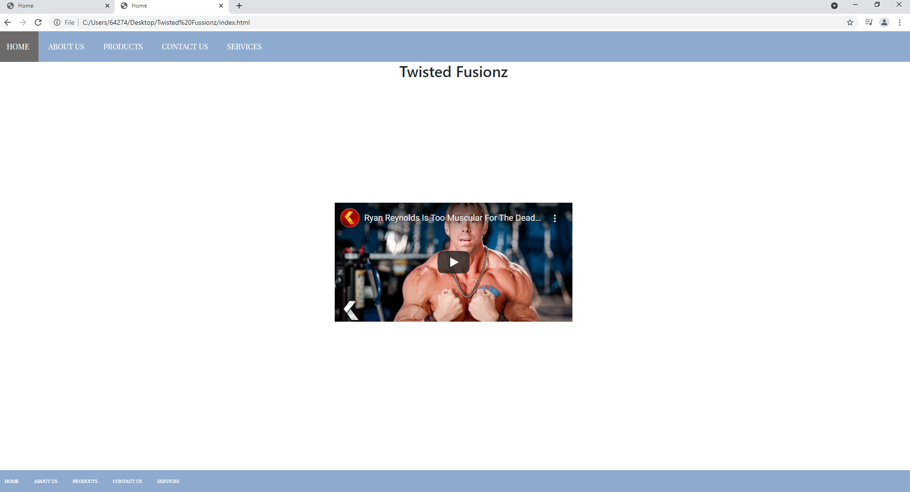

Problems with video size not properly changing to scale for mobile screens must be addressed

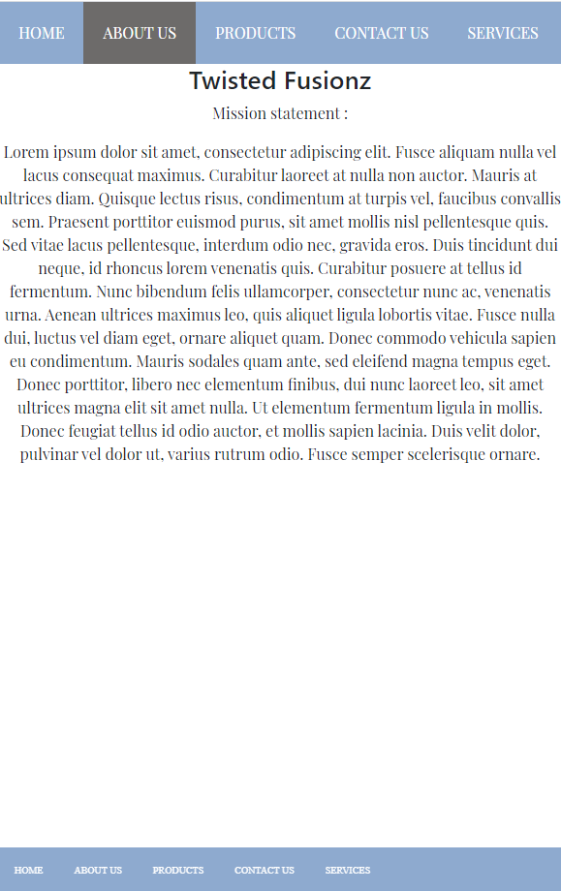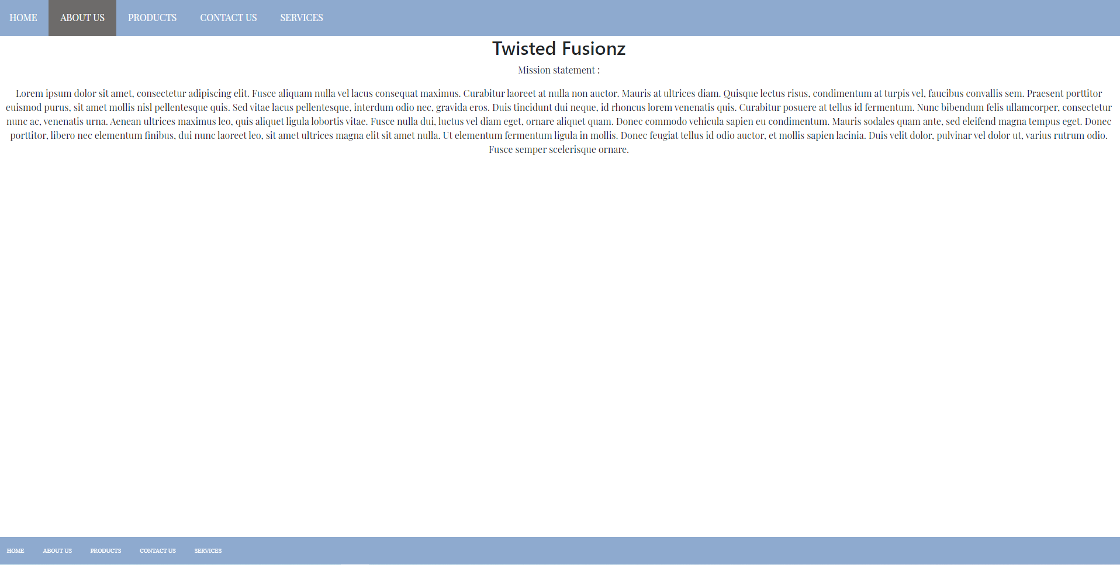

As one of the empty pages there is very little to fault here , text size and orientations still looks good in a mobile mode

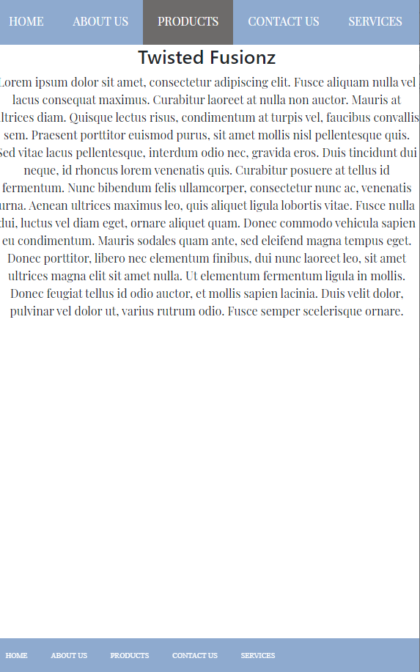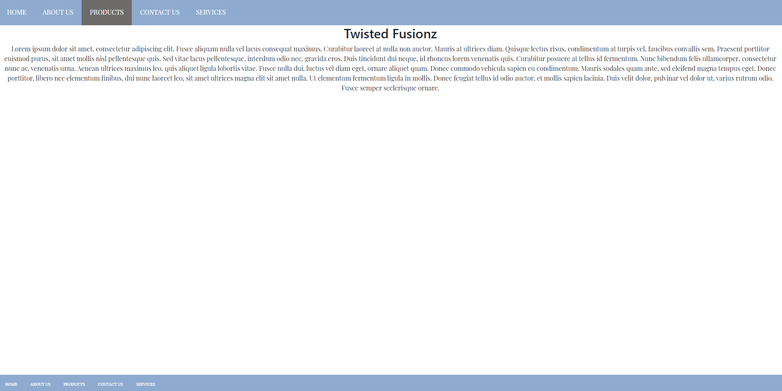

As one of the empty pages there is very little to fault here , text size and orientations still looks good in a mobile mode

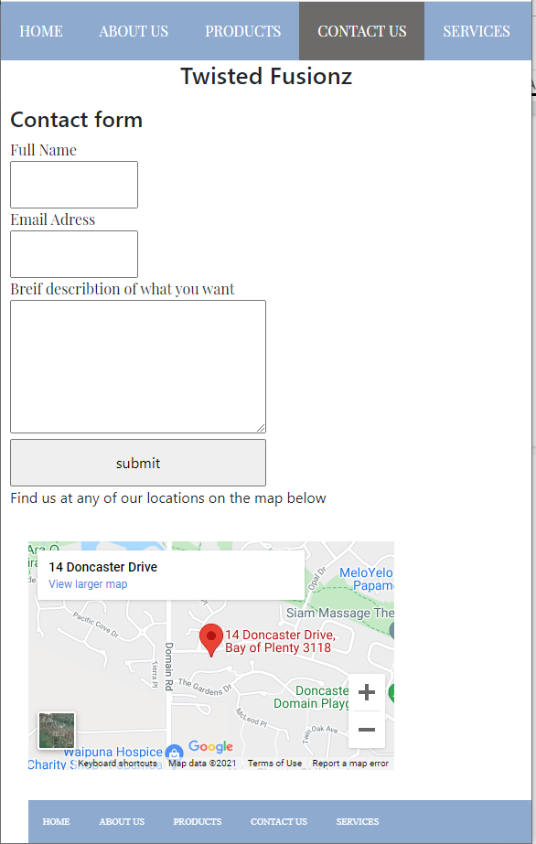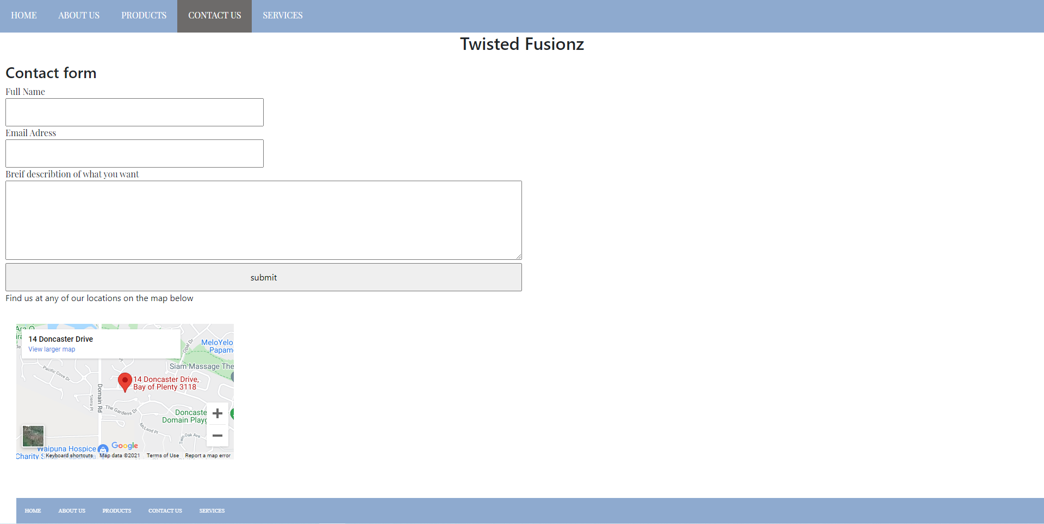

Problem with bottom navbar using the same padding as the map must be addressed and fixed asap

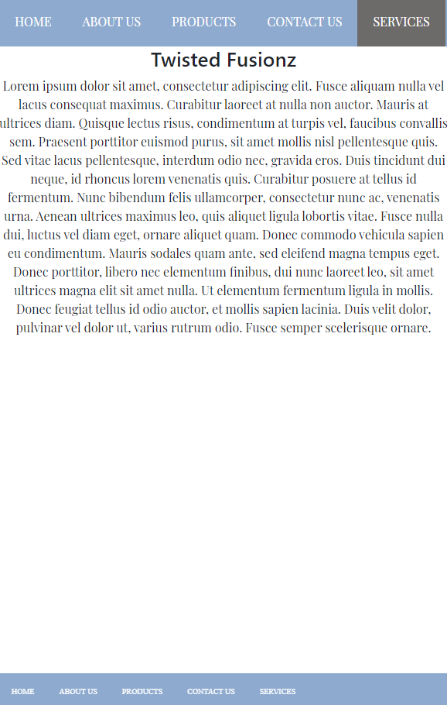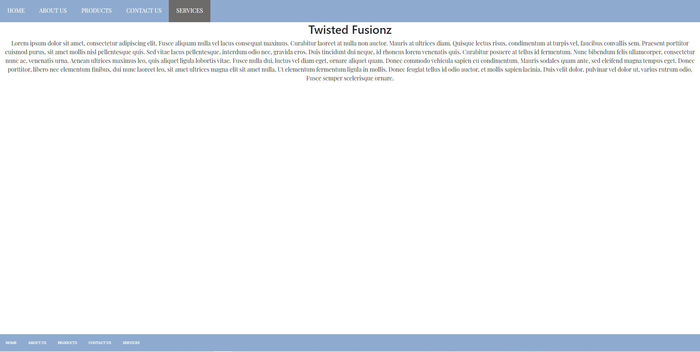

As one of the empty pages there is very little to fault here , text size and orientations still looks good in a mobile mode