# GradientBoostingRegressor

**import** pandas **as** pd  
**import** numpy **as** np  
df = pd.DataFrame([[1,5.56],[2,5.7],[3,5.91],[4,6.4],[5,6.8],[6,7.05],[7,8.9],[8,8.7],[9,9],[10,9.05]])  
X = df.iloc[:,[0]]  
Y = df.iloc[:,-1]  
**from** sklearn.ensemble **import** GradientBoostingRegressor  
model = GradientBoostingRegressor(max_depth=1,n_estimators=20)  
model.fit(X,Y)  
print(model.predict(X))

## fit

*fit initial model - FIXME make sample_weight optional*

### self.init_.fit(X, y, sample_weight)



*init predictions*

### y_pred = self.init_.predict(X)

y.fill(self.mean)

*fit the boosting stages*

### n_stages = self._fit_stages(X, y, y_pred, sample_weight, random_state,begin_at_stage, monitor, X_idx_sorted)

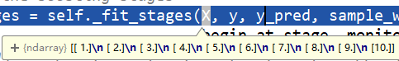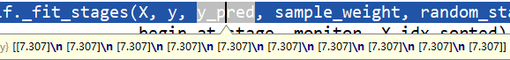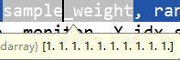

*# perform boosting iterations*i = begin_at_stage  
**for** i **in** range(begin_at_stage, self.n_estimators):  
 *# fit next stage of trees* y_pred = self._fit_stage(i, X, y, y_pred, sample_weight,sample_mask, random_state, X_idx_sorted,X_csc, X_csr) **return** i + 1

#### _fit_stage(self, i, X, y, y_pred, sample_weight, sample_mask,random_state, X_idx_sorted, X_csc=None, X_csr=None)

*K : int  
 The number of regression trees to be induced;  
 1 for regression and binary classification;  
 ``n_classes`` for multi-class classification.  
"""*

**for** k **in** range(loss.K):  
 residual = loss.negative_gradient(y, y_pred, k=k,  
 sample_weight=sample_weight)  
 *# induce regression tree on residuals* tree = DecisionTreeRegressor(  
 criterion=self.criterion,  
 splitter=**'best'**,  
 max_depth=self.max_depth,  
 min_samples_split=self.min_samples_split,  
 min_samples_leaf=self.min_samples_leaf,  
 min_weight_fraction_leaf=self.min_weight_fraction_leaf,  
 min_impurity_decrease=self.min_impurity_decrease,  
 min_impurity_split=self.min_impurity_split,  
 max_features=self.max_features,  
 max_leaf_nodes=self.max_leaf_nodes,  
 random_state=random_state,  
 presort=self.presort)  
  
 **if** X_csc **is not None**:  
 tree.fit(X_csc, residual, sample_weight=sample_weight,  
 check_input=**False**, X_idx_sorted=X_idx_sorted)  
 **else**:  
 tree.fit(X, residual, sample_weight=sample_weight,  
 check_input=**False**, X_idx_sorted=X_idx_sorted)  
  
 *# update tree leaves* **if** X_csr **is not None**:  
 loss.update_terminal_regions(tree.tree_, X_csr, y, residual, y_pred,  
 sample_weight, sample_mask,  
 self.learning_rate, k=k)  
 **else**:  
 loss.update_terminal_regions(tree.tree_, X, y, residual, y_pred,  
 sample_weight, sample_mask,  
 self.learning_rate, k=k)  
  
 *# add tree to ensemble* self.estimators_[i, k] = tree  
  
**return** y_pred

##### negative_gradient(self, y, pred, **kargs):

**return** y - pred.ravel()

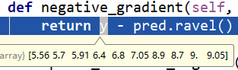

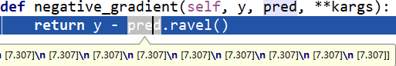

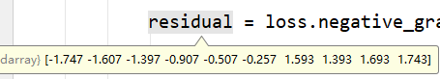

##### loss.update_terminal_regions(tree.tree_, X, y, residual, y_pred, sample_weight, sample_mask, self.learning_rate, k=k)

**def** update_terminal_regions(self, tree, X, y, residual, y_pred,  
 sample_weight, sample_mask,  
 learning_rate=1.0, k=0):  
 *"""Least squares does not need to update terminal regions.  
  
 But it has to update the predictions.  
 """  
 # update predictions* y_pred[:, k] += learning_rate * tree.predict(X).ravel()









## predict

model.predict(X)

### self._decision_function(X).ravel()

#### predict_stages(self.estimators_, X, self.learning_rate, score)

**def** predict_stages(*args, **kwargs): *# real signature unknown  
 """  
 Add predictions of ``estimators`` to ``out``.  
   
 Each estimator is scaled by ``scale`` before its prediction  
 is added to ``out``.  
 """* **pass**



使用gbdt做回归，loss=ls、learning_rate=0.1、**n_estimators** =20时

fit：

第一个y_pred是均值

循环**estimators** 次计算负梯度，使用回归树拟合，加入加法模型

最终得到加法模型

## 数据可视化

[[1,5.56],[2,5.7],[3,5.91],[4,6.4],[5,6.8],[6,7.05],[7,8.9],[8,8.7],[9,9],[10,9.05]]

### round1

第1轮加法模型会预测为均值

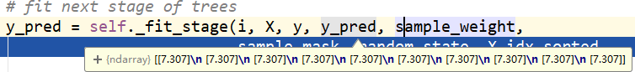

计算第1轮加法模型下损失函数的负梯度（残差）

5.56-7.307=-1.747

使用第1轮加法模型下损失函数的负梯度拟合一棵回归树

对拟合好的树执行update_terminal_regions()，不过Least squares does not need to update terminal regions

But it has to update the predictions.

y_pred[:, k] += learning_rate * tree.predict(X).ravel()



将回归树加入加法模型

self.estimators_[i, k] = tree

### round2

计算第2轮加法模型下损失函数的负梯度（残差）



5.56-7.199=-1.639

使用第2轮加法模型下的负梯度拟合一棵回归树，更新预测值



### round3

计算第3轮加法模型下损失函数的负梯度（残差）



5.56-7.103=-1.543

使用第3轮加法模型下的负梯度拟合一棵回归树，更新预测值



### 。。。

### round20





### 预测

**def** predict_stages(*args, **kwargs): *# real signature unknown  
 """  
 Add predictions of ``estimators`` to ``out``.  
   
 Each estimator is scaled by ``scale`` before its prediction  
 is added to ``out``.  
 """* **pass**

# GradientBoostingClassifier

**import** pandas **as** pd  
**import** numpy **as** np  
**import** math  
**from** sklearn.ensemble **import** GradientBoostingClassifier  
df = pd.DataFrame([[1,-1],[2,-1],[3,-1],[4,1],[5,1],  
 [6,-1],[7,-1],[8,-1],[9,1],[10,1]])  
X = df.iloc[:,[0]]  
Y = df.iloc[:,-1]  
model = GradientBoostingClassifier(n_estimators=20, learning_rate=1.0,  
 max_depth=1, random_state=0)  
model.fit(X, Y)  
print(model.predict(X))

## 模型初始化

第1轮加法模型不在预测为均值

**def** fit(self, X, y, sample_weight=**None**):  
 *# pre-cond: pos, neg are encoded as 1, 0* **if** sample_weight **is None**:  
 pos = np.sum(y)  
 neg = y.shape[0] - pos  
 **else**:  
 pos = np.sum(sample_weight * y)  
 neg = np.sum(sample_weight * (1 - y))  
  
 **if** neg == 0 **or** pos == 0:  
 **raise** ValueError(**'y contains non binary labels.'**)  
 self.prior = self.scale * np.log(pos / neg)



计算第1轮加法模型下损失函数的负梯度（残差）

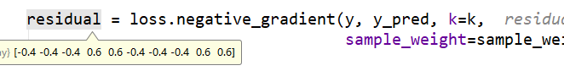

计算负梯度的公式 expit(x) = 1/(1+exp(-x))

**def** negative_gradient(self, y, pred, **kargs):  
 *"""Compute the residual (= negative gradient). """* **return** y - expit(pred.ravel())

## 调整叶子结点

使用第1轮加法模型的负梯度拟合一棵回归树，但这里要调整叶子结点，每个叶子结点的输出值依赖于选用的损失函数

**def** update_terminal_regions(self, tree, X, y, residual, y_pred,  
 sample_weight, sample_mask,  
 learning_rate=1.0, k=0):  
 *"""Update the terminal regions (=leaves) of the given tree and  
 updates the current predictions of the model. Traverses tree  
 and invokes template method `_update_terminal_region`.  
  
 Parameters  
 ----------  
 tree : tree.Tree  
 The tree object.  
 X : ndarray, shape=(n, m)  
 The data array.  
 y : ndarray, shape=(n,)  
 The target labels.  
 residual : ndarray, shape=(n,)  
 The residuals (usually the negative gradient).  
 y_pred : ndarray, shape=(n,)  
 The predictions.  
 sample_weight : ndarray, shape=(n,)  
 The weight of each sample.  
 sample_mask : ndarray, shape=(n,)  
 The sample mask to be used.  
 learning_rate : float, default=0.1  
 learning rate shrinks the contribution of each tree by  
 ``learning_rate``.  
 k : int, default 0  
 The index of the estimator being updated.  
  
 """  
 # compute leaf for each sample in ``X``.* terminal_regions = tree.apply(X)  
  
 *# mask all which are not in sample mask.* masked_terminal_regions = terminal_regions.copy()  
 masked_terminal_regions[~sample_mask] = -1  
  
 *# update each leaf (= perform line search)* **for** leaf **in** np.where(tree.children_left == TREE_LEAF)[0]:  
 self._update_terminal_region(tree, masked_terminal_regions,  
 leaf, X, y, residual,  
 y_pred[:, k], sample_weight)  
  
 *# update predictions (both in-bag and out-of-bag)* y_pred[:, k] += (learning_rate  
 * tree.value[:, 0, 0].take(terminal_regions, axis=0))

numerator = np.sum(sample_weight * residual)  
denominator = np.sum(sample_weight * (y - residual) * (1 - y + residual))

## 可视化

[[1,-1],[2,-1],[3,-1],[4,1],[5,1],[6,-1],[7,-1],[8,-1],[9,1],[10,1]]

### round1

第1轮加法模型不是预测为均值了

self.prior = self.scale * np.log(pos / neg)

pos 是1类数量 neg是-1类数量

np.log(4/6)=-0.4054



计算负梯度，程序会自动将-1类变为0

a = np.log(4/6)  
print(0-1/(1+np.exp(-a))) -0.4

**return** y - expit(pred.ravel())

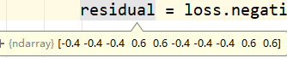

### round2

使用第1轮加法模型下的负梯度拟合一棵回归树，这里就需要对叶子结点进行调整了

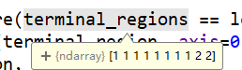

前8个样本被分在了左叶结点，后2个样本被分在了右叶结点

以左叶结点为例，该结点最终的输出值的计算如下：



分子/分母= -0.625，这里的学习率=1



加入加法模型后

-0.4054-0.625=-1.0304



### round3





### round4





### ...

### round20





### 预测

score = self.decision_function(X) 封装  
decisions = self.loss_._score_to_decision(score) 输出类别  
**return** self.classes_.take(decisions, axis=0)