VISUALIZATION

Visualization is a method of presenting information in a visual form. Data visualization means showing data using graphs or pictures so it becomes easier to understand. It helps us clearly see patterns, trends, and insights within the data.
In Python, there are libraries like Matplotlib, Seaborn.

Matplotlib
Matplotlib is used to create static 2D graphs such as line plots, bar charts, scatter plots, and histograms. It is built on numpy.
A Matplotlib plot consists of four components:
- Figure: The container that holds one or more plots.
- Axes: The actual plotting area inside the figure where data is displayed.
A plot can have 2 or 3 axes. xlabel(), ylabel() are used to set the labels
of x and y.
- Axis: Controls the ticks and limits of the x and y directions.
- Artists: All visible elements in the figure
Pyplot
Pyplot is a submodule of Matplotlib that contains the plotting functions. It provides plots such as bar charts, scatter plots, pie charts, histograms, and area charts.

Some of the plots in matplotlib:
LINE CHART
Line plots are the charts where a continuous line connects the dots.
Code Snippet: 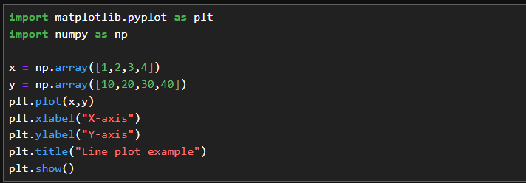
Output:
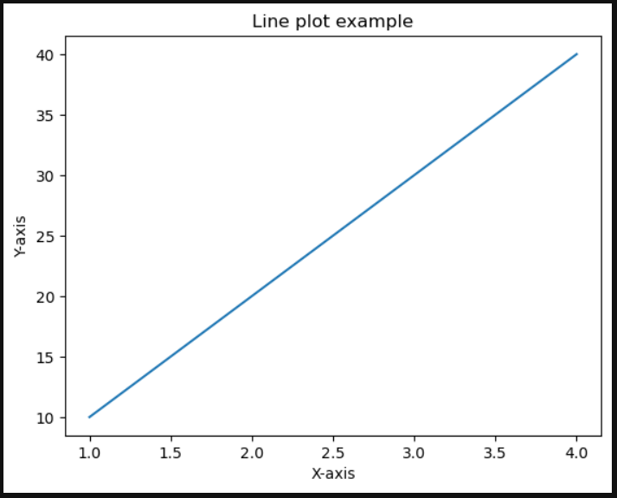
Description: np.array() will generate an array in the specified range.
plot() for the plotting the line chart.
title() for defining the title, ylabel() and xlabel () for labelling y and x axis respectively.
BAR GRAPH
Bar charts use rectangular bars, where the height of each bar represents the frequency of a specific element.
The bar() function is used to draw bar graphs and includes parameters such as x, y, width, and color, written as bar(x, y, color, width).
Code Snippet:
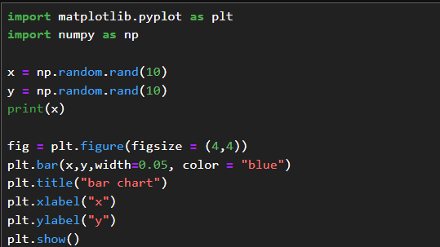
Output:
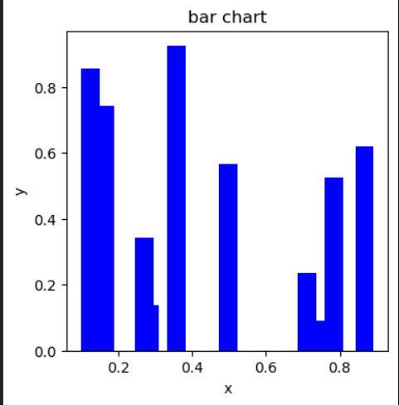
Description: random.rand(10) generates 10 random array values.
The bar() function is used with parameters such as width, which specifies the width of the rectangular bars, and color, which defines the color of the bars.
HISTOGRAM
A histogram is a type of bar graph in which data is displayed in grouped intervals.
The hist() function is used to plot histograms and includes parameters such as x, bins, color, and edgecolor.
Code Snippet:
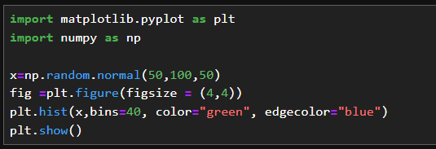
Output:
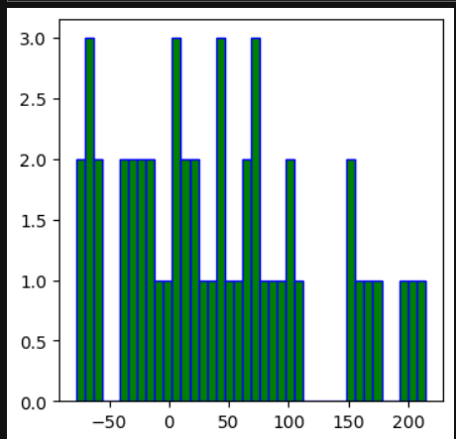
Description:
- x = np.random.normal(50, 100, 50)
Generates 50 random values following a normal distribution with mean 50 and standard deviation 100.
- plt.hist(x, bins=40, color="green", edgecolor="blue")
Plots a histogram of the data in x with 40 bins, green bars, and blue edges.
- Bins represent the number of intervals (or groups) into which the data range is divided in a histogram.

SCATTER PLOT
Scatter plot uses dots to show the relationship between data values. Multiple datasets can be shown together by using different colors.
Legends help identify each dataset.
Code Snippet:
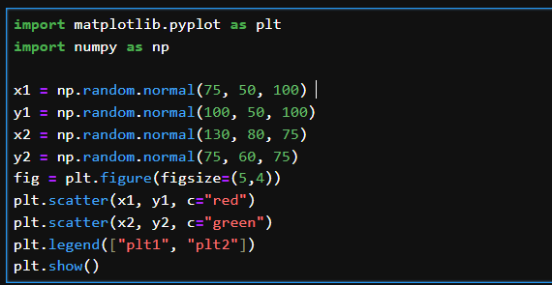
Output:
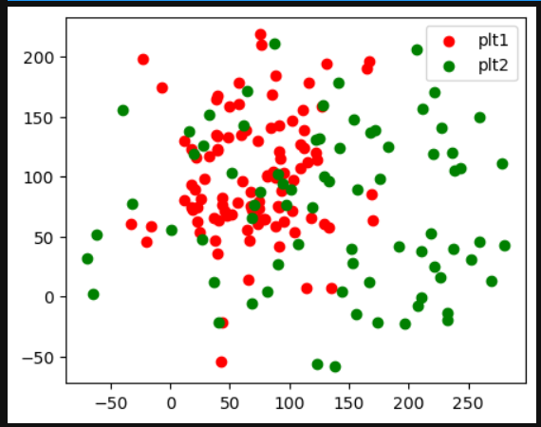
Description: It generates two sets of normally distributed random data and displays
them on a single scatter plot.
np.random.normal(mean, std, size)
Creates random values following a normal distribution.
- mean: average value
- std (standard deviation): controls how spread out the data is
- size: number of values generated
plt.legend(["plt1", "plt2"])
Adds a legend to differentiate between the two datasets.
PIECHART
Pie charts are used to represent a single series of data, showing how different parts contribute to the whole as percentages.
Code Snippet:
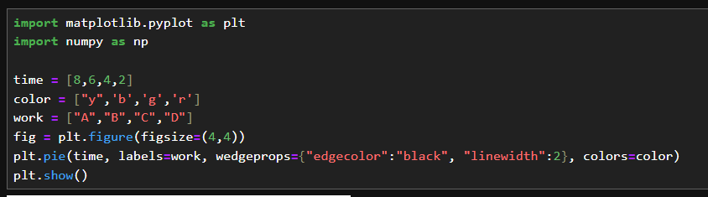
Output:
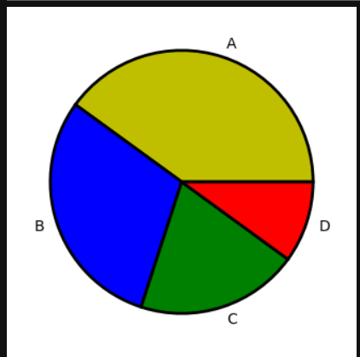
Description:
plt.pie(time, labels=work, wedgeprops={"edgecolor":"black", "linewidth":2}, colors=color)
Creates a pie chart:
- time determines the size of each slice
- labels=work adds labels to the slices
- wedgeprops={"edgecolor":"black","linewidth":2} adds black borders around slices
AREA CHART
In an area chart, the region between the line and the x-axis is filled or shaded.
This can be created using the fill_between() function or the stackplot() function.
Using fill_between() function
Code Snippet:
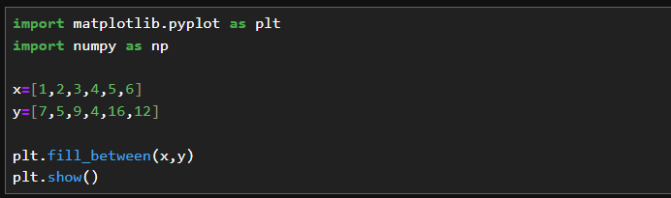
Output:
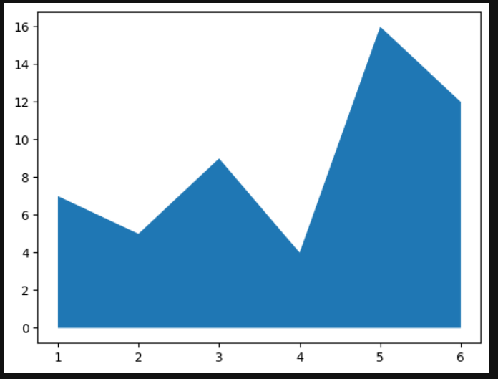
Description:
fill_between() function have parameters of x and y.

Using stackplot() function
Code Snippet:
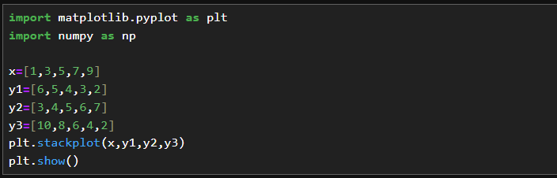
Output:
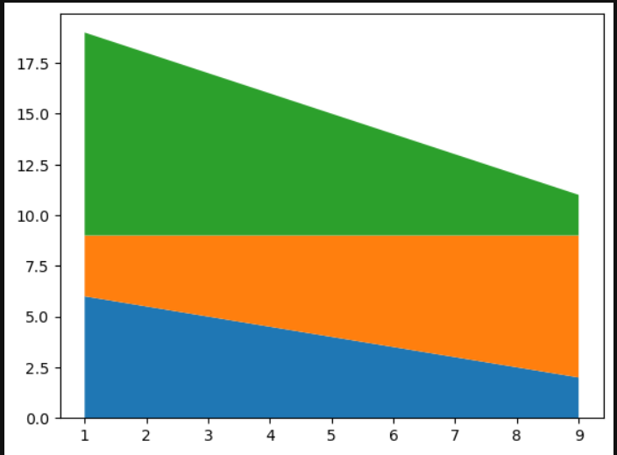
Description:
stackplot() function parameters are x, y1,y1,y3 where y1, y2, y3 are the different groups.

SEABORN
Seaborn is a Python visualization library built on top of Matplotlib. It is more advanced and comes with default styles and color palettes, making plots look better with less effort.
The different plots in each category:
1. Relational Plots:
- scatterplot()
- lineplot()
2. Categorical Plots:
- barplot()
- countplot()
- boxplot()

3. Distribution Plots:
- histplot()
- kdeplot()

4. Relational Plots:
- regplot()
- lmplot()
5. Matrix Plots:
- heatmap()
- clustermap()

Here are some sample codes for some of the graphs.
Scatter plot:
Code Snippet:
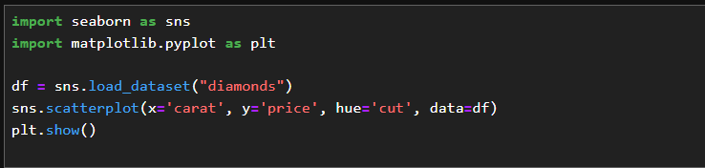

Output:
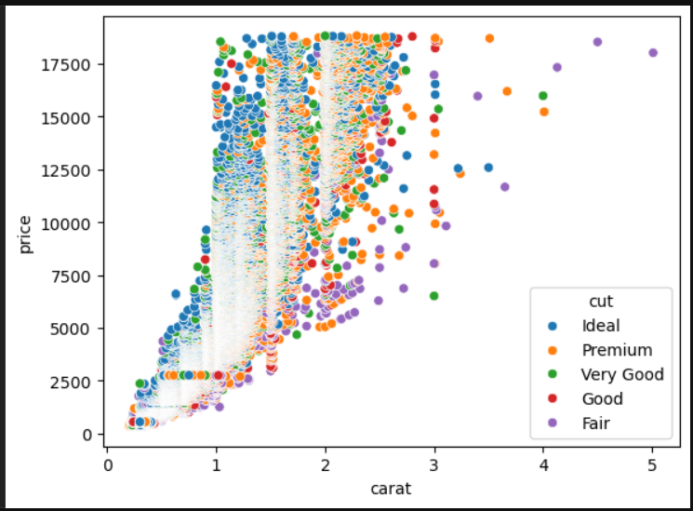
Description:
- The built-in diamonds dataset is loaded.
- Different colors represent different diamond cuts using hue='cut'.
- The plot helps visualize the relationship between carat and price.

LINE PLOT
Code Snippet:
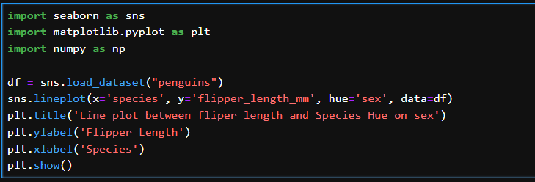
Output:
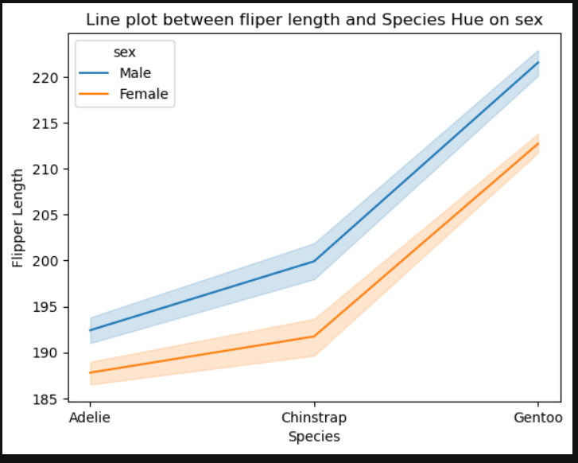
Description:
- The built-in penguins dataset is loaded.
- species is plotted on the x-axis.
- flipper_length_mm is plotted on the y-axis.
- Different colors represent penguin sex using hue='sex'.
BAR PLOT
Code Snippet: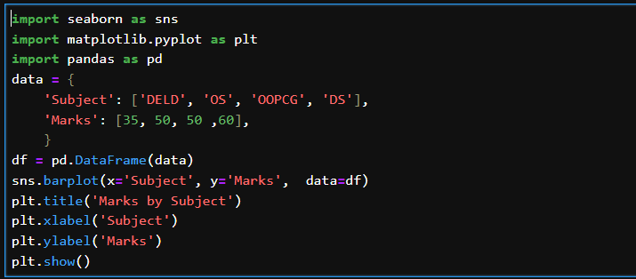
Output:
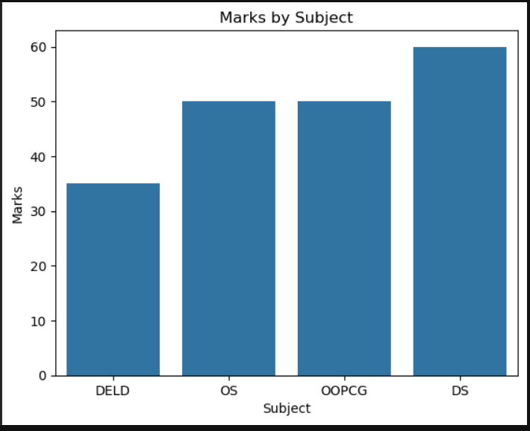
Description:
- Pandas is used to create a DataFrame with custom data.
- Seaborn is used to draw a bar plot.
- Subject is displayed on the x-axis.
- Marks are displayed on the y-axis.
- Each bar represents marks scored in a subject.

COUNT PLOT
Code Snippet:
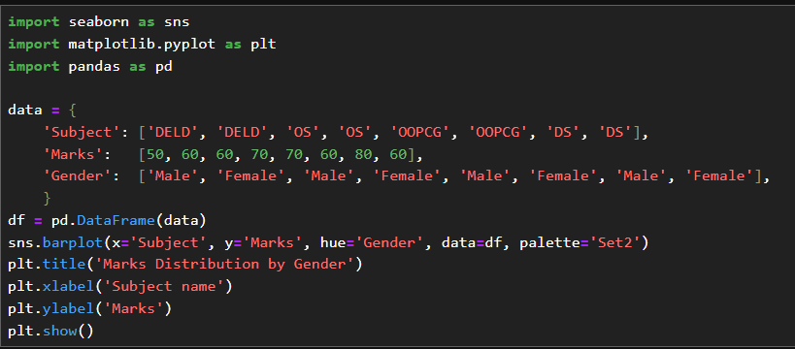
Output:
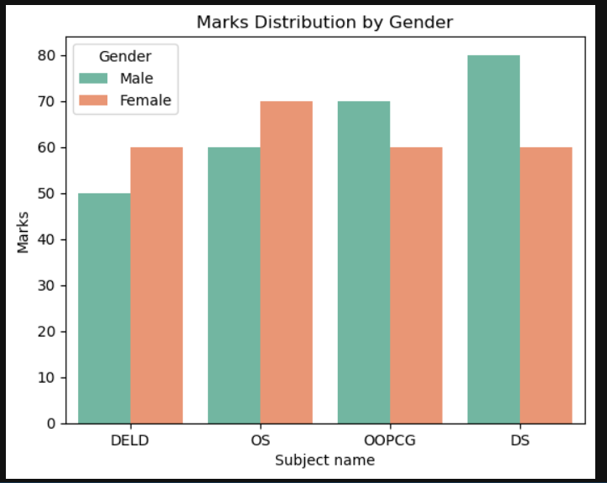
Description:
- The Pandas DataFrame is created with columns: Subject, Marks, and Gender.
- Seaborn’s barplot() is used to visualize the data.
- x='Subject' → the x-axis shows the subjects (DELD, OS, OOPCG, DS).
- y='Marks' → the y-axis shows the marks scored.
- hue='Gender' → bars are colored differently for Male and Female.
- palette='Set2' → sets the color scheme for the bars.
BOX PLOT
Box plot shows the quartiles where the data lies in interquartile range will be inside the box. The points which are away from the whiskers are outliers.
Code Snippet:
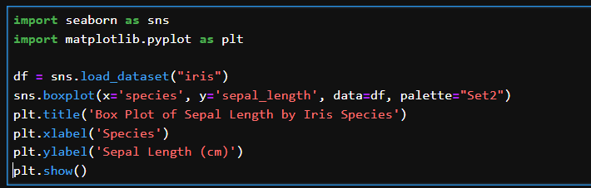
Output:
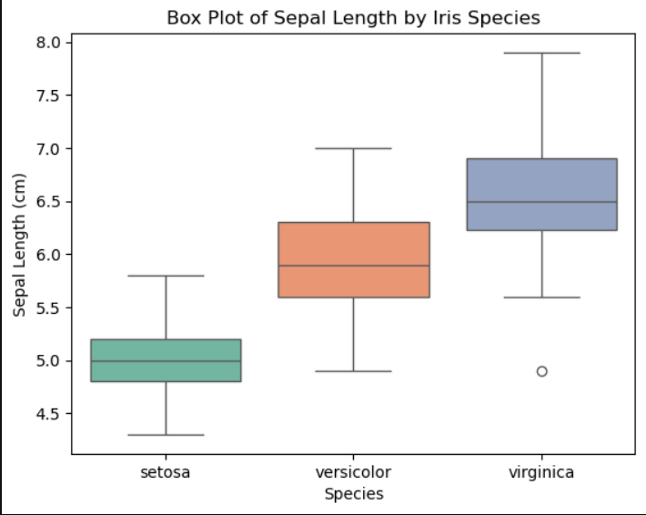
Description:
- The built-in iris dataset is loaded.
- species is displayed on the x-axis.
- sepal_length is displayed on the y-axis in centimeters.
- Each box represents the distribution of sepal length for a species.
- The plot shows the median, quartiles, and outliers.
HISTOPLOT
Code Snippet:
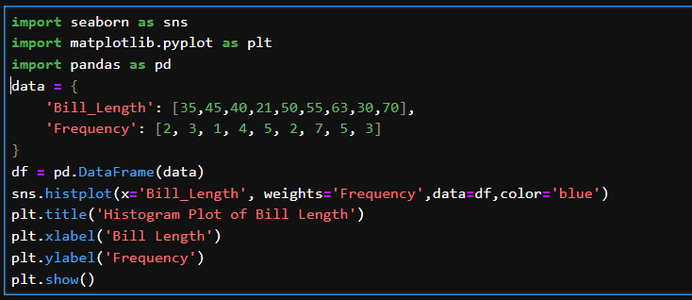
Output:
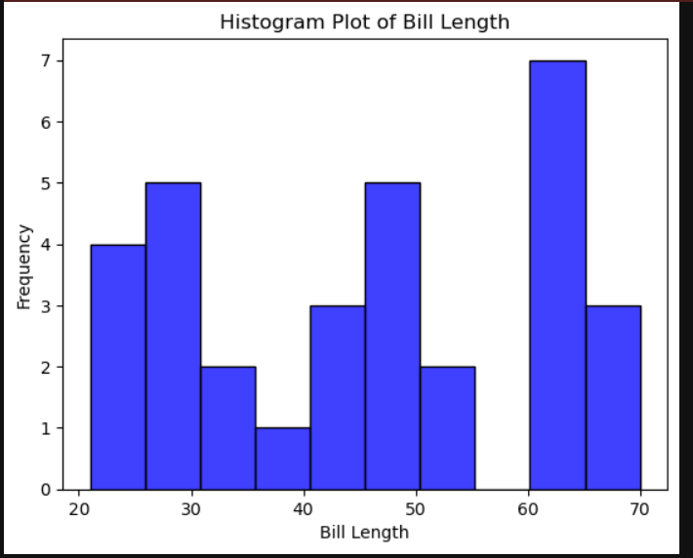
Description:
- The Bill_Length values are plotted on the X-axis.
- X-axis shows Bill Length, and Y-axis shows Frequency.
- weights are used when one data value represents multiple data points.
- Seaborn’s histplot () is used to draw the histogram.
KDEPLOT
KDE stands for kernel density estimate. It creates a curve as based on probability. It creates single graph for multiple data samples.
Code Snippet:
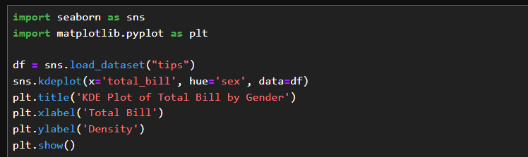
Output:
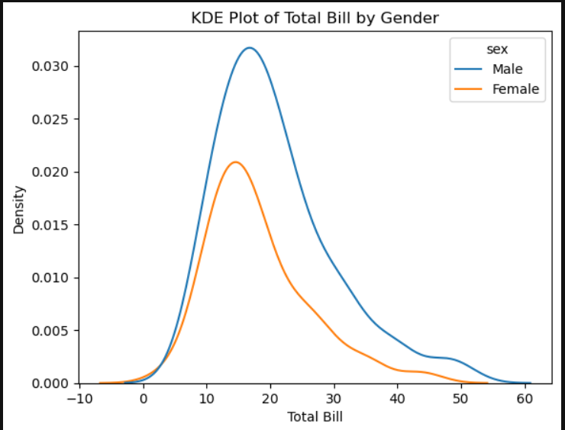
Description:
- The tips dataset is loaded using Seaborn, which contains information about restaurant bills and tips.
- sns.kdeplot() is used to create a Kernel Density Estimation (KDE) plot.
- total_bill is plotted on the x-axis to show the bill amount.
- hue='sex' separates the data into different curves for male and female customers.
- Each curve shows the distribution of total bill values for that group.
HEATMAP
A heatmap visualizes data using a correlation matrix, where higher values appear in brighter colors and lower values appear in darker colors.
Code Snippet:
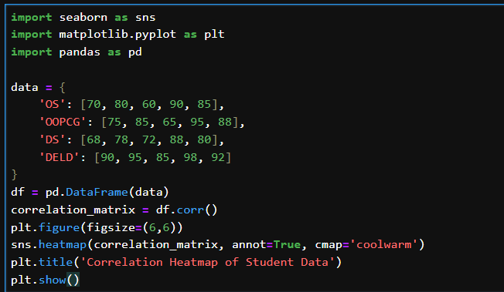
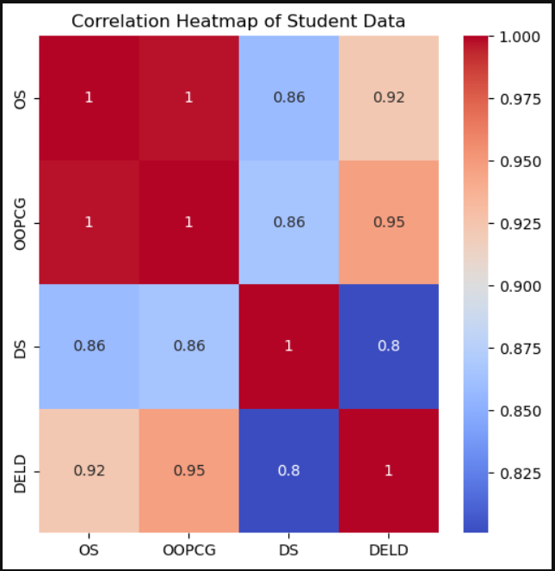
Description:
- A dataset containing marks of students in different subjects (OS, OOPCG, DS, DELD) is created.
- The data is converted into a Pandas DataFrame.
- df.corr() calculates the correlation matrix, showing how subjects are related to each other.
- sns.heatmap() is used to visualize these correlations.
- annot=True displays the correlation values inside each cell.
- The coolwarm color map highlights relationships:
REGPLOT
Regression plots shows the relationship between variables along with the regression line
Code Snippet:
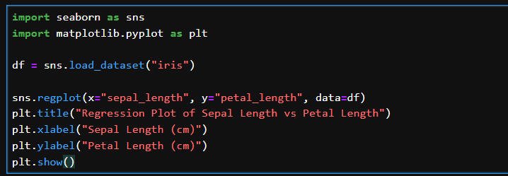
Output:
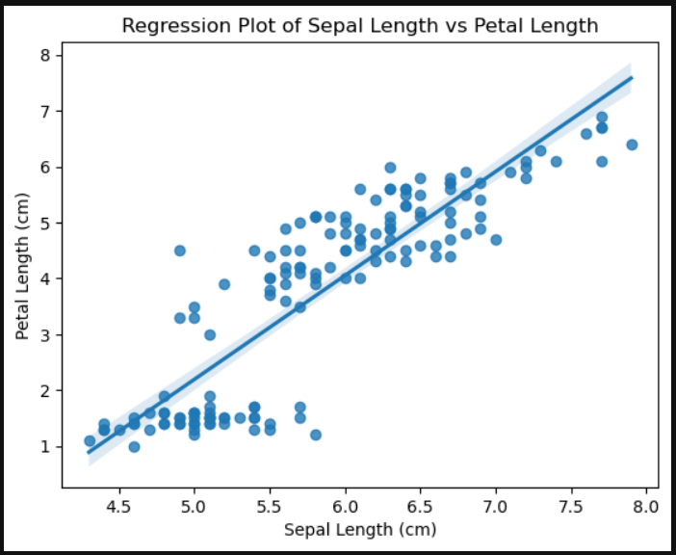
Description:
- The Iris dataset is loaded using Seaborn.
- sns.regplot() is used to create a regression plot.
- sepal_length is shown on the x-axis and petal_length on the y-axis.
- Each dot represents one flower observation.
- The straight line is the regression (best-fit) line.

Comparison of Matplotlib and Seaborn
Matplotlib
Matplotlib is the main plotting library in Python and forms the foundation for many other visualization tools. It gives users complete control over how a graph looks, making it suitable for everything from simple line charts to advanced visualizations like 3D plots and maps. Since it has been in use for many years, it is stable, reliable, and widely supported. One of its biggest strengths is customization—you can adjust almost every detail of a plot, including colors, labels, fonts, and annotations. It also works smoothly with libraries like NumPy, Pandas, and SciPy, which makes it a strong choice for detailed and professional-quality visualizations.
Advantages of Matplotlib
- Offers full control over plot design
- Supports many types of plots
- Well-documented with strong community support
- Ideal for creating publication-ready figures

Seaborn
Seaborn is built on top of Matplotlib and focuses on making data visualization easier and more visually appealing. It provides a higher-level interface, so you can create complex plots with much less code. Seaborn is especially good for statistical visualizations such as bar plots, box plots, violin plots, and regression plots. It comes with attractive default styles and color palettes, allowing you to produce clean and professional-looking graphs quickly. Seaborn also works very well with Pandas DataFrames, making it ideal for data analysis tasks.
Advantages of Seaborn
- Simple and user-friendly syntax
- Strong support for statistical plots
- Visually pleasing default styles
- Excellent for quick analysis and data exploration

Conclusion
Both libraries serve different purposes. Matplotlib is best when you need complete control and highly customized plots, while Seaborn is better for quick, clear, and statistically focused visualizations. In practice, many people use both together—Seaborn for fast and attractive plots, and Matplotlib for fine-tuning when needed.

