VODAFONE:

PURPOSE: For customer feedback and log analysis, and for Billing and revenue management

LAYMEN exp: the project is based on 3 steps:

1. Collecting data for mobile users billing cycle , subscriptions , data usage etc, which will be in BRM using users information in online portal it is put to RDBMS and from there it is taken to HDFS by SQOOP and then it is processed by HIVE and by tabluea a user understandable data is generated
2. For Log analysis, live data is collected from sensors and is parse through online medication here the data is filtered and only valuable data is passed to log server from where flume will come into picture, it will send the data to HDFS (every hour). From HDFS again the data will be processed and using tabluea again the data a user understandable data will be generated.

Architecture :

**BRM(Billing and Revenue Management) :** provided by oracle, a billing and pricing tool

**Online Mediation Controller** this will filter out the necessary data that is required for processing

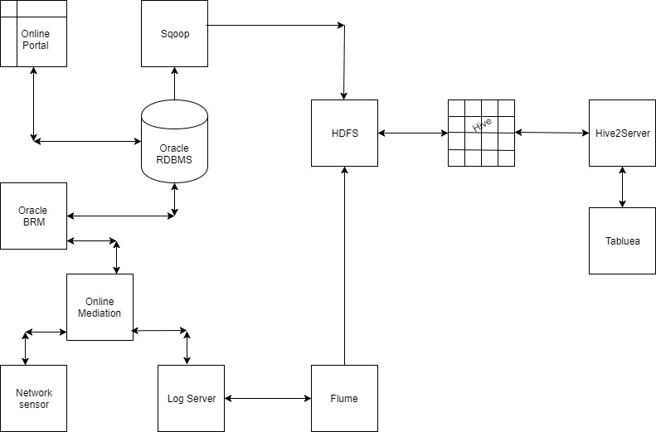

Divide into 2 parts : OSS(operational sub systems) and BSS(Business support system)

OSS related architecture

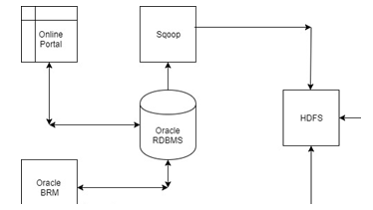

BSS related Architecture

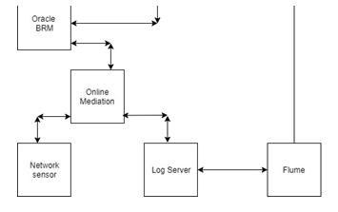

1. Data Migration-----------Data in the project is moved in 2 main ways
2. First from online portal and BRM to oracle RDBMS and from there to HDFS via SQOOP as it is offline data.
3. Second for customer crunch analysis(sensor analysis) from which data will be transferred from the network sensors to online mediation and then to log server ,from where we are sending it to HDFS by using FLUME as it is live data it has to be moved.

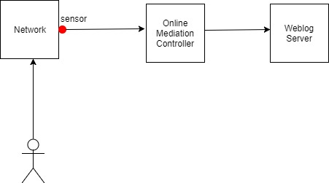

1. Data Processing

Using HIVE the data is processed and it is put to an understandable format for the analysis

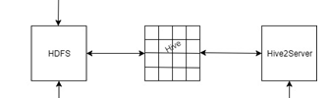

1. Data Analysis

Using tabluea we get the processed data in a easily understandable format.

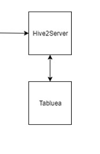

**Why they introduced Hadoop** :: As customers were getting increased day by day who were using service data, so it was very hectic to analyse this BIG DATA

& because of Customer Crunch Analysis : the customers calls and other network related issues are collected from the sensors, and the sensors will be keeping sending the CRDS through online Mediation Controller when call is initiated by the customer of every region these logs will be moved to hadoop cluster using flume for analysis.