# Strategist Developers are the Future of Fixed Income

Published on November 23, 2019

Kamyar Hazaveh Quantitative Macro Portfolio Manager

“Great people have both great character and great capabilities.” - Ray Dalio

The combination of low interest rates and advances in data and computing are resulting in unprecedented change in asset management. In public markets, fixed income asset management (probably due to its over-the-counter nature) is somewhat lagging behind equities in adapting to the new realities.

The increased sensitivity around active management fees have less to do with sudden revelations about active managers’ skill (or lack thereof) and more to do with the unfavorable mathematics of most of the legacy fixed income (or income) products under the current low rate environment. The value of fixed income advice through properly structured, efficiently built and fairly priced solutions is as great as ever.

Today, it is impossible to escape the unfavorable mathematics of active fixed income without employing the power of quant, data and technology. In some cases, the obstacle to change and survival in active fixed income is legacy leadership with beliefs formed over more than three decades of very profitable falling interest rates and a skillset that is unfit for the future of our industry. In my opinion, the investment manager of the future lives in the intersection of three broad abilities: capital markets expertise, quantitative finance and technology as shown below.

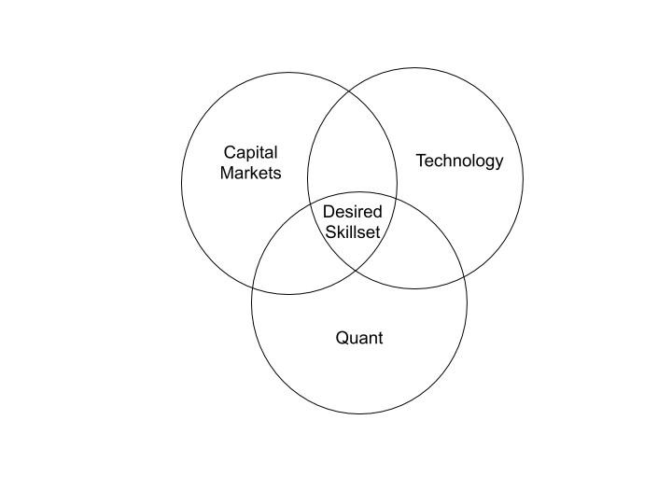

**The fixed income desk of the future is a team of strategist developers.** The investment manager of the future must be able to understand the theory and practice of markets, design systematic processes and actually implement (program). Unfortunately, it is difficult to find leaders that truly live in this intersection: professionals either have OTC trading and portfolio management experience the old-fashioned way, or come from pure quantitative backgrounds with little market or macro knowledge or are positioned in segregated IT groups as developers.