|  |  |  |  |  |  |  |
| --- | --- | --- | --- | --- | --- | --- |
| **Instrument**  **Selection Methods** | **CEMBI** | **CEMBI DIVERSIFIED** | **CEMBI BROAD** | **CEMBI BROAD DIVERSIFIED** | **EMERGING MARKETS CORPORATE PLUS INDEX (EMCB)** | **EMERGING MARKETS LIQUID CORPORATE PLUS INDEX (EMCL)** |
| Country Exposure | Includes countries defined by World Bank as ≤ middle per capita income bracket (Annual Per capita income ≤ USD$12,275). | Includes countries defined by World Bank as ≤ middle per capita income bracket (Annual Per capita income ≤ USD$12,275). | Includes countries defined by World Bank as ≤ middle per capita income bracket (Annual Per capita income ≤ USD$12,275). | Includes countries defined by World Bank as ≤ middle per capita income bracket (Annual Per capita income ≤ USD$12,275). | Includes countries defined by World Bank as ≤ middle per capita income bracket (Annual Per capita income ≤ USD$12,275). | Issuer must have risk exposure to countries other than members of G10, all Western European countries, and U.S. |
| Instrument Type | Includes bonds with fixed coupon instruments and embedded options/warrants.  Only two instruments from any one issuer may be included. | Includes bonds with fixed coupon instruments and embedded options/warrants.  Only two instruments from any one issuer may be included. | Includes fixed, floating, amortizing, capitalizing, and bonds with embedded options/warrants instruments.  All eligible instruments from any one issuer may be included. | Includes fixed, floating, amortizing, capitalizing, and bonds with embedded options/warrants instruments.  All eligible instruments from any one issuer may be included. | Includes fixed and floating rate instruments, zero-coupon bonds, global bonds, 144a, and PIKs.  . | Includes fixed and floating rate instruments, zero-coupon bonds, global bonds, 144a, and PIKs. |
| **Instrument**  **Selection Methods** | **CEMBI** | **CEMBI DIVERSIFIED** | **CEMBI BROAD** | **CEMBI BROAD DIVERSIFIED** | **EMERGING MARKETS CORPORATE PLUS INDEX (EMCB)** | **EMERGING MARKETS LIQUID CORPORATE PLUS INDEX (EMCL)** |
| Issuer Type | Only corporates. No Quasi’s or Sovereign’s.  quasi-sovereigns = 100% owned or guaranteed by the government | Only corporates. No Quasi’s or Sovereign’s.  quasi-sovereigns = 100% owned or guaranteed by the government | Only corporates. No Quasi’s or Sovereign’s.  quasi-sovereigns = 100% owned or guaranteed by the government | Only corporates. No Quasi’s or Sovereign’s.  quasi-sovereigns = 100% owned or guaranteed by the government | Only corporates. No Quasi’s or Sovereign’s.  quasi-sovereigns = 100% owned or guaranteed by the government | Includes corporate and quasi-sovereign bonds. Excludes sovereign and supranational debt. |
| Currency | USD | USD | USD | USD | USD & Euro | USD |
| Size | ≥ USD$500 million | ≥ USD$500 million | ≥ USD$300 million | ≥ USD$300 mln | IG> 250mln (EUR or USD)  HY > 100 mln (EUR or USD) | IG > USD$500 million  HY > USD$300 million |
| **Instrument**  **Selection Methods** | **CEMBI** | **CEMBI DIVERSIFIED** | **CEMBI BROAD** | **CEMBI BROAD DIVERSIFIED** | **EMERGING MARKETS CORPORATE PLUS INDEX (EMCB)** | **EMERGING MARKETS LIQUID CORPORATE PLUS INDEX (EMCL)** |
| Maturity | Instruments > 5 years are considered for inclusion.  Instruments remain in index until 3 years before maturity. | Instruments > 5 years are considered for inclusion.  Instruments remain in index until 3 years before maturity. | Instruments > 5 years are considered for inclusion.  Instruments remain in index until 1 year before maturity. | Instruments > 5 years are considered for inclusion.  Instruments remain in index until 1 year before maturity. | Must have at least 1 year until maturity. | Must have at least 1 year until maturity. |
| Legal Jurisdiction | Only instruments legal jurisdiction that is domestic to a G7 country. | Only instruments legal jurisdiction that is domestic to a G7 country. | Only instruments legal jurisdiction that is domestic to a G7 country. | Only instruments legal jurisdiction that is domestic to a G7 country. | No constraint | No constraint |
| Settlement | Must be able to settle internationally (through Euroclear or another institution domiciled outside the issuing country). | Must be able to settle internationally (through Euroclear or another institution domiciled outside the issuing country). | Must be able to settle internationally (through Euroclear or another institution domiciled outside the issuing country). | Must be able to settle internationally (through Euroclear or another institution domiciled outside the issuing country). | Must be able to settle internationally (through Euroclear or another institution domiciled outside the issuing country). | Must be able to settle internationally (through Euroclear or another institution domiciled outside the issuing country). |
| Quoted Price | Prices will be available either from an inter-dealer broker or JPM. | Prices will be available either from an inter-dealer broker or JPM. | Prices will be available either from an inter-dealer broker or JPM. | Prices will be available either from an inter-dealer broker or JPM. | Prices will be available either from an inter-dealer broker or BofA ML. | Prices will be available either from an inter-dealer broker or BofA ML. |
| **Instrument**  **Weighting Methods** | **CEMBI** | **CEMBI DIVERSIFIED** | **CEMBI BROAD** | **CEMBI BROAD DIVERSIFIED** | **EMERGING MARKETS CORPORATE PLUS INDEX (EMCB)** | **EMERGING MARKETS LIQUID CORPORATE PLUS INDEX (EMCL)** |
| Traditional Market Capitalization Approach | Issue weight = Issue’s market capitalization/ Index total market capitalization. |  | Issue weight = Issue’s market capitalization/ Index total market capitalization. |  | Issue weight = Issue’s market capitalization/ Index total market capitalization. |  |
| Other Approach |  | For each country:  100%: **bonds** < USD$2.5 bln  75%: USD$2.5 bln< **bonds** > USD$ 5 bln  50%: USD$5 bln< **bonds** > USD$ 7.5 bln  25%: USD$7.5 bln< **bonds** > USD$ 12.5 bln  10%: USD$12.5 bln< **bonds** > USD$ 17.5 bln  0%: **bonds** > USD$17.5 bln |  | Each country:  100%: **bonds** < USD$2.5 bln  75%: USD$2.5 bln< **bonds** > USD$ 5 bln  50%: USD$5 bln< **bonds** > USD$ 7.5 bln  25%: USD$7.5 bln< **bonds** > USD$ 12.5 bln  10%: USD$12.5 bln< **bonds** > USD$ 17.5 bln  0%: **bonds** > USD$17.5 bln |  | 10% Country Cap  2% Issuer Cap |

Appendix 1.a

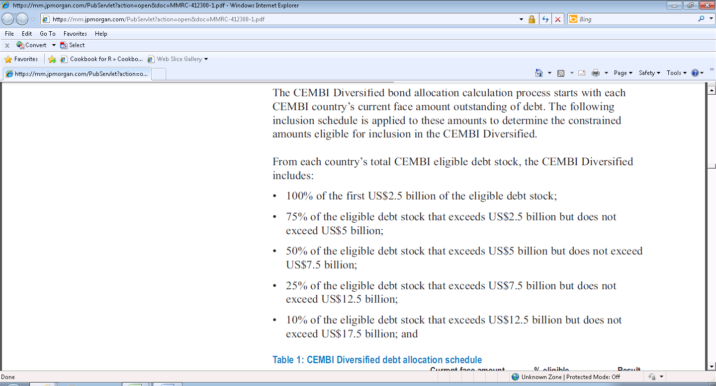

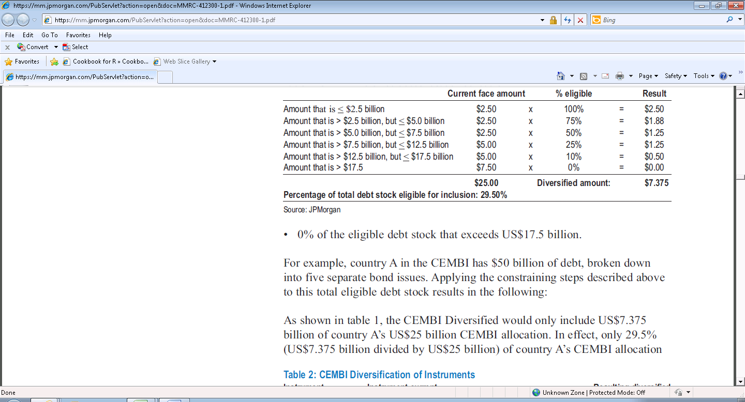

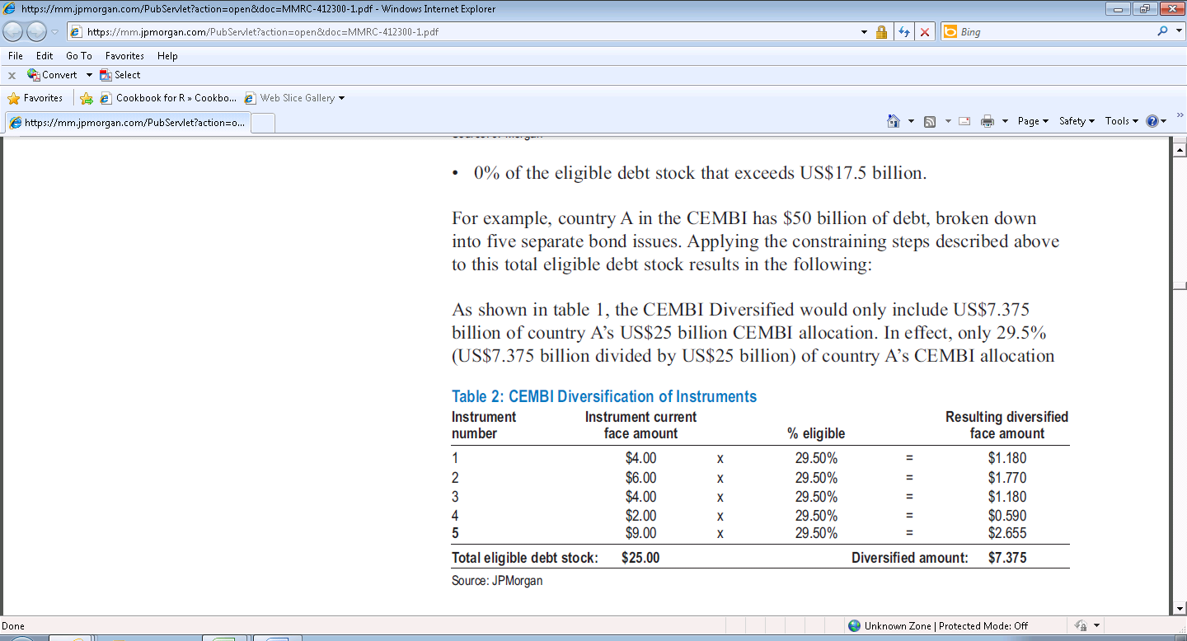

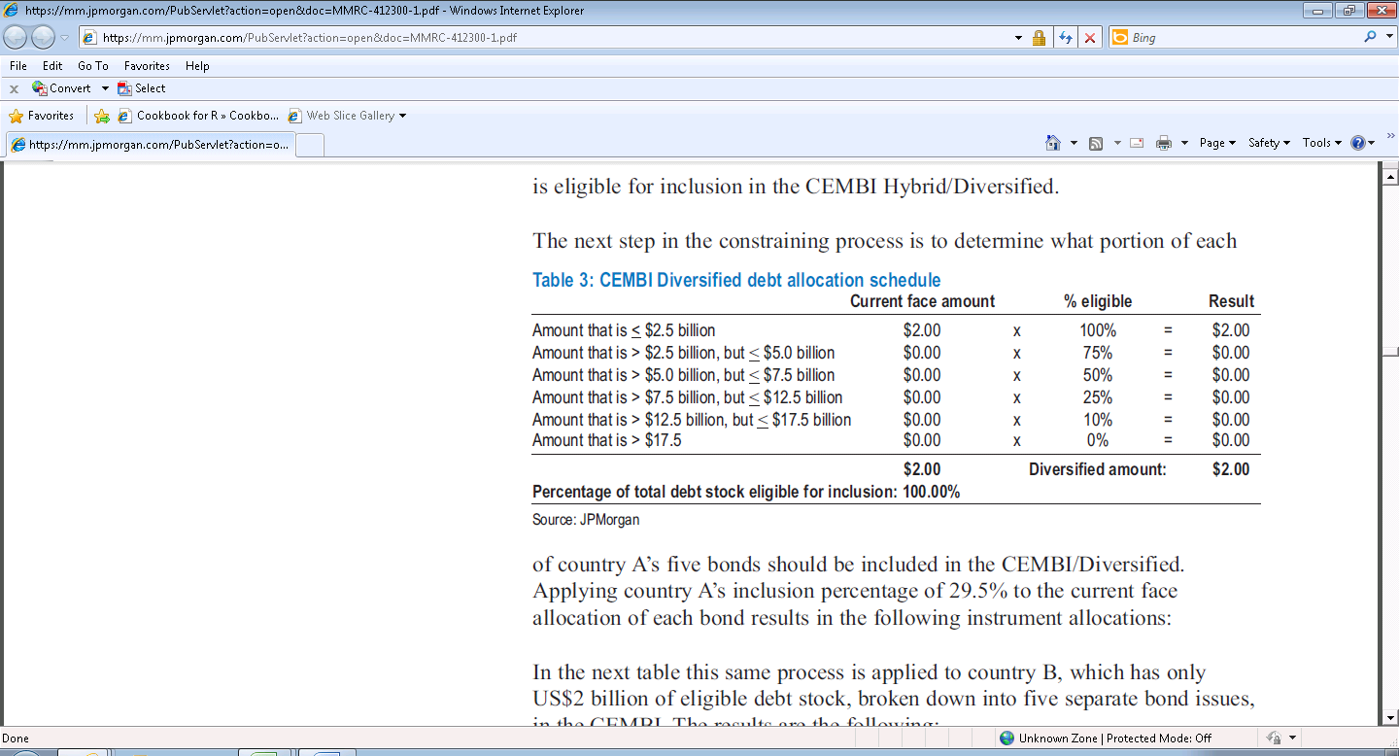

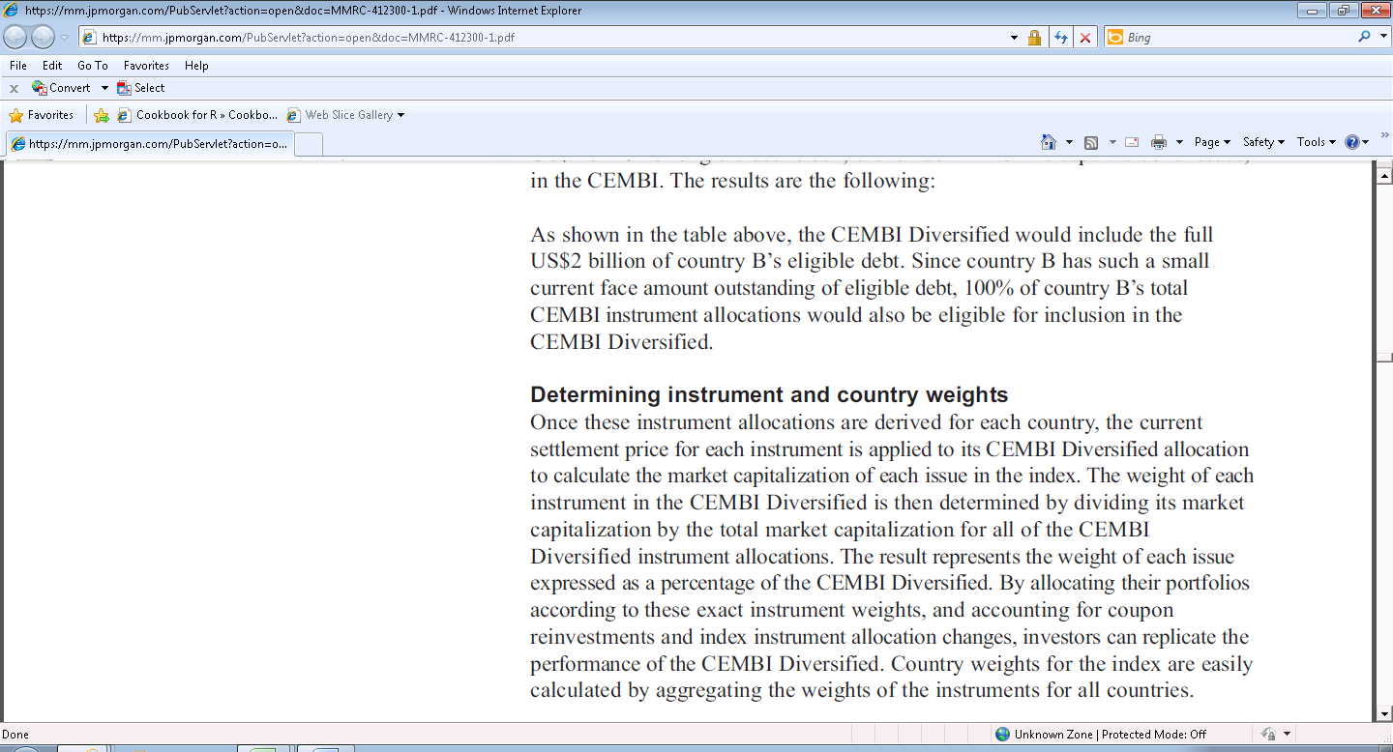

Appendix 1.b

Countries included:

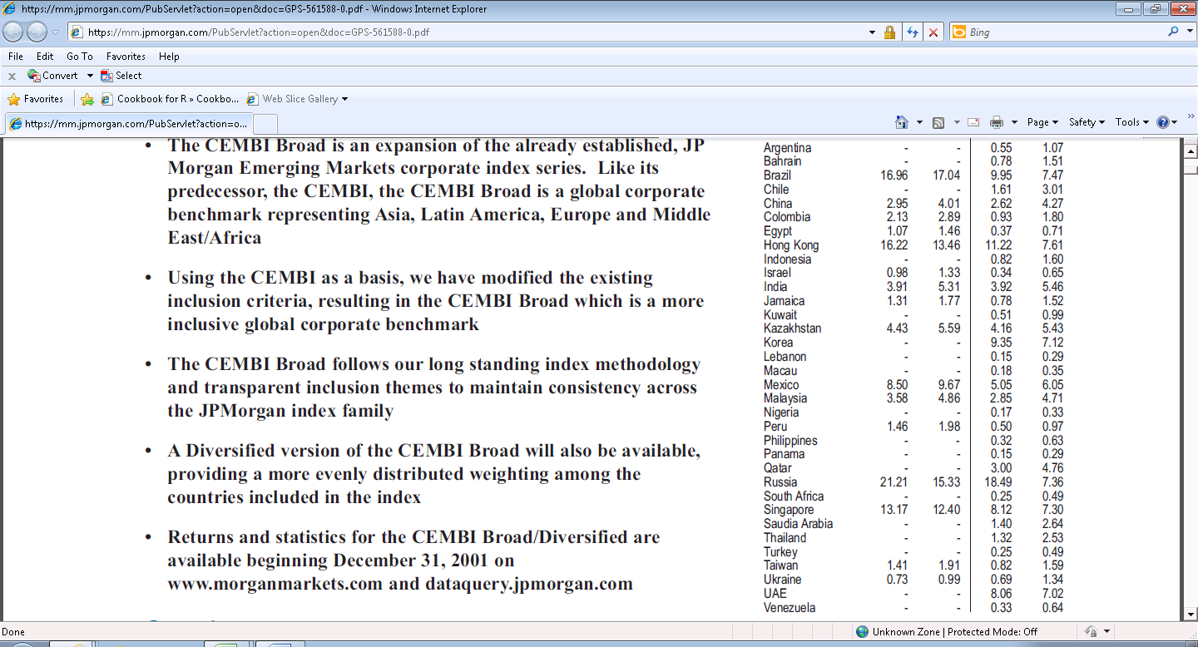

Appendix 1.c

