On further inspection, this may not be an ideal example.   Typically, one would expect the effective duration to lie between the duration to worst (15.88) and the duration to maturity (16.02).   Unfortunately, Bloomberg shows an effective duration (16.36) greater than 16.02 (the duration to maturity).   That’s a result of a shortcoming in the methodology for calculating OAD, which is a discussion for another day.     I will try to find a better example.

**From:** Steve Rich   
**Sent:** Tuesday, January 31, 2017 6:33 PM  
**To:** Jean Anne Laico ([jeananne.laico@mackayshields.com](mailto:jeananne.laico@mackayshields.com)) <[jeananne.laico@mackayshields.com](mailto:jeananne.laico@mackayshields.com)>  
**Cc:** Steven Buckley <[Steven.Buckley@mackayshields.com](mailto:Steven.Buckley@mackayshields.com)>; James Cardamone <[James.Cardamone@mackayshields.com](mailto:James.Cardamone@mackayshields.com)>  
**Subject:** Effective Duration example for Taiyo.

Jean Anne:

Below is a snapshot of a Bloomberg price/yield calculator; specifically, the YA page.     The snapshot refers to a bond in the Taiyo portfolio:  Intel 4.9% of 29 July 2045, which is callable on or after 29 January 2045 with 30 days notice.     According to Bloomberg, the effective duration is 16.364 years (this is the first value under the OAS column in the upper right-hand corner).    In contrast, the duration-to-worst is 15.878 years, according to Bloomberg (see first value under the Workout column in the upper left-hand corner of the screen).    The duration-to-worst is the duration associated with the bond’s most likely redemption date which, according to Bloomberg, is the call date of 29 January 2045.         If James Cardamone were to get you a Factset estimate for the bond’s effective duration (or, what might be called the modified option-adjusted duration, or the modified OAD, or just OAD) as of 31 January 2017 using a price of 112-00, Factset should return something similar to 16.4 years.   Since Factset and Bloomberg probably use similar model-based methodologies to estimate effective duration, you could suggest to the client to have their Bloomberg technical support representative walk them through the detailed calculation in lieu of our providing details.   As I mentioned earlier, I doubt we could tease from Factset all the intermediate results that roll into the calculation, implying our attempt at a detailed response might prove unsatisfactory.

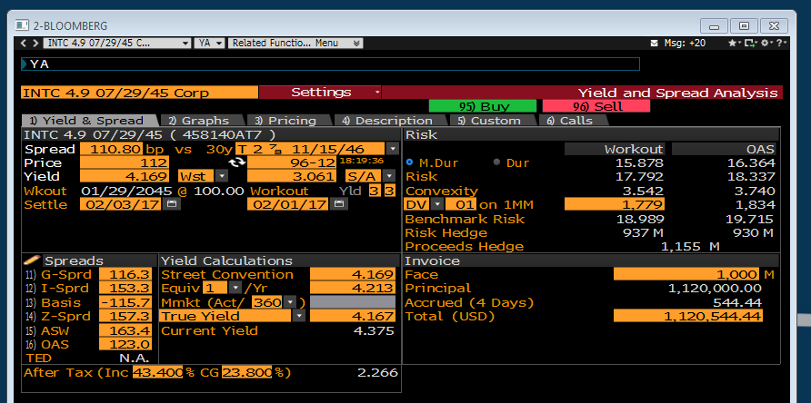

Here is an explanation of the calculation’s general framework:

Effective duration (or what is often called modified option-adjusted duration) is a first-order approximation of price sensitivity to yield changes based on the formula:

                                                                P down – P up

                                                                -----------------

                                                                2 * delta * P base

where delta is the number of basis points by which all simulated interest-rate paths are shifted up and down.   Often delta is set to 50 basis points, so that 2 * delta conveniently equates to 0.01 and turns (P down – P up) / P base into a percentage.

There are four preparatory steps to the calculation of effective duration:

* A set of interest-rate paths are postulated.    The collection of interest-rate paths reflect the stochastic nature by which the treasury yield-curve’s term structure evolves over time.   The selection of the paths is informed by the prevailing slope of the yield curve and the prevailing interest-rate volatility, both short- and long-term.
* For each interest-rate path, the timing and magnitude of a bond’s cash-flows are estimated.    This process is deterministic when the bond’s cash-flows are known with certainty a priori (i.e., cash flows are interest-rate path independent).    Alternatively, when the bond has embedded optionality (e.g., the bond is callable), the trajectory of the simulated interest-rate path influences the potential for an option to be exercised.  For this reason, the  timing and magnitude of the bond’s cash flows are interest-rate path dependent.
* Once the prior step is completed for each interest-rate path, the net present values of the cash flows along each path are determined.   In other words, there is one realization of net present value for each simulated interest-rate path.   The net present value is the sum of discounted cash flows, where the discount factor is based on the applicable spot rate adjusted with a spread to the treasury curve.     For example, if we have quarterly spot rates, the following discount factor would be applied to a cash flow occurring six months forward:

                                                                                Discount factor =   1 / [1 + 6 mo treasury spot rate + spread to treasury curve] 0.5

* The pricing model attempts to find the spread that enables the average price across the simulated interest-rate paths to equate to the bond’s observed price.    This is the base-case price (P-base).    The spread is frequently called the option-adjusted spread (OAS).

The pricing routine is repeated twice more:

* All simulated interest-rate paths are raised by 50 basis points.    The timing and magnitude of the bond’s cash-flows are estimated along each adjusted interest-rate path.    From there, the net present value of the simulated cash flows is calculated (if there are 100 interest-rate paths, then there will be 100 realizations of net present value).   For this step, the same spread used to determine P-base is incorporated in the discount factor.     The average of the net present values is P-up.
* All simulated interest-rate paths are lowered by 50 basis points.    The timing and magnitude of the bond’s cash-flows are estimated along each adjusted interest-rate path.   From there, the net present value of the simulated cash flows is calculated.   For this step, the same spread that equilibrated P-base to the observed price is incorporated in the discount factor.   The average of the net present values is P-down.

Finally, as noted above, with a parallel shift (i.e., delta) of 50 basis points,  effective duration is (P down – P up) / P base.