FI Performance Attribution Calcs

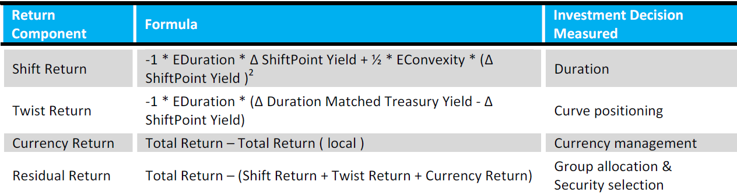

Shift Return – Measures the price return component due to a parallel shift in the curve. It measures the managers long or short duration bet relative to the index based. The rate or shift point yield change can be based on a single point or average of several points. The rate is based on the local par curve (observable) of the security. The convexity adjustment is added in to represent that a security’s price change is not linear, however this will have a very small impact on the return. For simplifying my examples I’ve assumed it to be zero.

Scenarios:

When rates go down you want to be longer duration relative to the index. For example if you are at a portfolio duration of 5 and the index is at 6, when rates drop 10bps over the month you’ll lose 10bps due to Shift Effect. Shift Effect is the variation in Shift Return for the portfolio & benchmark so Port = (-1x5x-10 or 50bps) vs Bmk (-1x6x-10 or 60bps) or 50bps-60bps=-10bps. In a decreasing rate environment you want to be neutral or long duration relative to the index.

When rates go up, you want to be shorter duration relative to the index. So using the same values as above, you benefit from being short duration if rates increase by 10bps. You would gain 10bps due to Shift Effect here. Port = (-1x5x10 or -50bps) vs Bmk=(-1x6x10 or -60bps) or -50bps - -60bps =10bps . In an increasing rate environment you want to be neutral or short duration relative to the index.

Twist Return – Measures the price return component due to a non-parallel shift in the curve. Twist will measure yield curve positioning relative to the index. Similar to Shift, Twist Effect is the difference in Portfolio Twist Return – Benchmark Twist Return. To measure the non-parallel change in interest rates FactSet creates a Duration Matched Treasury (DMT) for each security and measures the yield change. The DMT is a synthetically created treasury of the same currency as the security and it represents a RF investment with the same effective duration as each security in the portfolio. The daily change in yield of the DMT is used to approximate the impact of the non-parallel yield curve change. The shift point yield change is subtracted from the DMT change in yield to arrive at Twist Return.

Scenarios:

There a few components to Twist Return so when rates go down you want to be long or duration neutral and you want to be on parts of the curve that decline more than the average change in rates (shift point). On a relative basis you want to see more decline in your portfolio DMT yield change than the index.

So the first part long duration relative to the index:

Portfolio Duration of 6 vs benchmark of 5 and portfolio DMT yield drops more than the average change in rates and more than the index DMT yield drop.

Port Shift Point Yield Change = -10bps

Port DMT Yield Change = -20bps

Index Shift Point Yield Change = -10bps

Index DMT Yield Change = -5bps

Port Twist Return: -1 x 6 (-20bps - -10bps)= -6 x (-10bps) or +60bps

Index Twist Return: -1 x 5 (-5bps - - 10bps)= -5 x (+5bps) or -25bps.

Here you benefit from being longer duration & seeing more decline in yield change relative to the index.

When Rates go up you want the opposite. You want to be short duration relative to the index and see your DMT rate go up less than the average level of rates (Shift Point). From a relative basis you want to see your Port DMT yield change go up less than the index DMT yield change to achieve a positive differential.

Portfolio Duration of 5 vs benchmark of 6 and DMT yield increases less than the average change in rates and less than the index DMT yield increase.

Port Shift Point Yield Change = 10bps

Port DMT Yield Change = 5bps

Index Shift Point Yield Change = 10bps

Index DMT Yield Change = 15bps

Port Twist Return: -1 x 5 (5bps - 10bps)= -5 x (-5bps) or +25bps

Index Twist Return: -1 x 6 (15bps - 10bps)= -6 x (5bps) or -30bps.

\*There are multiple ways to achieve a positive differential in lowering & rising rate environments based on the inputs but what I described is a general rule to achieve a positive differential.