**Wage Growth Likely, Even as Jobs Shift from Manufacturing**

Stagnant wage growth has been a source of continued concern in the United States throughout the current economic expansion, but other advanced economies are also experiencing this phenomenon, including the United Kingdom, the eurozone, and Australia. There are several factors at work in keeping wage growth down around the world, some of which are already showing signs of reversal, but others are the result of major structural shifts in global workforces that are likely to continue.

## **Rising Inflation Expectations**

One factor that has contributed to the suppression of wage growth is low inflation expectations. In an environment of [continued expansionary monetary policy](https://insight.factset.com/central-banks-maintain-policy-positions-for-now) around the world, inflation has remained subdued, and workers have had little leverage or incentive to push for raises. Total wage growth over the last five years has averaged just 2.2% for the U.S., 1.8% for the UK, 1.5% for the eurozone, and 2.6% for Australia. Over that same period, inflation has remained at historic lows, keeping real wages stable.

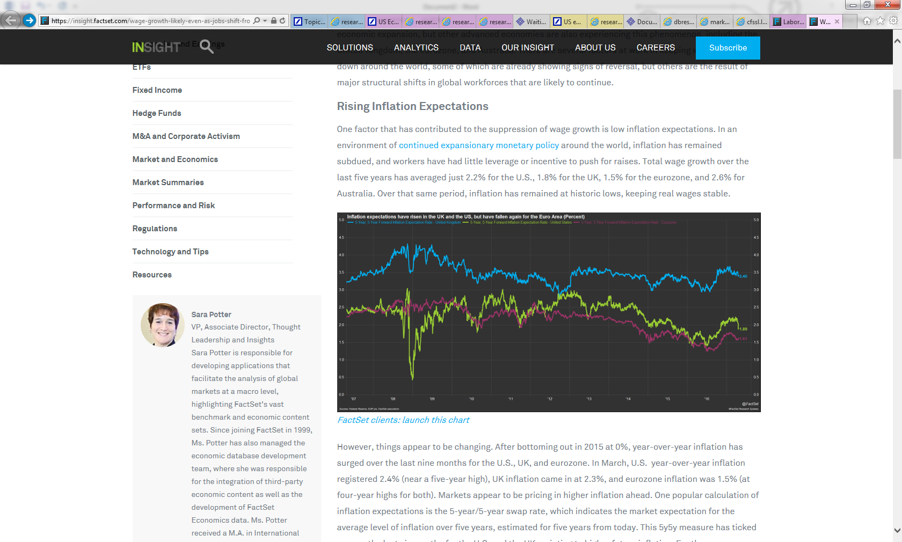

However, things appear to be changing. After bottoming out in 2015 at 0%, year-over-year inflation has surged over the last nine months for the U.S., UK, and eurozone. In March, U.S. year-over-year inflation registered 2.4% (near a five-year high), UK inflation came in at 2.3%, and eurozone inflation was 1.5% (at four-year highs for both). Markets appear to be pricing in higher inflation ahead. One popular calculation of inflation expectations is the 5-year/5-year swap rate, which indicates the market expectation for the average level of inflation over five years, estimated for five years from today. This 5y5y measure has ticked up over the last six months for the U.S. and the UK, pointing to higher future inflation. For the eurozone, inflation expectations shifted higher in the last quarter of 2016, but have come back down since in the face of weak economic growth and growing political uncertainty in the region.

With higher inflation expectations and tighter job markets, workers may just now be feeling confident about asking for raises. Unemployment rates have fallen to new lows in the U.S. and UK and many analysts believe that those economies are at or near full employment, another indication of higher wage growth ahead.

## **Shift Away from Manufacturing Jobs**

Rising inflation expectations and tightening labor markets are both indicators of higher wages ahead for some countries, but many may still face headwinds from ongoing shifts in the composition of jobs on a global scale. We are seeing a long-term shift away from high-paying manufacturing jobs to lower paying service jobs around the world. While global manufacturing output continues to grow at a healthy pace, manufacturing jobs are on the decline in many advanced economies as technology continues to improve production processes and reduce the need for low-skilled manufacturing labor.

[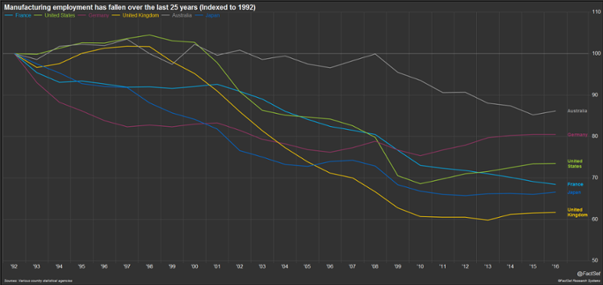](https://insight.factset.com/hubfs/Insight/2017/Insight_April_2017/04.26.17_Econ/Manufacturing-employment-is-down.png)

According to the United Nations, the five largest manufacturing countries in the world are China, the U.S., Japan, Germany, and South Korea. With the exception of Japan, [whose economy has been struggling for the last two decades](https://insight.factset.com/theres-optimism-in-the-air-for-japans-economy), manufacturing output for these countries has seen strong growth over the last 25 years. However, technology has allowed these countries to expand factory production with fewer workers. Even in China, the world’s largest manufacturing country, the government is looking to expand the services share of the economy according to the government’s latest five-year plan. Approved a year ago, [the 13th five-year plan](https://www.uscc.gov/Research/13th-five-year-plan) targets a 56% services share of GDP by 2020 and shifts the manufacturing sector to higher value-added production through technology investment.

[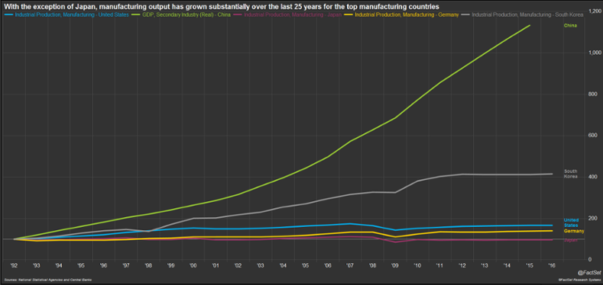](https://insight.factset.com/hubfs/Insight/2017/Insight_April_2017/04.26.17_Econ/Global-MFG-remains-strong.png)

A few countries have seen modest growth in manufacturing jobs over the past few years as their economies have expanded with the global economic recovery (U.S., UK, Germany), but service jobs have expanded even faster. Between 2010 and 2016, the U.S. added 12.2 million private service-providing jobs, compared to just 819,000 new manufacturing jobs.

According to data from the U.S. Bureau of Labor Statistics, average hourly earnings for the largest growth area within the services category, professional and business services, currently exceed manufacturing wages ($31.65 vs. $26.37 in March 2017). However, the next three biggest growth areas (trade, transportation and utilities, education and health services, leisure and hospitality), which make up 64% of private service job gains over the last six years, all lag behind ($22.63, $26.06 and $15.33, respectively).

[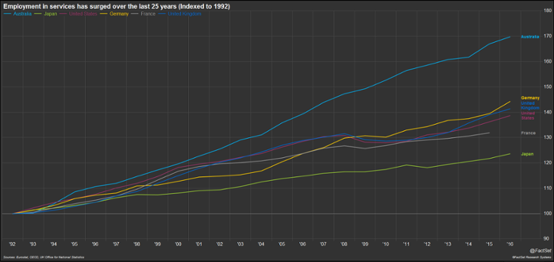](https://insight.factset.com/hubfs/Insight/2017/Insight_April_2017/04.26.17_Econ/Employment-in-service-has-surged.png)

Even if wages grow faster in the service sector than in manufacturing, as long as service wages remain below manufacturing wages, the sheer number of new lower-wage jobs will suppress overall average wages, keeping the growth rate low.

When looking to overseas labor markets, the landscape is changing. China is no longer the destination for low-cost manufacturing due to rapid wage growth in recent years. As the leading manufacturing countries shift toward more high value-added manufacturing and service jobs, low-tech manufacturing jobs will move to today’s emerging markets, such as Vietnam, Bangladesh, and Indonesia. Advanced economies will need to capitalize on their competitive advantages in high-end manufacturing and services in order to boost productivity and wages while also maximizing economic growth.